
Carry out vehicle maintenance or minor
repairs
D2.TTO.CL4.02
Trainer Guide

Carry out vehicle maintenance or minor repairs

D2.TTO.CL4.02

Trainer Guide





Project Base
William Angliss Institute of TAFE
555 La Trobe Street
Melbourne 3000 Victoria
Telephone: | (03) 9606 2111
Facsimile: | (03) 9670 1330
Acknowledgements
Project Director: | Wayne Crosbie
Project Manager | Jim Irwin
Chief Writer: | Alan Hickman
Subject Writer: | Alan Hickman
Editor: | Jim Irwin
DTP/Production: | Daniel Chee, Mai Vu, Cindy Curran

The Association of Southeast Asian Nations (ASEAN) was established on 8 August 1967. The Member States of the Association are Brunei Darussalam, Cambodia, Indonesia, Lao PDR, Malaysia, Myanmar, Philippines, Singapore, Thailand and Viet Nam.
The ASEAN Secretariat is based in Jakarta, Indonesia.
General Information on ASEAN appears online at the ASEAN Website: www.asean.org.
All text is produced by William Angliss Institute of TAFE for the ASEAN Project on “Toolbox Development for Tourism Labour Divisions for Travel Agencies and Tour Operations”.
This publication is supported by the Australian Government’s aid program through the ASEAN- Australia Development Cooperation Program Phase II (AADCP II).
Copyright: Association of Southeast Asian Nations (ASEAN) 2015. All rights reserved.
Disclaimer
Every effort has been made to ensure that this publication is free from errors or omissions. However, you should conduct your own enquiries and seek professional advice before relying on any fact, statement or matter contained in this book. The ASEAN Secretariat and William Angliss Institute of TAFE are not responsible for any injury, loss or damage as a result of material included or omitted from this course. Information in this module is current at the time of publication. Time of publication is indicated in the date stamp at the bottom of each page.
Some images appearing in this resource have been purchased from stock photography suppliers Shutterstock and iStockphoto and other third party copyright owners and as such are non-transferable and non-exclusive. Clip arts, font images and illustrations used are from the Microsoft Office Clip Art and Media Library. Some images have been provided by and are the property of William Angliss Institute.
Additional images have been sourced from Flickr and SXC and are used under Creative Commons licence: http://creativecommons.org/licenses/by/2.0/deed.en
File name: TG_Carry_out_vehicle_maintenance_minor_repairs_270715



Table of contents
Competency Based Training (CBT) and assessment – An introduction for trainers 1
Competency standard 11
Notes and PowerPoint slides 23
Recommended training equipment 295
Instructions for Trainers for using PowerPoint – Presenter View 299
Appendix – ASEAN acronyms 301

© ASEAN 2015
Trainer Guide Carry out vehicle maintenance or minor repairs

© ASEAN 2015
Trainer Guide
Carry out vehicle maintenance or minor repairs

Competency Based Training (CBT) and assessment – An introduction for trainers
Competency
Competency refers to the ability to perform particular tasks and duties to the standard of performance expected in the workplace.
Competency requires the application of specified knowledge, skills and attitudes relevant to effective participation, consistently over time and in the workplace environment.
The essential skills and knowledge are either identified separately or combined.
Knowledge identifies what a person needs to know to perform the work in an informed and effective manner.
Skills describe the application of knowledge to situations where understanding is converted into a workplace outcome.
Attitude describes the founding reasons behind the need for certain knowledge or why skills are performed in a specified manner.
Competency covers all aspects of workplace performance and involves:
- Performing individual tasks
- Managing a range of different tasks
- Responding to contingencies or breakdowns
- Dealing with the responsibilities of the workplace
- Working with others.

Unit of competency

Like with any training qualification or program, a range of subject topics are identified that focus on the ability in a certain work area, responsibility or function.
Each manual focuses on a specific unit of competency that applies in the hospitality workplace.
In this manual a unit of competency is identified as a ‘unit’.
Each unit of competency identifies a discrete workplace requirement and includes:
- Knowledge and skills that underpin competency
- Language, literacy and numeracy
- Occupational safety and health requirements.
Each unit of competency must be adhered to in training and assessment to ensure consistency of outcomes.

Element of competency
An element of competency describes the essential outcomes within a unit of competency. The elements of competency are the basic building blocks of the unit of competency.
They describe in terms of outcomes the significant functions and tasks that make up the competency.
In this manual elements of competency are identified as an ‘element’.

Performance criteria

Performance criteria indicate the standard of performance that is required to demonstrate achievement within an element of competency. The standards reflect identified industry skill needs.
Performance criteria will be made up of certain specified skills, knowledge and attitudes.

Learning

For the purpose of this manual learning incorporates two key activities:
- Training
- Assessment.
Both of these activities will be discussed in detail in this introduction.
Today training and assessment can be delivered in a variety of ways. It may be provided to participants:
- On-the-job – in the workplace
- Off-the-job – at an educational institution or dedicated training environment
- As a combination of these two options.
No longer is it necessary for learners to be absent from the workplace for long periods of time in order to obtain recognised and accredited qualifications.

Learning approaches

This manual will identify two avenues to facilitate learning: Competency Based Training (CBT)
This is the strategy of developing a participant’s competency.
Educational institutions utilise a range of training strategies to ensure that participants are able to gain the knowledge and skills required for successful:
- Completion of the training program or qualification
- Implementation in the workplace.
The strategies selected should be chosen based on suitability and the learning styles of participants.

Competency Based Assessment (CBA)

This is the strategy of assessing competency of a participant.
Educational institutions utilise a range of assessment strategies to ensure that participants are assessed in a manner that demonstrates validity, fairness, reliability, flexibility and fairness of assessment processes.

Flexibility in learning

It is important to note that flexibility in training and assessment strategies is required to meet the needs of participants who may have learning difficulties. The strategies used will vary, taking into account the needs of individual participants with learning difficulties.
However they will be applied in a manner which does not discriminate against the participant or the participant body as a whole.
Catering for participant diversity
Participants have diverse backgrounds, needs and interests. When planning training and assessment activities to cater for individual differences, trainers and assessors should:
- Consider individuals’ experiences, learning styles and interests
- Develop questions and activities that are aimed at different levels of ability
- Modify the expectations for some participants
- Provide opportunities for a variety of forms of participation, such as individual, pair and small group activities
- Assess participants based on individual progress and outcomes.
The diversity among participants also provides a good reason for building up a learning community in which participants support each other’s learning.
Participant centred learning
This involves taking into account structuring training and assessment that:
- Builds on strengths – Training environments need to demonstrate the many positive features of local participants (such as the attribution of academic success to effort, and the social nature of achievement motivation) and of their trainers (such as a strong emphasis on subject disciplines and moral responsibility). These strengths and uniqueness of local participants and trainers should be acknowledged and treasured
- Acknowledges prior knowledge and experience – The learning activities should be planned with participants’ prior knowledge and experience in mind
- Understands learning objectives – Each learning activity should have clear learning objectives and participants should be informed of them at the outset. Trainers should also be clear about the purpose of assignments and explain their significance to participants
- Teaches for understanding – The pedagogies chosen should aim at enabling participants to act and think flexibly with what they know
- Teaches for independent learning – Generic skills and reflection should be nurtured through learning activities in appropriate contexts of the curriculum. Participants should be encouraged to take responsibility for their own learning

- Enhances motivation – Learning is most effective when participants are motivated. Various strategies should be used to arouse the interest of participants
- Makes effective use of resources – A variety of teaching resources can be employed as tools for learning
- Maximises engagement – In conducting learning activities, it is important for the minds of participants to be actively engaged
- Aligns assessment with learning and teaching – Feedback and assessment should be an integral part of learning and teaching
- Caters for learner diversity – Trainers should be aware that participants have different characteristics and strengths and try to nurture these rather than impose a standard set of expectations.
Active learning
The goal of nurturing independent learning in participants does not imply that they always have to work in isolation or solely in a classroom. On the contrary, the construction of knowledge in tourism and hospitality studies can often best be carried out in collaboration with others in the field. Sharing experiences, insights and views on issues of common concern, and working together to collect information through conducting investigative studies in the field (active learning) can contribute a lot to their eventual success.
Active learning has an important part to play in fostering a sense of community in the class. First, to operate successfully, a learning community requires an ethos of acceptance and a sense of trust among participants, and between them and their trainers. Trainers can help to foster acceptance and trust through encouragement and personal example, and by allowing participants to take risks as they explore and articulate their views, however immature these may appear to be. Participants also come to realise that their classmates (and their trainers) are partners in learning and solving.
Trainers can also encourage cooperative learning by designing appropriate group learning tasks, which include, for example, collecting background information, conducting small-scale surveys, or producing media presentations on certain issues and themes.
Participants need to be reminded that, while they should work towards successful completion of the field tasks, developing positive peer relationships in the process is an important objective of all group work.

Competency Based Training (CBT)

Principle of Competency Based Training
Competency based training is aimed at developing the knowledge, skills and attitudes of participants, through a variety of training tools.

Training strategies
The aims of this curriculum are to enable participants to:
- Undertake a variety of subject courses that are relevant to industry in the current environment
- Learn current industry skills, information and trends relevant to industry
- Learn through a range of practical and theoretical approaches
- Be able to identify, explore and solve issues in a productive manner

- Be able to become confident, equipped and flexible managers of the future
- Be ‘job ready’ and a valuable employee in the industry upon graduation of any qualification level.
To ensure participants are able to gain the knowledge and skills required to meet competency in each unit of competency in the qualification, a range of training delivery modes are used.

Types of training
In choosing learning and teaching strategies, trainers should take into account the practical, complex and multi-disciplinary nature of the subject area, as well as their participant’s prior knowledge, learning styles and abilities.
Training outcomes can be attained by utilising one or more delivery methods:
Lecture/tutorial
This is a common method of training involving transfer of information from the trainer to the participants. It is an effective approach to introduce new concepts or information to the learners and also to build upon the existing knowledge. The listener is expected to reflect on the subject and seek clarifications on the doubts.
Demonstration
Demonstration is a very effective training method that involves a trainer showing a participant how to perform a task or activity. Through a visual demonstration, trainers may also explain reasoning behind certain actions or provide supplementary information to help facilitate understanding.
Group discussions
Brainstorming in which all the members in a group express their ideas, views and opinions on a given topic. It is a free flow and exchange of knowledge among the participants and the trainer. The discussion is carried out by the group on the basis of their own experience, perceptions and values. This will facilitate acquiring new knowledge. When everybody is expected to participate in the group discussion, even the introverted persons will also get stimulated and try to articulate their feelings.
The ideas that emerge in the discussions should be noted down and presentations are to be made by the groups. Sometimes consensus needs to be arrived at on a given topic.
Group discussions are to be held under the moderation of a leader guided by the trainer. Group discussion technique triggers thinking process, encourages interactions and enhances communication skills.
Role play
This is a common and very effective method of bringing into the classroom real life situations, which may not otherwise be possible. Participants are made to enact a particular role so as to give a real feel of the roles they may be called upon to play. This enables participants to understand the behaviour of others as well as their own emotions and feelings. The instructor must brief the role players on what is expected of them. The role player may either be given a ready-made script, which they can memorize and enact, or they may be required to develop their own scripts around a given situation. This technique is extremely useful in understanding creative selling techniques and human relations. It can be entertaining and energizing and it helps the reserved and less literate to express their feelings.

Simulation games
When trainees need to become aware of something that they have not been conscious of, simulations can be a useful mechanism. Simulation games are a method based on "here and now" experience shared by all the participants. The games focus on the participation of the trainees and their willingness to share their ideas with others. A "near real life" situation is created providing an opportunity to which they apply themselves by adopting certain behaviour. They then experience the impact of their behaviour on the situation. It is carried out to generate responses and reactions based on the real feelings of the participants, which are subsequently analysed by the trainer.
While use of simulation games can result in very effective learning, it needs considerable trainer competence to analyse the situations.
Individual /group exercises
Exercises are often introduced to find out how much the participant has assimilated. This method involves imparting instructions to participants on a particular subject through use of written exercises. In the group exercises, the entire class is divided into small groups, and members are asked to collaborate to arrive at a consensus or solution to a problem.
Case study
This is a training method that enables the trainer and the participant to experience a real life situation. It may be on account of events in the past or situations in the present, in which there may be one or more problems to be solved and decisions to be taken. The basic objective of a case study is to help participants diagnose, analyse and/or solve a particular problem and to make them internalize the critical inputs delivered in the training. Questions are generally given at the end of the case study to direct the participants and to stimulate their thinking towards possible solutions. Studies may be presented in written or verbal form.
Field visit
This involves a carefully planned visit or tour to a place of learning or interest. The idea is to give first-hand knowledge by personal observation of field situations, and to relate theory with practice. The emphasis is on observing, exploring, asking questions and understanding. The trainer should remember to brief the participants about what they should observe and about the customs and norms that need to be respected.
Group presentation
The participants are asked to work in groups and produce the results and findings of their group work to the members of another sub-group. By this method participants get a good picture of each other's views and perceptions on the topic and they are able to compare them with their own point of view. The pooling and sharing of findings enriches the discussion and learning process.
Practice sessions
This method is of paramount importance for skills training. Participants are provided with an opportunity to practice in a controlled situation what they have learnt. It could be real life or through a make-believe situation.

Games
This is a group process and includes those methods that involve usually fun-based activity, aimed at conveying feelings and experiences, which are everyday in nature, and applying them within the game being played. A game has set rules and regulations, and may or may not include a competitive element. After the game is played, it is essential that the participants be debriefed and their lessons and experiences consolidated by the trainer.
Research
Trainers may require learners to undertake research activities, including online research, to gather information or further understanding about a specific subject area.

Competency Based Assessment (CBA)

Principle of Competency Based Assessment
Competency based assessment is aimed at compiling a list of evidence that shows that a person is competent in a particular unit of competency.
Competencies are gained through a multitude of ways including:
- Training and development programs
- Formal education
- Life experience
- Apprenticeships
- On-the-job experience
- Self-help programs.
All of these together contribute to job competence in a person. Ultimately, assessors and participants work together, through the ‘collection of evidence’ in determining overall competence.
This evidence can be collected:
- Using different formats
- Using different people
- Collected over a period of time.
The assessor who is ideally someone with considerable experience in the area being assessed, reviews the evidence and verifies the person as being competent or not.

Flexibility in assessment
Whilst allocated assessment tools have been identified for this subject, all attempts are made to determine competency and suitable alternate assessment tools may be used, according to the requirements of the participant.
The assessment needs to be equitable for all participants, taking into account their cultural and linguistic needs.

Competency must be proven regardless of:
- Language
- Delivery Method
- Assessment Method.

Assessment objectives
The assessment tools used for subjects are designed to determine competency against the ‘elements of competency’ and their associated ‘performance criteria’.
The assessment tools are used to identify sufficient:
- Knowledge, including underpinning knowledge
- Skills
- Attitudes
Assessment tools are activities that trainees are required to undertake to prove participant competency in this subject.
All assessments must be completed satisfactorily for participants to obtain competence in this subject. There are no exceptions to this requirement, however, it is possible that in some cases several assessment items may be combined and assessed together.

Types of assessment
Allocated Assessment Tools
There are a number of assessment tools that are used to determine competency in this subject:
- Work projects
- Written questions
- Oral questions
- Third Party Report
- Observation Checklist.
Instructions on how assessors should conduct these assessment methods are explained in the Assessment Manuals.
Alternative assessment tools
Whilst this subject has identified assessment tools, as indicated above, this does not restrict the assessor from using different assessment methods to measure the competency of a participant.
Evidence is simply proof that the assessor gathers to show participants can actually do what they are required to do.
Whilst there is a distinct requirement for participants to demonstrate competency, there are many and diverse sources of evidence available to the assessor.
Ongoing performance at work, as verified by a supervisor or physical evidence, can count towards assessment. Additionally, the assessor can talk to customers or work colleagues to gather evidence about performance.

A range of assessment methods to assess competency include:
- Practical demonstrations
- Practical demonstrations in simulated work conditions
- Problem solving
- Portfolios of evidence
- Critical incident reports
- Journals
- Oral presentations
- Interviews
- Videos
- Visuals: slides, audio tapes
- Case studies
- Log books
- Projects
- Role plays
- Group projects
- Group discussions
- Examinations.

Recognition of Prior Learning
Recognition of Prior Learning is the process that gives current industry professionals who do not have a formal qualification, the opportunity to benchmark their extensive skills and experience against the standards set out in each unit of competency/subject.
Also known as a Skills Recognition Audit (SRA), this process is a learning and assessment pathway which encompasses:
- Recognition of Current Competencies (RCC)
- Skills auditing
- Gap analysis and training
- Credit transfer.

Assessing competency
As mentioned, assessment is the process of identifying a participant’s current knowledge, skills and attitudes sets against all elements of competency within a unit of competency. Traditionally in education, grades or marks were given to participants, dependent on how many questions the participant successfully answered in an assessment tool.
Competency based assessment does not award grades, but simply identifies if the participant has the knowledge, skills and attitudes to undertake the required task to the specified standard.

10
© ASEAN 2015
Trainer Guide
Therefore, when assessing competency, an assessor has two possible results that can be awarded:
- Pass Competent (PC)
- Not Yet Competent (NYC).
Pass Competent (PC)
If the participant is able to successfully answer or demonstrate what is required, to the expected standards of the performance criteria, they will be deemed as ‘Pass Competent’ (PC).
The assessor will award a ‘Pass Competent’ (PC) if they feel the participant has the necessary knowledge, skills and attitudes in all assessment tasks for a unit.
Not Yet Competent’ (NYC)
If the participant is unable to answer or demonstrate competency to the desired standard, they will be deemed to be ‘Not Yet Competent’ (NYC).
This does not mean the participant will need to complete all the assessment tasks again. The focus will be on the specific assessment tasks that were not performed to the expected standards.
The participant may be required to:
- Undertake further training or instruction
- Undertake the assessment task again until they are deemed to be ‘Pass Competent’.

Competency standard

UNIT TITLE: CARRY OUT VEHICLE MAINTENANCE OR MINOR REPAIRS |  | NOMINAL HOURS: 80
UNIT NUMBER: D2.TTO.CL4.02
UNIT DESCRIPTOR: This unit deals with skills and knowledge required to provide the scheduled service and basic repairs to vehicles.
ELEMENTS AND PERFORMANCE CRITERIA | UNIT VARIABLE AND ASSESSMENT GUIDE
Element 1: Provide scheduled service to vehicles  - Identify necessary minor servicing requirements for specific vehicles  - Determine situations in which maintenance may need to be carried out  - Undertake visual inspections of the vehicle  - Check and adjust vehicle structure  - Check and adjust lighting  - Check and adjust vision-related items  - Check and adjust entrances and exits  - Check and adjust vehicle interior  - Check and adjust brakes  - Check and adjust steering  - Check and adjust exhaust | Unit Variables  The Unit Variables provide advice to interpret the scope and context of this unit of competence, allowing for differences between enterprises and workplaces. It relates to the unit as a whole and facilitates holistic assessment.  This unit applies to organisations that are involved in producing brochures and marketing materials within the labour divisions of the hotel and travel industries and may include:  - Travel Agencies  - Tour Operation  Identify necessary minor servicing requirements may include:  - Researching manufacturer requirements in relation to routine servicing periods and items to be checked and serviced  - Reading owner manual  - Identifying internal vehicle service periods and requirements that may override stated manufacturer’s requirements

- Check and adjust towing connections  - Check and adjust miscellaneous items  - Check and adjust load restraints  - Check and replenish on-board emergency equipment and supplies, where necessary  - Make arrangements for external service provision where requirements cannot be accommodated internally  - Comply with mandated safety requirements  while undertaking service  Element 2: Diagnose minor vehicle faults  - Identify minor faults  - Determine cause of faults  Element 3: Undertake minor repairs to vehicles  - Remove, repair and/or refit vehicle components  - Use correct tools and follow manufacturer’s instructions  - Make arrangements for external repair provision where requirements cannot be accommodated internally  - Comply with mandated safety requirements while undertaking repairs  Element 4: Complete documentation  4.1 Ensure vehicle inspection checklists are completed | - Referring to documentation relating to previous servicing that has taken place  - Talking with vehicle operators to identify items requiring attention  - Identifying host country legislation that applies to the maintenance of commercial vehicles used for passenger transport.  Vehicles will include any commercial vehicle, petrol or diesel, used by the employer to support the delivery of tours and/or transfers and may include:  - Cars  - Four-wheel drives  - Utilities  - Light and heavy commercial vehicles  - Combination vehicles.  Situations in which maintenance may need to be carried out may include:  - Operations conducted at day or night  - Typical weather conditions  - In tight or confined spaces, exposed conditions and controlled or open environments  - While in the depot, base or warehouse  - While in the vehicle on the road/on tour  - While at the client workplace.  Undertake visual inspections may relate to:  - Looking for signs of damage  - Checking for missing parts  - Identifying leaking fluids  - Identifying projections from the vehicle

- Complete internal documents to record provision of service and repairs  - Adhere to requirements in relation to the completion and maintenance of vehicle service and repair documentation | - Noting defects and matters requiring attention  - Taking immediate action to rectify problems  - Checking condition of operator pedals, switches, knobs and other items required to operate or control the vehicle.
Check and adjust vehicle structure may relate to:
- Panels and chassis
- Vehicle stability and suspension
- Roof racks, pack racks and other similar fittings.
Check and adjust lighting may relate to:
- Headlights, front and rear fog lights and driving lights
- Turning indicators
- Side marker lights
- Brake lights
- Reversing lights, including reversing warning device
- Spotlights
- Rear reflectors
- Internal lights, including roof and individual passenger lights, map-reading lights, boot and cargo compartment lights
- Dashboard and instrument illumination
- Warning lights.

Check and adjust vision-related items may relate to:
- Glazing
- Sun visors
- Windscreen wipers and washing system
- Internal and external rear-view mirrors
- Condition of windscreen
- Demisters.
Check and adjust entrances and exits may relate to:
- Doors, including hinged, sliding and pneumatic
- Bonnet, boot, cargo holds and side/drop doors
- Entry steps, ramps and hoists
- Pneumatic supports used to keep doors open
- Emergency exits.
Check and adjust vehicle interior may relate to:
- Seats and seat anchorage
- Head restraints
- Aisles
- Seatbelts, restraints and anchor points
- Airbags
- Heating and ventilation
- Fire protection
- On-board signs and instructions

- Emergency passenger signals
- Audible warning devices.
Check and adjust brakes may relate to:
- Travel of brake pedal
- Condition of braking system and components, including fluid level
- Parking brake and on-board secondary braking systems.
Check and adjust steering may relate to:
- Steering wheel, steering column, linkages and joints
- Power steering systems, including fluid levels
- Steering box or rack
- Steering arms and kingpins
- Suspension
- Mounting points.
Check and adjust exhaust may relate to:
- Internal fumes
- External smoke
- Noise.
Check and adjust towing connections may relate to:
- Tow bar and chains
- Fixed/jockey wheel
- Draw beam
- Electrical connections.

Check and adjust miscellaneous items may relate to:
- Engine, including topping up and changing engine oil
- Transmission, including automatic transmission fluid level and gearbox oil level
- Fuel system, including dual fuel systems and changing of filters
- Electrical wiring
- Water, including levels in radiator, secondary supply reservoirs, windscreen washers, flushing cooling system and adding cooling system additives, where required
- Tyres, including condition, pressures, on-road tyres, spare tyres and checking on-board compressors and pumps and other items used to deflate and inflate tyres
- On-board personal service facilities, including toilets, sinks, radio, television, tape systems and other items specific to individual types of vehicles
- On-board communication systems, including public address systems, global positioning system, two-way radios and Emergency Position Indicating Radio Beacon (EPIRB)
- Equipment for driving vehicle in specific conditions, including wheel chains, studs and rails.
Check and adjust load restraints may relate to:
- Load anchorage
- Retention devices
- Cab guards, headboards, sideboards and tailboards
- Curtain systems
- Baggage and cargo restraints.
Make arrangements for external service provision may include:
- Contacting the authorised or preferred service provider
- Advising service provider of the nature of the fault or repairs required

- Making a booking for vehicle to be serviced
- Ensuring vehicle is not used until the required service has been completed, where safety is a concern.
Mandated safety requirements will include:
- Compliance with legislated requirements in relation to occupational health, safety and welfare
- Compliance with external inspection requirements by authorised officers and inspectors.
Identify minor faults may include:
- Talking with vehicle operators to identify type and nature of fault, including symptoms and indicators, frequency and conditions under which fault occurs/presents
- Test driving vehicle to induce fault
- Running stationary vehicle to induce fault.
Determine cause of faults may include:
- Referring to service and operator manuals
- Seeking advice from manufacturer, including on-line advice, over the phone assistance and in-person help
- Eliminating factors from the scenario that are causing the fault on a sequential and structured basis while continuing ongoing testing
- Referring to personal experience
- Loading vehicle onto jacks or hydraulic lift
- Using applicable sensory appraisal, including sight, feel, smell and hearing
- Monitoring on-board gauges and instruments
- Monitoring externally attached diagnostic equipment.

Vehicle components may include:
- Globes, reflectors and lenses
- Fan belt and other belts
- Fuses
- Spark plugs and glow plugs
- Mirrors
- Tyres and tubes
- Coolant hoses.
Make arrangements for external repair provision may include:
- Contacting the authorised or preferred service provider
- Advising service provider of the nature of the repairs required
- Making a booking for vehicle to be repaired
- Ensuring vehicle is not used until the required repairs have been completed, where safety is a concern.
Complete internal documents may include:
- Describing service and repairs provided
- Updating future scheduled service times/dates
- Noting matters that will/may require attention at next service
- Costing items and labour involved in service and/or repair provision.
Requirements in relation to the completion and maintenance of vehicle service and repair documentation may include:
- Host enterprise requirements
- Legislated requirements

- Requirements imposed on the business by clients such as tour operators, venues and site operators who contract the use of vehicles
- Requirements imposed on the business by third parties such as insurers and auditors.
Assessment Guide
The following skills and knowledge must be assessed as part of this unit:
- Enterprise policies and procedures in regard to vehicle maintenance and minor repairs, authorisation to engage the services of external service providers, staff and customer safety and record keeping
- Knowledge of host country legislated and other requirements in relation to the service and maintenance of commercial passenger vehicles
- Principles of diagnosing vehicle faults
- Ability to use basic repair and maintenance tools, equipment and techniques
- Ability to apply knowledge of standard and basic maintenance and repair procedures
- Knowledge of vehicle manufacturer’s instructions, specifications and recommended procedures for maintenance, troubleshooting and repairs
- Knowledge of safety requirements that apply when servicing and/or repairing vehicles.
Linkages To Other Units
- Implement occupational health and safety procedures
- Drive various types of service vehicles
- Establish and maintain safe touring conditions
- Drive large tour buses or coaches
- Manage operational risk
- Maintain tourism vehicles in safe and clean operational condition

- Operate and maintain a 4-WD vehicle in safe working condition
- Manage legal requirements for business compliance.
Critical Aspects of Assessment
Evidence of the following is essential:
- Understanding of host enterprise policies and procedures in regard to vehicle maintenance and minor repairs, authorisation to engage the services of external service providers, staff and customer safety and record keeping
- Understanding of host country legislated obligations that apply to the maintenance, inspection and repair of commercial passenger vehicles
- Demonstrated ability to inspect and provide scheduled/routine service to a nominated vehicle type at a designated scheduled service interval
- Demonstrated ability to provide effective and compliant service to a nominated vehicle type following its operation under designated adverse conditions such as sand, mud, water or off-road
- Demonstrated ability to diagnose and provide effective and compliant repairs to at least three simulated, minor and unidentified faults on a nominated vehicle.
Context of Assessment
Assessment must ensure:
- Actual or simulated workplace application of vehicle maintenance and repair skills.
Resource Implications
Training and assessment must include the use of real vehicles, real tools and resources and a range of vehicles requiring a range of maintenance and repair provisions; and access to workplace standards, procedures, policies, guidelines, tools and equipment. Note: vehicle faults and problems may be simulated.

Assessment Methods
The following methods may be used to assess competency for this unit:
- Observation of practical candidate performance
- Test runs of vehicles that have been serviced and/or repaired
- Portfolio of documents providing evidence of vehicle inspections, servicing and repairs
- Oral and written questions
- Third party reports completed by a supervisor
- Project and assignment work.
Key Competencies in this Unit
Level 1 = competence to undertake tasks effectively Level 2 = competence to manage tasks
Level 3 = competence to use concepts for evaluating
 | Key Competencies | Level | Examples
 | Collecting, organising and analysing information | 2 | Check vehicles for faults and damage
 | Communicating ideas and information | 1 | Notify specialists regarding service and repair requirements
 | Planning and organising activities | 1 | Schedule vehicle servicing
 | Working with others and in teams | 1 | Liaise with vehicle operators to assist in fault diagnosis and identification of service and repair needs

22
© ASEAN 2015
Trainer Guide

 | Using mathematical ideas and techniques | 1 | Calculate quantities/volumes of fluids, air and other resources needed to service and repair vehicles
 | Solving problems | 2 | Identify and diagnose faults
 | Using technology | 2 | Use diagnostic equipment to determine faults

Notes and PowerPoint slides


Slide
Slide No
Trainer Notes
1.
Trainer welcomes students to class.

Slide
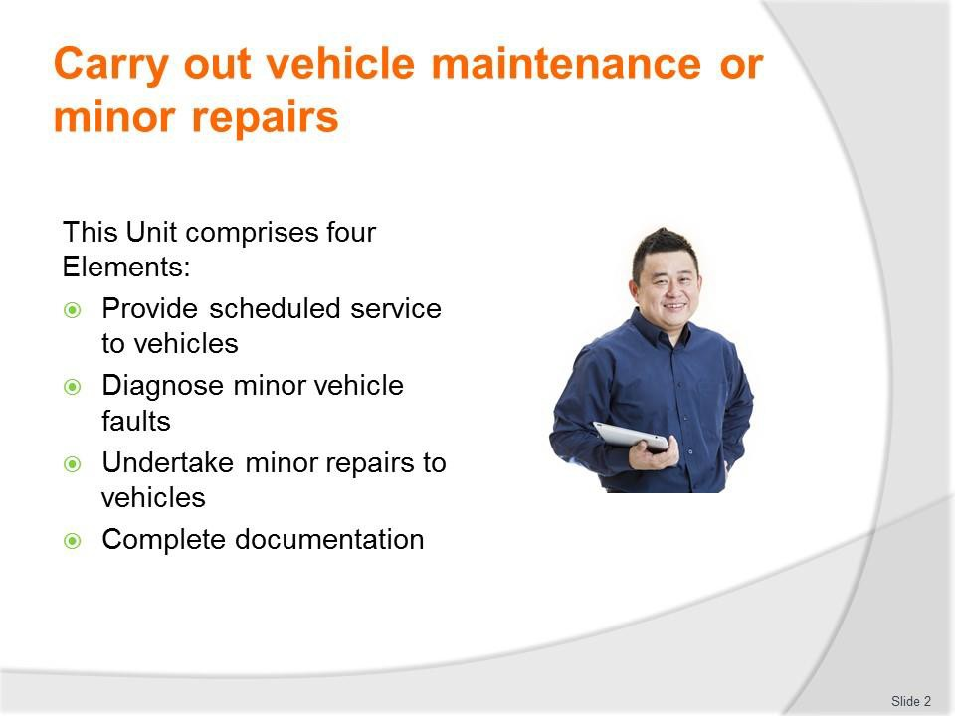
Slide No | Trainer Notes
2. | Trainer advises trainees this Unit comprises four Elements, as listed on the slide explaining:  - Each Element comprises a number of Performance Criteria which will be identified throughout the class and explained in detail  - Trainees can obtain more detail from their Trainee Manual  - At times the course presents advice and information about various protocols but where their workplace requirements differ to what is presented, the workplace practices and standards, as well as policies and procedures must be observed.

Slide
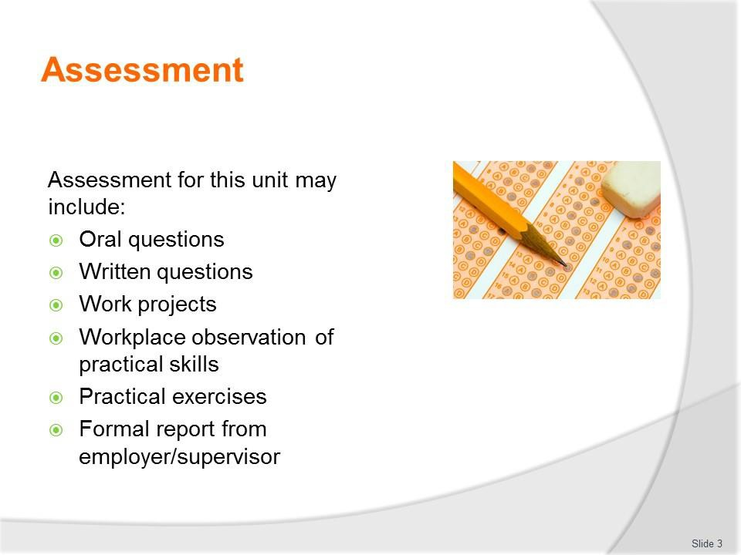
Slide No | Trainer Notes
3. | Trainer advises trainees that assessment for this Unit may take several forms, all of which are aimed at verifying they have achieved competency for the Unit as required.  Trainer indicates to trainees the methods of assessment that will be applied to them for this Unit.

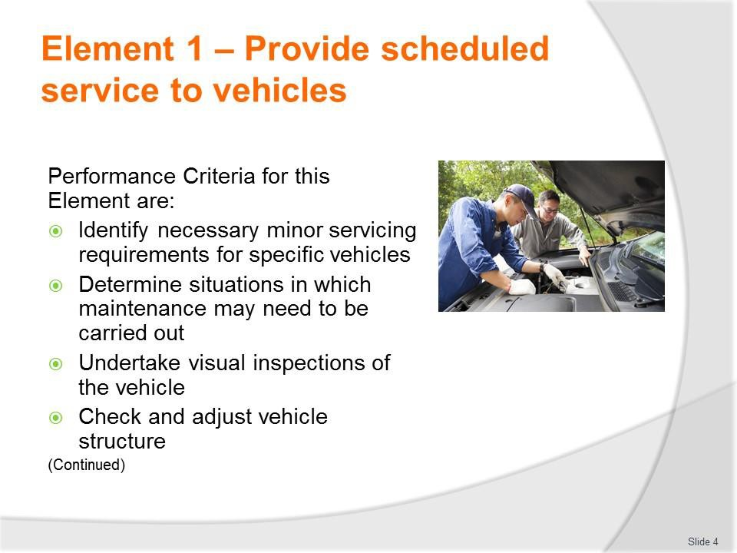
Slide
Slide No
Trainer Notes
4.
Trainer identifies for trainees the Performance Criteria for this Element, as listed on the slide.

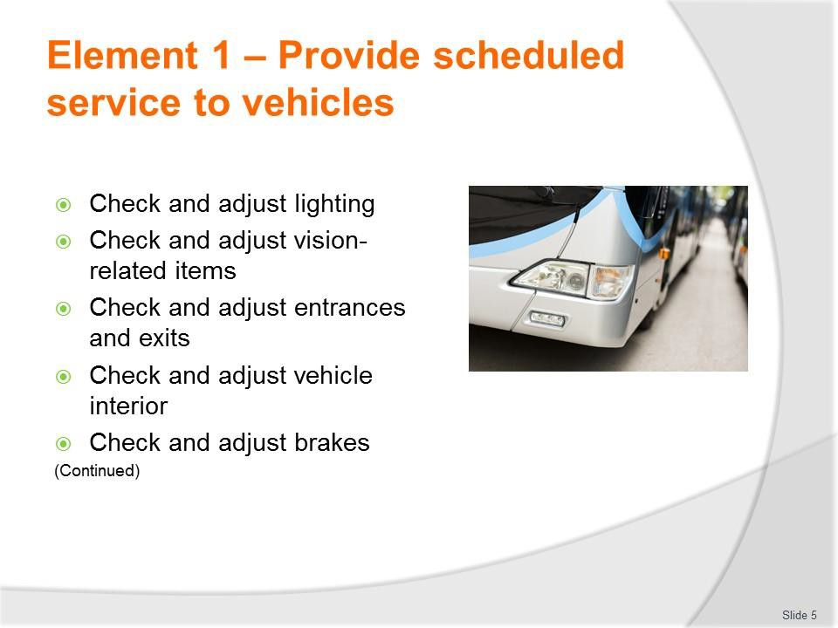
Slide
Slide No
Trainer Notes
5.
Trainer identifies for trainees the Performance Criteria for this Element, as listed on the slide.

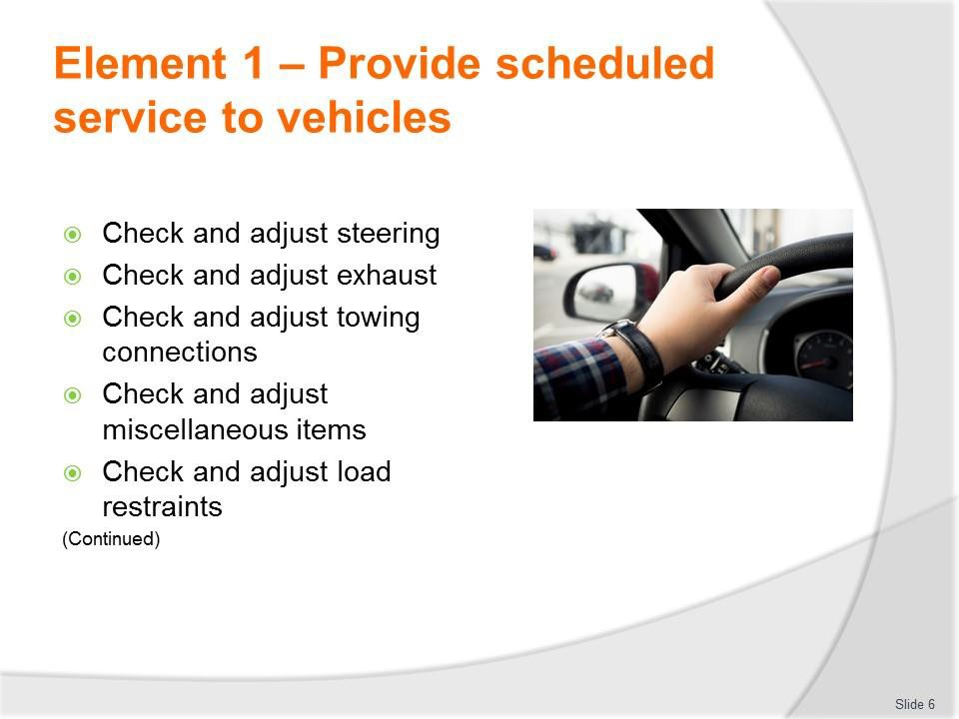
Slide
Slide No
Trainer Notes
6.
Trainer identifies for trainees the Performance Criteria for this Element, as listed on the slide.

Slide
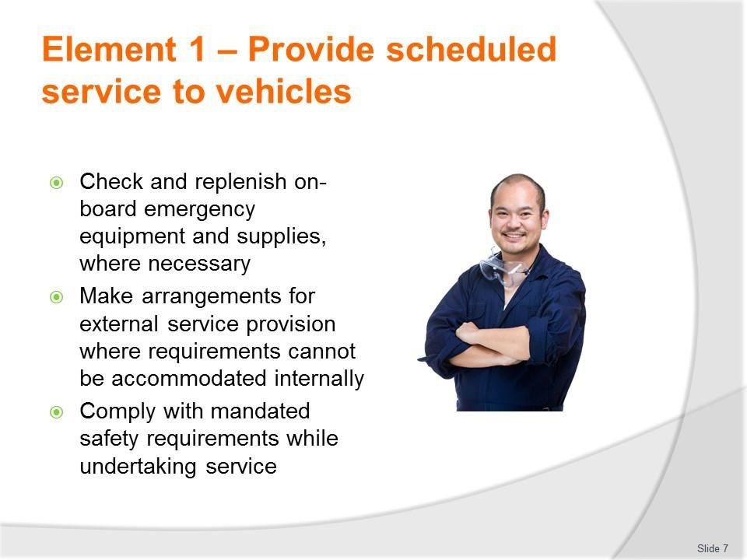
Slide No | Trainer Notes
7. | Trainer identifies for trainees the Performance Criteria for this Element, as listed on the slide.  Class Activity – General Discussion  Trainer leads a general class discussion by asking questions such as:  - What experience do you have with servicing vehicles and undertaking minor repairs?  - Where was this and for how long?  - What type of vehicles did you work on?

Slide
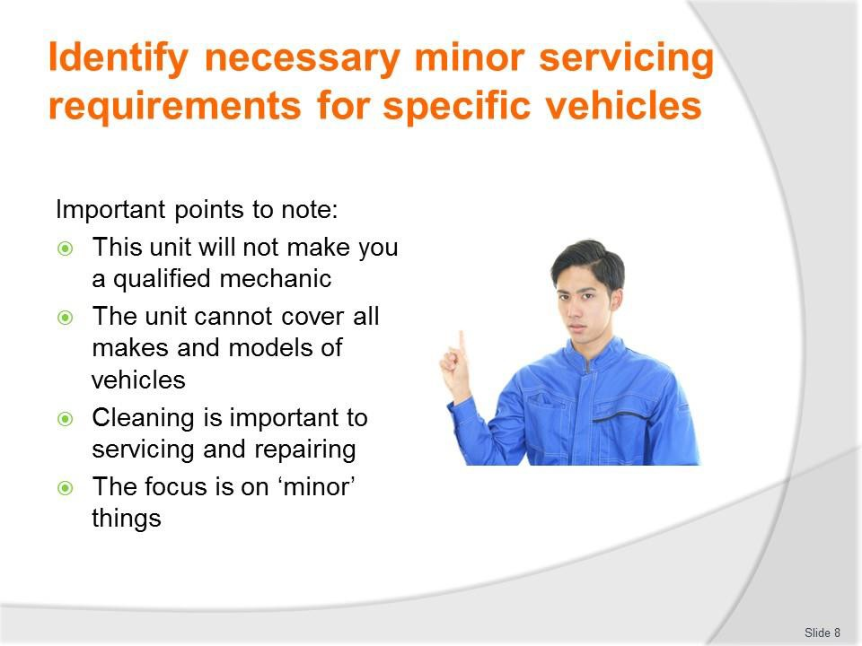
Slide No | Trainer Notes
8. | Trainer highlights in relation to this topic it is important to understand:  - This unit is not intended to provide the training needed for becoming a fully- qualified/A-grade mechanic  - To become a properly trained professional there is a need to undertake a three or four year apprenticeship that covers much more than is contained in this unit and requires many more hours of practical experience  - The manual and the notes cannot address the requirements for all types, makes and models of vehicles  - There are too many choices in the marketplace, too many variations, and too many after-market and up-grade options  - Cleaning is an important element of servicing and repairing vehicles in two ways:  - Cleaning prior to performing inspections and repairs will make it easier to identify problems and diagnose issues  - Cleaning of certain components is an essential part of the preventative maintenance process as it removes dirt, dust, grit, sand and other materials which can interfere with and damage correct operation of items  - The title of the unit gives an indication about the focus of the unit – it is focussed on carrying out basic maintenance and minor repairs.

Slide
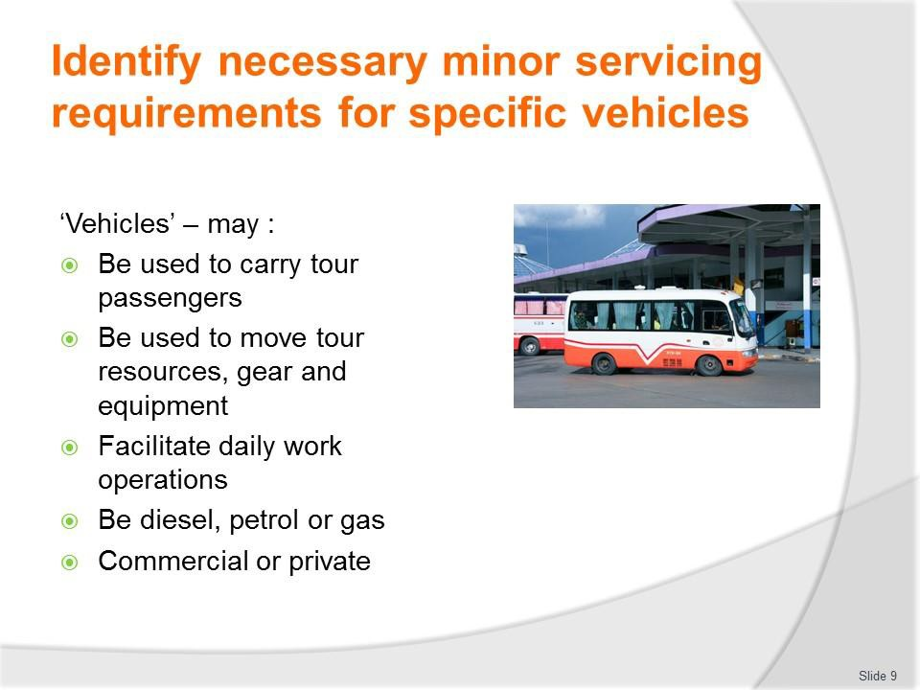
Slide No | Trainer Notes
9. | Trainer discusses ‘vehicles’ which may be serviced/repaired stating for the purposes of this unit ‘vehicles’ can relate to any means of transport used to:  - Carry tour passengers and tour staff – on tour  - Move tour resources – such as activity gear, food, camping equipment, tools, mobile facilities  - Facilitate the day-to-day activities of the organisation – such as:  - Picking up and moving tour group members – ‘transfers’  - Travelling to see potential customers/clients and make presentations/pitches  - Collecting items from suppliers, going to the bank, and doing the ‘hundred and one’ small things required in every business  - The vehicle will generally be a commercial vehicle (as distinct to a private one)  - It may be powered by petrol, diesel or gas.

Classroom Activity – Question and Answer session
Trainer asks class to identify types of vehicles which may require service or repairs.
Possible answers:
- Cars and a range of two-wheel drive vehicles
- Four-wheel drives
- SUVs
- Utilities
- Station wagons
- Vans
- Light trucks
- Heavy commercial vehicles
- Combination vehicles
- Buses/coaches
- Trailers.

Slide
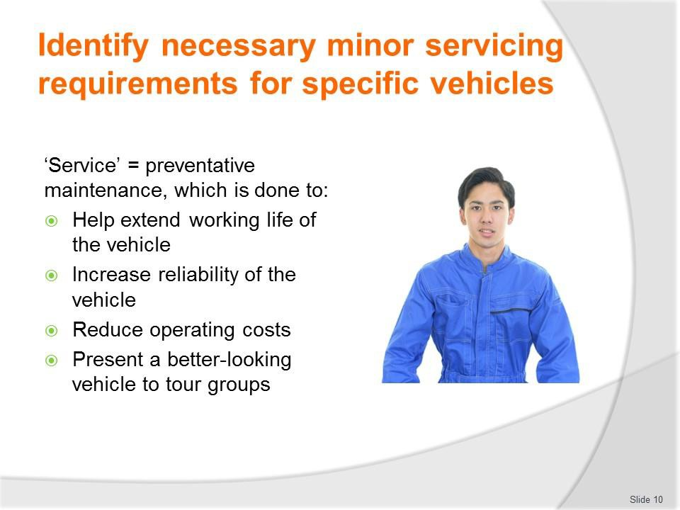
Slide No | Trainer Notes
10. | Trainer discusses vehicle ‘service’ noting:  - Providing ‘service’ to vehicles refers to providing preventative maintenance  - It is different to ‘repairing’ a vehicle which is done when damage has occurred/been identified  - Provision of regular service and maintenance will/can:  - Help extend working life of the vehicle  - Increase reliability of the vehicle  - Reduce operating costs  - Present a better-looking vehicle to tour groups – which increases confidence in the tour staff and tour operator.

Slide
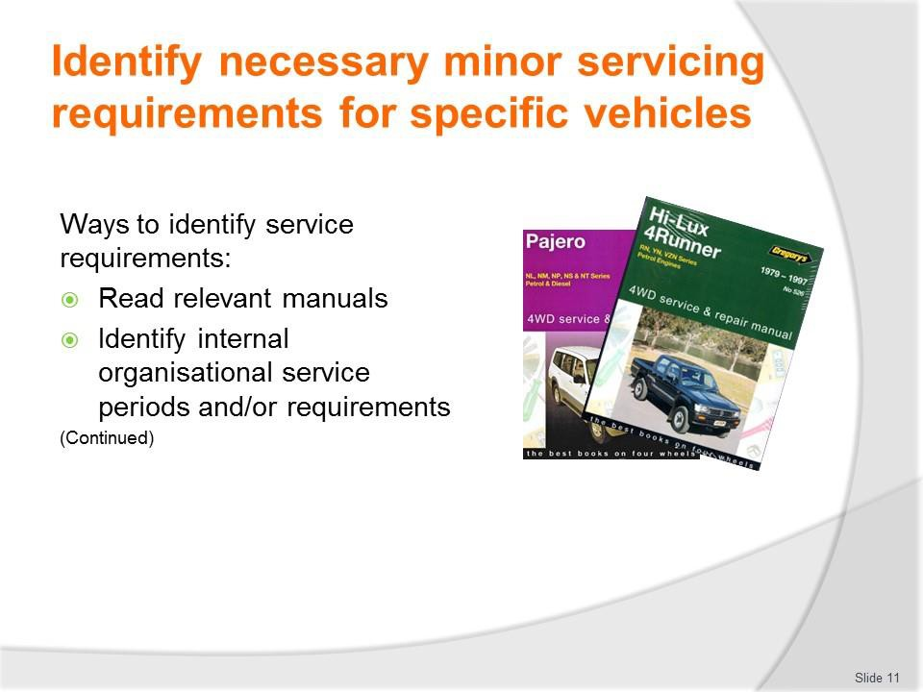
Slide No | Trainer Notes
11. | Trainer identifies ways to identify service requirements:  - Researching/reading manufacturer requirements in relation to routine servicing periods and items to be checked and serviced – as prescribed in:  - Warranties and guarantees  - Service manuals  - Owner manuals  - Repair manuals  - Identifying internal vehicle service periods and requirements that may override stated manufacturer’s requirements – this highlights:  - Some organisations elect to service their vehicles more frequently/differently to specifications in owner manuals/manufacturer’s specifications  - The condition of roads over which some vehicles are driven necessitate more frequent attention  - The use some vehicles are put to puts increased stress on the vehicles and demands more frequent service.  Class Activity – General Discussion  Trainer distributes and discusses sample manuals identified on slide.

Slide
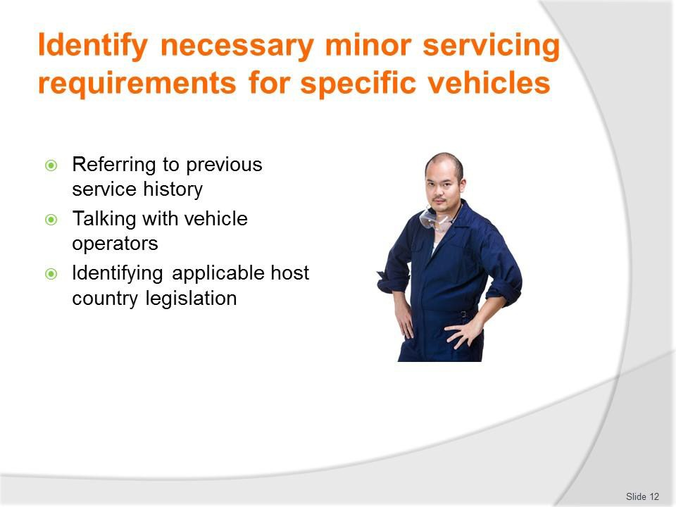
Slide No | Trainer Notes
12. | Trainer continues identifying ways to identify service requirements:  - Referring to documentation relating to previous servicing that has taken place – which will provide:  - Target date or distance (odometer reading) for the next scheduled service  - Indicate issues which were identified at the last service and flagged for attention at the next service  - Talking with vehicle operators – in order to identify:  - Any on-the-road repairs which may have been made by tour staff or third party providers to the vehicle while (for example) it was on tour  - Items they believe/know require attention  - Issues they have identified as emerging and which, if dealt with, will avoid them becoming an actual problem  - Identifying host country legislation that applies to the maintenance of commercial vehicles used for passenger transport – in order to ensure the safe transport of passengers.  Class Activity – Guest Speaker  Trainer arranges for representative from local vehicle registration authority to attend and discuss legislated requirements regarding vehicle service and maintenance.

Slide
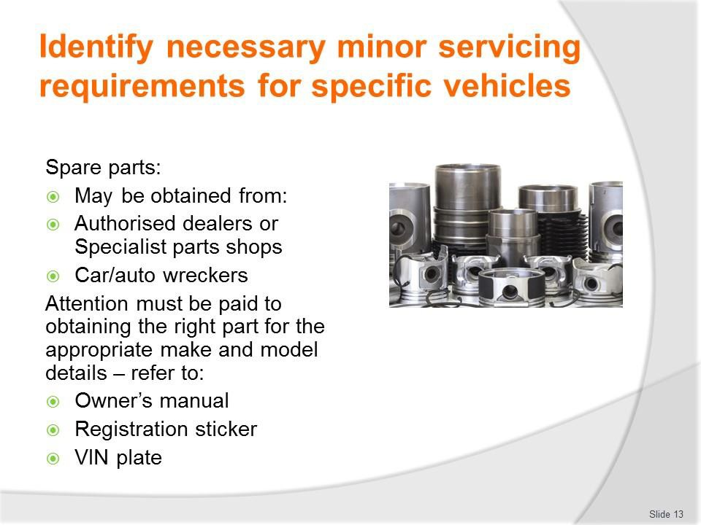
Slide No | Trainer Notes
13. | Trainer talks about vehicle spare parts observing:  - Spare parts for vehicles may be obtained from:  - Authorised dealers  - Specialist parts shops  - Car wreckers  - Always ensure spare parts are suitable for the make, model and year of the vehicle being serviced or repaired  - Ways to identify include reference to:  - Vehicle Owner’s Manual  - Registration sticker  - VIN plate.  Class Activity – Guest Speaker  Trainer shows class a VIN plate and helps them interpret the information it contains.

Slide
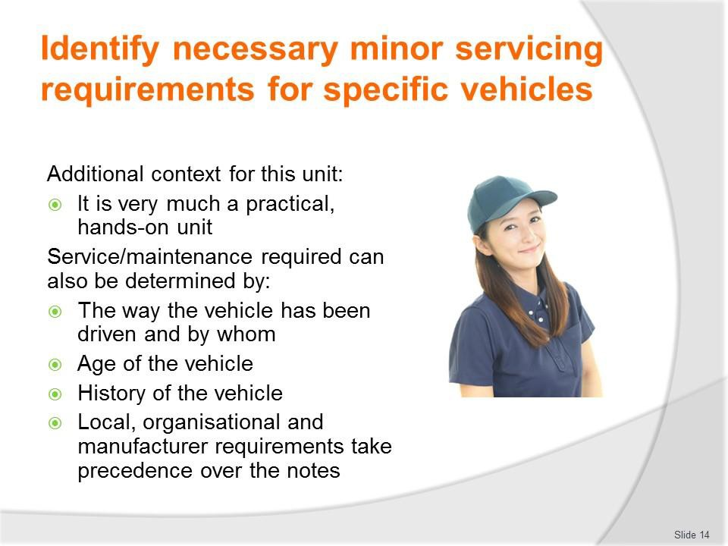
Slide No | Trainer Notes
14. | Trainer provides more context for the unit identifying:  - This unit is very much a practical unit – where the focus will be on actually carrying out maintenance and performing minor repairs  - Service and maintenance required for some vehicles can also be determined (to an extent/partially) by:  - The way the vehicle has been driven/who has driven it – the simple fact of life is some drivers are harder on their equipment than others  - Age of the vehicle – generally speaking older vehicles require more frequent service  - History of the vehicle – in terms of the result of combining factors such as distances travelled over time, conditions the vehicle was used in, previous services provided, accidents or incidents the vehicle has been involved in and any damage which has occurred to the vehicle  - Regardless of what is presented in these notes there is always a need to – as appropriate:  - Follow manufacturer’s instructions  - Adhere to organisational SOPs  - Conform to workshop manuals and/or service manuals and/or owner manuals

- Use qualified staff to provide nominated maintenance and/or repairs
- Comply with all local legislation regarding safety and roadworthiness requirements.

Slide
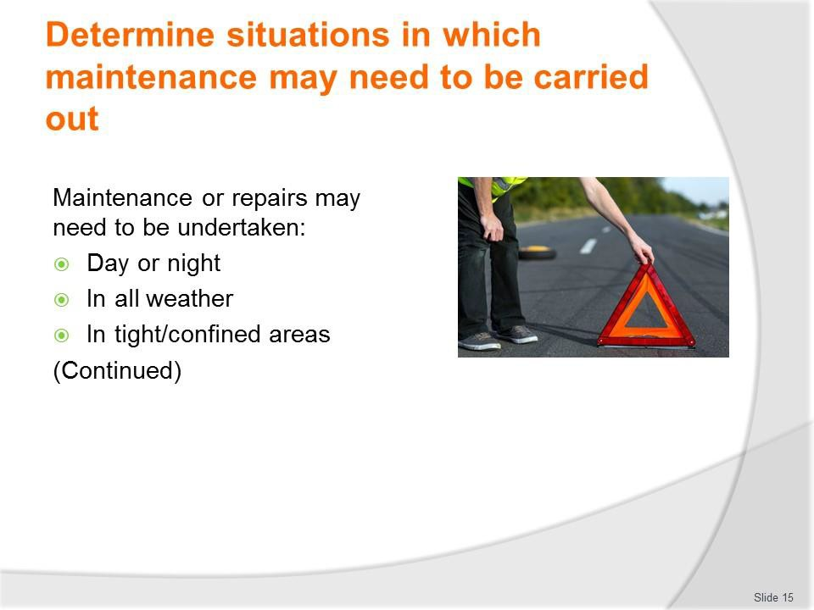
Slide No | Trainer Notes
15. | Trainer explains maintenance to and/or minor repairs to tour and travel vehicles may need to be carried out in a range of operating conditions, including:  - Operations conducted at day or night – meaning:  - Not all breakdowns or problems occur during the day  - There is a need to have lighting equipment available to allow work to be carried out on vehicles at night time – such as floodlights, inspection lights, torches  - All weather conditions – meaning there may be a need to take action in the heat of the day, during rain or a storm, and/or in high winds. These conditions may require:  - Waiting – until unacceptable conditions pass and it is safe/safer to take action  - Seeking shade from the sun – or moving the vehicle to a shaded location  - Erecting barricades against the wind/dust/sand – and/or moving the vehicle to a protected position  - Placing the vehicle under cover or putting up a cover of some description – to avoid rain  - In tight or confined spaces – such as:  - In situ in a parking area or parking bay  - When wedged/stuck in an off-road situation – prior to taking other action to retrieve the vehicle.

Slide
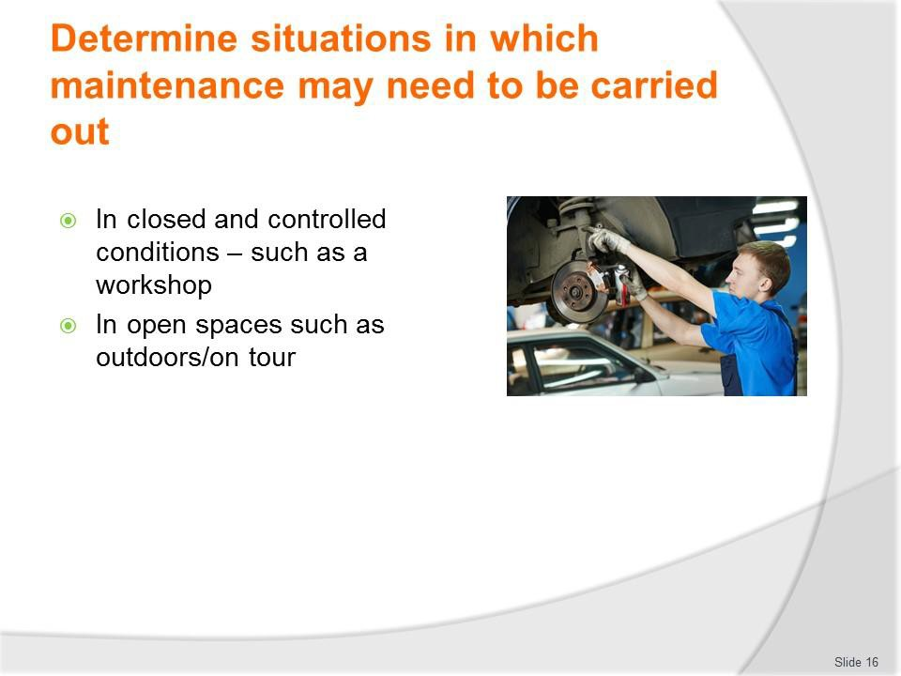
Slide No | Trainer Notes
16. | Trainer continues explaining different conditions under which service or repairs may be required:  - In closed and controlled locations as well as in exposed and open environments – where:  - Closed and controlled locations can refer to a workshop, depot, base, warehouse or client workplace (office, pick-up or transfer point, muster area) or other position where:  - There is no danger from passing vehicles  - There is no adverse impact from the environment/climatic conditions  - Significant tools and equipment are readily available  - There is a ready source of spare parts and fluids  - The vehicle can be moved around, and maintained/repaired in, the location where it is parked  - Exposed and open environments refers to on-the-road and on-tour locations where:  - Other vehicles are passing or over-taking the vehicle  - The vehicle is open to the elements – and other factors which might include dangers/risks posed by animals, crowds, rising water  - Only on-board tools, spare parts and fluids are available  - The vehicle may need to be moved to a different position in order to allow work to be safely and effectively undertaken – such as off a grade, or away from/out of mud or sand.

Slide
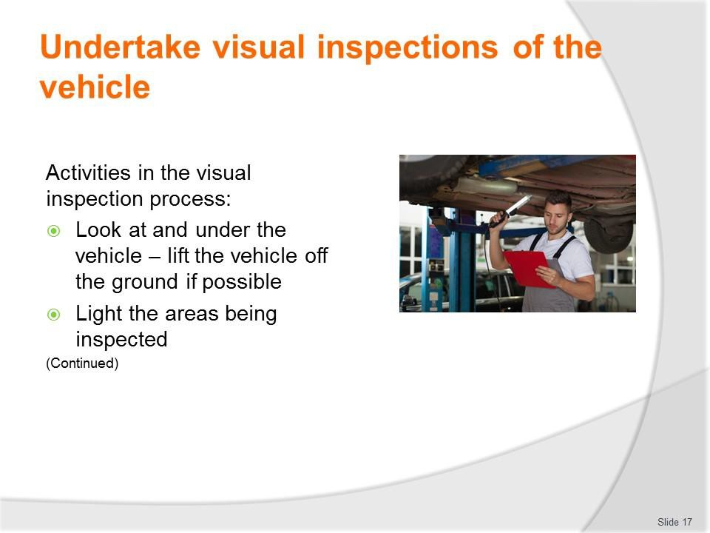
Slide No | Trainer Notes
17. | Trainer describes activities involved in the inspection process:  - Looking at and under the vehicle and closely checking all aspects of the vehicle – while it is:  - On the ground, and/or  - On a hoist or over an inspection pit – if a hoist or inspection pit is not available the inspection can occur by using:  - Trolley jacks  - Car stands  - Under-vehicle car trolleys/creepers  - Lighting the areas being inspected – with:  - Inspection lights  - Torches.  Classroom Activity – Demonstration and Practical  Trainer demonstrates and explains the vehicle inspection activities shown on the slide and provides opportunity for students to do the same.

Slide
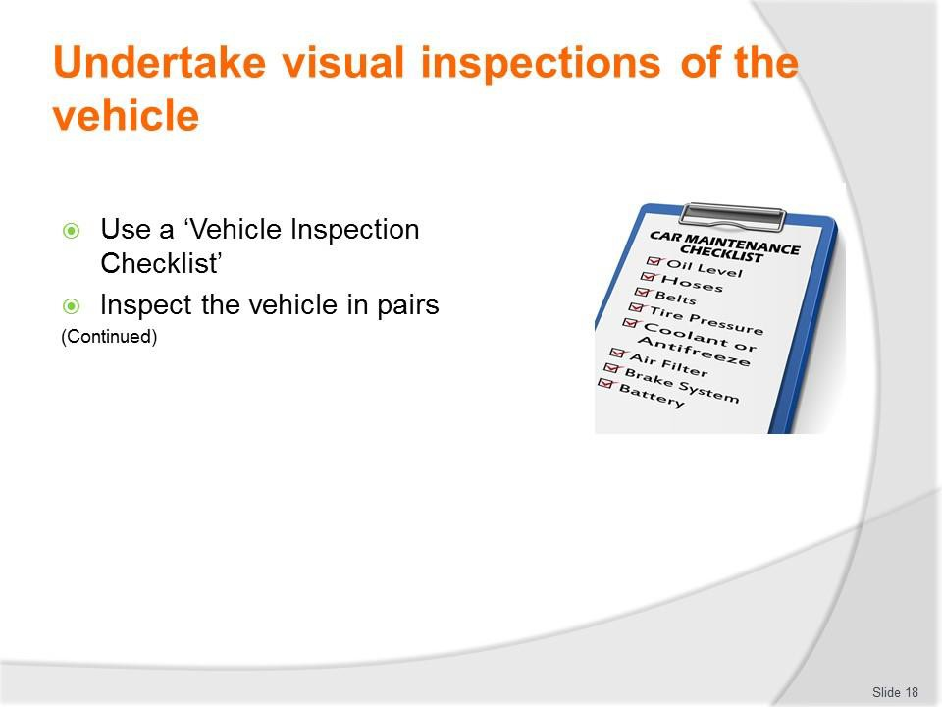
Slide No | Trainer Notes
18. | Trainer continues describing activities involved in the inspection process:  - Using a checklist – to:  - Provide evidence the inspection occurred  - Note defects and matters requiring attention  - Inspecting the vehicle in pairs – so that:  - Issues can be analysed/discussed  - A more effective inspection takes place – that is, there is less chance something will be missed if two people do the inspection.  Classroom Activity – Handout  Trainer distributes and discusses use of sample vehicle inspection checklist.

Slide
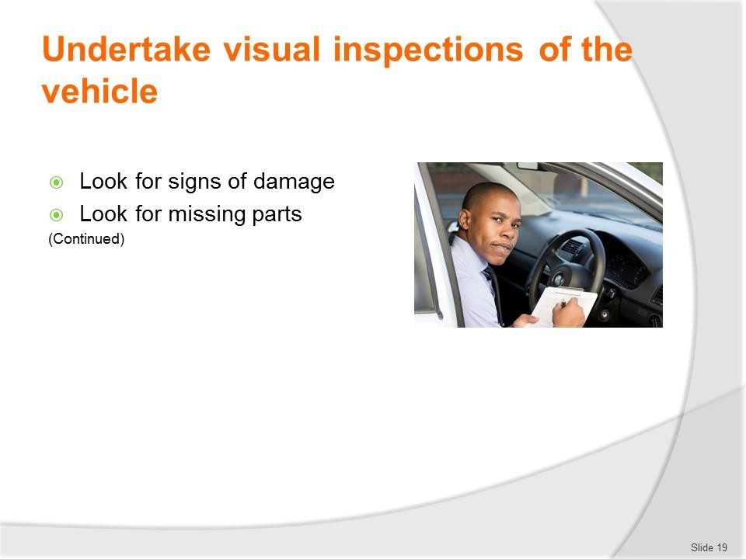
Slide No | Trainer Notes
19. | Trainer continues describing activities involved in the inspection process:  - Looking for signs of damage to the vehicle – as these signs can indicate:  - Where a more detailed inspection needs to occur to determine:  - If the damage has caused a problem/further problem  - Whether the damage is a result of another issue  - Need for immediate action – to:  - Fix the cause  - Take temporary action to reduce/prevent further damage  - Keep the vehicle on-the-road/operational  - Need to take later action – which may not be immediately necessary to  - Possible cause or source of the damage  - What may be needed/possible to prevent recurrence  - Checking for missing parts – from:  - Inside the cabin  - Inside the passenger area  - On the exterior of the vehicle  - Under the hood/bonnet.

Classroom Activity – Demonstration and Practical
Trainer demonstrates and explains the vehicle inspection activities shown on the slide and provides opportunity for students to do the same.

Slide
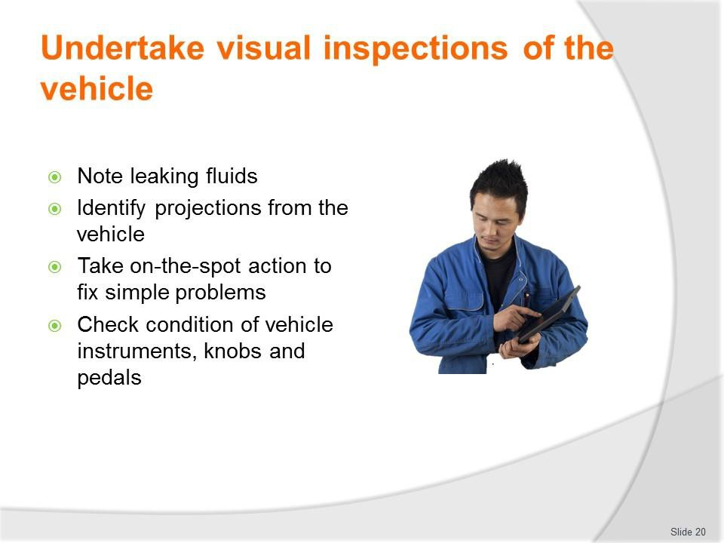
Slide No | Trainer Notes
20. | Trainer continues describing activities involved in the inspection process:  - Noting leaking fluids – as this can:  - Identify type of fluid  - Identify location of leak  - Indicate severity of problem  - Determine, to an extent, the type of problem needing to be addressed  - Identifying projections from the vehicle – this relates to:  - Body parts which have been worked loose, damaged or snagged and are hanging loose or sticking out from beyond the normal dimensions of the vehicle presenting a danger to other vehicles, people or structures  - Items caught up under the vehicle or under wheel wells, around wheels and brake lines, in the engine bay or from vehicle protection bars or lighting bars  - Taking immediate action to rectify problems – which can be quickly and easily fixed on-the-spot, such as:  - Clearing blockages  - Tightening screws, nuts, bolts and fittings  - Checking condition of vehicle instruments – while this is not just a visual inspection it involves a visual element in relation to, for example:  - Confirming travel of pedals and freedom from blockages/interference  - Activating knobs and switches and seeing they function as required.

Classroom Activity – Demonstration and Practical
Trainer demonstrates and explains the vehicle inspection activities shown on the slide and provides opportunity for students to do the same.

Slide
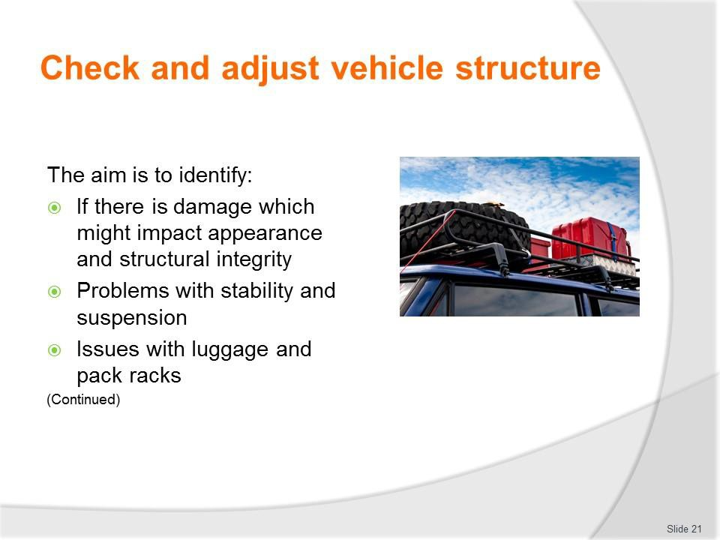
Slide No | Trainer Notes
21. | Trainer states in essence this check seeks to identify:  - If there is damage – to panels (which adversely impact the appearance of the vehicle – and/or the structure integrity of the vehicle (which may compromise strength, tracking and handling)  - If there are problems with vehicle stability and suspension – which can present handling, ride comfort and safety problems  - If there are issues with luggage and pack racks – which may cause units to work loose from the vehicle and damage the body, or become separated from the vehicle.

Slide
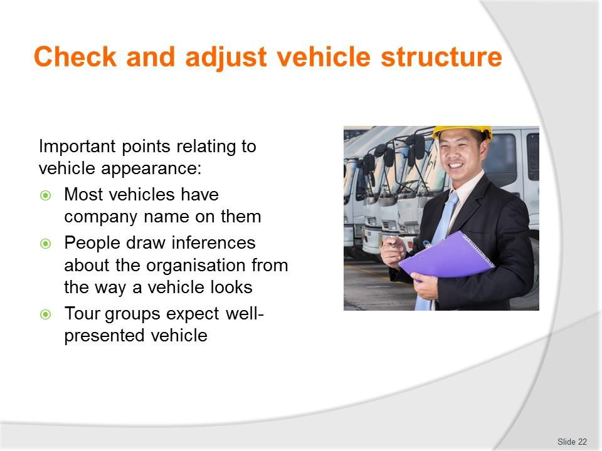
Slide No | Trainer Notes
22. | Trainer explains in relation to the physical appearance of the vehicle it must be remembered:  - The vehicle nearly always has the name of the tour company on it – so people judge the business by the way the vehicle looks (and the way it is driven)  - People (including tour group members) draw inferences about the tour and the tour organisation based on the way the vehicle looks – as in:  - A well-presented, clean, undamaged vehicle tends to generate confidence in the tour staff and the tour operator  - A poorly presented vehicle that looks dirty and lacking in maintenance will cause concern among tour group members and often cause them to look for problems elsewhere with the tour  - Tour group members expect their tour vehicles to be clean and properly maintained when they commence a tour – and be appropriately serviced as required while on tour.

Slide
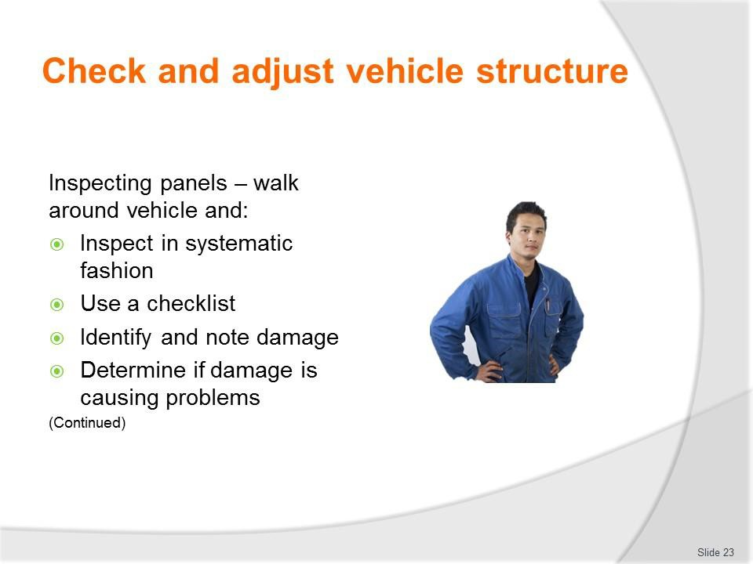
Slide No | Trainer Notes
23. | Trainer indicates checking the panels involves a visual inspection highlighting the best way is to walk around the vehicle and:  - Inspect in a systematic fashion  - Use a checklist to record observations  - Identify and note the location and type of any damage observed  - Determine if obvious panel damage is causing/has already caused operational issues for other components of the vehicle.  Classroom Activity – Demonstration and Practical  Trainer shows students how to undertake activities listed on the slide and provides an opportunity for them to do the same.

Slide
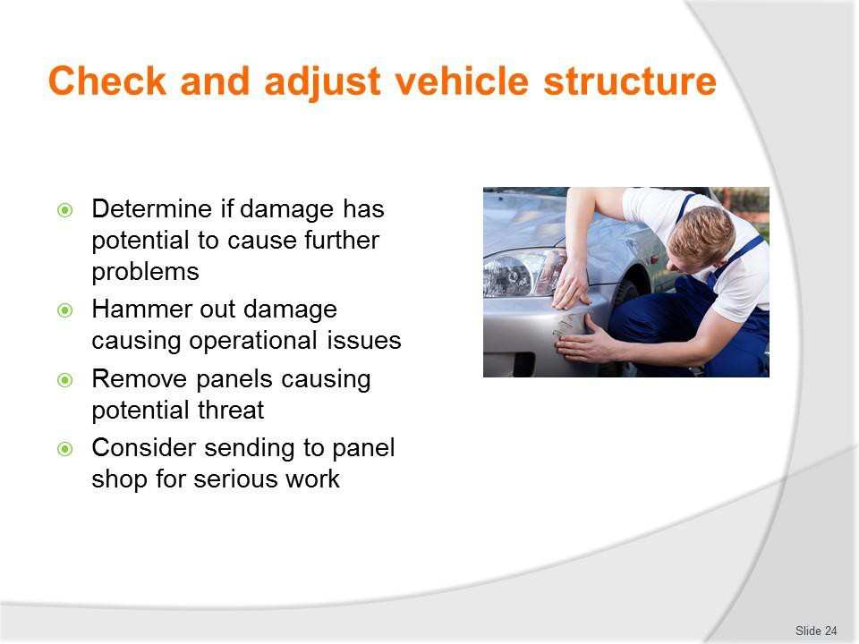
Slide No | Trainer Notes
24. | Trainer continues discussing panel inspections:  - Work out if the panel damage has the potential to cause operational issues or further damage to other components  - Hammer out damage which is preventing proper use of the vehicle – or using a pull bar or suction device  - Unbolt or cut away panels which are seriously damaged and present a clear threat to the further operation and/or safety of the vehicle.  More permanent repairs to panels (such as properly removing and filling dents) and other serious panel work, replacing panels, and spray painting, needs to be undertaken by a fully qualified panel beater.  Classroom Activity – Demonstration and Practical  Trainer shows students how to undertake activities listed on the slide and provides an opportunity for them to do the same.

Slide
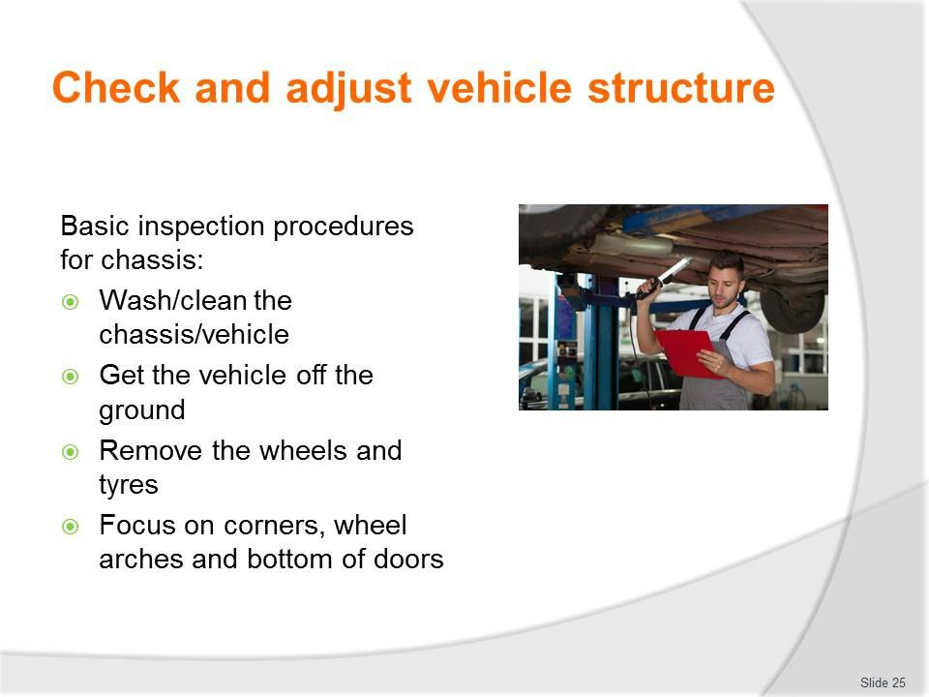
Slide No | Trainer Notes
25. | Trainer notes basic inspection procedures for chassis are:  - Wash/clean the chassis/vehicle  - Get the vehicle off the ground – a hoist is preferable  - Remove the wheels and tyres  - Focus on corners, wheel arches and bottom of doors.  Classroom Activity – Demonstration and Practical  Trainer shows students how to undertake activities listed on the slide and provides an opportunity for them to do the same.

Slide
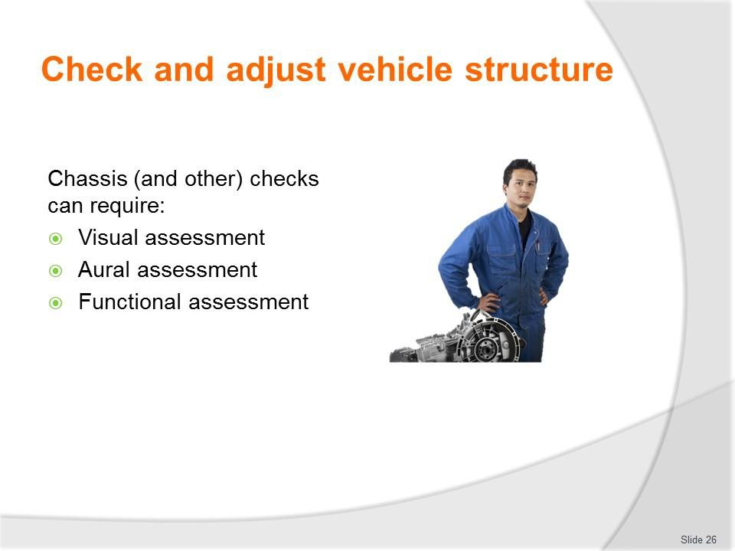
Slide No | Trainer Notes
26. | Trainer notes chassis checks can require the use of three basic diagnostic tools/assessments:  - Visual assessment – by getting under the vehicle or raising it on a hoist  - Aural assessment – by listening to the vehicle as it travels over uneven ground  - Functional assessment – by gauging the operation/performance of the vehicle on- the-road.

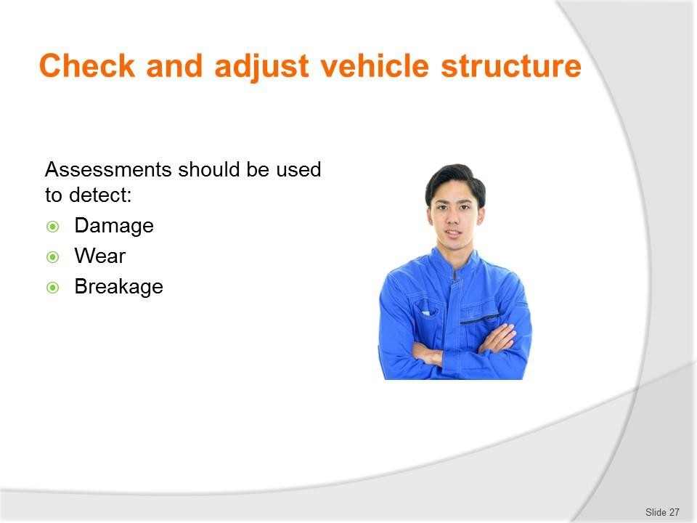
Slide
Slide No
Trainer Notes
27.
Trainer states assessments should be used to detect:
- Damage – caused by impact with obstacles
- Wear – normal wear and tear occasioned by use of the vehicle
- Breakage – due to stress, misuse, or age.

Slide
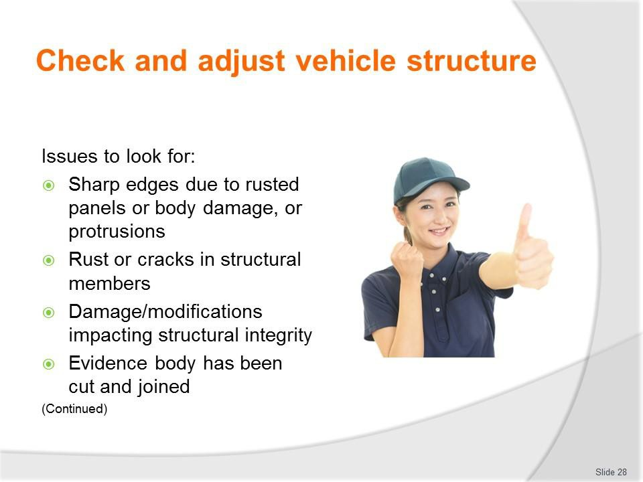
Slide No | Trainer Notes
28. | Trainer indicates issues to look for:  - Exterior body work and fittings have sharp edges due to rusted panels or body damage, or protrusion of any after-market object of fittings, not technically essential to the operation of the vehicle which protrudes from any part of the vehicle that could cause injury to a person coming into contact with the vehicle  - Any structural member such as a sub frame, floor panel, door sill, seat or seat belt anchorage, is cracked or has advanced rust  - Unrepaired damage or modifications affecting the structural integrity of the vehicle  - Any evidence that body has been cut and joined.  Classroom Activity – Demonstration and Practical  Trainer shows students how to undertake activities listed on the slide and provides an opportunity for them to do the same.

Slide
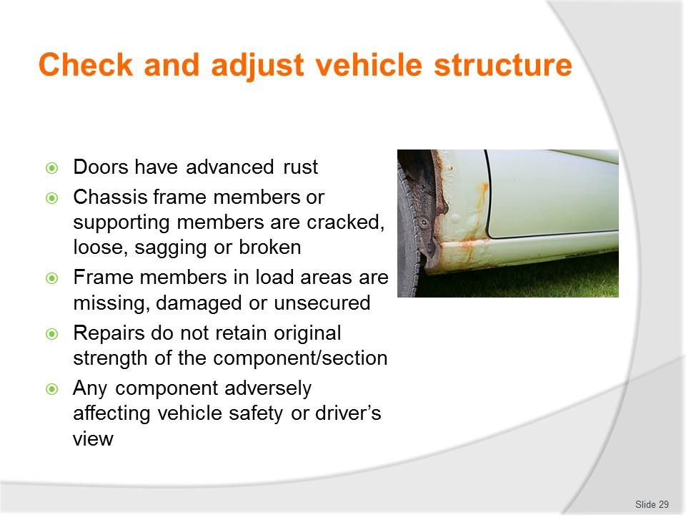
Slide No | Trainer Notes
29. | Trainer continues indicating issues to look for:  - The doors of a vehicle have advanced rust  - Chassis frame members or supporting members are cracked, loose, sagging or broken  - Frame members in load areas are missing, damaged or unsecured  - Any repairs carried out do not retain the original strength of the component/section  - Any component that adversely affects the safety of the vehicle, and in particular, obscures the drivers view.  Classroom Activity – Demonstration and Practical  Trainer shows students how to undertake activities listed on the slide and provides an opportunity for them to do the same.

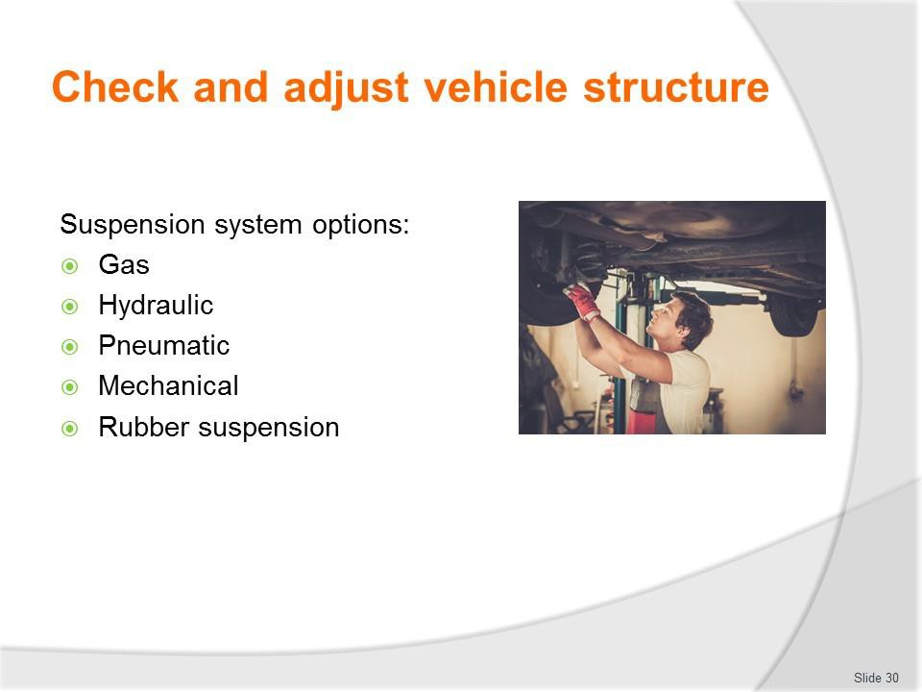
Slide
Slide No
Trainer Notes
30.
Trainer discusses suspension systems identifying may be:
- Gas
- Hydraulic
- Pneumatic
- Mechanical
- Rubber suspension.
Classroom Activity – Presentation
Trainer presents and differentiates between suspension types.

Slide
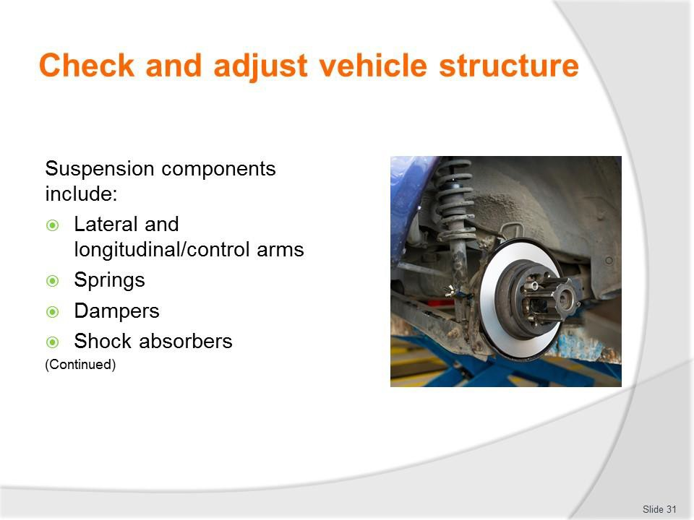
Slide No | Trainer Notes
31. | Trainer identifies suspension system components:  - Lateral and longitudinal/control arms  - Springs – coil, leaf, torsion bars or air springs (to absorb energy)  - Dampers – to dissipate energy  - Shock absorbers.  Classroom Activity – Presentation  Trainer presents and describes function of suspension components shown on slide.

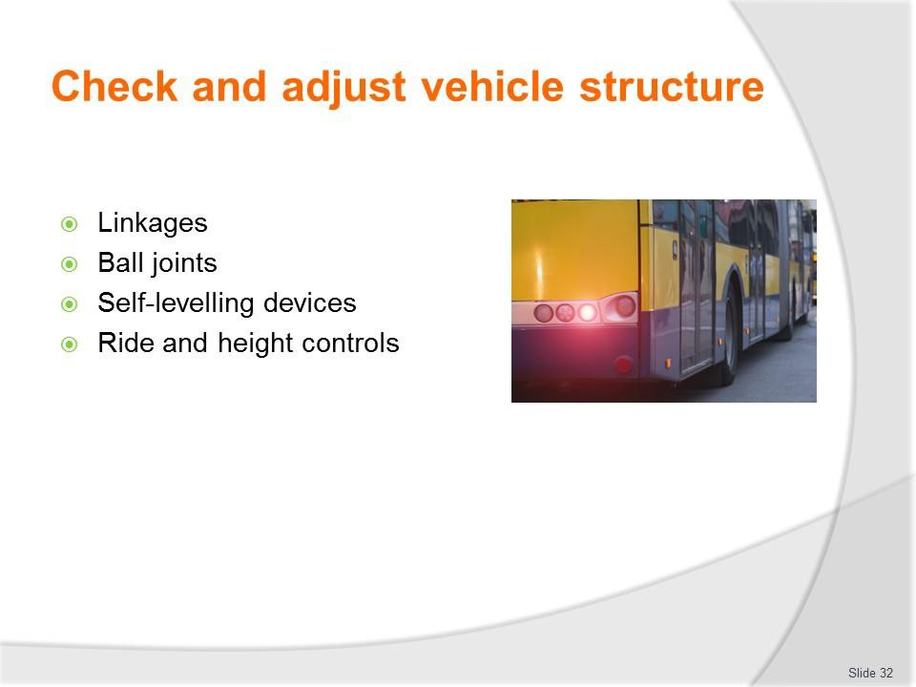
Slide
Slide No
Trainer Notes
32.
Trainer continues identifying suspension system components:
- Linkages
- Ball joints
- Self-levelling devices
- Ride and height controls.
Classroom Activity – Presentation
Trainer presents and describes function of suspension components shown on slide.

Slide
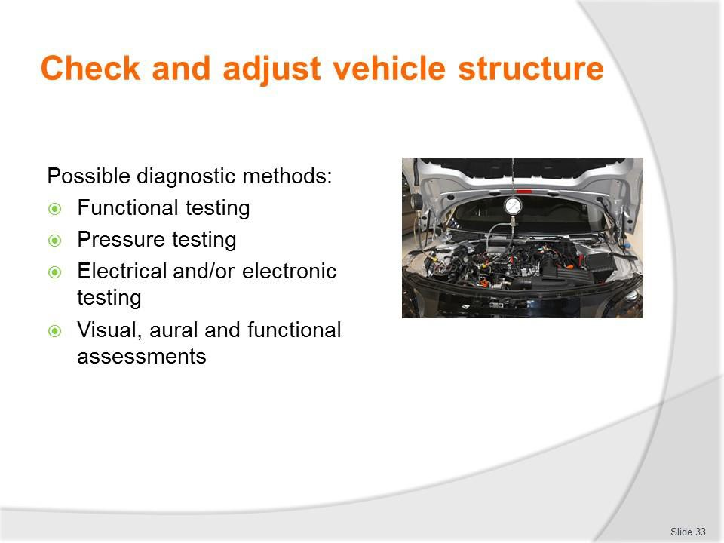
Slide No | Trainer Notes
33. | Trainer indicates diagnostic methods include:  - Functional testing of the vehicle  - Pressure testing of air systems  - Electrical and/or electronic testing  - Visual, aural and functional assessments – with checks for physical damage, corrosion, fluid levels, fluid and grease leaks, air leaks, wear, alignment.  Classroom Activity – Demonstration and Practical  Trainer shows students how to undertake activities listed on the slide and provides an opportunity for them to do the same.

Slide
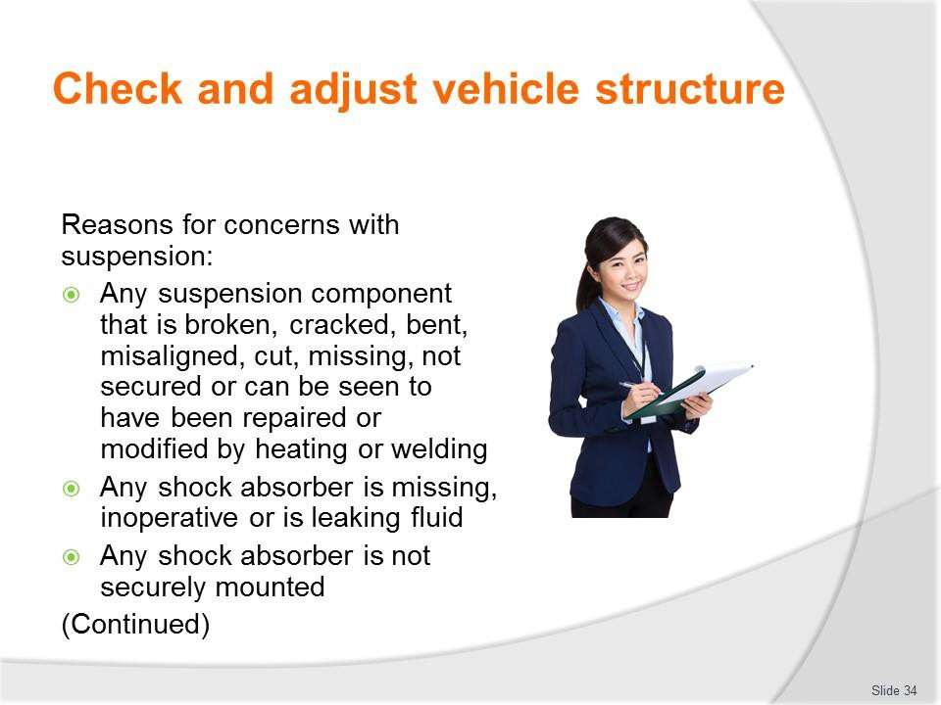
Slide No | Trainer Notes
34. | Trainer indicates reasons for concern with suspension:  - Any suspension component that is broken, cracked, bent, misaligned, cut, missing, not secured or can be seen to have been repaired or modified by heating or welding  - Any shock absorber is missing, inoperative or is leaking fluid  - Any shock absorber is not securely mounted.  Classroom Activity – Demonstration and Practical  Trainer shows students how to undertake activities listed on the slide and provides an opportunity for them to do the same.

Slide
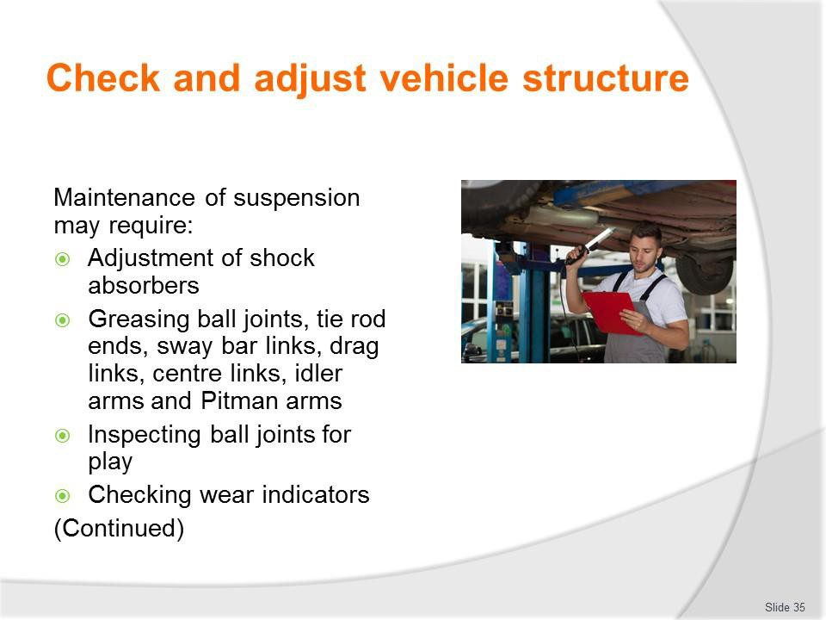
Slide No | Trainer Notes
35. | Trainer indicates maintenance can include:  - Adjustment of shock absorbers  - Greasing ball joints, tie rod ends, sway bar links, drag links, centre links, idler arms and Pitman arms  - Inspecting ball joints for play  - Checking wear indicators.  Classroom Activity – Demonstration and Practical  Trainer shows students how to undertake activities listed on the slide and provides an opportunity for them to do the same.

Slide
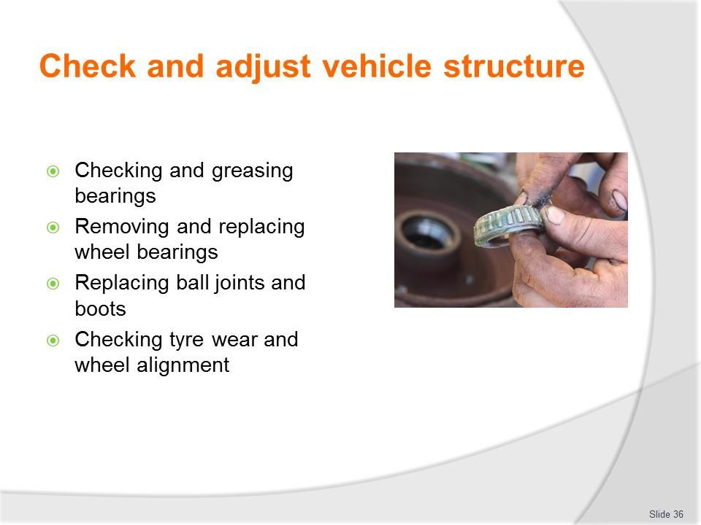
Slide No | Trainer Notes
36. | Trainer continues indicating possible suspension maintenance:  - Checking and greasing bearings  - Removing and replacing wheel bearings  - Replacing ball joints and boots  - Checking tyre wear and wheel alignment.  Classroom Activity – Demonstration and Practical  Trainer shows students how to undertake activities listed on the slide and provides an opportunity for them to do the same.

Slide
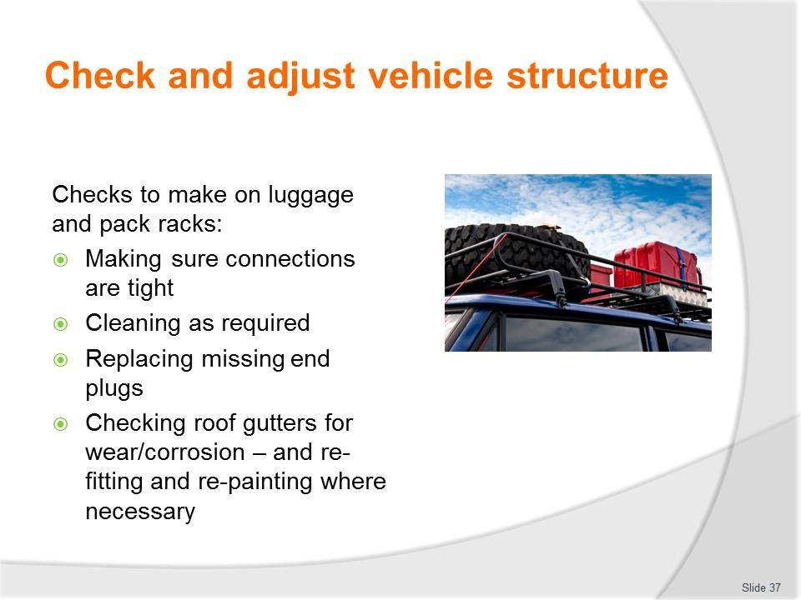
Slide No | Trainer Notes
37. | Trainer discusses checks which need to be made of luggage and pack racks attached to vehicles:  - Making sure connections are tight  - Cleaning as required  - Replacing missing end plugs  - Checking roof gutters for wear/corrosion – and re-fitting and re-painting where necessary.

Slide
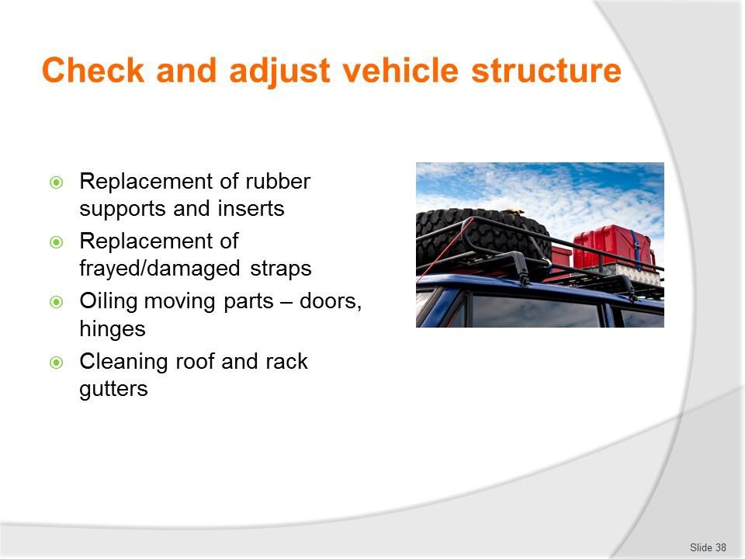
Slide No | Trainer Notes
38. | Trainer continues discussing checks which need to be made of luggage and pack racks attached to vehicles:  - Replacement of rubber supports and inserts  - Replacement of frayed/damaged straps  - Oiling moving parts – doors, hinges  - Cleaning roof and rack gutters.

Slide
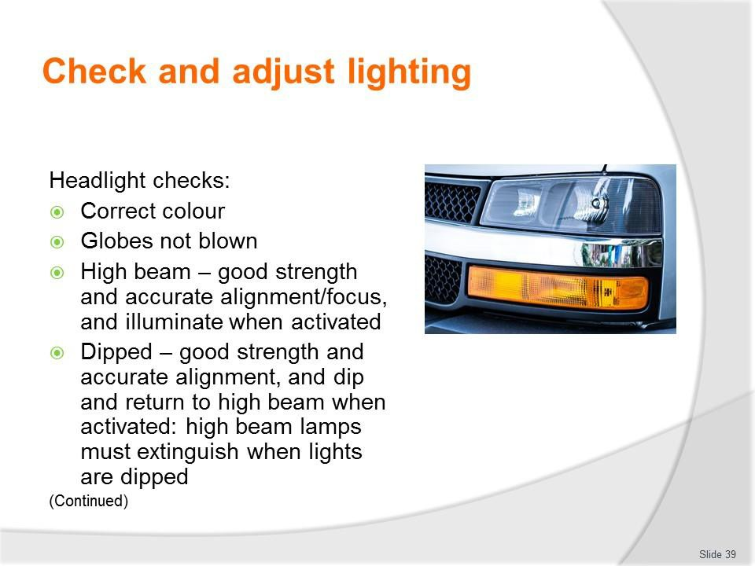
Slide No | Trainer Notes
39. | Trainer discusses headlight checks:  - Correct colour  - Globes not blown  - High beam – they have good strength and accurate alignment/focus, and illuminate when activated  - Dipped – they have good strength and accurate alignment, and dip and return to high beam when activated: high beam lamps must extinguish when lights are dipped.  Classroom Activity – Demonstration and Practical  Trainer shows students how to undertake activities listed on the slide and provides an opportunity for them to do the same.

Slide
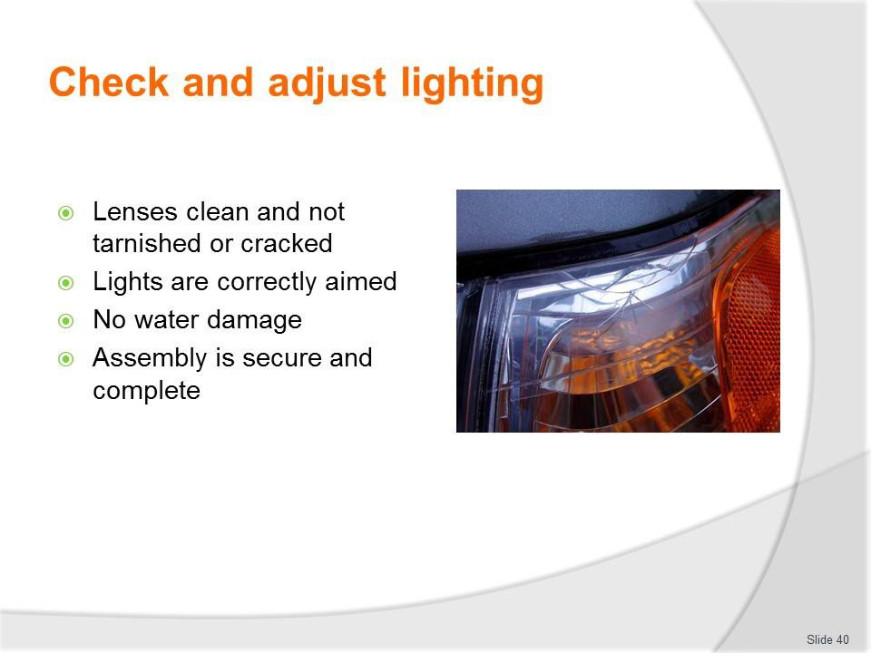
Slide No | Trainer Notes
40. | Trainer continues discussing headlight checks:  - Lenses clean and not tarnished or cracked  - Lights are correctly aimed  - No water damage  - Assembly is secure and complete.  Classroom Activity – Demonstration and Practical  Trainer shows students how to undertake activities listed on the slide and provides an opportunity for them to do the same.

Slide
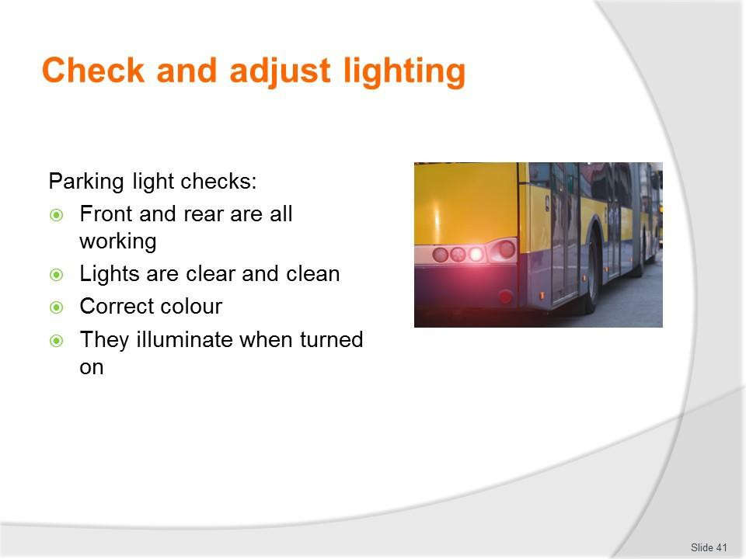
Slide No | Trainer Notes
41. | Trainer discusses parking light checks:  - Front and rear are all working  - Lights are clear and clean  - Correct colour  - They illuminate when turned on.  Classroom Activity – Demonstration and Practical  Trainer shows students how to undertake activities listed on the slide and provides an opportunity for them to do the same.

Slide
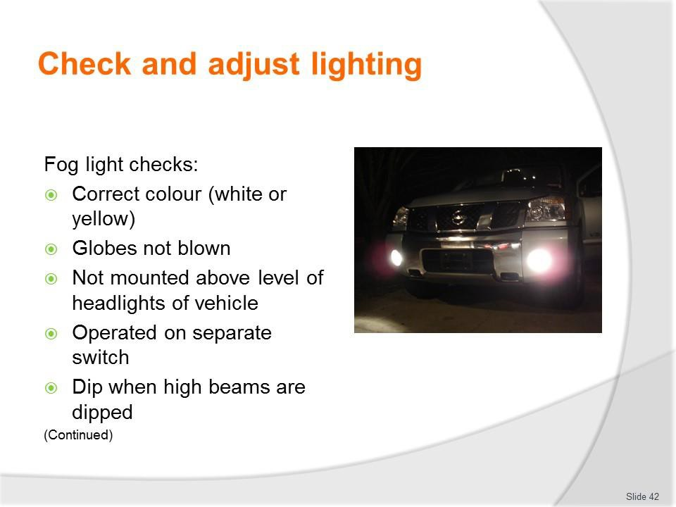
Slide No | Trainer Notes
42. | Trainer discusses fog light checks (front and rear):  - Correct colour (white or yellow)  - Globes not blown  - Not mounted above level of headlights of vehicle  - Operated on separate switch  - Dip when high beams are dipped.  Classroom Activity – Demonstration and Practical  Trainer shows students how to undertake activities listed on the slide and provides an opportunity for them to do the same.

Slide
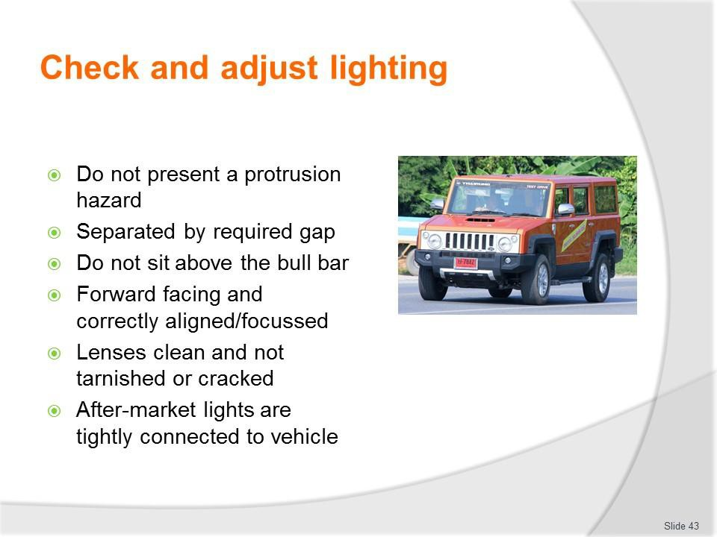
Slide No | Trainer Notes
43. | Trainer continues discussing fog light checks:  - Do not present a protrusion hazard  - Separated by required gap (for example, 600 mm)  - Do not sit above the bull bar (where fitted)  - Forward facing and correctly aligned/focussed  - Lenses clean and not tarnished or cracked  - After-market lights are tightly connected to vehicle.  Classroom Activity – Demonstration and Practical  Trainer shows students how to undertake activities listed on the slide and provides an opportunity for them to do the same.

Slide
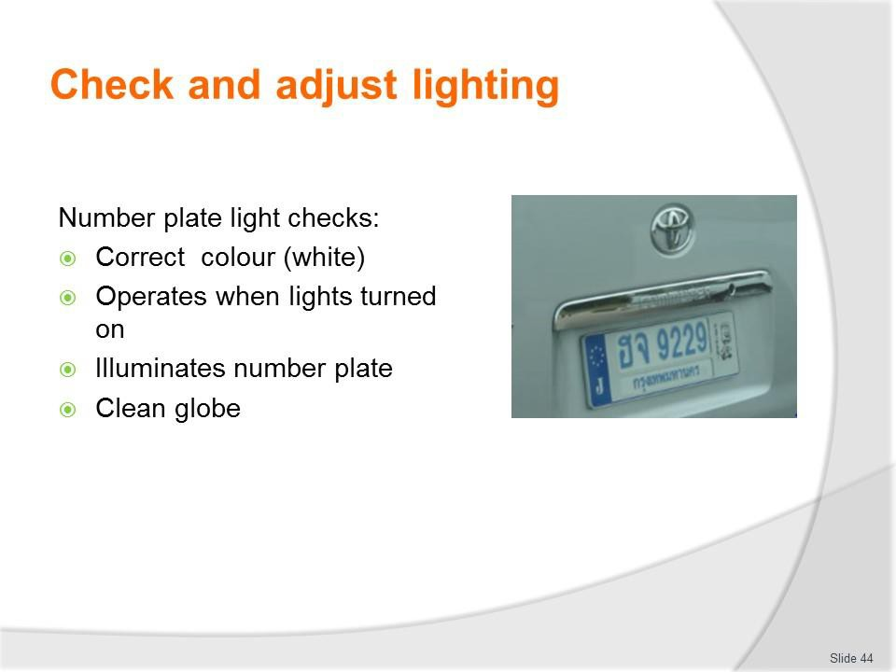
Slide No | Trainer Notes
44. | Trainer discusses number plate light checks (front and rear):  - Correct colour (white)  - Operates when lights turned on  - Illuminates number plate  - Clean globe.  Classroom Activity – Demonstration and Practical  Trainer shows students how to undertake activities listed on the slide and provides an opportunity for them to do the same.

Slide
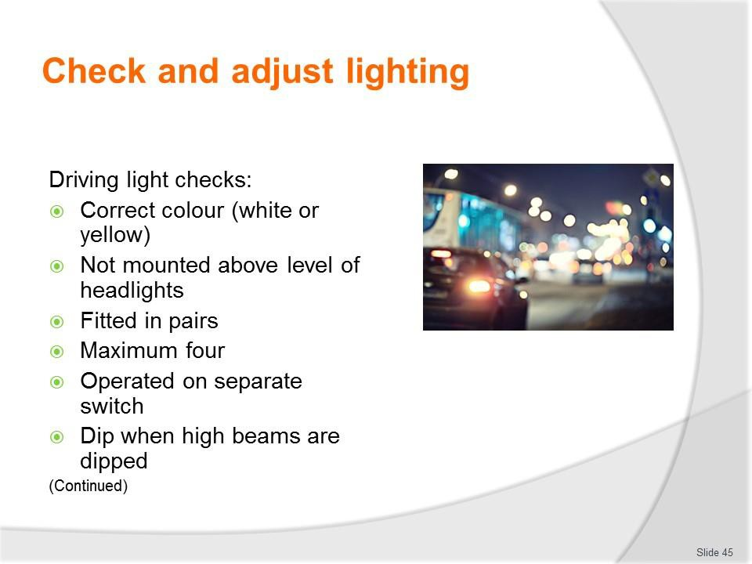
Slide No | Trainer Notes
45. | Trainer discusses driving light checks:  - Correct colour (white or yellow)  - Not mounted above level of headlights of vehicle  - Fitted in pairs  - Maximum four per vehicle  - Operated on separate switch  - Dip when high beams are dipped.  Classroom Activity – Demonstration and Practical  Trainer shows students how to undertake activities listed on the slide and provides an opportunity for them to do the same.

Slide
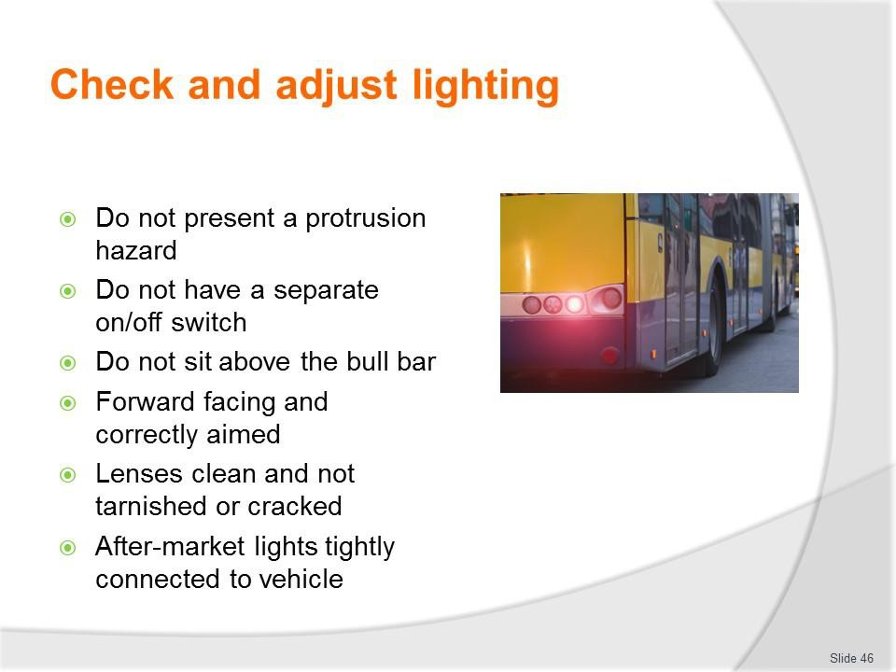
Slide No | Trainer Notes
46. | Trainer continues discussing driving light checks:  - Do not present a protrusion hazard  - Do not have a separate on/off switch  - Do not sit above the bull bar (where fitted)  - Forward facing and correctly aligned and aimed  - Lenses clean and not tarnished or cracked  - After-market lights are tightly connected to vehicle.  Classroom Activity – Demonstration and Practical  Trainer shows students how to undertake activities listed on the slide and provides an opportunity for them to do the same.

Slide
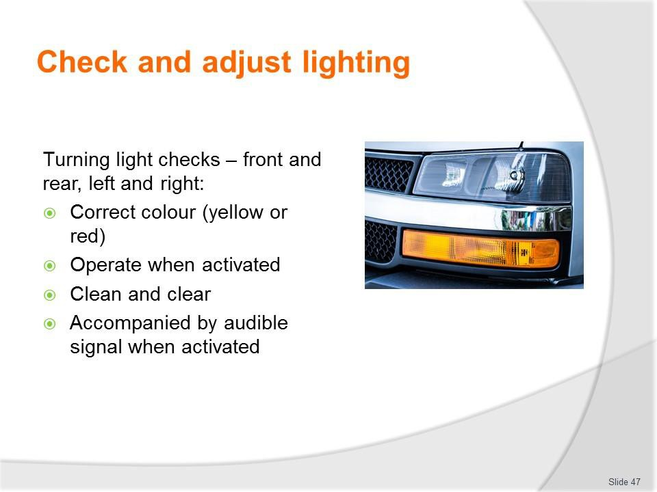
Slide No | Trainer Notes
47. | Trainer discusses turning light checks (front and rear, left and right)  - Correct colour (yellow or red)  - Operate when activated  - Clean and clear  - Accompanied by audible signal when activated.  Classroom Activity – Demonstration and Practical  Trainer shows students how to undertake activities listed on the slide and provides an opportunity for them to do the same.

Slide
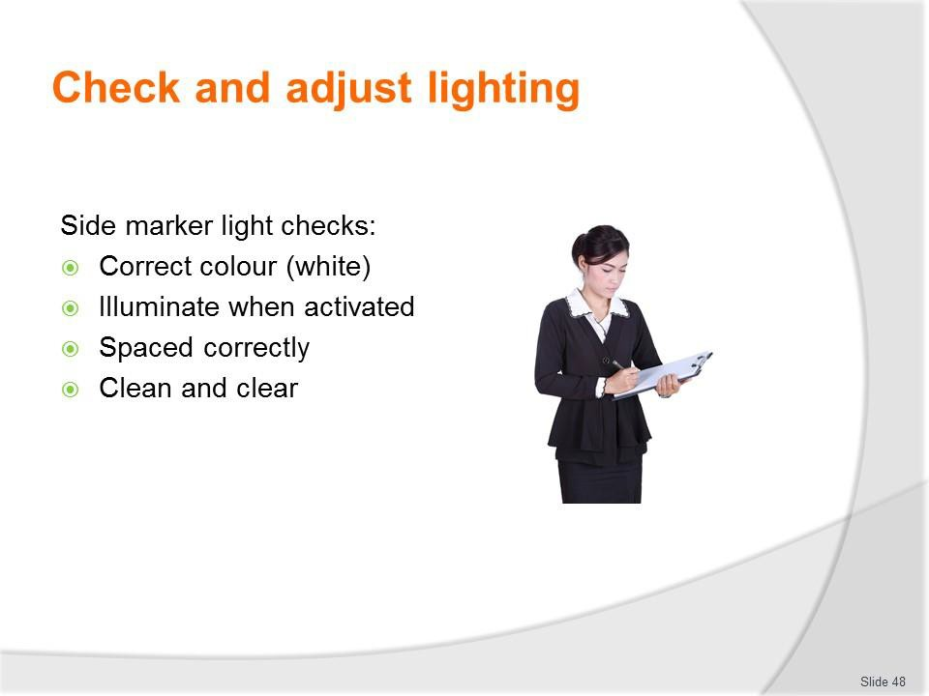
Slide No | Trainer Notes
48. | Trainer discusses side marker light checks:  - Correct colour (white)  - Illuminate when activated  - Spaced correctly (for example, no less than 400 mm apart)  - Clean and clear.  Classroom Activity – Demonstration and Practical  Trainer shows students how to undertake activities listed on the slide and provides an opportunity for them to do the same.

Slide
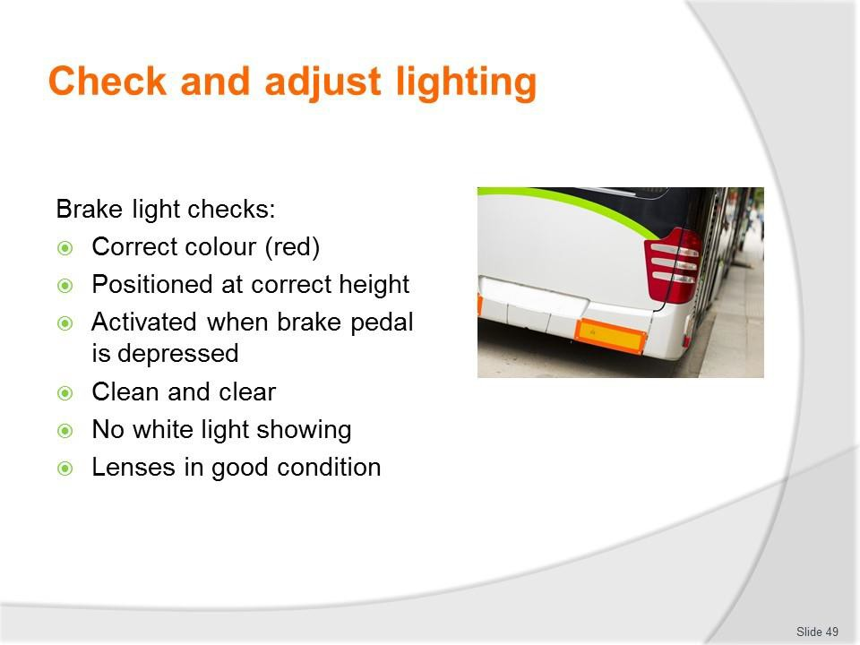
Slide No | Trainer Notes
49. | Trainer discusses brake light checks:  - Correct colour (red)  - Positioned at correct height  - Activated when brake pedal is depressed  - Clean and clear  - No white light shows through the red cover of the light  - Lenses in good condition.  Classroom Activity – Demonstration and Practical  Trainer shows students how to undertake activities listed on the slide and provides an opportunity for them to do the same.

Slide
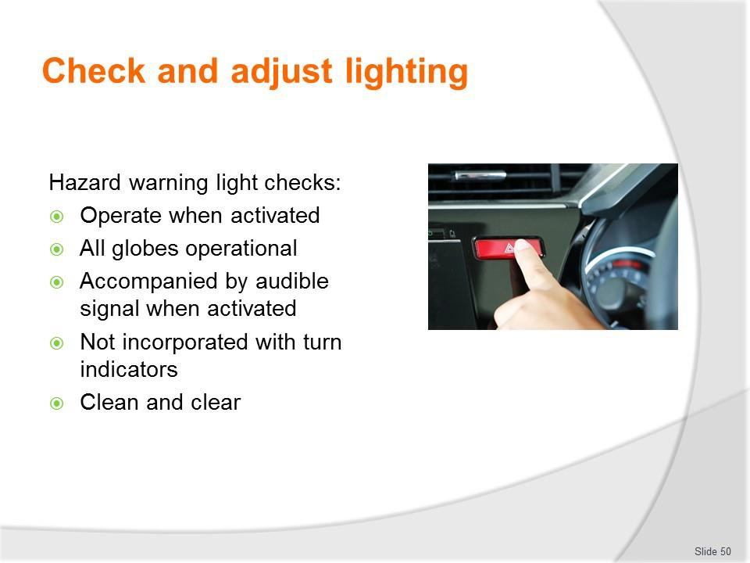
Slide No | Trainer Notes
50. | Trainer discusses hazard warning light checks:  - Operate when activated  - All globes operational  - Accompanied by audible signal when activated  - Not incorporated with turn indicators  - Clean and clear.  Classroom Activity – Demonstration and Practical  Trainer shows students how to undertake activities listed on the slide and provides an opportunity for them to do the same.

Slide
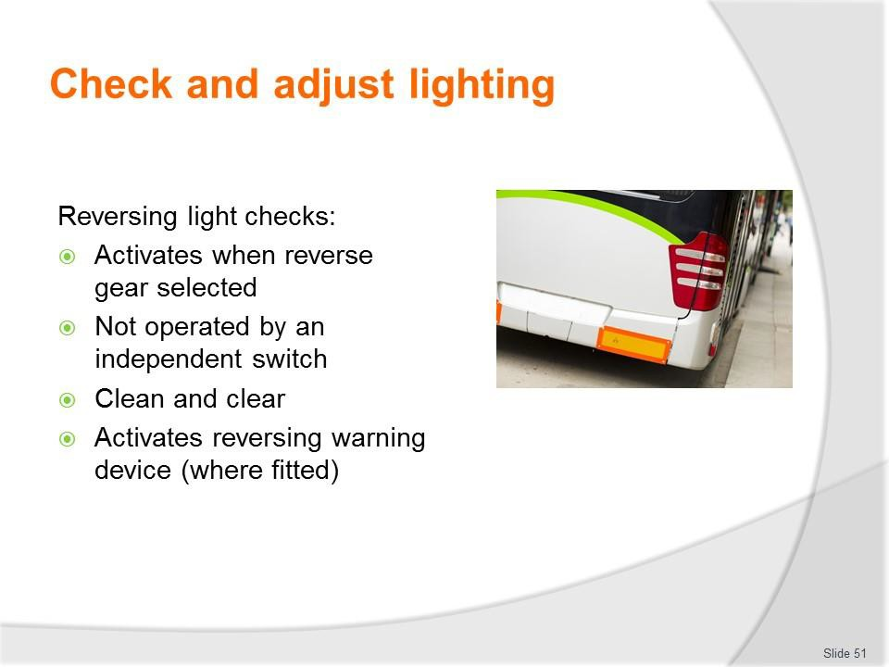
Slide No | Trainer Notes
51. | Trainer discusses reversing light checks:  - Activates when reverse gear selected  - Not operated by an independent switch  - Clean and clear  - Activates reversing warning device (where fitted).  Classroom Activity – Demonstration and Practical  Trainer shows students how to undertake activities listed on the slide and provides an opportunity for them to do the same.

Slide
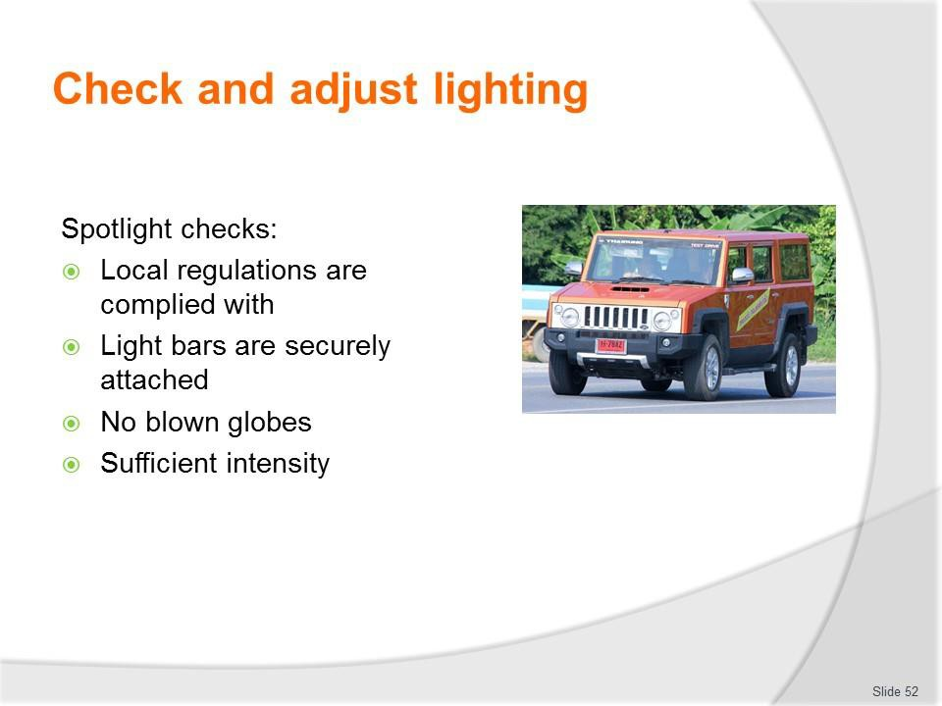
Slide No | Trainer Notes
52. | Trainer discusses spotlight checks:  - Local regulations are complied with – there is usually a ban on fitting spotlights to vehicles other than as in compliance with the requirements for driving lights although some tour vehicles may carry hand-held spotlights which run off the vehicle  - Light bars are securely attached  - No blown globes  - Sufficient intensity.  Classroom Activity – Demonstration and Practical  Trainer shows students how to undertake activities listed on the slide and provides an opportunity for them to do the same.

Slide
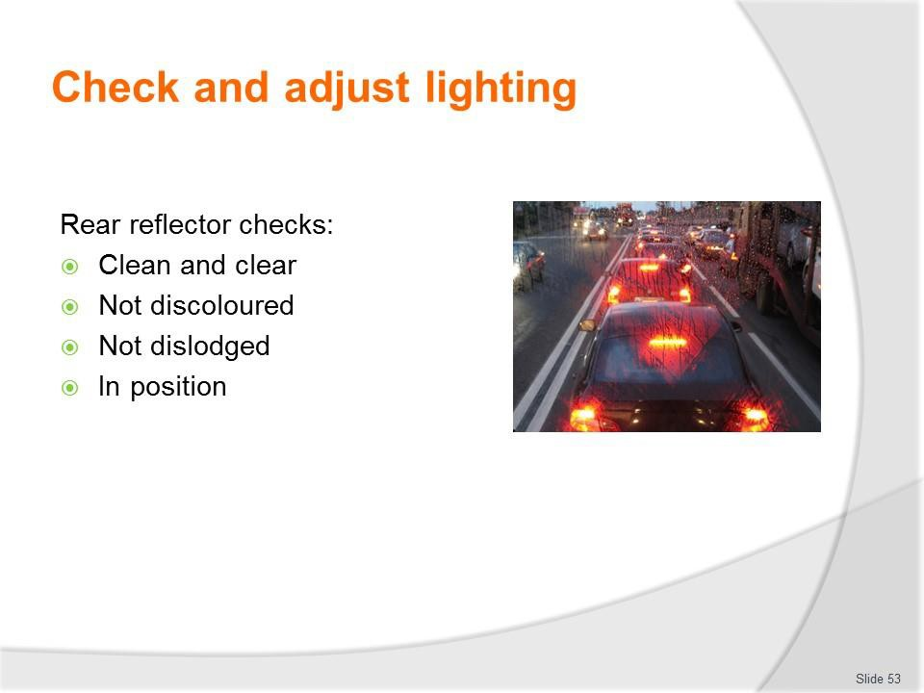
Slide No | Trainer Notes
53. | Trainer discusses rear reflector checks:  - These need to be checked to ensure they are clean and have not become discoloured or dislodged  - Dirty reflectors need to be cleaned and those which are discoloured or missing must be replaced or tightened.  Classroom Activity – Demonstration and Practical  Trainer shows students how to undertake activities listed on the slide and provides an opportunity for them to do the same.

Slide
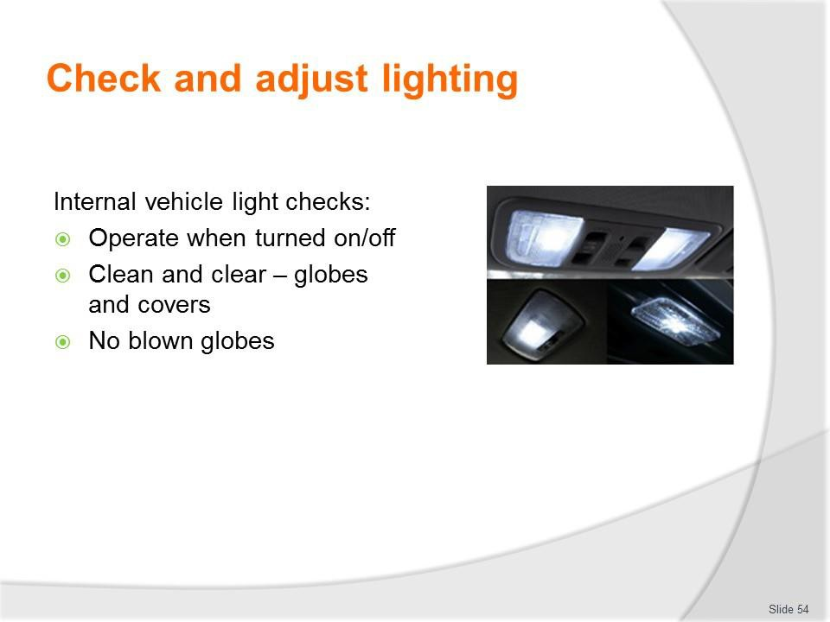
Slide No | Trainer Notes
54. | Trainer discusses internal lights checks:  - Operate when turned on/off  - Clean and clear – globes and covers  - No blown globes.  Classroom Activity – Demonstration and Practical  Trainer shows students how to undertake activities listed on the slide and provides an opportunity for them to do the same.

Slide
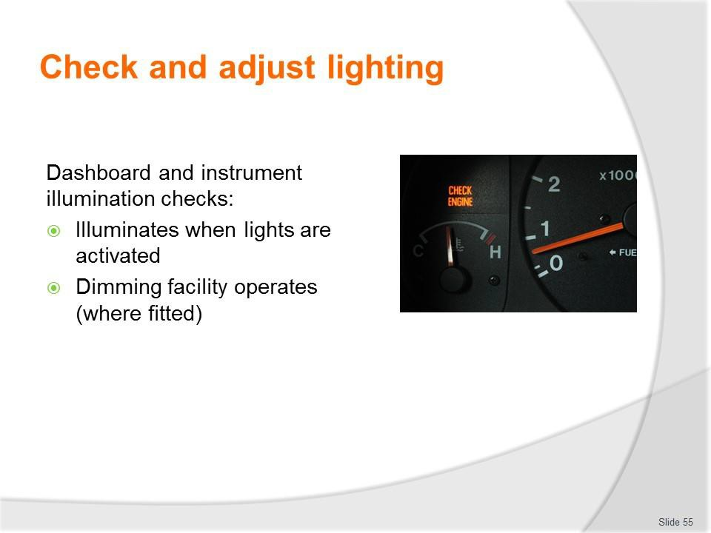
Slide No | Trainer Notes
55. | Trainer discusses dashboard and instrument illumination checks:  - Illuminates when lights are activated  - Dimming facility operates (where fitted)  - Warning (or ‘tell tale’) lights (the owner manual needs to be consulted to ensure there is complete knowledge of all warning lights fitted to the vehicle) – check to ensure, for example:  - Seatbelt light and audible warning activates if seat belts are not connected  - Dashboard warning activates when hazard warning lights are operated  - Turn signal dashboard light illuminates when turn signal used – left and right  - Required lights (for example: oil, temperature, brake system, temperature, battery and others) illuminate:  - As required  - When vehicle is turned on.  Classroom Activity (1) – Demonstration and Practical  Trainer shows students how to undertake activities listed on the slide and provides an opportunity for them to do the same.  Classroom Activity (2) – internet Research  Trainer facilitates research and discussion of: http://www.2pass.co.uk/dashboard-lights.htm#.VRnnqI6ddh8

Slide
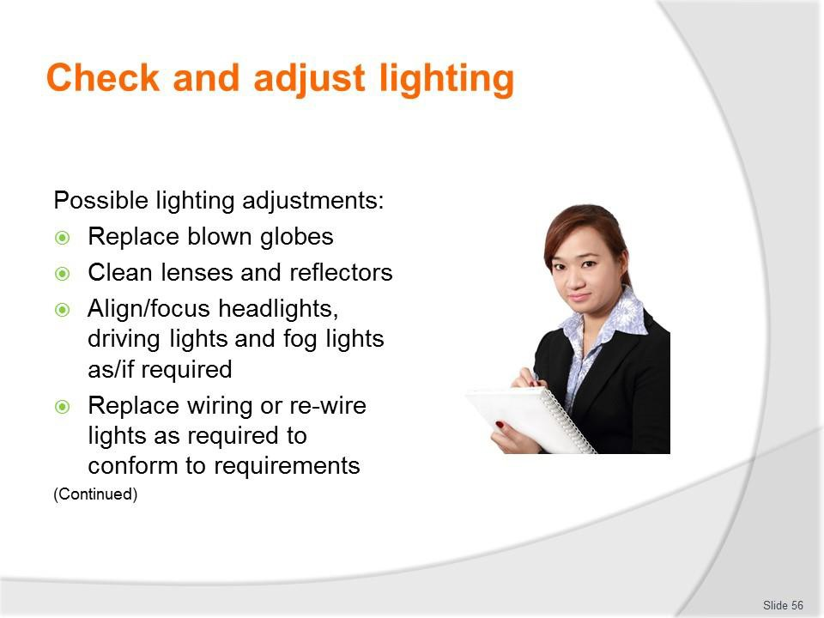
Slide No | Trainer Notes
56. | Trainer identifies possible lighting adjustments:  - Replace blown globes  - Clean lenses and reflectors  - Align/focus headlights, driving lights and fog lights as/if required  - Replace wiring or re-wire lights as required to conform to requirements.  Classroom Activity – Demonstration and Practical  Trainer shows students how to undertake activities listed on the slide and provides an opportunity for them to do the same.

Slide
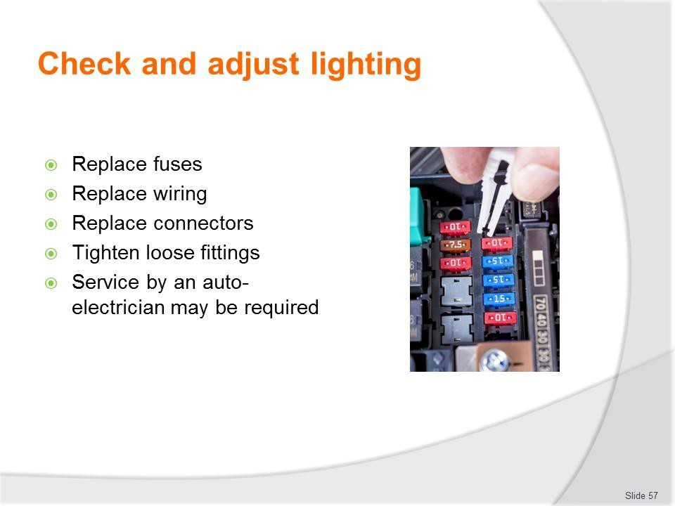
Slide No | Trainer Notes
57. | Trainer continues identifying possible lighting adjustments:  - Replace fuses  - Replace wiring  - Replace connectors  - Tighten loose fittings.  Technical adjustments may require the services of a qualified auto electrician.  Classroom Activity – Demonstration and Practical  Trainer shows students how to undertake activities listed on the slide and provides an opportunity for them to do the same.

Slide
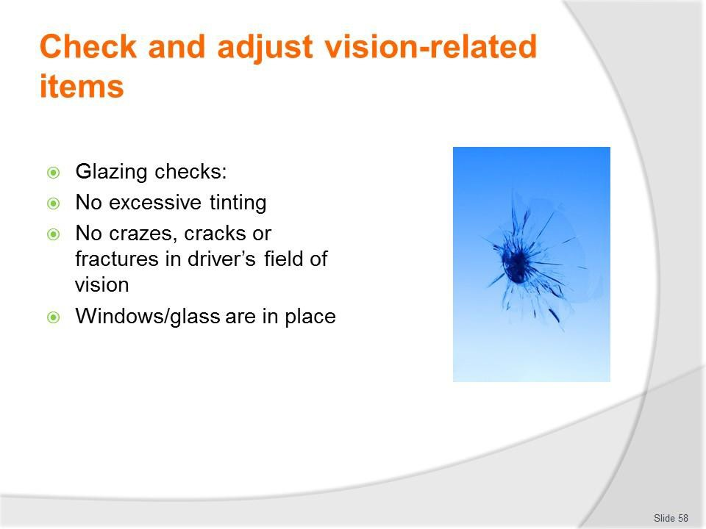
Slide No | Trainer Notes
58. | Trainer discusses glazing checks:  - Tinting is not excessive and permits sufficient light to pass in accordance with local regulations – that is, tinting for front and front-side windows must not be ‘too dark’  - There may be no restrictions for:  - Passenger windows located rear of the driver  - A limited band (say, maximum 10% of the total windscreen) at the top of the windscreen  - No cracks, crazes, fractures in field of vision of driver  - Windows/glass are in place.  Classroom Activity – Demonstration and Practical  Trainer shows students how to undertake activities listed on the slide and provides an opportunity for them to do the same.

Slide
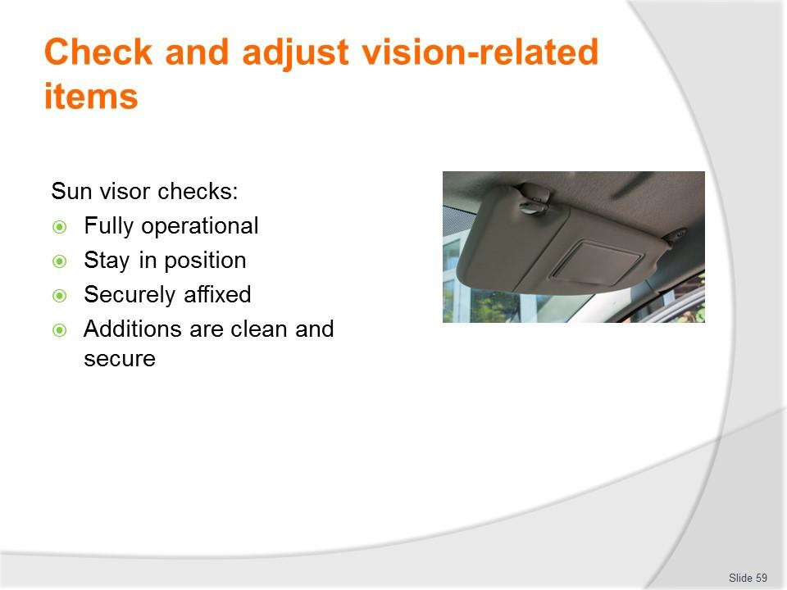
Slide No | Trainer Notes
59. | Trainer discusses sun visor checks:  - Fully operational and easy/smooth to use – in terms of:  - Flipping down and up  - Moving laterally – where appropriate  - They will stay in the position required by the user  - They are securely affixed to the vehicle  - Additions (mirrors, pockets, attachments) are clean and secure.  Classroom Activity – Demonstration and Practical  Trainer shows students how to undertake activities listed on the slide and provides an opportunity for them to do the same.

Slide
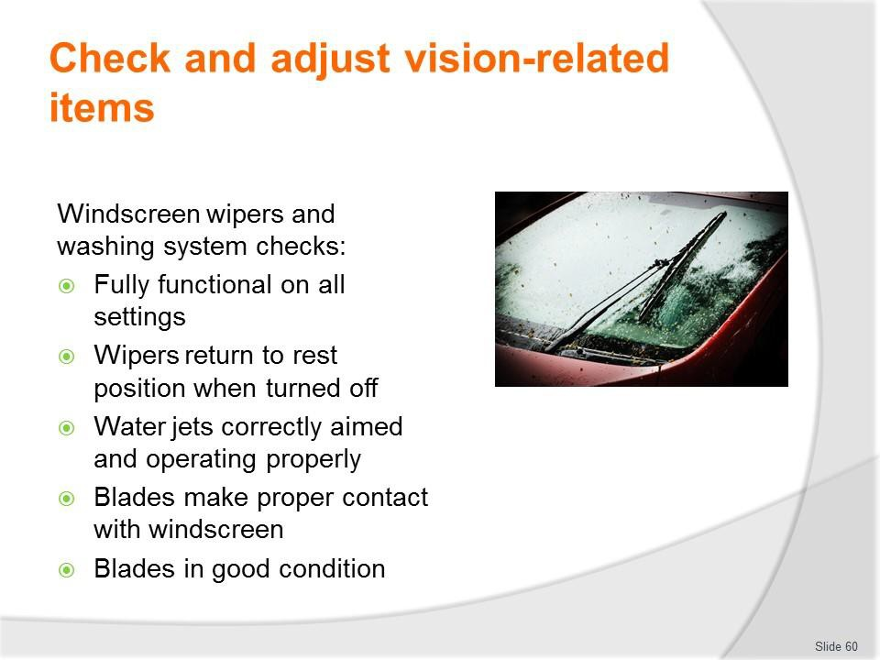
Slide No | Trainer Notes
60. | Trainer discusses windscreen wipers and washing system checks:  - System is fully functional at all settings – and blades return to their resting position when the system is turned off  - Water jets are correctly aimed and of sufficient pressure  - Water jets are operating properly and are not blocked or disconnected  - Wipers and washers can be operated from the driver’s seat  - Blades of the wipers make contact with/sweep only the glass and no other part of the vehicles  - Blades are in place and in good condition – that is, they are not dried, cracked or otherwise damaged or defective.  Classroom Activity – Demonstration and Practical  Trainer shows students how to undertake activities listed on the slide and provides an opportunity for them to do the same.

Slide
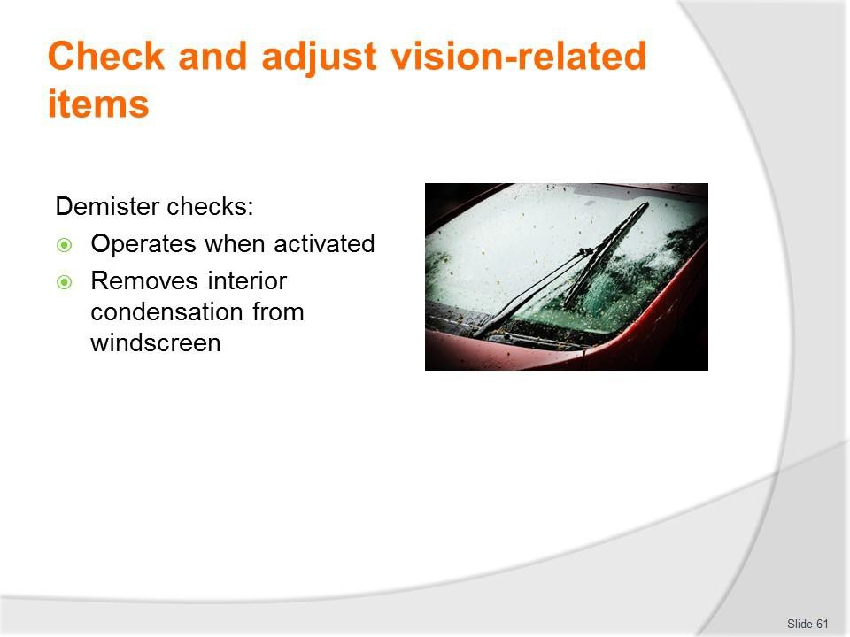
Slide No | Trainer Notes
61. | Trainer discusses demister checks:  - The demister operates correctly when turned on – and removes condensation from inside the windscreens as required for the individual design and requirements of the vehicle.  Classroom Activity – Demonstration and Practical  Trainer shows students how to undertake activities listed on the slide and provides an opportunity for them to do the same.

Slide
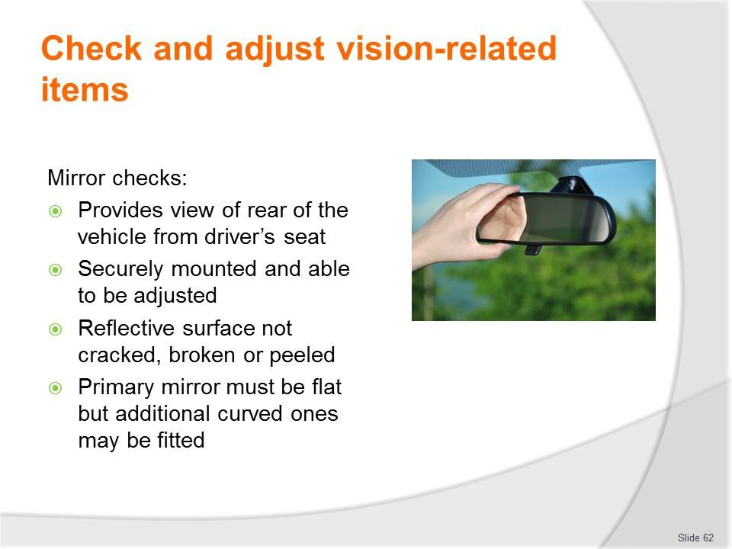
Slide No | Trainer Notes
62. | Trainer discusses mirror checks:  - The rear view mirrors must provide a view of the rear of the vehicle from the driver’s seat  - Mirrors must be securely mounted and able to be adjusted  - The reflective surface must not be cracked, broken or peeled  - The primary rear vision mirror must be flat but additional curved ones may be fitted.  Classroom Activity – Demonstration and Practical  Trainer shows students how to undertake activities listed on the slide and provides an opportunity for them to do the same.

Slide
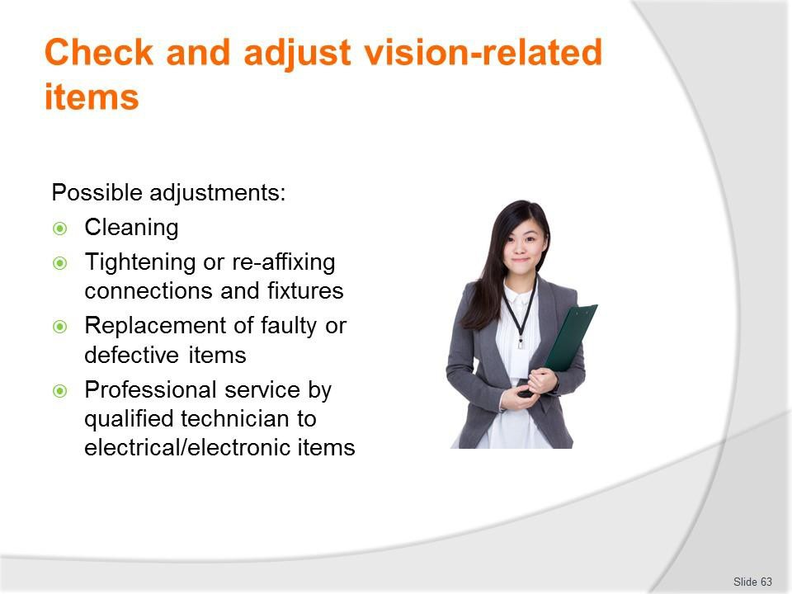
Slide No | Trainer Notes
63. | Trainer describes adjustments:  - Cleaning  - Tightening or re-affixing connections and fixtures  - Replacement of faulty or defective items  - Professional service by qualified technician to electrical/electronic items.  Classroom Activity – Demonstration and Practical  Trainer shows students how to undertake activities listed on the slide and provides an opportunity for them to do the same.

Slide
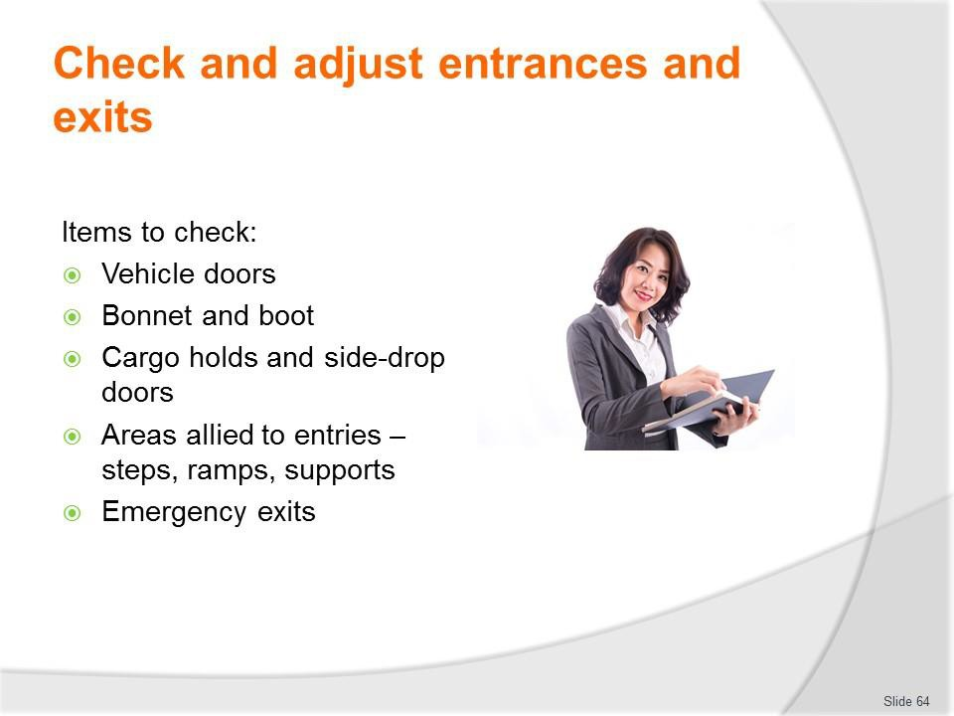
Slide No | Trainer Notes
64. | Trainer identifies items which may need to be checked:  - The operation of all doors of the vehicle – including:  - Hinged doors  - Sliding doors  - Pneumatic doors  - The operation of other opening panels/parts of the vehicle – such as:  - Bonnet  - Boot  - Cargo holds  - Side/drop doors  - Aspects of the vehicle allied to entrances and exits – such as:  - Entry steps  - Ramps and hoists  - Pneumatic supports – used to keep doors open  - Emergency exits.

Slide
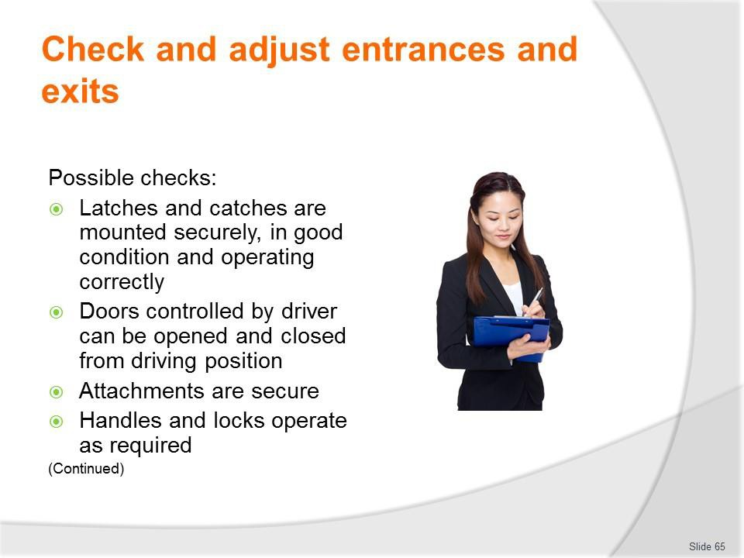
Slide No | Trainer Notes
65. | Trainer identifies possible checks:  - Ensuring latches and catches are mounted securely, in good condition and operating correctly and effectively as required – every door/opening (left and right, front and back – and top of vehicle, were sun-roofs are fitted) needs to be physically tested  - Making sure doors which are controlled by the driver can be opened and closed from the driving position  - Checking to make sure all door attachments/fittings and fixtures are securely attached – and do not present a protrusion hazard  - Testing and checking the operation of door handles and locks – including the operation of remote opening/locking devices.  Classroom Activity – Demonstration and Practical  Trainer shows students how to undertake activities listed on the slide and provides an opportunity for them to do the same.

Slide
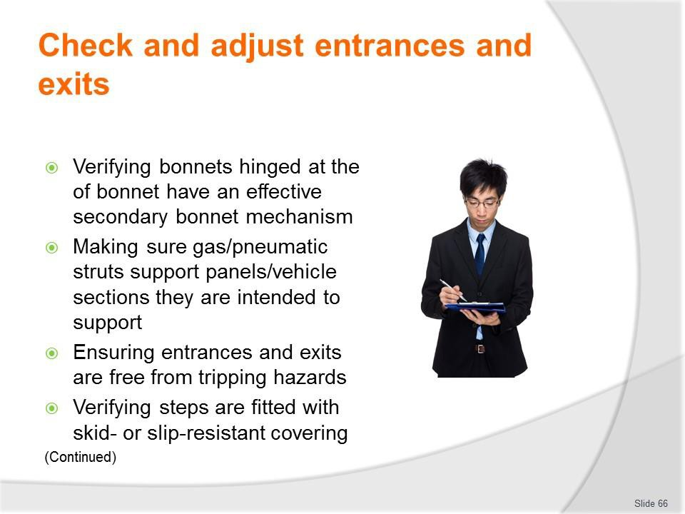
Slide No | Trainer Notes
66. | Trainer continues identifying possible checks:  - Verifying bonnets which are hinged at the rear of the bonnet (near the windscreen) have an effective secondary bonnet mechanism (catch or straps) in place – to prevent the bonnet flying up if the primary catch fails  - Making sure gas/pneumatic struts support the panels/vehicle sections they are intended to support – and do not allow that area to drop or unintentionally lower slowly or close without notice  - Ensuring entrances and exits are free from tripping hazards – such as worn rubber, torn carpet, or lifted seals/strips  - Verifying steps are fitted with skid- or slip-resistant covering.  Classroom Activity – Demonstration and Practical  Trainer shows students how to undertake activities listed on the slide and provides an opportunity for them to do the same.

Slide
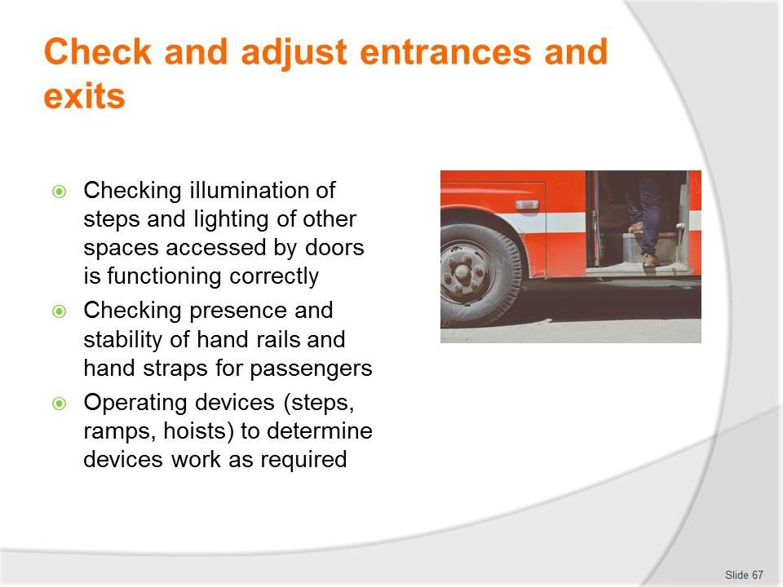
Slide No | Trainer Notes
67. | Trainer continues identifying possible checks:  - Checking illumination of steps (as/if fitted) and lighting of other spaces accessed by doors is functioning correctly – and there are no blown globes  - Checking presence and stability of hand rails and hand straps for passengers – at entrances/exist and at each seat (where provided)  - Operating mechanical and pneumatic devices provided on the vehicle (which may include steps, ramps, hoists) – to determine devices work as required (all functions  – stop, start, hold, up, down and other as relevant) using all control unit options (such as those in the driving cabin as well as remote or hand-held units.  Classroom Activity – Demonstration and Practical  Trainer shows students how to undertake activities listed on the slide and provides an opportunity for them to do the same.

Slide
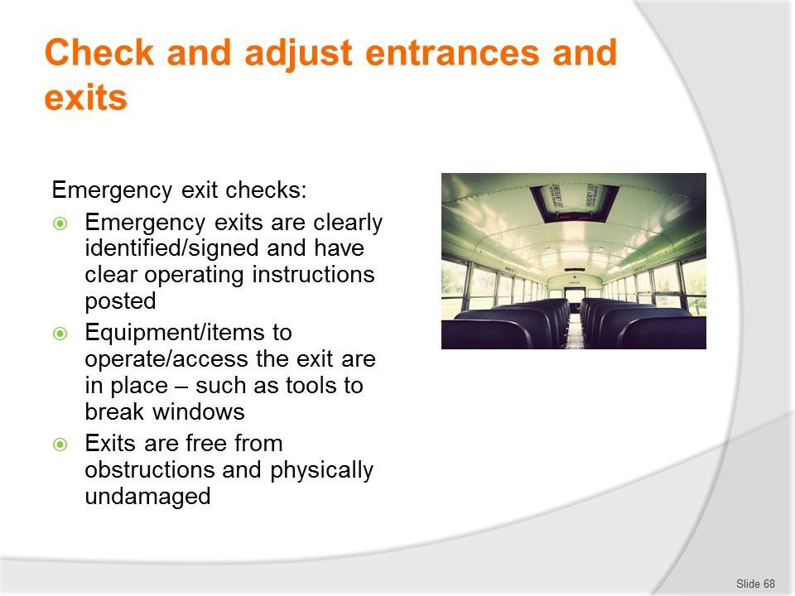
Slide No | Trainer Notes
68. | Trainer discusses emergency exit checks:  - Emergency exits are clearly identified/signed and have clear operating instructions posted  - Equipment/items to operate/access the exit are in place – such as tools to break windows  - Exits are free from obstructions and physically undamaged.  Classroom Activity – Demonstration and Practical  Trainer shows students how to undertake activities listed on the slide and provides an opportunity for them to do the same.

Slide
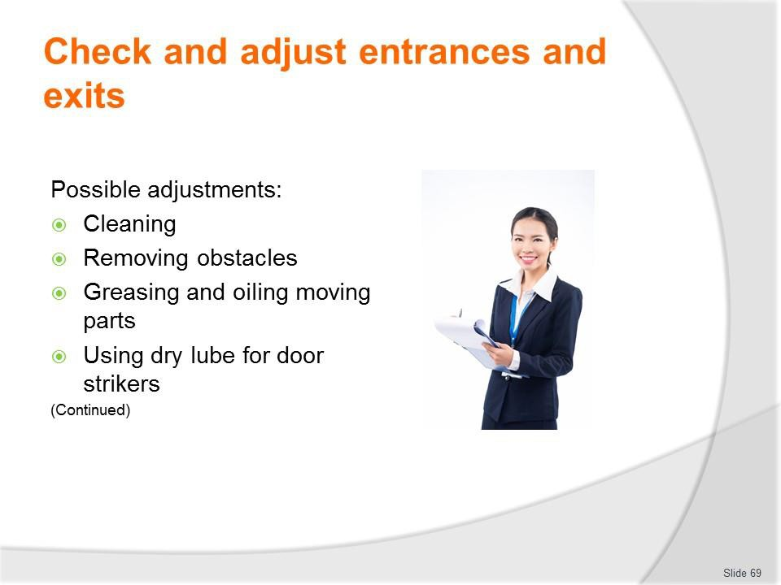
Slide No | Trainer Notes
69. | Trainer presents possible adjustments:  - Cleaning  - Removing obstacles  - Greasing and oiling moving parts  - Using dry lube for door strikers.  Classroom Activity – Demonstration and Practical  Trainer shows students how to undertake activities listed on the slide and provides an opportunity for them to do the same.

Slide
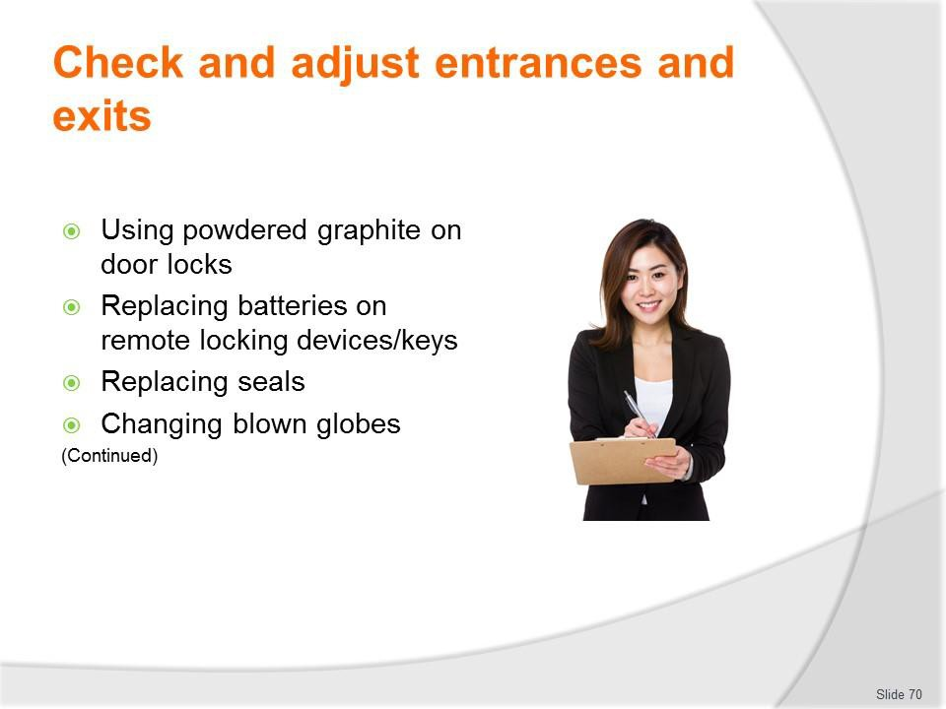
Slide No | Trainer Notes
70. | Trainer continues presenting possible adjustments:  - Using powdered graphite on door locks  - Replacing batteries on remote locking devices/keys  - Replacing seals  - Changing blown globes.  Classroom Activity – Demonstration and Practical  Trainer shows students how to undertake activities listed on the slide and provides an opportunity for them to do the same.

Slide
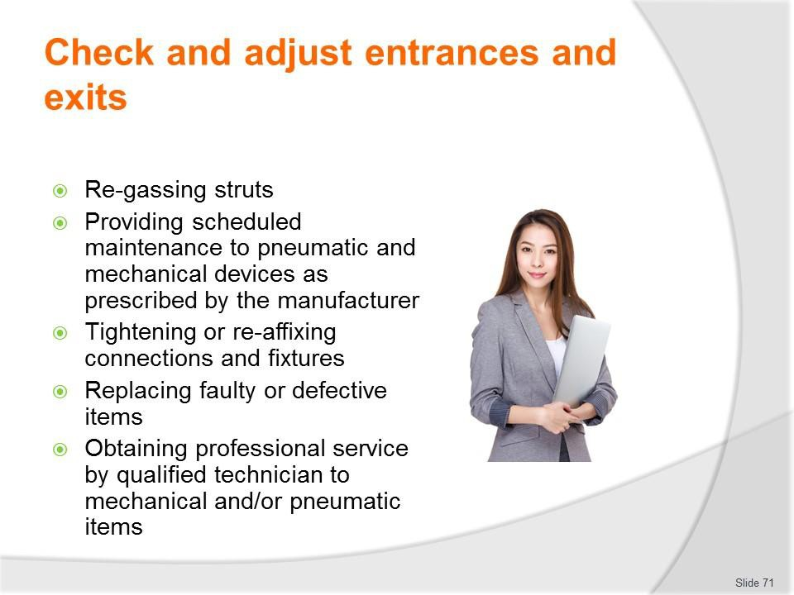
Slide No | Trainer Notes
71. | Trainer continues presenting possible adjustments:  - Re-gassing struts  - Providing scheduled maintenance to pneumatic and mechanical devices as prescribed by the manufacturer  - Tightening or re-affixing connections and fixtures  - Replacing faulty or defective items  - Obtaining professional service by qualified technician to mechanical and/or pneumatic items.  Classroom Activity – Demonstration and Practical  Trainer shows students how to undertake activities listed on the slide and provides an opportunity for them to do the same.

Slide
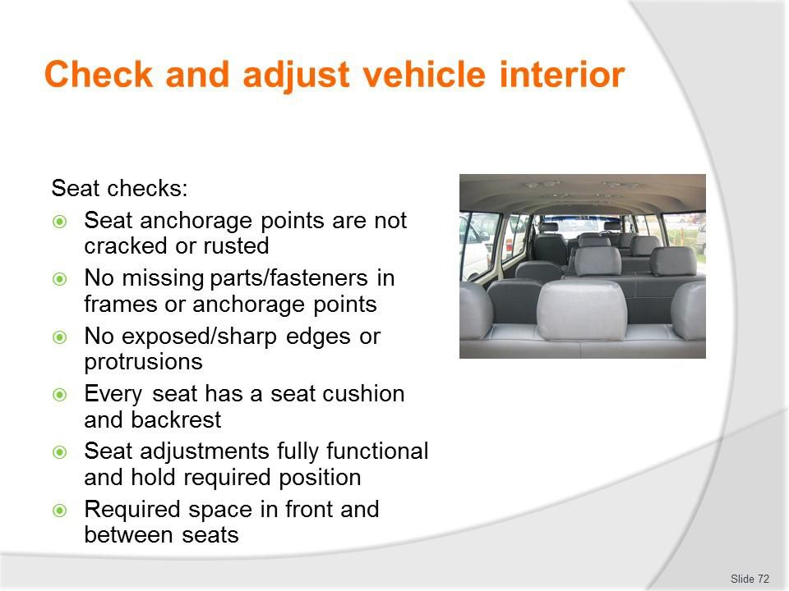
Slide No | Trainer Notes
72. | Trainer discusses seat checks:  - Seat anchorage points are not cracked or rusted  - There are no missing parts/fasteners in the seat frames or anchorage points  - There are no exposed/sharp edges or protrusions – which may cut/harm people  - Every seat has a seat cushion and backrest – and will provide basic/required level of comfort for passengers  - Seat adjustments (for example, seat height and angle, lumbar support, position of backrest, forward and rear movement/slides) are fully functional – and hold the designated position as required  - Required space around (in front of and in between) seats is provided – in accordance with the type and size of the vehicle as prescribed by relevant transport authority.  Classroom Activity – Demonstration and Practical  Trainer shows students how to undertake activities listed on the slide and provides an opportunity for them to do the same.

Slide
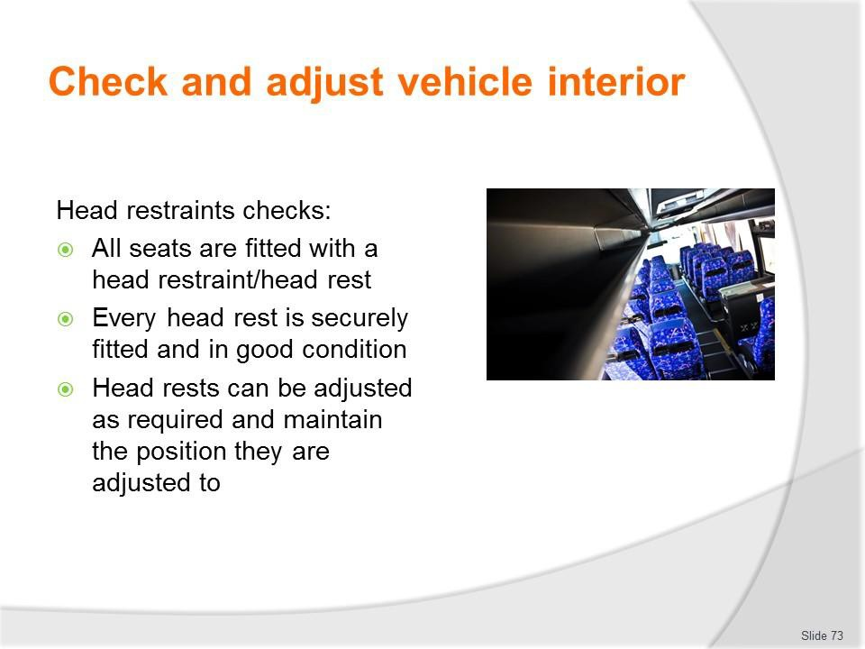
Slide No | Trainer Notes
73. | Trainer discusses head restraint checks:  - All seats are fitted with a head restraint/head rest  - Every head rest is securely fitted and in good condition  - Head rests can be adjusted as required – and maintain the position they are adjusted to.  Classroom Activity – Demonstration and Practical  Trainer shows students how to undertake activities listed on the slide and provides an opportunity for them to do the same.

Slide
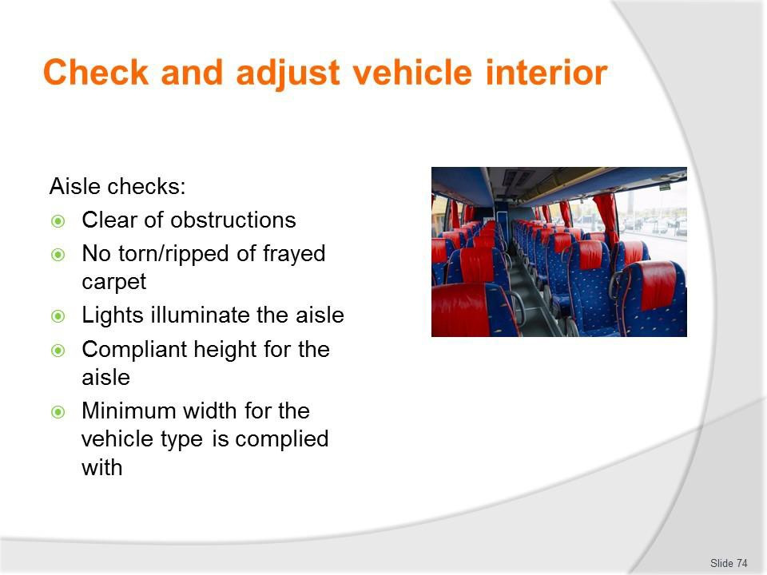
Slide No | Trainer Notes
74. | Trainer discusses aisle checks: It is clear of obstructions  - There is no torn/ripped of frayed carpet or floor covering – to present a tripping hazard  - Lights illuminate the aisle – where fitted  - Compliant height for the aisle – which can vary between bus types (and their use) and can (for example) range from a minimum floor-to-roof height of 1.2 metres (for very small buses) through different measurements up to 1.8 metres for large buses  - Minimum width for the vehicle type is complied with – these can range from (for example) 300 mm in a small bus up to 380 mm in a larger bus.  Classroom Activity – Demonstration and Practical  Trainer shows students how to undertake activities listed on the slide and provides an opportunity for them to do the same.

Slide
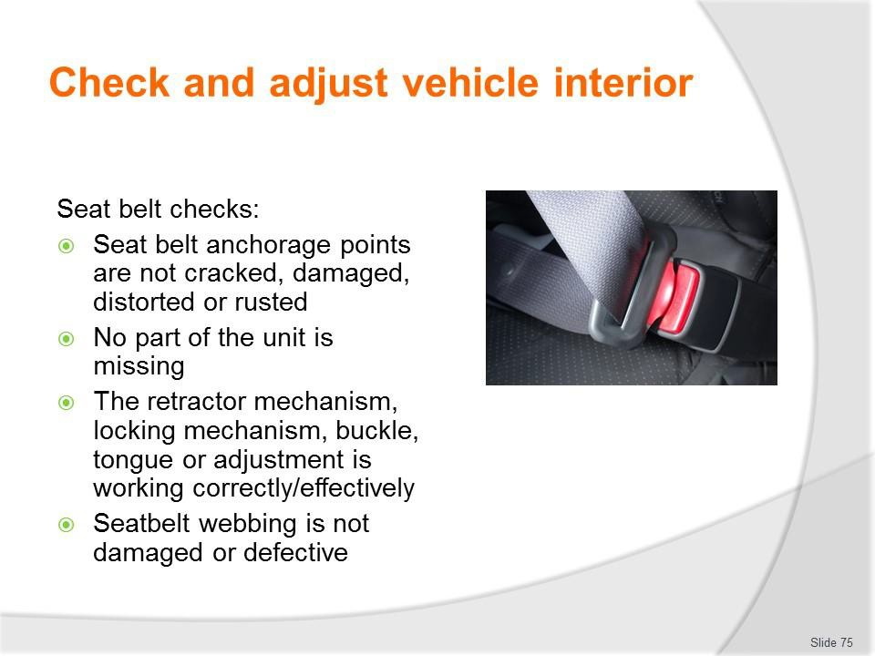
Slide No | Trainer Notes
75. | Trainer discusses seat belt checks:  - Seat belt anchorage points are not cracked, damaged, distorted or rusted  - No part of the unit is missing  - The retractor mechanism, locking mechanism, buckle, tongue or adjustment device is working correctly and effectively  - Seatbelt webbing is not:  - Damaged  - Frayed  - Stretched  - Tied in a knot  - Twisted  - Split  - Torn  - Cut  - Altered or modified  - Severely deteriorated  - Burnt  - Not correctly and firmly secured to each end fitting  - Has webbing/stitching which is detached at any point.

Classroom Activity – Demonstration and Practical
Trainer shows students how to undertake activities listed on the slide and provides an opportunity for them to do the same.

Slide
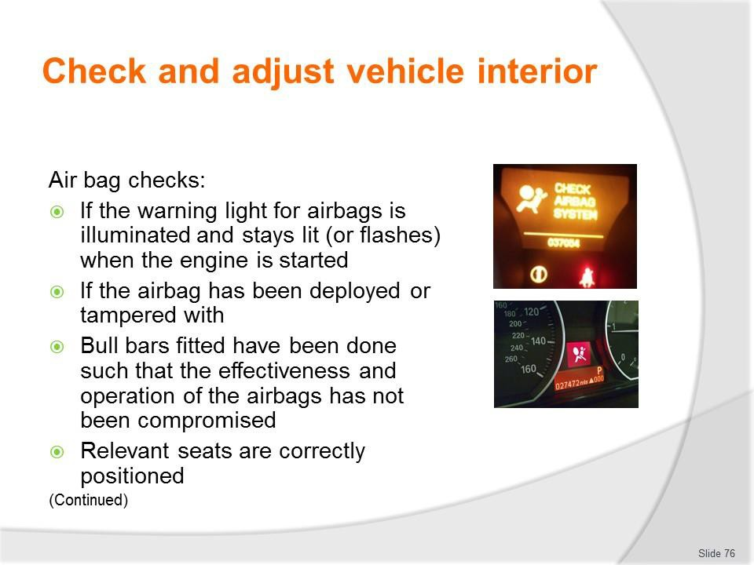
Slide No | Trainer Notes
76. | Trainer discusses air bag checks:  - If the warning light for airbags is illuminated and stays lit (or flashes) when the engine is started – after the system has performed it own self-test  - If the airbag has been deployed or tampered with  - That bull bars fitted to the vehicle have been done such that the effectiveness and operation of the airbags has not been compromised  - Relevant seats are correctly positioned – according to manufacturer’s instructions – there are optimum/recommended positions for driver and passenger seats.  Classroom Activity – Demonstration and Practical  Trainer shows students how to undertake activities listed on the slide and provides an opportunity for them to do the same.

Slide
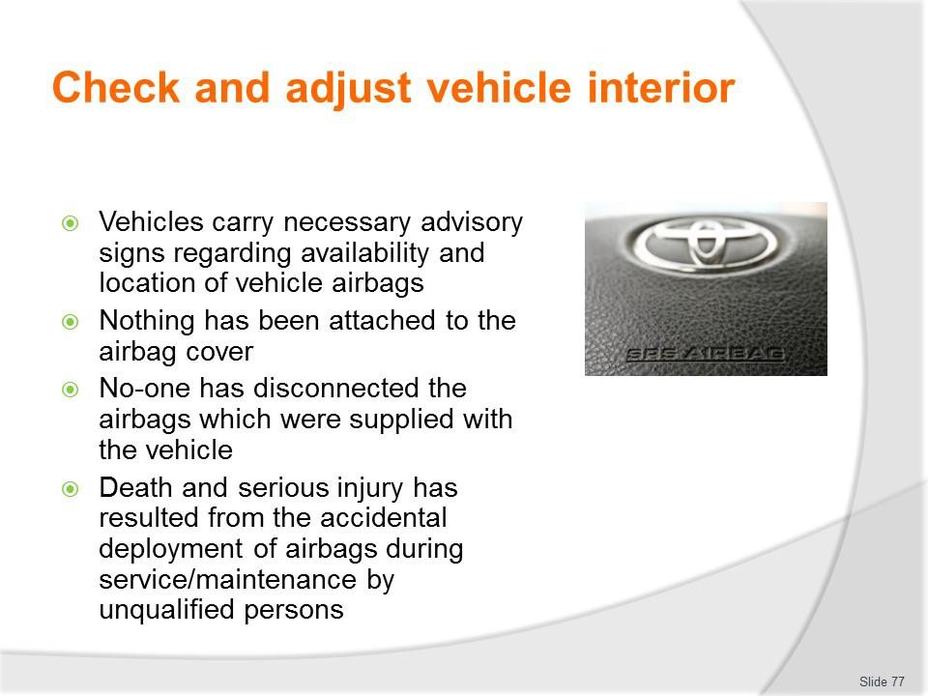
Slide No | Trainer Notes
77. | Trainer continues discussing air bag checks:  - Vehicles carry necessary advisory signs regarding availability and location of vehicle airbags  - Nothing has been attached to the airbag cover – which could become dangerous projectiles in the event of airbag deployment  - No-one has disconnected the airbags which were supplied with the vehicle.  Important note: Death and serious injury has resulted from the accidental deployment of airbags during service/maintenance by unqualified persons.  Classroom Activity – Demonstration and Practical  Trainer shows students how to undertake activities listed on the slide and provides an opportunity for them to do the same.

Slide
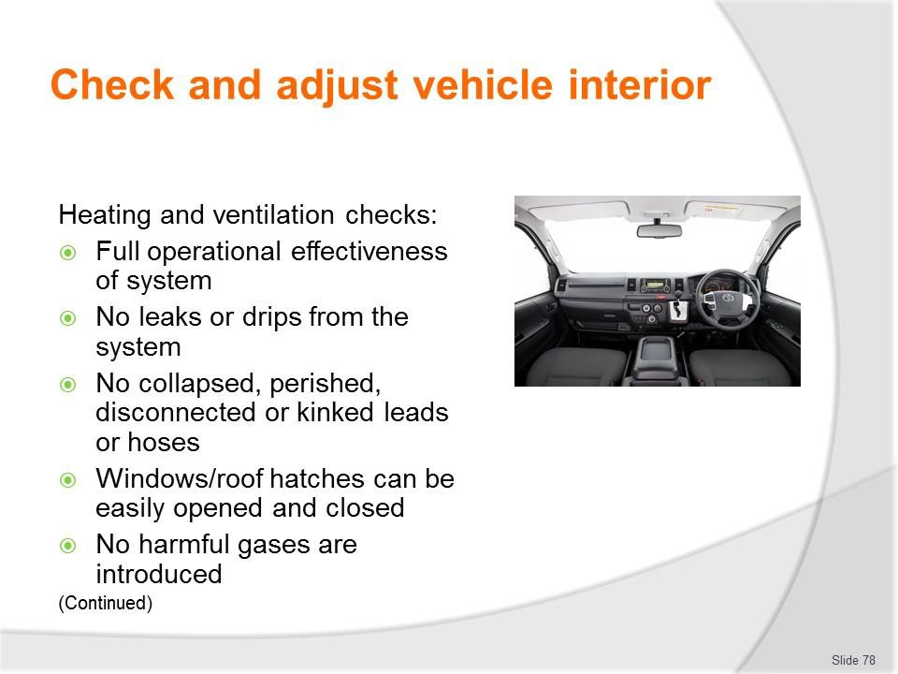
Slide No | Trainer Notes
78. | Trainer discusses heating and ventilation checks:  - Operational effectiveness of the heating and cooling system:  - At all settings  - In all sections of the vehicle  - From all operator panels  - No leaks or drips from the system  - No collapsed, perished, disconnected or kinked leads or hoses  - Windows and roof hatches can be easily opened and closed  - No harmful gases are introduced as a result of any heating or cooling process.  Classroom Activity – Demonstration and Practical  Trainer shows students how to undertake activities listed on the slide and provides an opportunity for them to do the same.

Slide
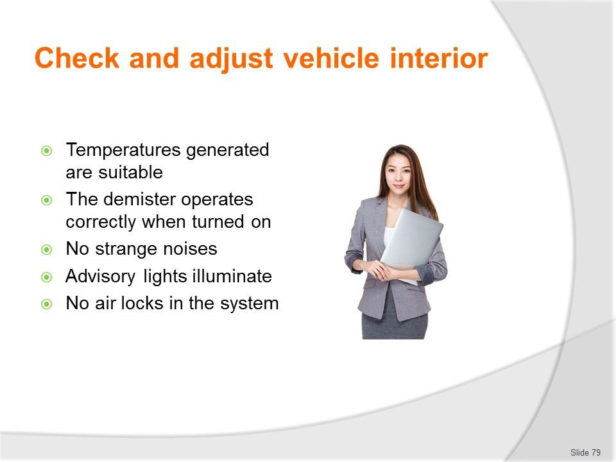
Slide No | Trainer Notes
79. | Trainer continues discussing heating and ventilation checks:  - Temperatures generated are suitable – for the requirements of the business/tour operator  - The demister operates correctly when turned on – and removes condensation from inside the windscreens as required for the individual design and requirements of the vehicle  - No strange noises – when the system is operated  - Advisory lights illuminate (where fitted) – when system activated  - No air locks in the system.  Classroom Activity – Demonstration and Practical  Trainer shows students how to undertake activities listed on the slide and provides an opportunity for them to do the same.

Slide
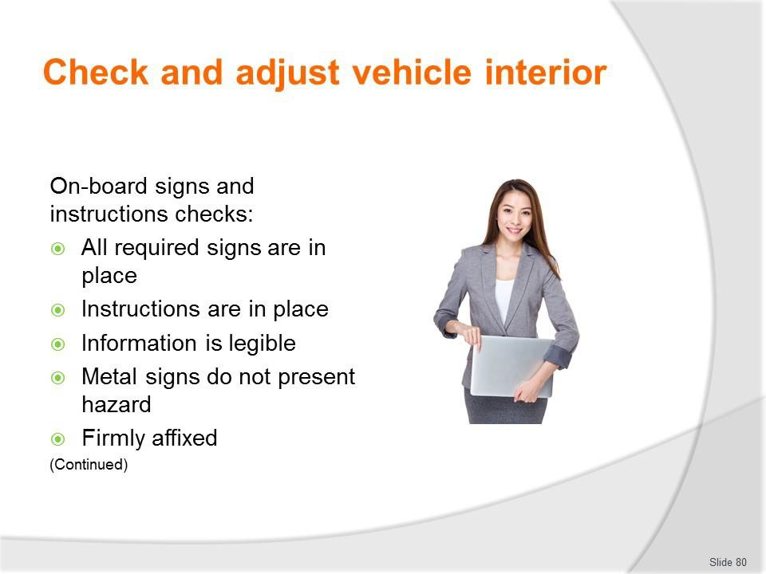
Slide No | Trainer Notes
80. | Trainer continues discussing heating and ventilation checks:  - Temperatures generated are suitable – for the requirements of the business/tour operator  - The demister operates correctly when turned on – and removes condensation from inside the windscreens as required for the individual design and requirements of the vehicle  - No strange noises – when the system is operated  - Advisory lights illuminate (where fitted) – when system activated  - No air locks in the system.  Classroom Activity – Demonstration and Practical  Trainer shows students how to undertake activities listed on the slide and provides an opportunity for them to do the same.

Slide
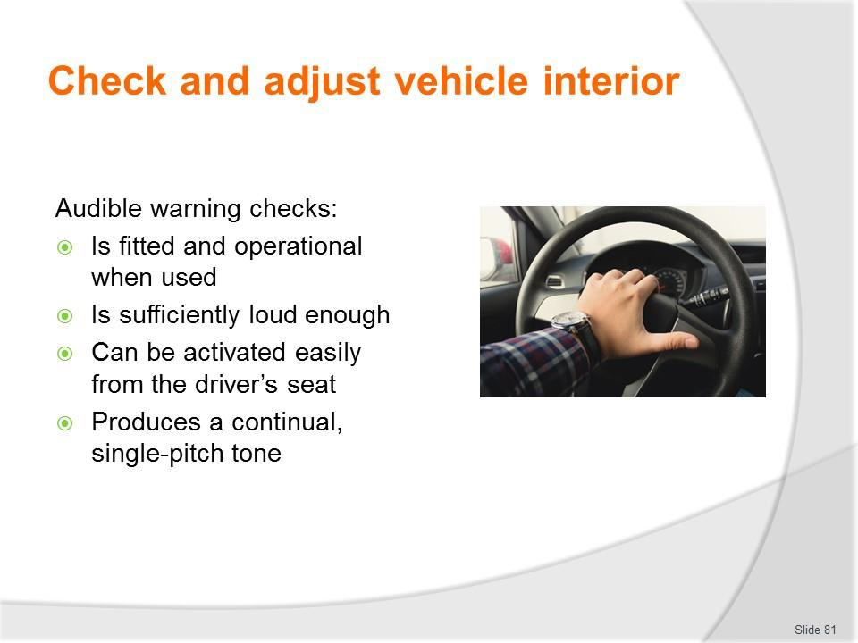
Slide No | Trainer Notes
81. | Trainer discusses audible warning checks:  - Is fitted and operational when used  - Is sufficiently loud enough  - Can be activated easily from the driver’s seat  - Produces a continual, single-pitch tone.  Classroom Activity – Demonstration and Practical  Trainer shows students how to undertake activities listed on the slide and provides an opportunity for them to do the same.

Slide
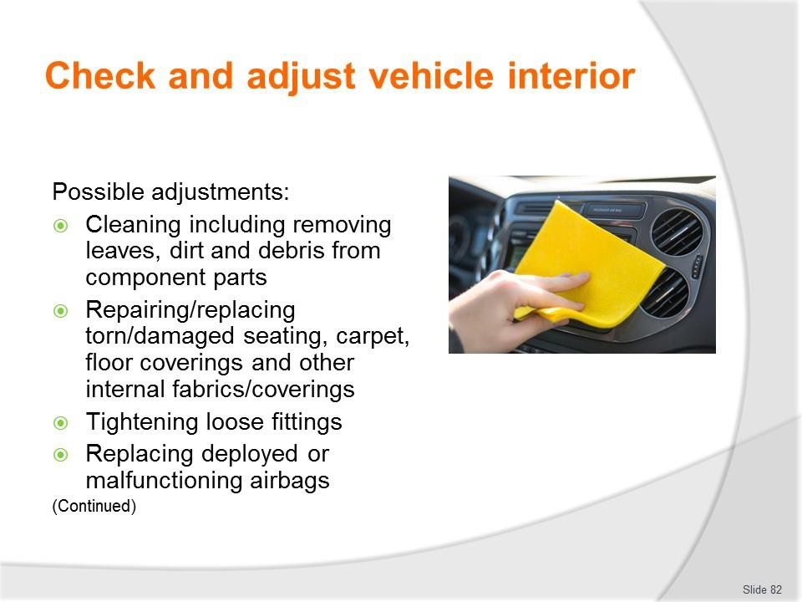
Slide No | Trainer Notes
82. | Trainer presents adjustments:  - Cleaning including removing leaves, dirt and debris from component parts  - Repairing and/or replacing torn/damaged seating, carpet, floor coverings and other internal fabrics/coverings  - Tightening loose fittings  - Replacing deployed or malfunctioning airbags.  Classroom Activity – Demonstration and Practical  Trainer shows students how to undertake activities listed on the slide and provides an opportunity for them to do the same.

Slide
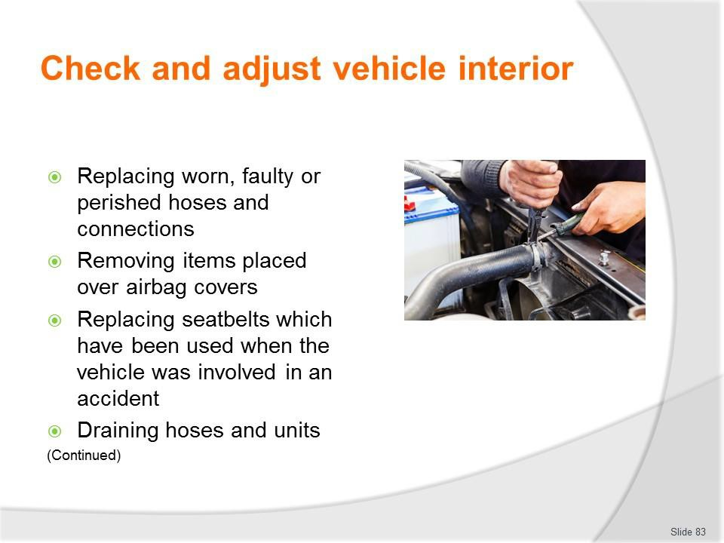
Slide No | Trainer Notes
83. | Trainer continues presenting adjustments:  - Replacing worn, faulty or perished hoses and connections  - Removing items placed over airbag covers  - Replacing seatbelts which have been used when the vehicle was involved in an accident  - Draining hoses and units.  Classroom Activity – Demonstration and Practical  Trainer shows students how to undertake activities listed on the slide and provides an opportunity for them to do the same.

Slide
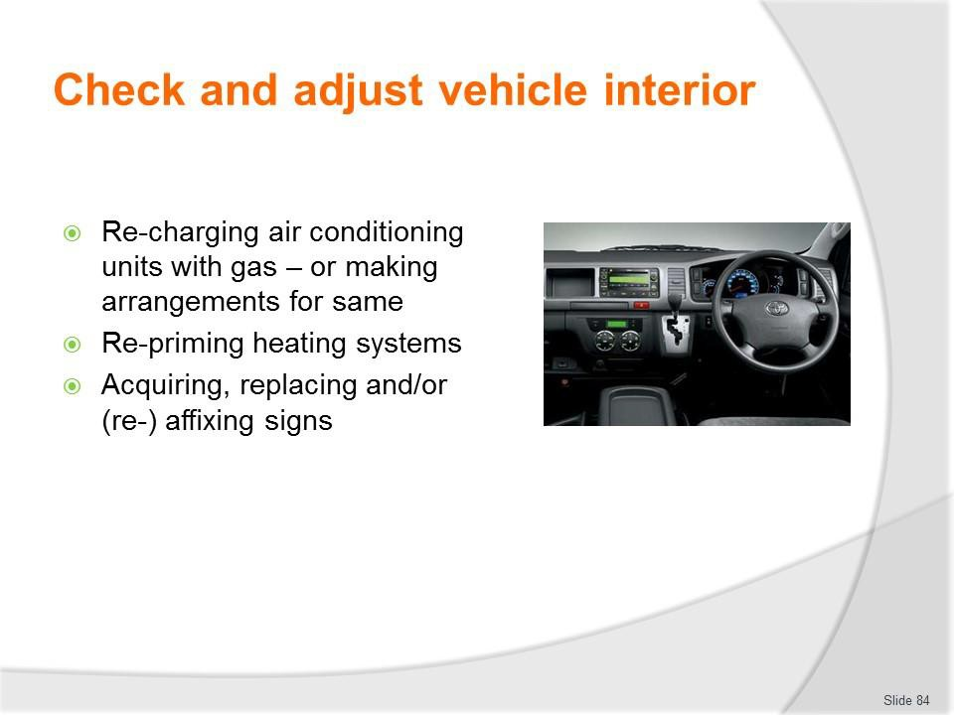
Slide No | Trainer Notes
84. | Trainer continues presenting adjustments:  - Re-charging air conditioning units with gas – or making arrangements for same  - Re-priming heating systems  - Acquiring, replacing and/or (re-) affixing signs.  Classroom Activity – Demonstration and Practical  Trainer shows students how to undertake activities listed on the slide and provides an opportunity for them to do the same.

Slide
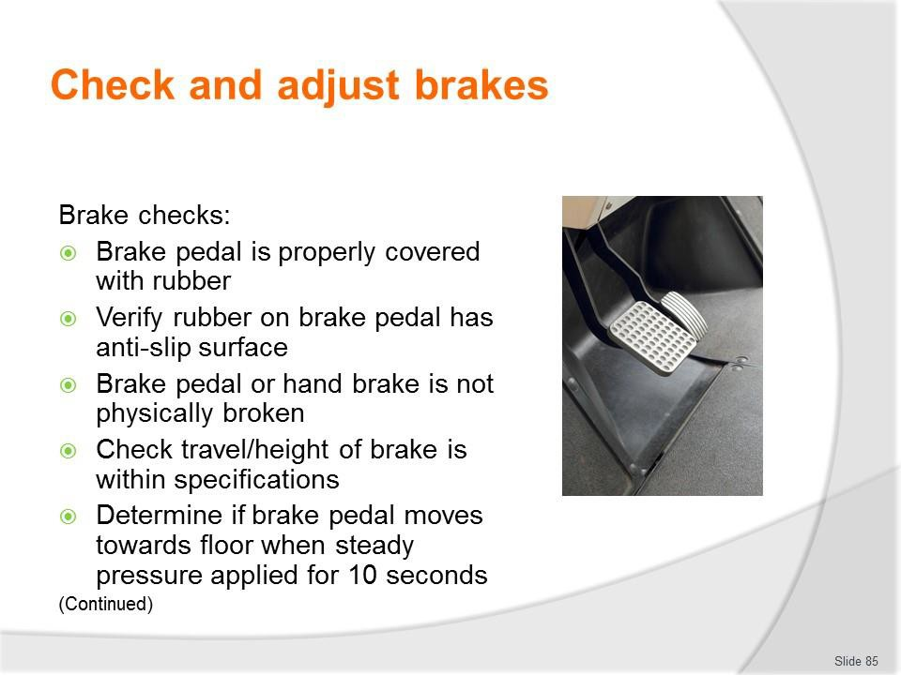
Slide No | Trainer Notes
85. | Trainer discusses brake checks:  - Ensure brake pedal is properly covered with rubber and there is no metal showing through  - Verify rubber on brake pedal has anti-slip surface and that surface is sufficient and in good condition  - Ensure the brake pedal or the hand brake is not physically broken  - Check the travel/height of the brake pedal when applied and ensure it is within manufacturer specifications – for example, less than 20% travel  - Determine if the brake pedal moves to the floor/towards the floor (or if the brake indicator/warning light comes on) when steady pressure is applied for 10 seconds.  Classroom Activity – Demonstration and Practical  Trainer shows students how to undertake activities listed on the slide and provides an opportunity for them to do the same.

Slide
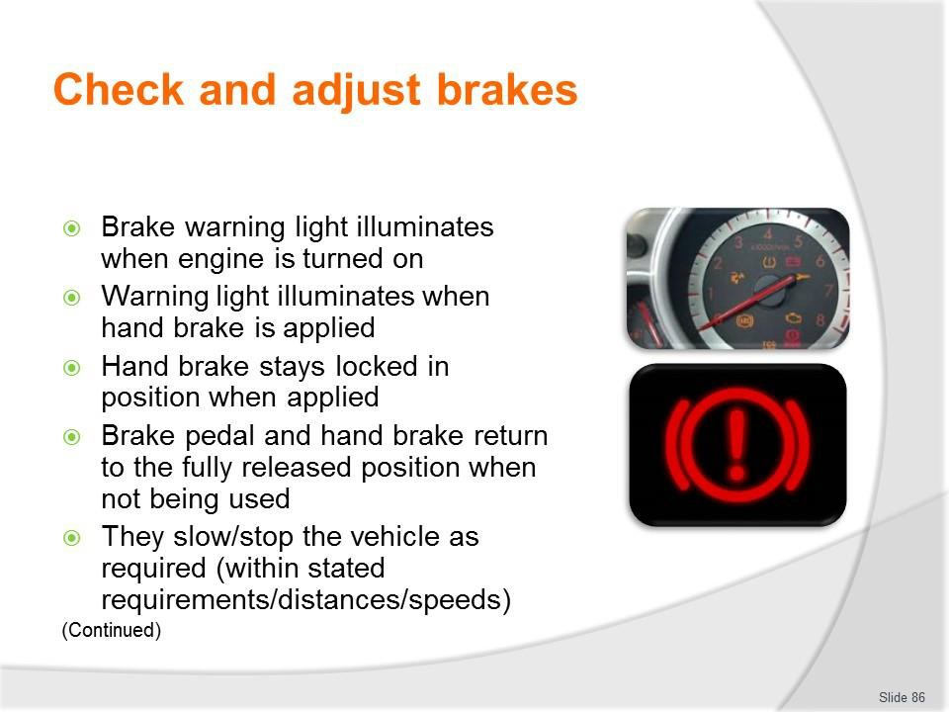
Slide No | Trainer Notes
86. | Trainer continues discussing brake checks:  - Ensure brake warning light illuminates when engine is turned on  - Ensure hand brake warning light illuminates when hand brake is applied – and extinguishes when the hand brake is released  - Make sure the hand brake stays locked in position when applied  - Make sure the brake pedal and the hand brake return to the fully released position when not being used  - Test the brakes to ensure they slow/stop the vehicle as required (within stated requirements: that is, within a given distance from a nominated speed – for example, within 11 metres from a speed of 35 kph).  Classroom Activity – Demonstration and Practical  Trainer shows students how to undertake activities listed on the slide and provides an opportunity for them to do the same.

Slide
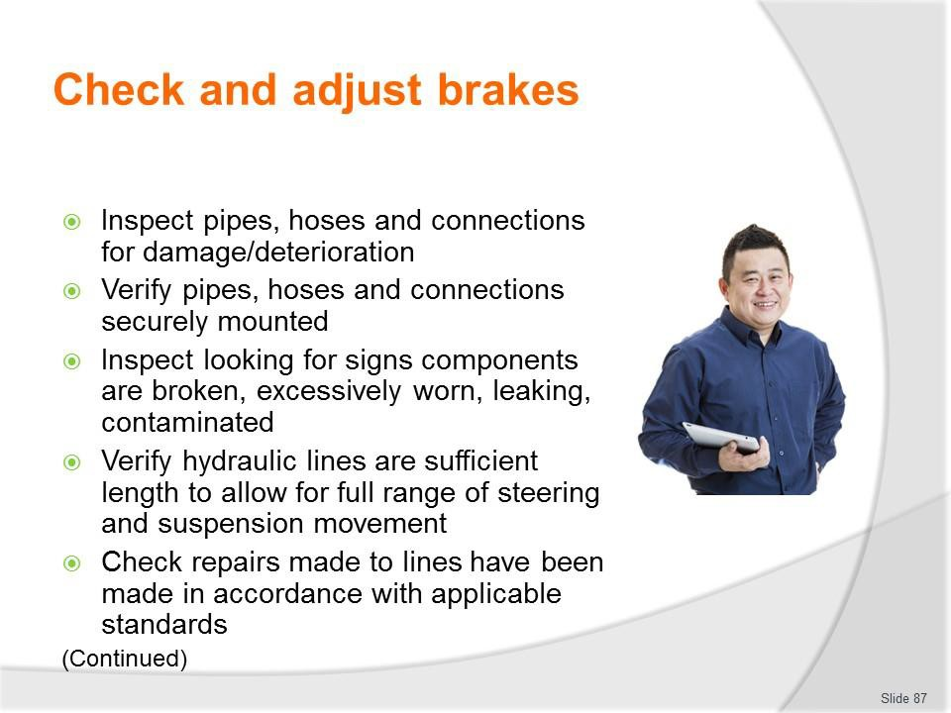
Slide No | Trainer Notes
87. | Trainer continues discussing brake checks:  - Inspect the brake pipes, hoses and connections for signs of damage or severe deterioration, kinks, crimping, heat damage or visible signs of leakage, swelling or bulging  - Inspect the brake pipes, hoses and connections to verify they are securely mounted, and not cracked or broken  - Inspect visible brake components looking for signs they are broken, excessively worn, leaking, contaminated or not securely mounted  - Verify hydraulic lines are of sufficient length to allow for the full range of steering and suspension movement, and are not twisted  - Check any repairs made to hydraulic lines have been made in accordance with applicable standards (for example, they have not been made through heating or welding, and parts used comply with required ratings/standards).  Classroom Activity – Demonstration and Practical  Trainer shows students how to undertake activities listed on the slide and provides an opportunity for them to do the same.

Slide
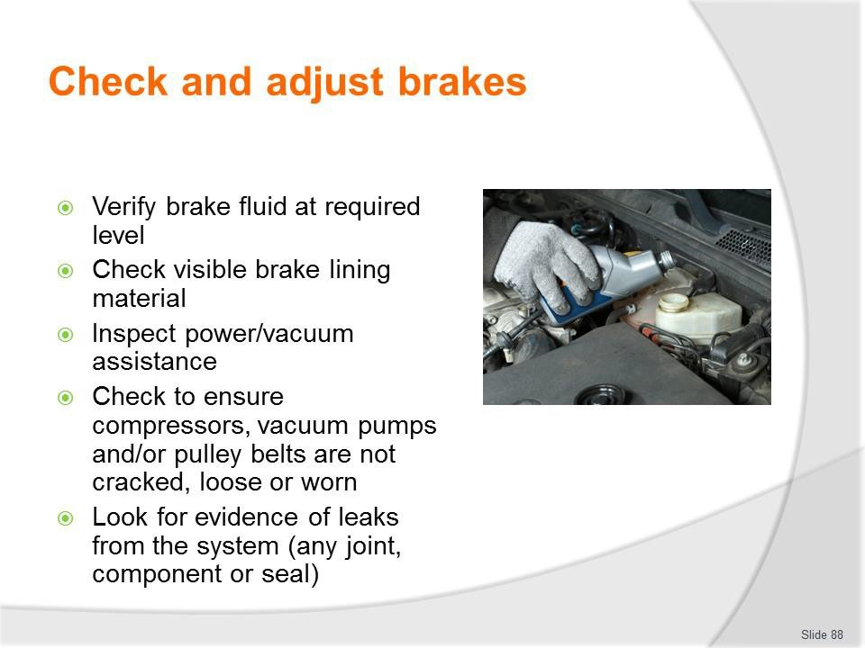
Slide No | Trainer Notes
88. | Trainer continues discussing brake checks:  - Check brake fluid and verify it is at required level  - Check visible brake lining material to ensure it is worn to less than manufacturers limits or if the limits are not known 0.8mm above bonded shoe or pad mounting surface and level with the rivet or bolt heads on riveted or bolted lining  - Inspect power/vacuum assistance for brakes to make sure they are operating properly  - Check to ensure compressors, vacuum pumps and/or pulley belts are not cracked, loose or worn  - Look for evidence of leaks from the system (any joint, component or seal).  Classroom Activity – Demonstration and Practical  Trainer shows students how to undertake activities listed on the slide and provides an opportunity for them to do the same.

Slide
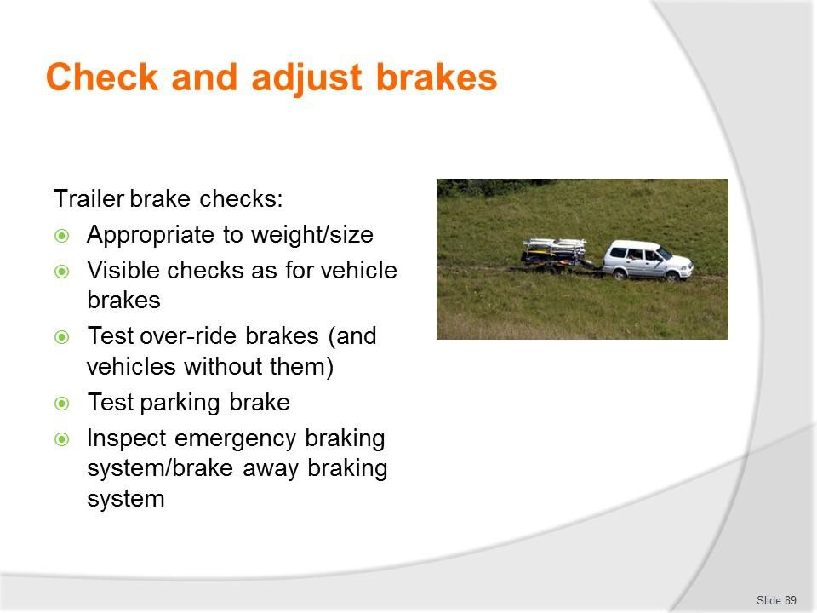
Slide No | Trainer Notes
89. | Trainer discusses trailer brake checks:  - Verify the trailer has brakes which conform to requirements relating to weight/size and year of manufacture  - Inspect the visible components of the system – checking:  - There are no leaks  - Mountings are secure  - Cables are operative, effective and in good condition  - Wiring for electrical brakes is in good condition  - Brake fluid it is at required level  - Brake fluid reservoir for hydraulic brakes is appropriately sealed  - Brake lines are in good condition – no bulges, leaks, corrosion  - All repairs made to hydraulic lines have been made in accordance with applicable standards  - No brake component is seized, severely corroded or inoperative or, where visible, is worn beyond manufacturer’s limits  - Test trailers fitted with over-ride brakes – by compressing the brake-actuating device and attempting to move the trailer (usually this can only be carried out where a parking brake is fitted to the trailer)

- Test parking brake (with towing vehicle in neutral and its brakes off) – where fitted to ensure the trailer cannot move when brake is applied, and the brake stays in the required position
- Test trailers fitted with brakes other than override brakes – by attaching the trailer to a tow vehicle, applying the trailer service brake and attempting to move the trailer forward: the brake should stop movement of the trailer
- Inspect emergency braking system/brake away braking system – where fitted the emergency braking system/brake away braking system should automatically apply when the trailer is detached from the towing vehicle.
Classroom Activity – Demonstration and Practical
Trainer shows students how to undertake activities listed on the slide and provides an opportunity for them to do the same.

Slide
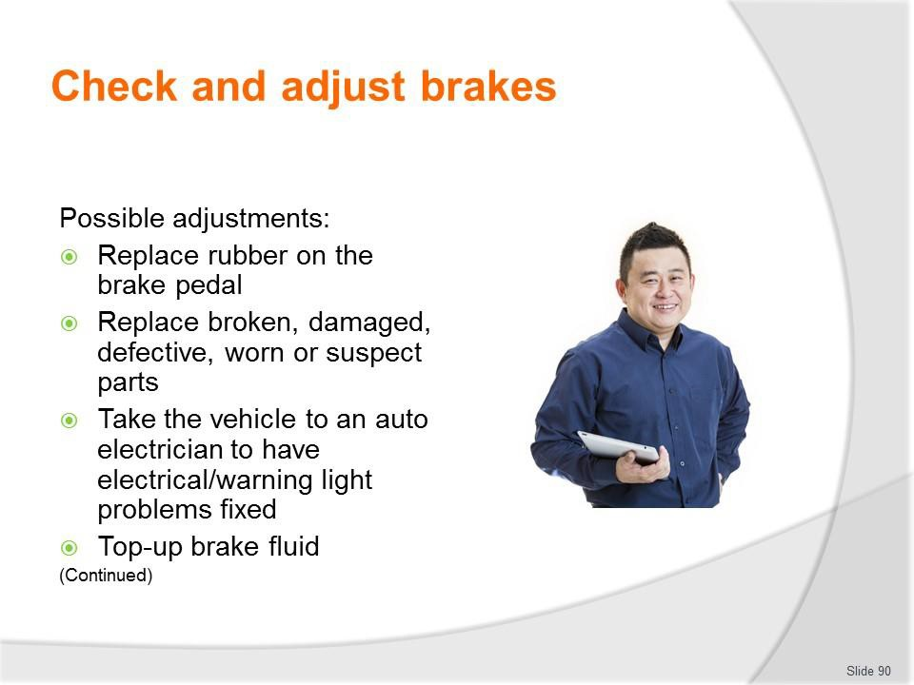
Slide No | Trainer Notes
90. | Trainer presents adjustments:  - Replace rubber on the brake pedal  - Replace broken, damaged, defective, worn or suspect parts – as opposed to repairing them  - Take the vehicle to an auto electrician – to have electrical/warning light problems or frayed electrical wiring replaced/fixed  - Top-up brake fluid.  Classroom Activity – Demonstration and Practical  Trainer shows students how to undertake activities listed on the slide and provides an opportunity for them to do the same.

Slide
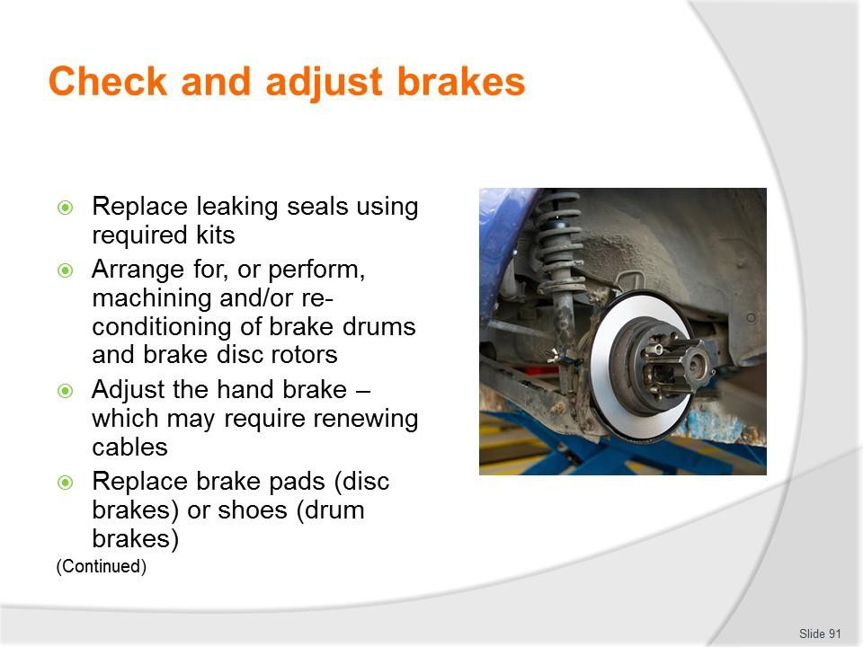
Slide No | Trainer Notes
91. | Trainer continues presenting adjustments:  - Replace leaking seals using required kits  - Arrange for, or perform, machining and/or re-conditioning of brake drums and brake disc rotors  - Adjust the hand brake – which may require renewing cables  - Replace brake pads (disc brakes) or shoes (drum brakes).  Classroom Activity – Demonstration and Practical  Trainer shows students how to undertake activities listed on the slide and provides an opportunity for them to do the same.

Slide
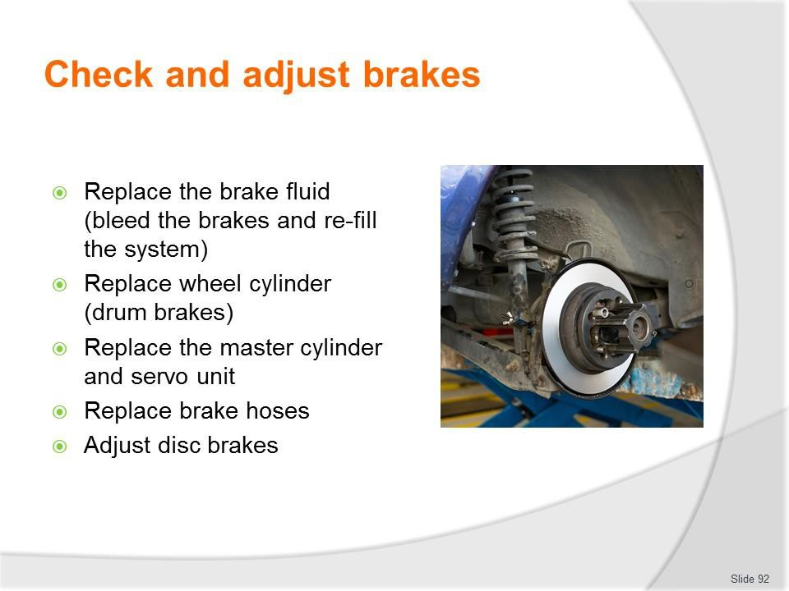
Slide No | Trainer Notes
92. | Trainer continues presenting adjustments:  - Replace the brake fluid (bleed the brakes and re-fill the system)  - Replace wheel cylinder (drum brakes)  - Replace the master cylinder and servo unit  - Replace brake hoses  - Adjust disc brakes.  Classroom Activity – Demonstration and Practical  Trainer shows students how to undertake activities listed on the slide and provides an opportunity for them to do the same.

Slide
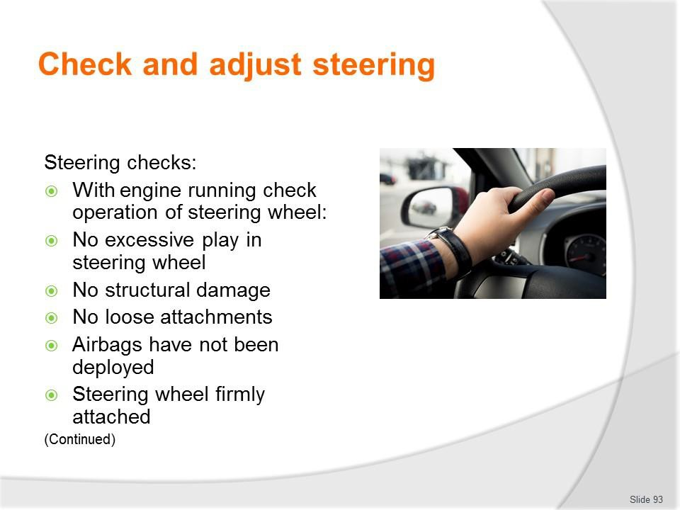
Slide No | Trainer Notes
93. | Trainer presents steering checks:  - With the engine running, check the operation of the steering by moving the steering wheel – to ensure:  - There is here is no more than 50 mm rotational free play in the wheel  - The steering wheel is free from structural damage  - Any accessories fitted to steering wheels (padded hubs, covers etc.) are not loose  - The steering wheel is securely attached to the steering column  - Where a SRS airbag is fitted, there is any evidence airbags or other SRS system are operative: check the indicator light, where fitted - this usually illuminates when the ignition is first switched “on” and extinguishes after the system passes a self-test.  Classroom Activity – Demonstration and Practical  Trainer shows students how to undertake activities listed on the slide and provides an opportunity for them to do the same.

Slide
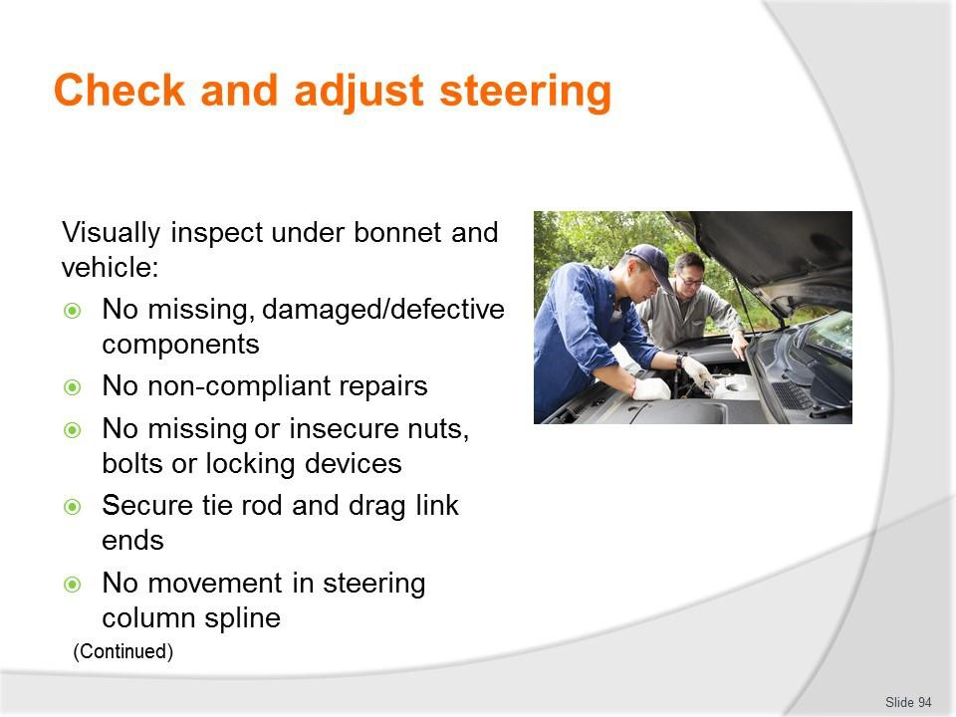
Slide No | Trainer Notes
94. | Trainer continues presenting steering checks:  - Visually inspect all steering components under the bonnet and under the vehicle – to ensure:  - No steering component is missing, cracked or broken or is worn beyond manufacturer’s limits  - No steering component can be seen to have been repaired or modified by bending, heating or welding (unless in accordance with manufacturer’s specifications)  - No nut, bolt or locking device is missing or insecure  - Tie rod and drag link ends are secured in both the rod and taper with fasteners suitably locked (e.g. split pins, lock-wire, tabs or self-locking nuts)  - There is no movement on the spline between Pitman arm and the steering box or between any thread or tapered joint.  Classroom Activity – Demonstration and Practical  Trainer shows students how to undertake activities listed on the slide and provides an opportunity for them to do the same.

Slide
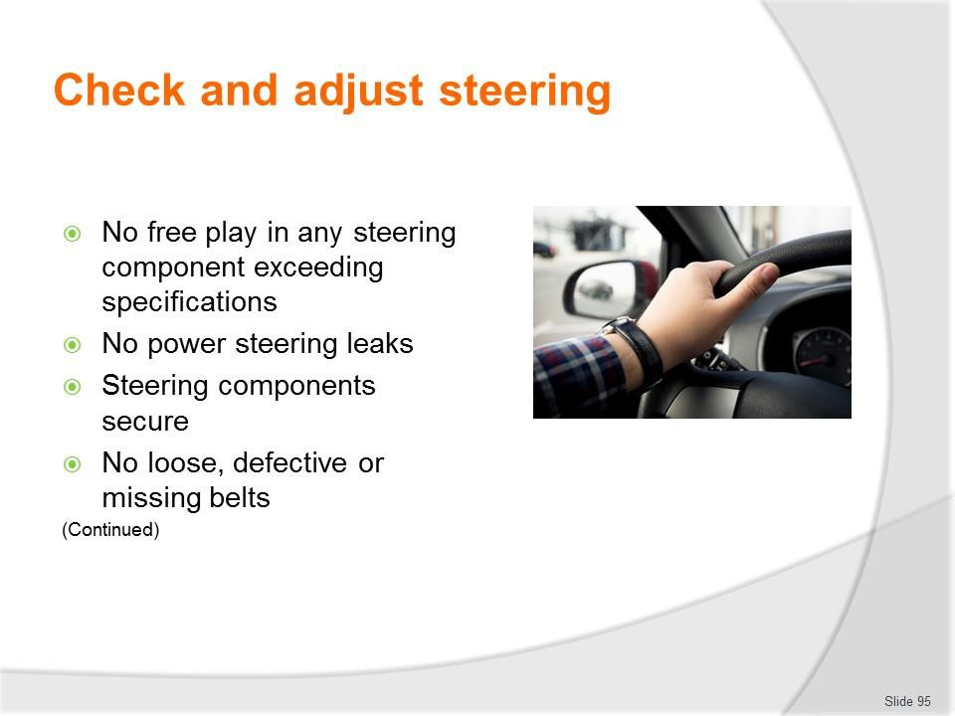
Slide No | Trainer Notes
95. | Trainer continues presenting steering checks:  - (Continued) With the engine running, check the operation of the steering by moving the steering wheel – to ensure:  - No free play due to wear in any steering component which exceeds manufacturer’s specification (if that specification is not known, free play exceeds 3 mm)  - Power steering has no leaks, no defects and is not inoperative  - Any manual or power steering componentry is securely mounted and free from excessive side or end play, roughness, or binding  - Power steering belts are not loose, broken, frayed, missing, or cracked through to reinforcing plies.  Classroom Activity – Demonstration and Practical  Trainer shows students how to undertake activities listed on the slide and provides an opportunity for them to do the same.

Slide
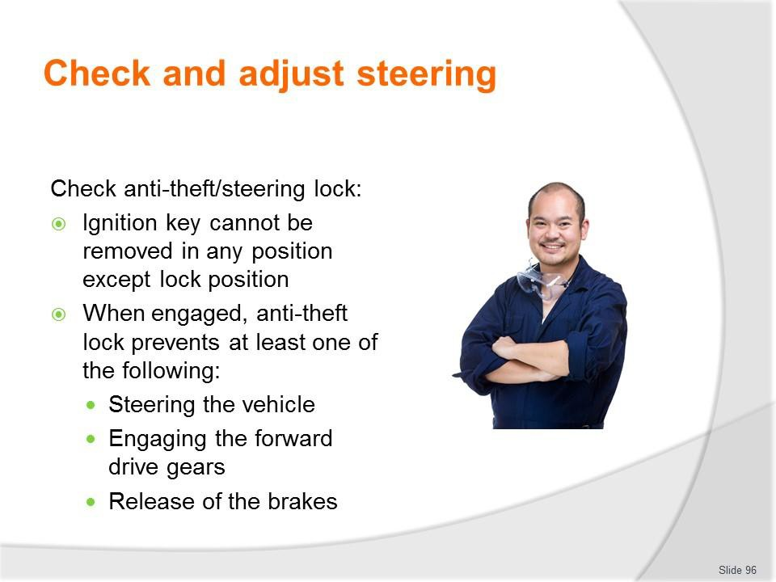
Slide No | Trainer Notes
96. | Trainer continues presenting steering checks:  - Check the operation of the anti-theft/steering lock – to ensure:  - The ignition key cannot be removed in any position except the “anti-theft” (lock) position  - When engaged, the anti-theft lock prevents at least one of the following actions:  - Steering the vehicle  - Engaging the forward drive gears  - Release of the brakes.  Classroom Activity (1) – Demonstration and Practical  Trainer shows students how to undertake activities listed on the slide and provides an opportunity for them to do the same.  Classroom Activity (2) – internet Research Trainer facilitates research and discussion of: http://www.howacarworks.com/steering

Slide
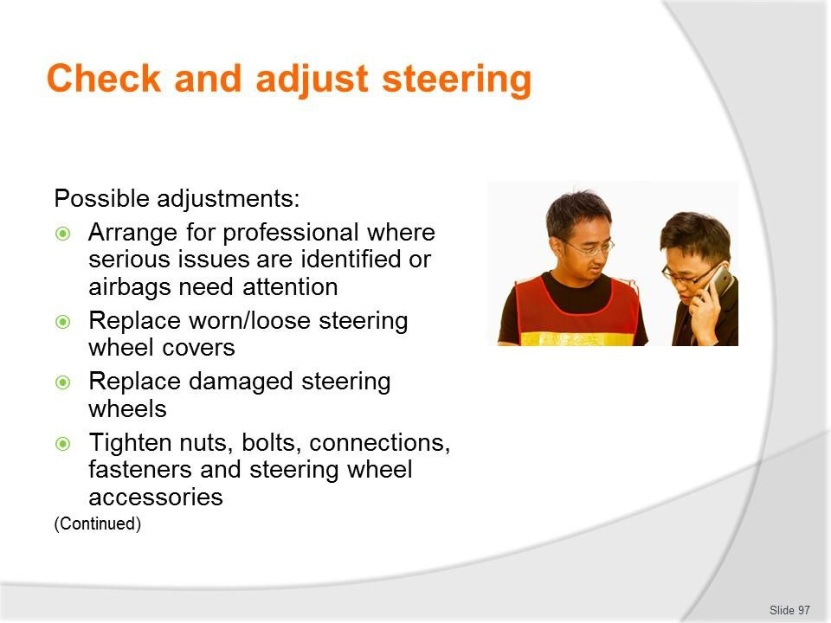
Slide No | Trainer Notes
97. | Trainer presents adjustments:  - Arrange for professional repairs to be made where serious issues are identified and/or where work involving airbags needs to be done  - Replace worn/loose steering wheel covers  - Replace damaged steering wheels  - Tighten nuts, bolts, connections, fasteners and steering wheel accessories.  Classroom Activity – Demonstration and Practical  Trainer shows students how to undertake activities listed on the slide and provides an opportunity for them to do the same.

Slide
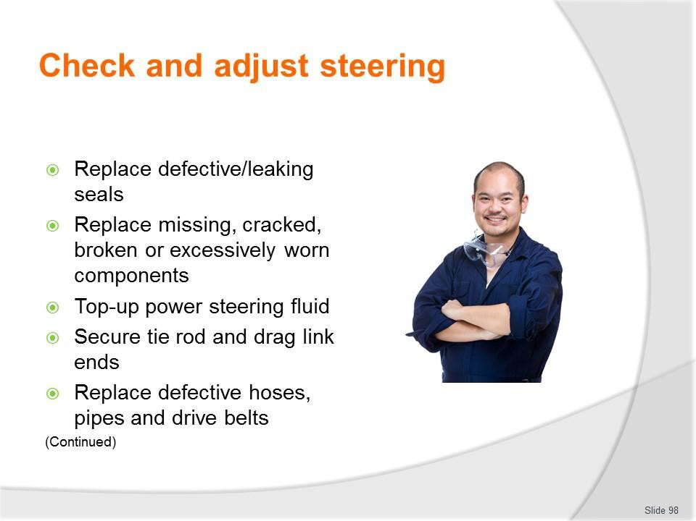
Slide No | Trainer Notes
98. | Trainer continues presenting adjustments:  - Replace defective/leaking seals  - Replace missing, cracked, broken or excessively worn components  - Top-up power steering fluid  - Secure tie rod and drag link ends where required  - Replace defective/damaged hoses, pipes and drive belts.  Classroom Activity – Demonstration and Practical  Trainer shows students how to undertake activities listed on the slide and provides an opportunity for them to do the same.

Slide
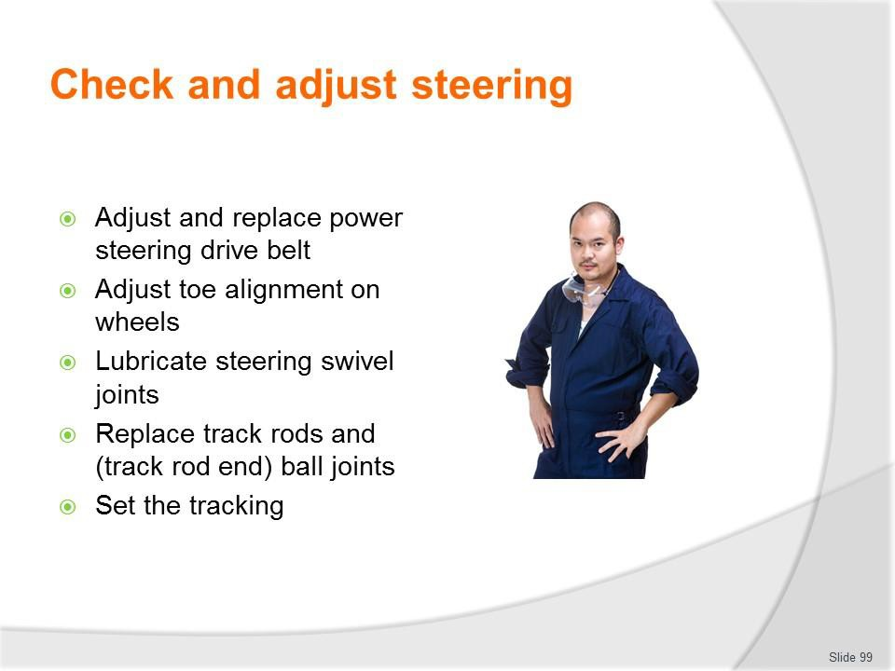
Slide No | Trainer Notes
99. | Trainer continues presenting adjustments:  - Adjust and replace power steering drive belt  - Adjust toe alignment on wheels  - Lubricate steering swivel joints  - Replace track rods and (track rod end) ball joints  - Set the tracking.  Classroom Activity – Demonstration and Practical  Trainer shows students how to undertake activities listed on the slide and provides an opportunity for them to do the same.

Slide
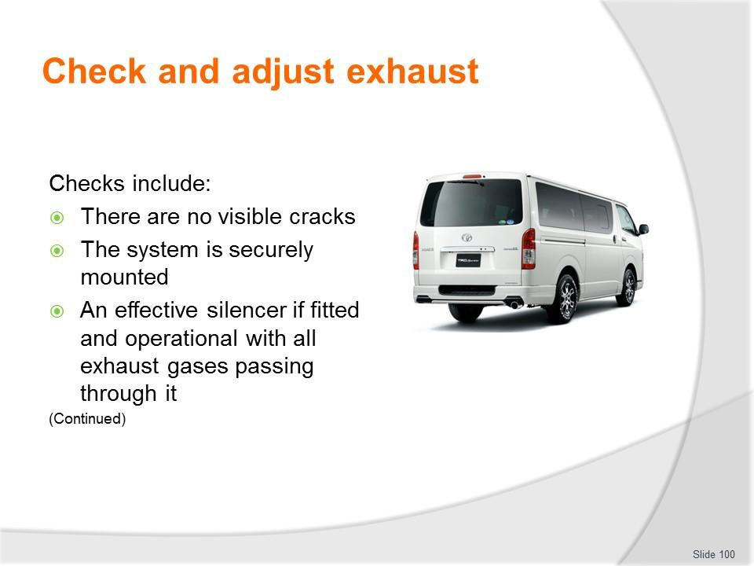
Slide No | Trainer Notes
100. | Trainer discusses exhaust checks:  - There are no visible cracks  - The system is securely mounted – across its entire length  - An effective silencer if fitted and operational with all exhaust gases passing through it – so vehicle noise is not excessive in accordance with local regulations/mandated noise levels.  Classroom Activity – Demonstration and Practical  Trainer shows students how to undertake activities listed on the slide and provides an opportunity for them to do the same.

Slide
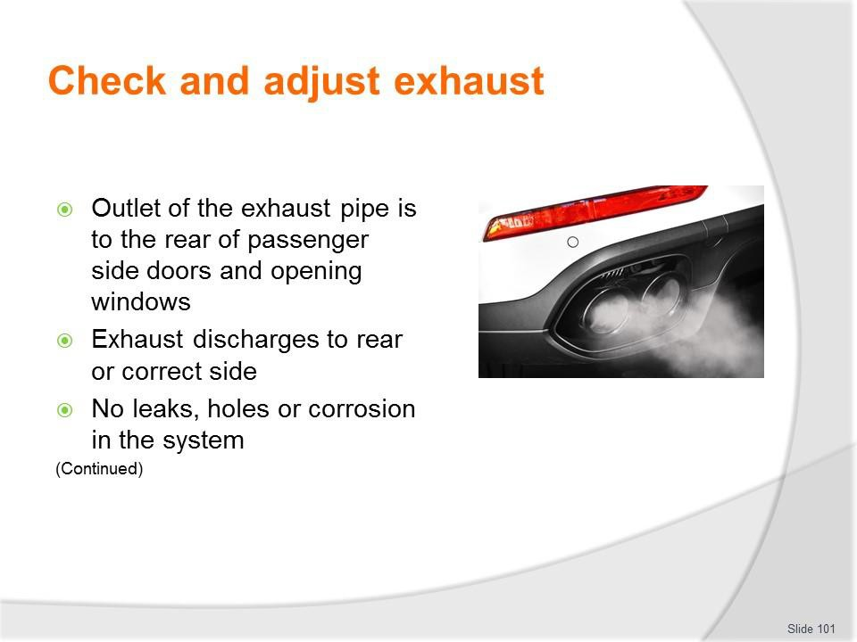
Slide No | Trainer Notes
101. | Trainer continues discussing exhaust checks:  - Outlet of the exhaust pipe is to the rear of passenger side doors and opening windows  - Exhaust discharges:  - Rear of vehicle  - To the correct side of the vehicle (left or right) depending on which side of the road the vehicle is driven on – fumes/exhaust must not be directed at footpath- side  - No leaks, holes or corrosion in the system – apart from intentional drain holes provided by manufacturers in mufflers.  Classroom Activity – Demonstration and Practical  Trainer shows students how to undertake activities listed on the slide and provides an opportunity for them to do the same.

Slide
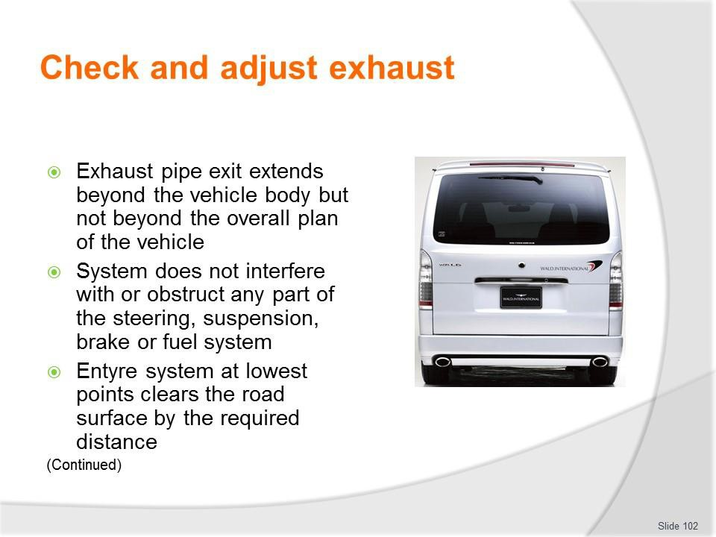
Slide No | Trainer Notes
102. | Trainer continues discussing exhaust checks:  - The exhaust pipe exit extends beyond the vehicle body but not beyond the overall plan of the vehicle – so the pipe does not end under the body but extends to under the rear bumper bar  - The system does not interfere with or obstruct any part of the steering, suspension, brake or fuel system  - The entire system at its lowest points clears the road surface by the required distance – for example, 100 mm.  Classroom Activity – Demonstration and Practical  Trainer shows students how to undertake activities listed on the slide and provides an opportunity for them to do the same.

Slide
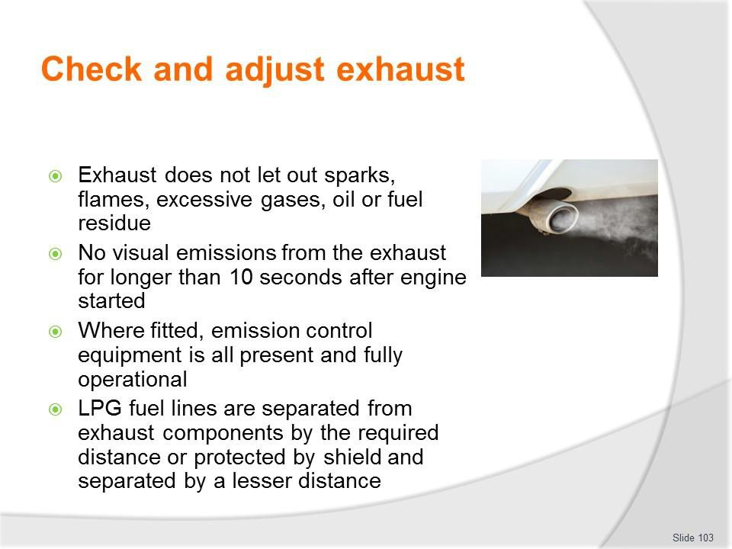
Slide No | Trainer Notes
103. | Trainer continues discussing exhaust checks:  - The exhaust does not let out sparks, flames, excessive gases, oil or fuel residue  - No visual emissions from the exhaust for longer than 10 seconds after the engine has been started  - Where fitted, emission control equipment is all present and fully operational  - LPG fuel lines are separated from exhaust components by the required distance (say 150 mm) and/or protected by a shield and separated by a lesser distance, say 50 mm.  Classroom Activity (1) – Demonstration and Practical  Trainer shows students how to undertake activities listed on the slide and provides an opportunity for them to do the same.  Classroom Activity (2) – internet Research  Trainer facilitates research and discussion of page 6 of: https://www.vicroads.vic.gov.au/searchresultpage?q=toadworthiness%20requirements

Slide
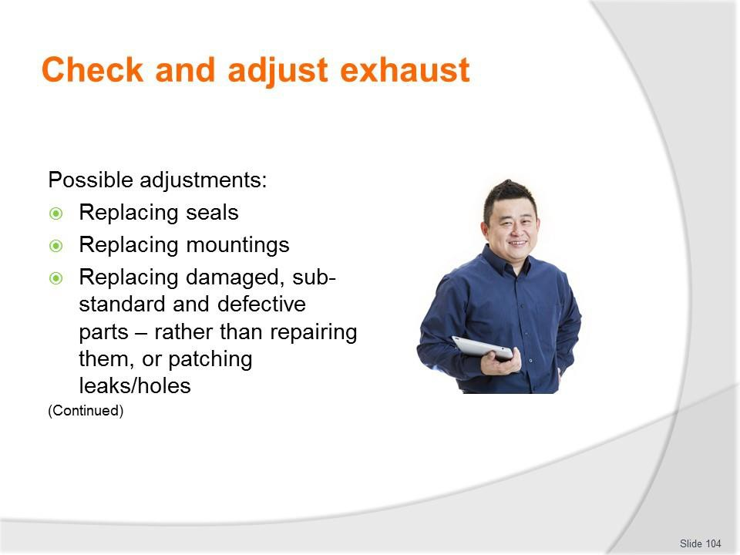
Slide No | Trainer Notes
104. | Trainer presents possible adjustments:  - Replacing seals  - Replacing mountings  - Replacing damaged, sub-standard and defective parts – rather than repairing them, or patching leaks/holes.  Classroom Activity – Demonstration and Practical  Trainer shows students how to undertake activities listed on the slide and provides an opportunity for them to do the same.

Slide
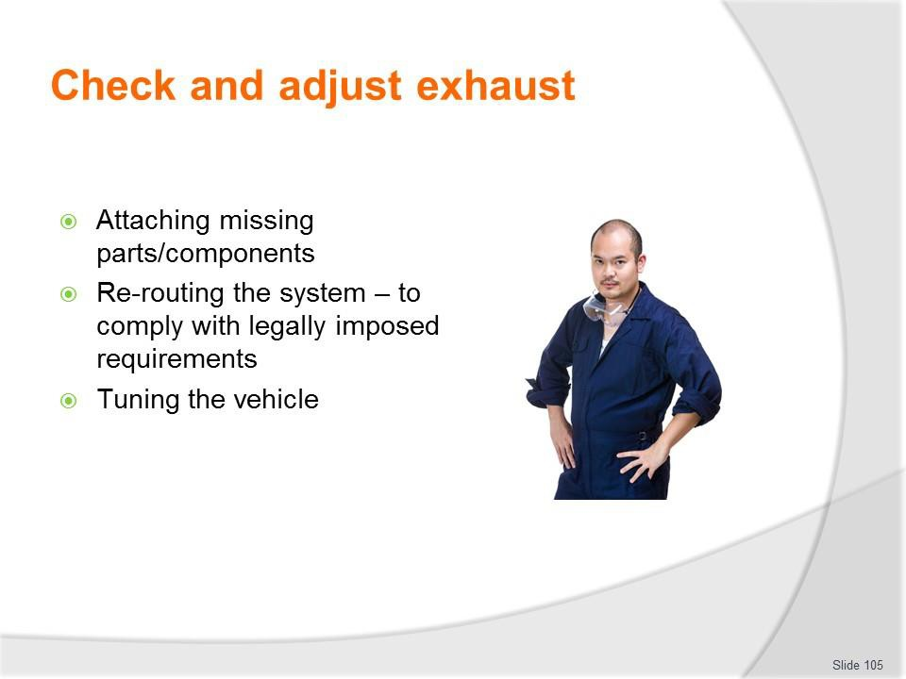
Slide No | Trainer Notes
105. | Trainer continues presenting possible adjustments:  - Attaching missing parts/components  - Re-routing the system – to comply with legally imposed requirements  - Tuning the vehicle.  Classroom Activity – Demonstration and Practical  Trainer shows students how to undertake activities listed on the slide and provides an opportunity for them to do the same.

Slide
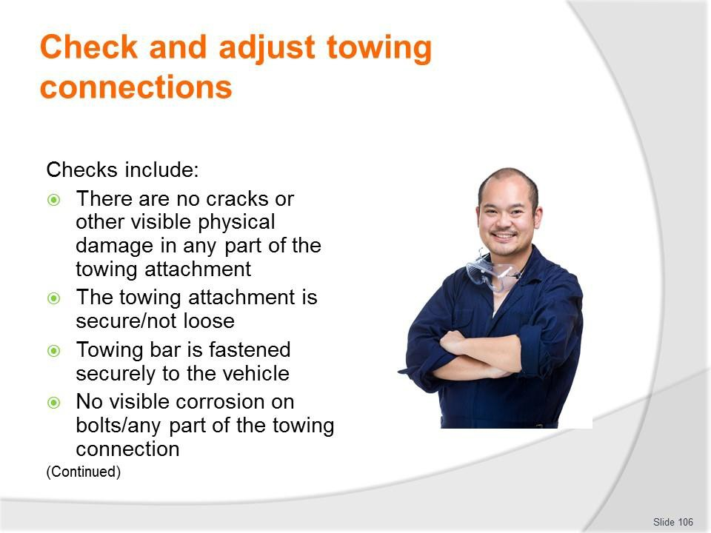
Slide No | Trainer Notes
106. | Trainer discusses towing connection checks:  - There are no cracks or other visible physical damage in any part of the towing attachment  - The towing attachment is secure/not loose  - Towing bar is fastened securely to the vehicle  - No visible corrosion on bolts/any part of the towing connection.  Classroom Activity – Demonstration and Practical  Trainer shows students how to undertake activities listed on the slide and provides an opportunity for them to do the same.

Slide
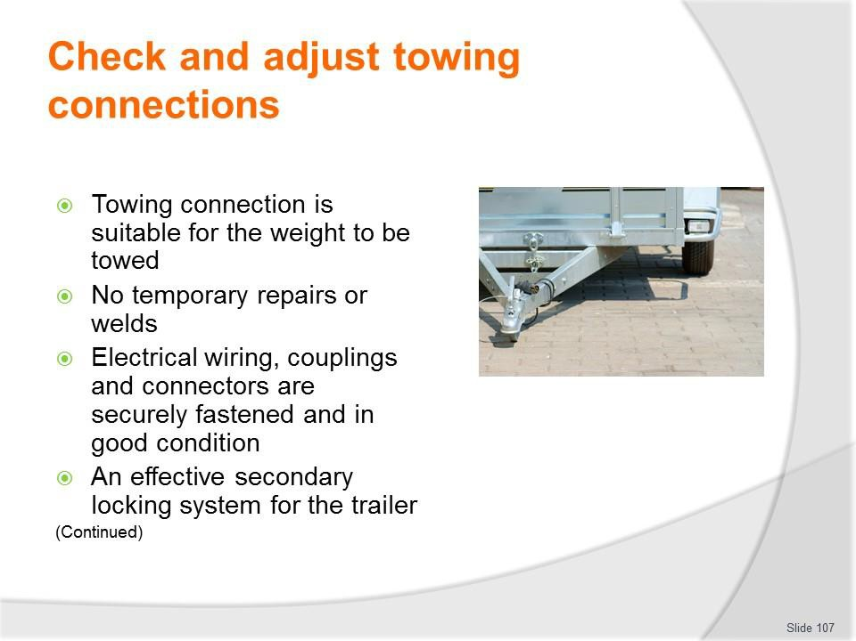
Slide No | Trainer Notes
107. | Trainer continues discussing towing connection checks:  - Towing connection is suitable for the weight to be towed – and the vehicle displays (where and as required) an appropriate label to this effect  - No temporary repairs or welds (especially where drawbar is marked ‘Do Not Weld’ by the manufacturer) have been made to the connection  - Electrical wiring, couplings and connectors are securely fastened and in good condition  - An effective secondary locking system for the trailer.  Classroom Activity – Demonstration and Practical  Trainer shows students how to undertake activities listed on the slide and provides an opportunity for them to do the same.

Slide
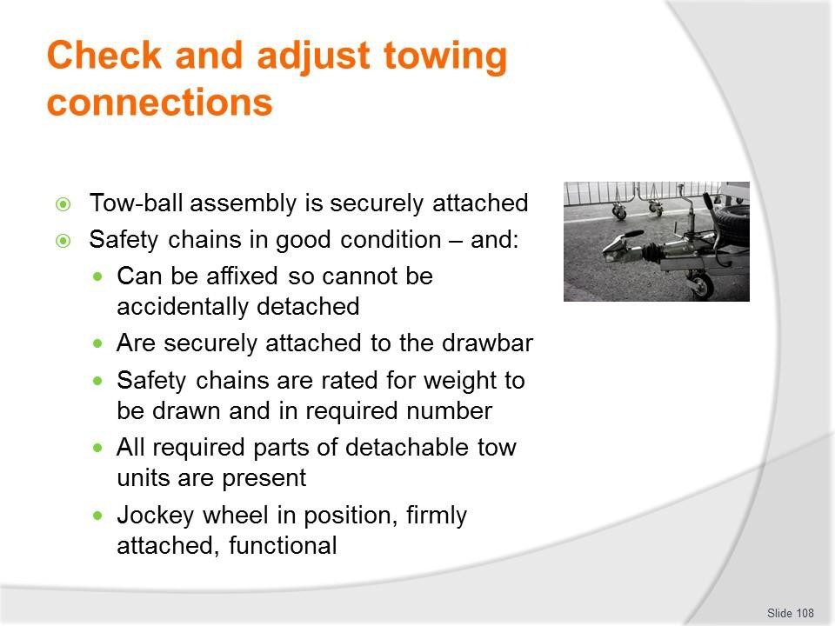
Slide No | Trainer Notes
108. | Trainer continues discussing towing connection checks:  - Tow-ball assembly is securely attached  - Safety chains and/or cables are in good condition – and:  - Can be affixed so they cannot be accidentally detached  - Are securely attached to the drawbar  - Safety chains are rated for the weight to be drawn – and in the required number  - All required parts of detachable tow units are in position/present in the assembly  - Jockey wheel is in position, firmly attached and fully functional.  Classroom Activity – Demonstration and Practical  Trainer shows students how to undertake activities listed on the slide and provides an opportunity for them to do the same.

Slide
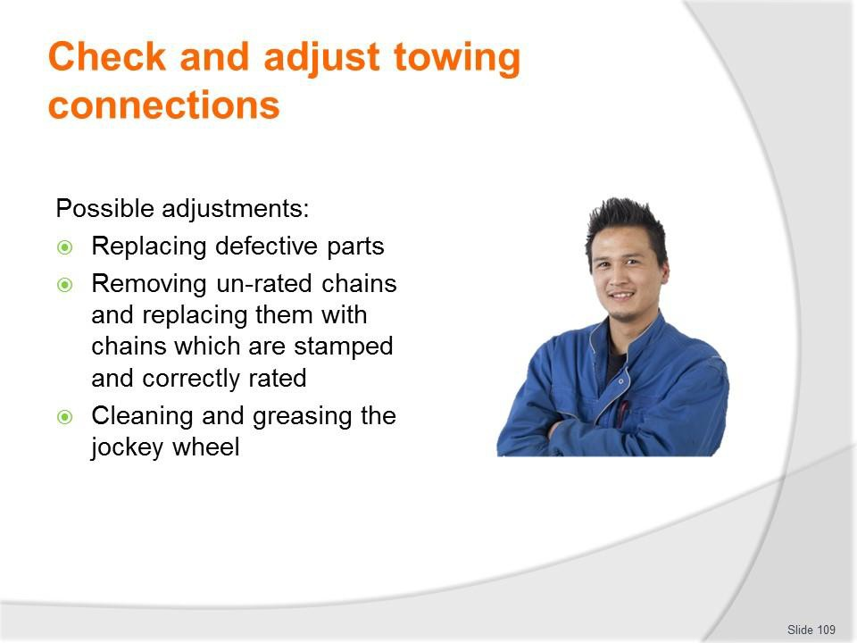
Slide No | Trainer Notes
109. | Trainer presents possible adjustments:  - Replacing defective parts – rather than repairing them  - Removing un-rated chains and replacing them with chains which are stamped and correctly rated – for the intended towing weight  - Cleaning and greasing the jockey wheel.  Classroom Activity – Demonstration and Practical  Trainer shows students how to undertake activities listed on the slide and provides an opportunity for them to do the same.

Slide
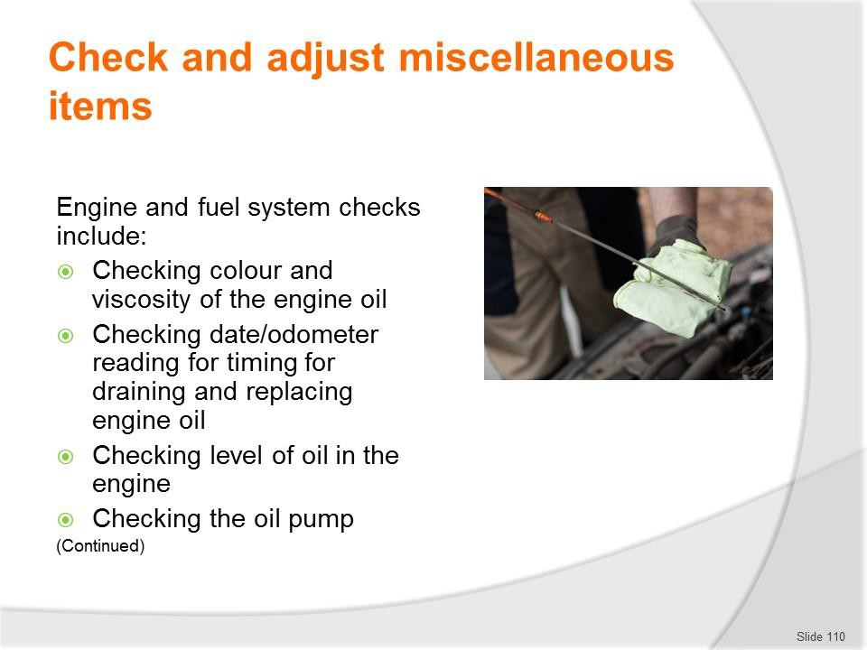
Slide No | Trainer Notes
110. | Trainer discusses engine and fuel system checks:  - Checking condition (colour and viscosity) of the engine oil  - Checking date/odometer reading for timing for draining and replacing engine oil  - Checking level of oil in the engine  - Checking the oil pump.

Slide
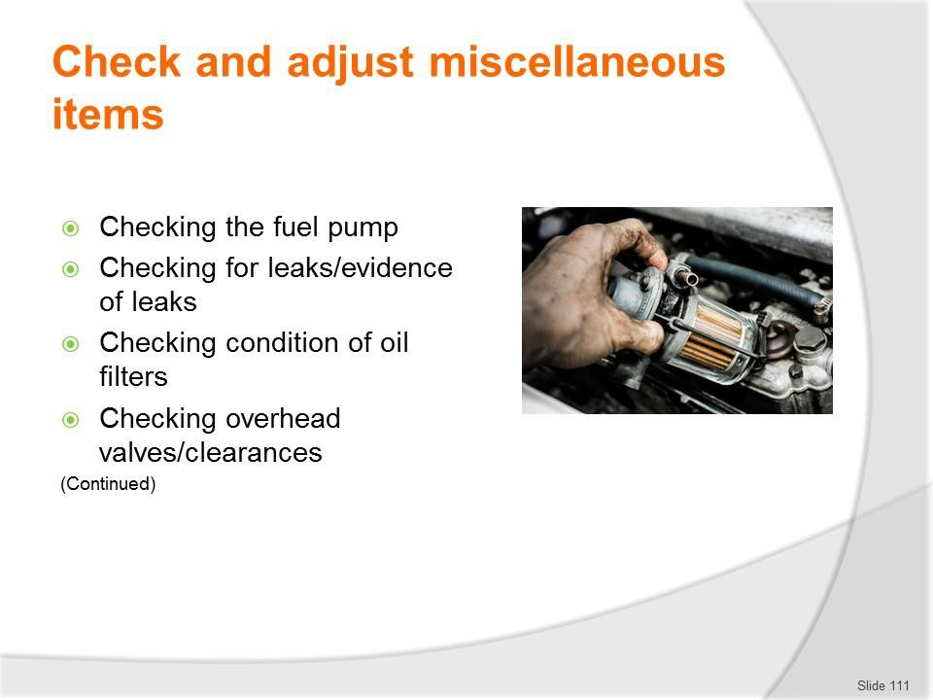
Slide No | Trainer Notes
111. | Trainer continues discussing engine and fuel system checks:  - Checking the fuel pump  - Checking for leaks/evidence of leaks  - Checking condition of oil filters  - Checking overhead valves/clearances.  Classroom Activity – Demonstration and Practical  Trainer shows students how to undertake activities listed on the slide and provides an opportunity for them to do the same.

Slide
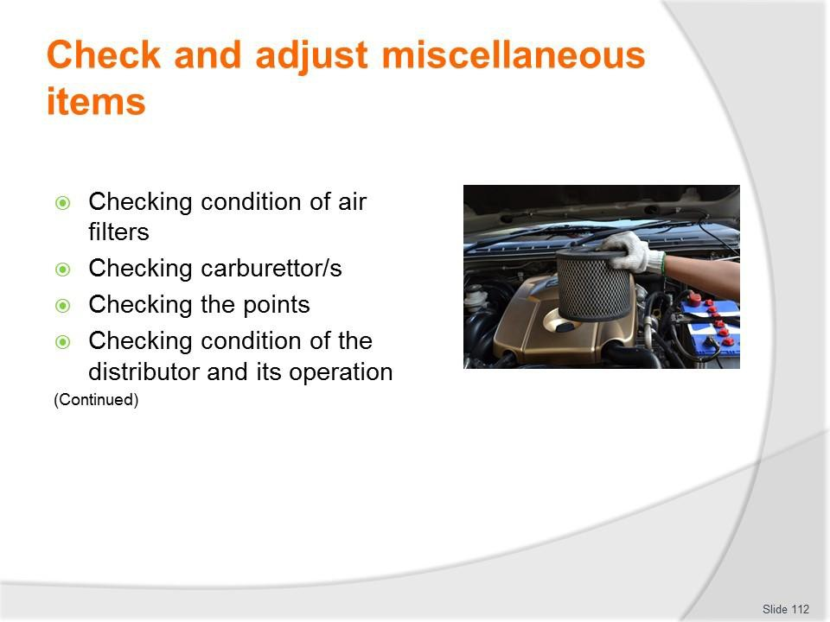
Slide No | Trainer Notes
112. | Trainer continues discussing engine and fuel system checks:  - Checking condition of air filters  - Checking carburettor/s  - Checking the points  - Checking condition of the distributor and its operation.  Classroom Activity – Demonstration and Practical  Trainer shows students how to undertake activities listed on the slide and provides an opportunity for them to do the same.

Slide
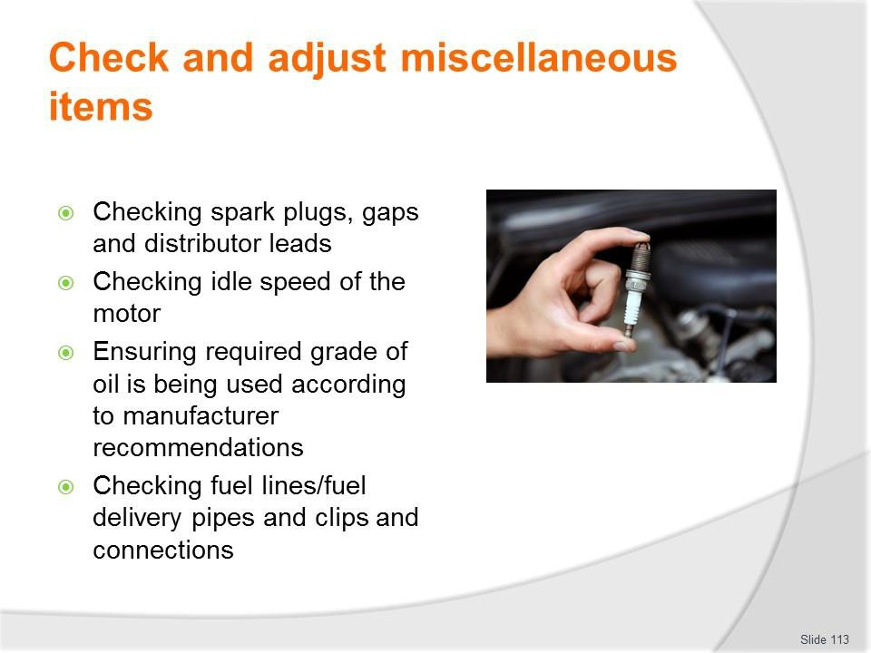
Slide No | Trainer Notes
113. | Trainer continues discussing engine and fuel system checks:  - Checking spark plugs, gaps and distributor leads  - Checking idle speed of the motor  - Ensuring required grade of oil is being used according to manufacturer recommendations (who usually provide a chart for determining the grade of oil to use under different conditions) and intended use of the vehicle:  - SAE 10 is thin  - SAE is thick  - Some are blended/multi-grade: such as 20W/50  - Checking fuel lines/fuel delivery pipes and clips and connections.  Classroom Activity (1) – Demonstration and Practical  Trainer shows students how to undertake activities listed on the slide and provides an opportunity for them to do the same.  Classroom Activity (2) – internet Research  Trainer facilitates research and discussion of: http://www.nairaland.com/1054692/knowledge-101-which-engine-oil

Slide
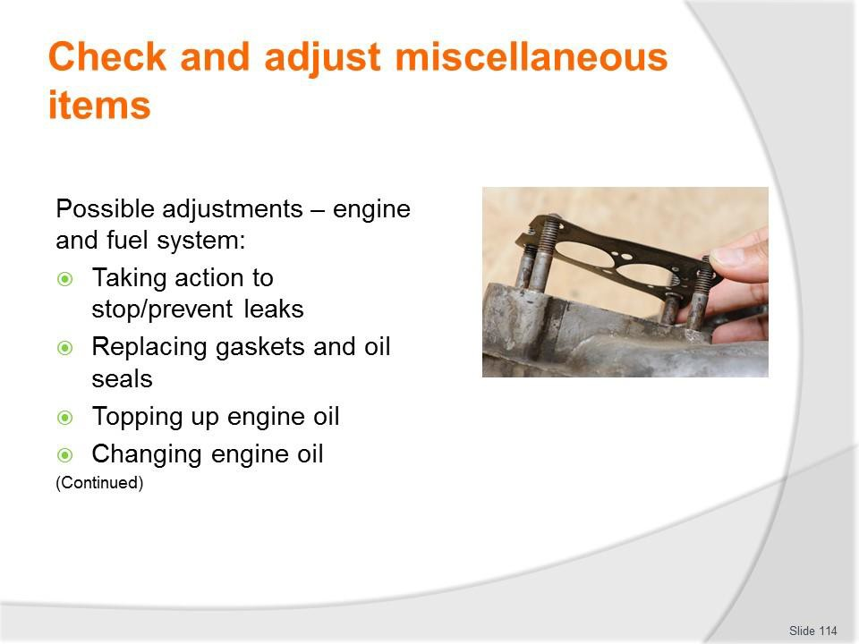
Slide No | Trainer Notes
114. | Trainer presents possible adjustments:  - Taking action to stop/prevent leaks  - Replacing gaskets and oil seals  - Topping up engine oil  - Changing engine oil.  Classroom Activity – Demonstration and Practical  Trainer shows students how to undertake activities listed on the slide and provides an opportunity for them to do the same.

Slide
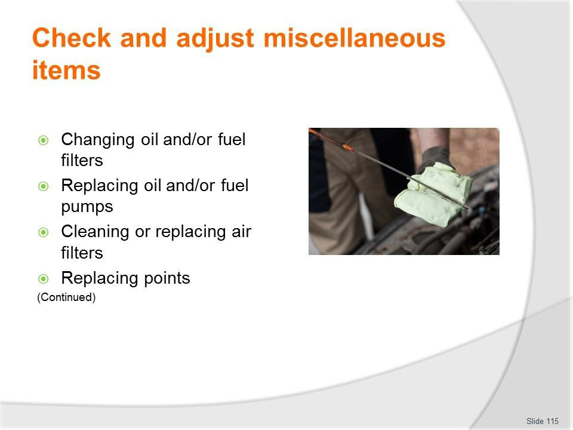
Slide No | Trainer Notes
115. | Trainer continues presenting possible adjustments:  - Changing oil and/or fuel filters  - Replacing oil and/or fuel pumps  - Cleaning or replacing air filters  - Replacing points.  Classroom Activity – Demonstration and Practical  Trainer shows students how to undertake activities listed on the slide and provides an opportunity for them to do the same.

Slide
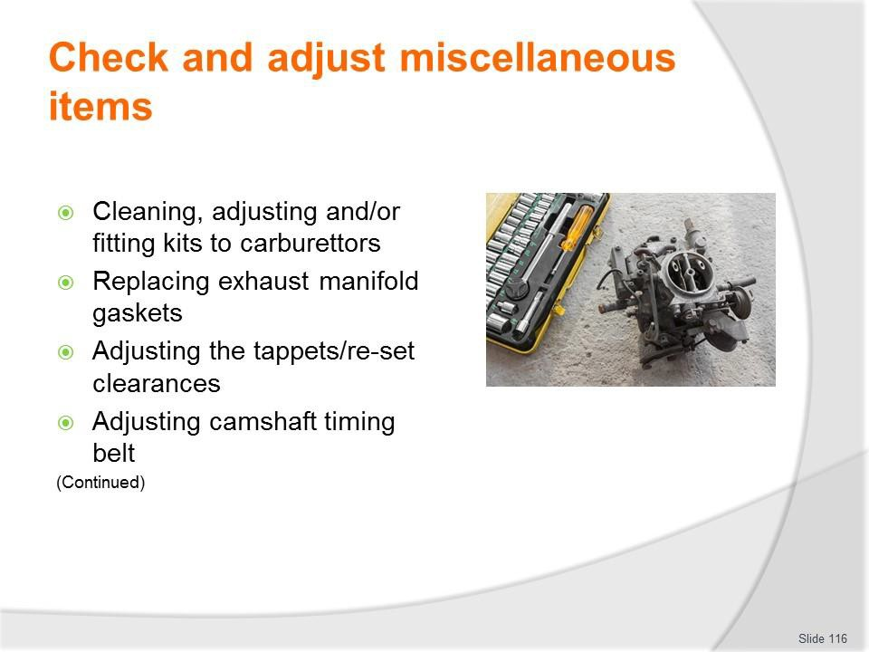
Slide No | Trainer Notes
116. | Trainer continues presenting possible adjustments:  - Cleaning, adjusting and/or fitting kits to carburettors  - Replacing exhaust manifold gaskets  - Adjusting the tappets/re-set clearances  - Adjusting camshaft timing belt.  Classroom Activity – Demonstration and Practical  Trainer shows students how to undertake activities listed on the slide and provides an opportunity for them to do the same.

Slide
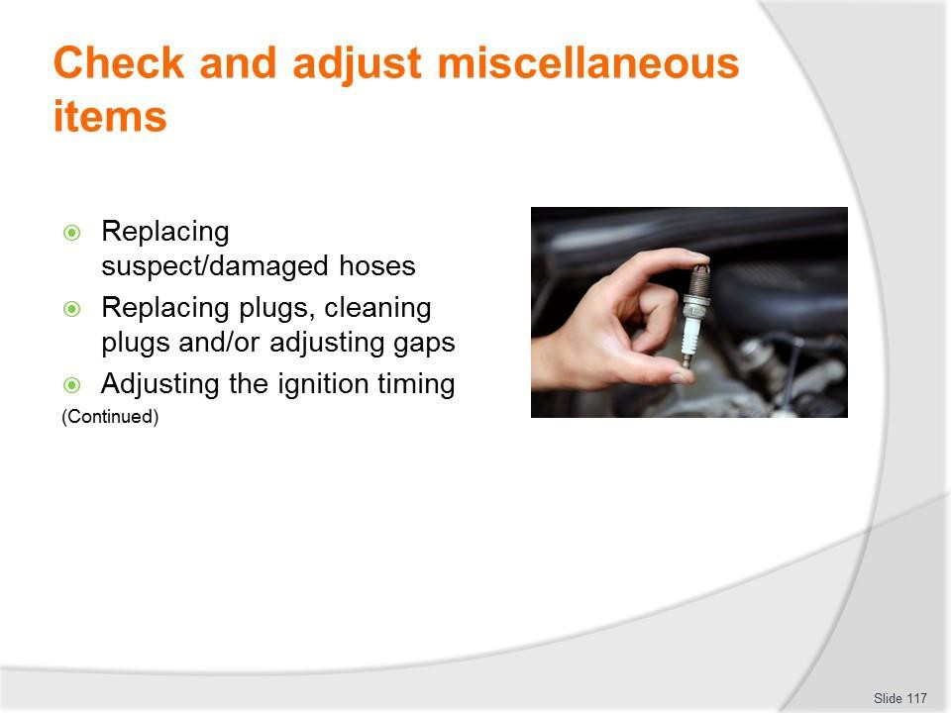
Slide No | Trainer Notes
117. | Trainer continues presenting possible adjustments:  - Replacing suspect/damaged hoses  - Replacing plugs, cleaning plugs and/or adjusting gaps  - Adjusting the ignition timing.  Classroom Activity – Demonstration and Practical  Trainer shows students how to undertake activities listed on the slide and provides an opportunity for them to do the same.

Slide
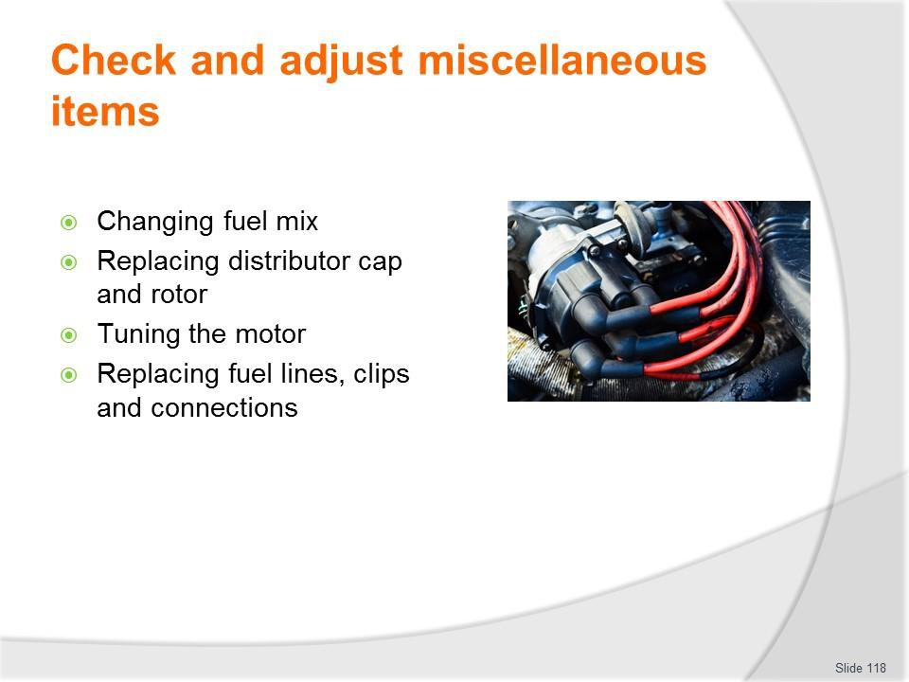
Slide No | Trainer Notes
118. | Trainer continues presenting possible adjustments:  - Changing fuel mix  - Replacing distributor cap and rotor  - Tuning the motor  - Replacing fuel lines, clips and connections.  Classroom Activity – Demonstration and Practical  Trainer shows students how to undertake activities listed on the slide and provides an opportunity for them to do the same.

Slide
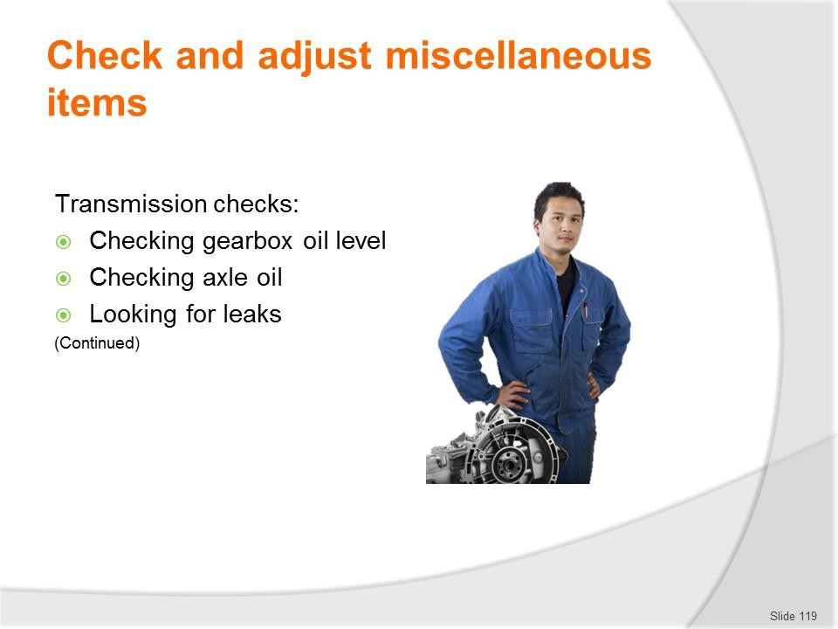
Slide No | Trainer Notes
119. | Trainer discusses transmission checks:  - Checking gearbox oil level  - Checking axle oil  - Looking for leaks.  Classroom Activity – Demonstration and Practical  Trainer shows students how to undertake activities listed on the slide and provides an opportunity for them to do the same.

Slide
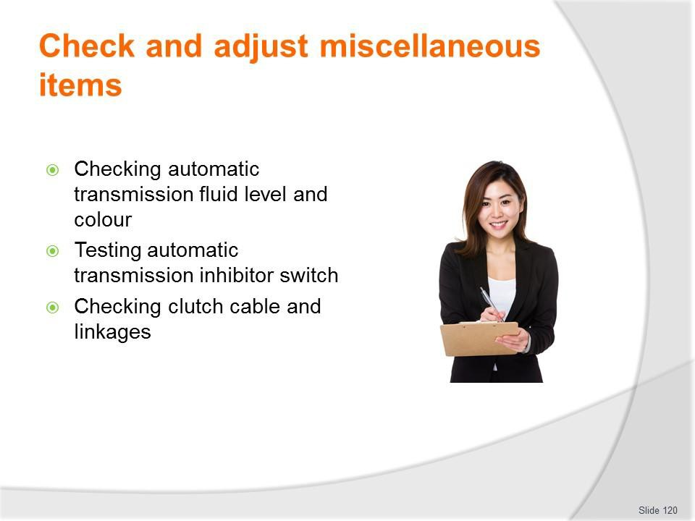
Slide No | Trainer Notes
120. | Trainer continues discussing transmission checks:  - Checking automatic transmission fluid level and colour  - Testing automatic transmission inhibitor switch  - Checking clutch cable and linkages.  Classroom Activity – Demonstration and Practical  Trainer shows students how to undertake activities listed on the slide and provides an opportunity for them to do the same.

Slide
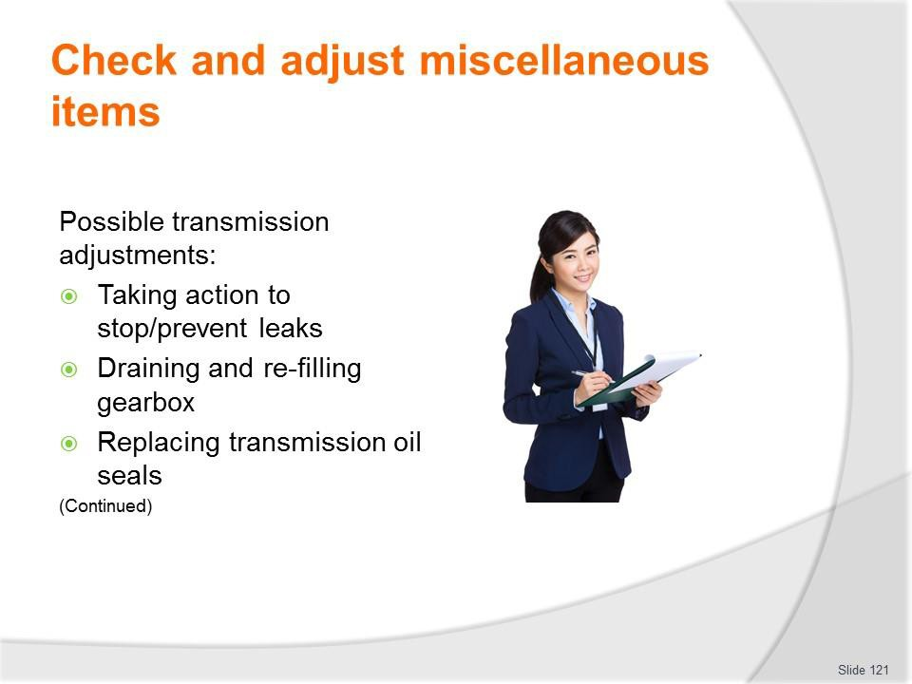
Slide No | Trainer Notes
121. | Trainer presents adjustments to transmissions:  - Taking action to stop/prevent leaks  - Draining and re-filling gearbox  - Replacing transmission oil seals.  Classroom Activity – Demonstration and Practical  Trainer shows students how to undertake activities listed on the slide and provides an opportunity for them to do the same.

Slide
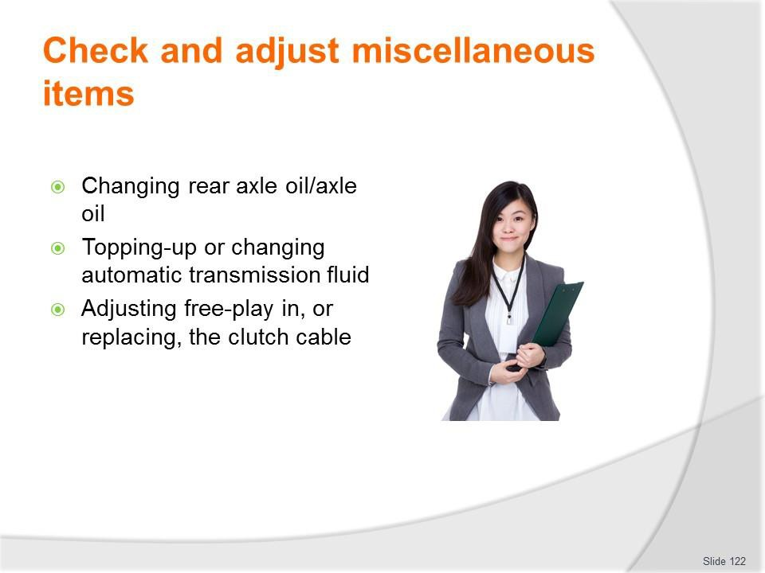
Slide No | Trainer Notes
122. | Trainer continues presenting adjustments to transmissions:  - Changing rear axle oil/axle oil  - Topping-up or changing automatic transmission fluid  - Adjusting free-play in, or replacing, the clutch cable.  Classroom Activity – Demonstration and Practical  Trainer shows students how to undertake activities listed on the slide and provides an opportunity for them to do the same.

Slide
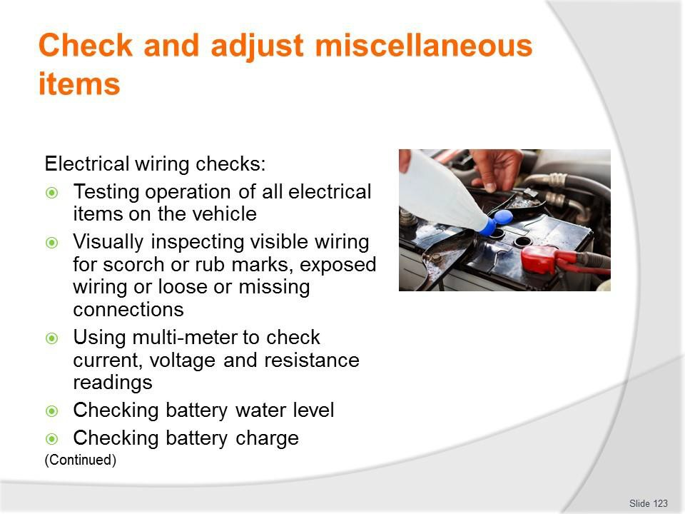
Slide No | Trainer Notes
123. | Trainer discusses electrical wiring checks:  - Testing operation of all electrical items on the vehicle  - Visually inspecting all visible wiring looking for scorch or rub marks, exposed wiring or loose or missing connections  - Using multi-meter to check current, voltage and resistance readings  - Checking battery water level  - Checking battery charge.  Classroom Activity – Demonstration and Practical  Trainer shows students how to undertake activities listed on the slide and provides an opportunity for them to do the same.

Slide
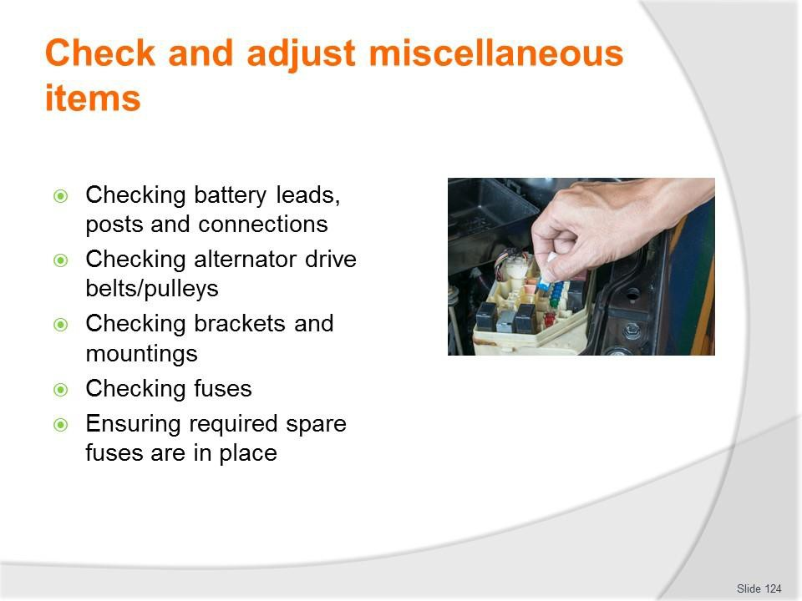
Slide No | Trainer Notes
124. | Trainer continues discussing electrical wiring checks:  - Checking battery leads, posts and connections  - Checking alternator drive belts/pulleys  - Checking brackets and mountings  - Checking fuses  - Ensuring required spare fuses are in place.  Classroom Activity – Demonstration and Practical  Trainer shows students how to undertake activities listed on the slide and provides an opportunity for them to do the same.

Slide
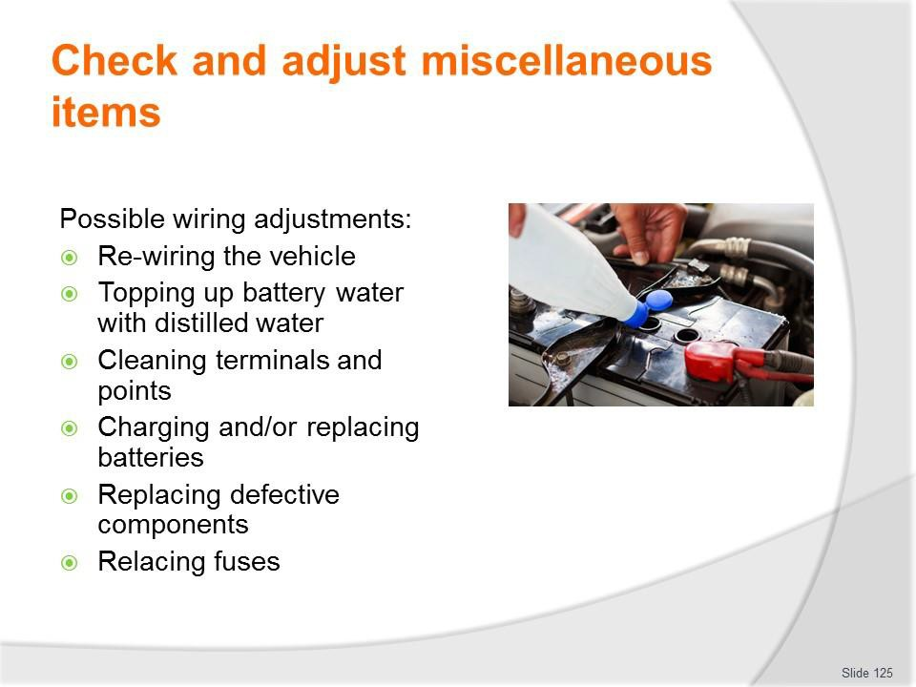
Slide No | Trainer Notes
125. | Trainer presents electrical wiring adjustments:  - Re-wiring the vehicle  - Topping up battery water with distilled water  - Cleaning terminals and points  - Charging and/or replacing batteries  - Replacing defective components  - Relacing fuses.  Classroom Activity – Demonstration and Practical  Trainer shows students how to undertake activities listed on the slide and provides an opportunity for them to do the same.

Slide
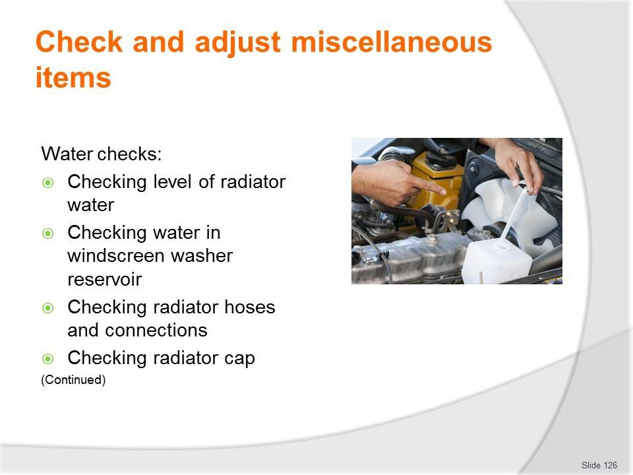
Slide No | Trainer Notes
126. | Trainer discusses water checks:  - Checking level of radiator water  - Checking water in windscreen washer reservoir  - Checking radiator hoses and connections  - Checking radiator cap.  Classroom Activity – Demonstration and Practical  Trainer shows students how to undertake activities listed on the slide and provides an opportunity for them to do the same.

Slide
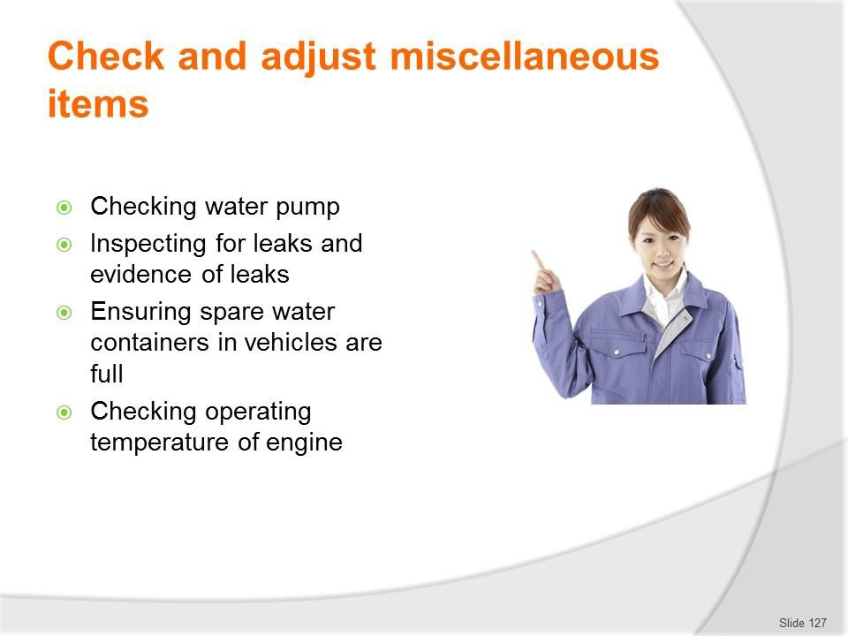
Slide No | Trainer Notes
127. | Trainer continues discussing water checks:  - Checking water pump  - Inspecting for leaks and evidence of leaks  - Ensuring spare water containers in vehicles are full  - Checking operating temperature of engine.  Classroom Activity – Demonstration and Practical  Trainer shows students how to undertake activities listed on the slide and provides an opportunity for them to do the same.

Slide
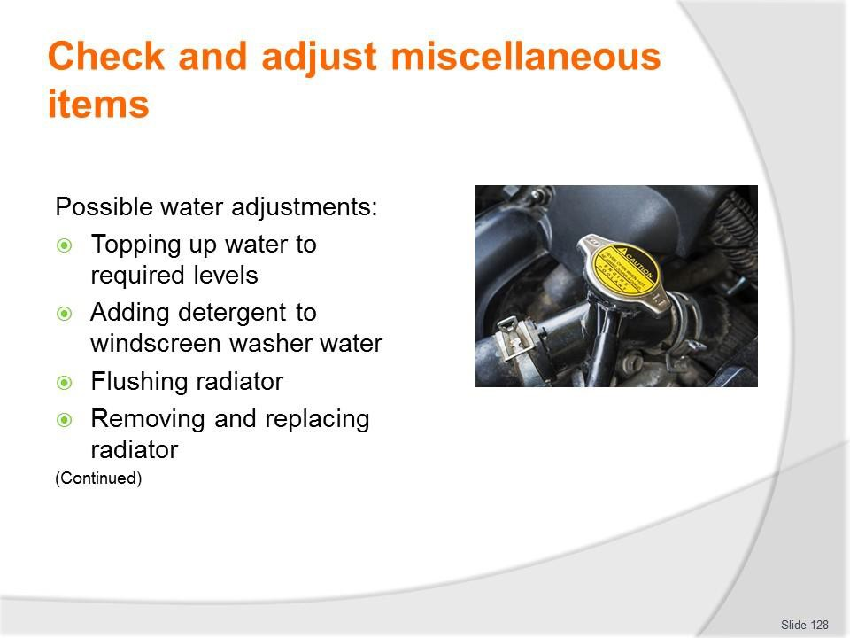
Slide No | Trainer Notes
128. | Trainer presents water adjustments:  - Topping up water to required levels  - Adding detergent to windscreen washer water  - Flushing radiator  - Removing and replacing radiator.  Classroom Activity – Demonstration and Practical  Trainer shows students how to undertake activities listed on the slide and provides an opportunity for them to do the same.

Slide
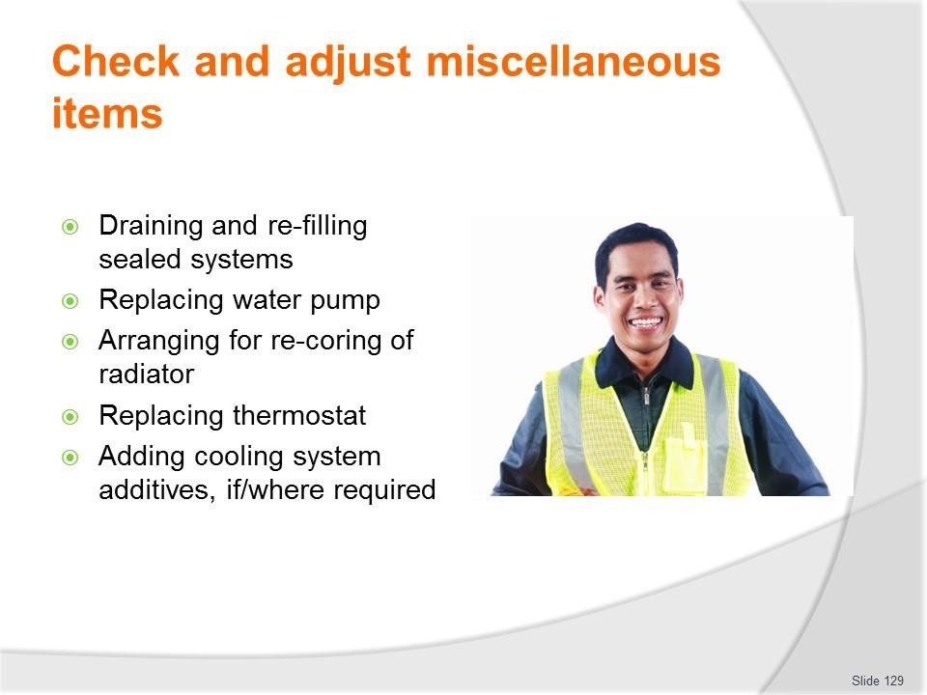
Slide No | Trainer Notes
129. | Trainer continues presenting water adjustments:  - Draining and re-filling sealed systems  - Replacing water pump  - Arranging for re-coring of radiator  - Replacing thermostat  - Adding cooling system additives, if/where required.  Classroom Activity – Demonstration and Practical  Trainer shows students how to undertake activities listed on the slide and provides an opportunity for them to do the same.

Slide
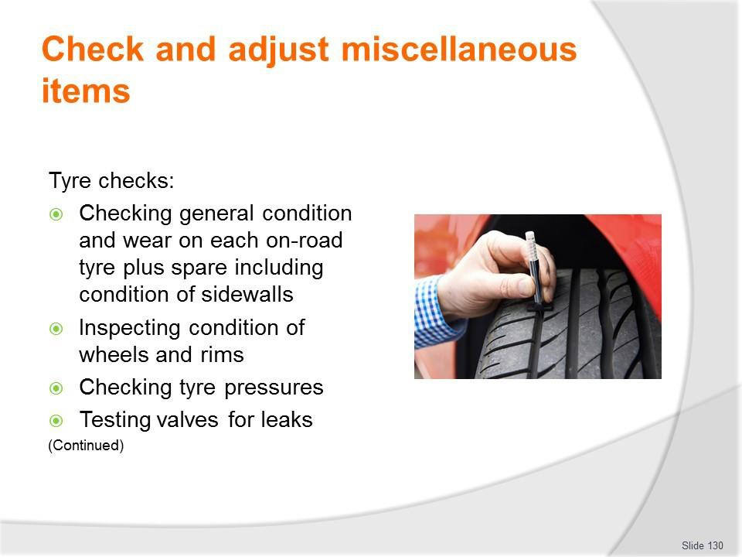
Slide No | Trainer Notes
130. | Trainer discusses tyre checks:  - Checking general condition and wear on each on-road tyre plus the spare tyre, including condition of sidewalls  - Inspecting condition of wheels and rims  - Checking tyre pressures  - Testing valves for leaks.  Classroom Activity (1) – Demonstration and Practical  Trainer shows students how to undertake activities listed on the slide and provides an opportunity for them to do the same.  Classroom Activity (2) – internet Research  Trainer facilitates research and discussion of:  http://www.howacarworks.com/wheels-and-tyres/avoiding-tyre-wear - Avoiding tyre wear

Slide
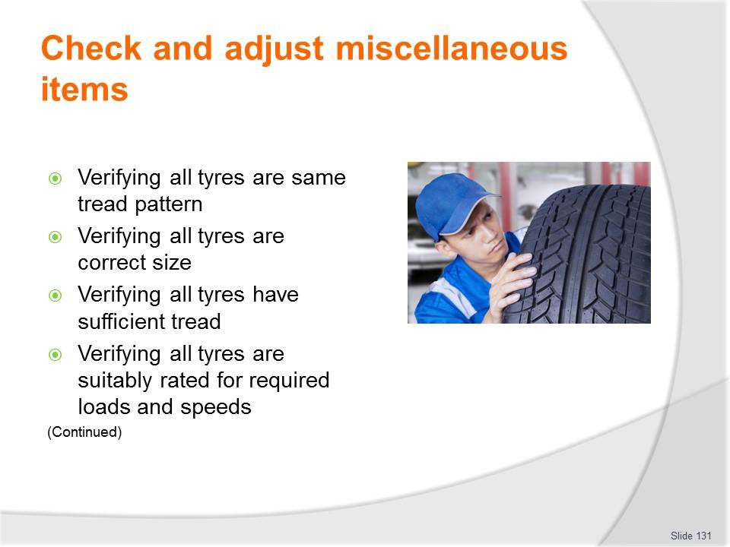
Slide No | Trainer Notes
131. | Trainer continues discussing tyre checks:  - Verifying all tyres are of the same tread pattern  - Verifying all tyres are the correct size  - Verifying all tyres have sufficient tread  - Verifying all tyres are suitably rated for required loads and speeds – according to tyre manufacturer charts.  Classroom Activity – Demonstration and Practical  Trainer shows students how to undertake activities listed on the slide and provides an opportunity for them to do the same.

Slide
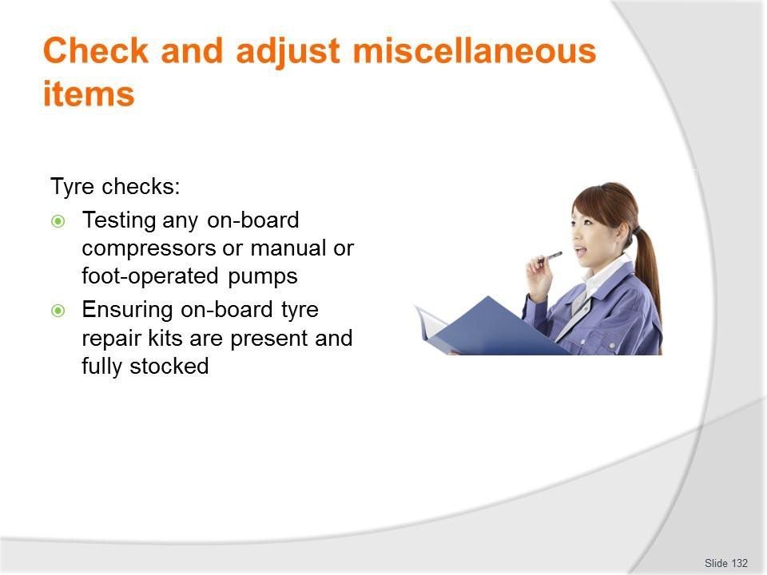
Slide No | Trainer Notes
132. | Trainer continues discussing tyre checks:  - Testing any on-board compressors or manual or foot-operated pumps loaded onto tour vehicles – to:  - Verify proper operation  - Compare pressure shown on gauges against pressure shown on workshop tyre pressure gauge  - Ensuring on-board tyre repair kits are present and fully stocked.  Classroom Activity – Demonstration and Practical  Trainer shows students how to undertake activities listed on the slide and provides an opportunity for them to do the same.

Slide
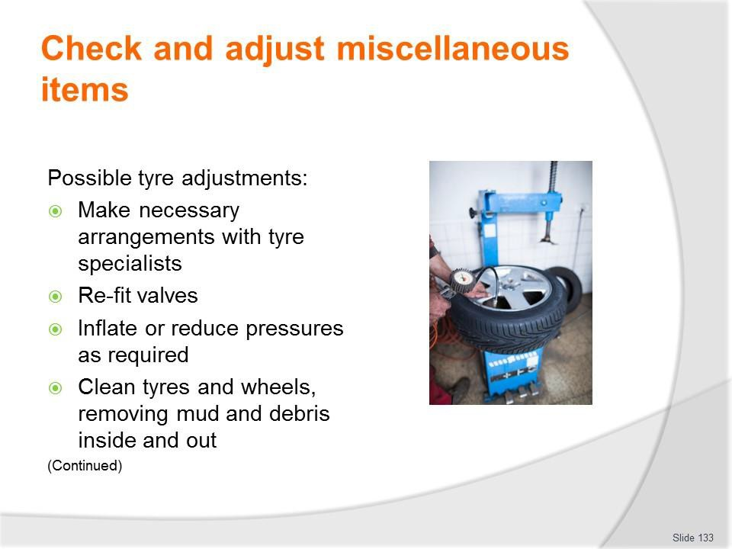
Slide No | Trainer Notes
133. | Trainer presents tyre adjustments:  - Make arrangements for qualified tyre specialists to:  - Do wheel alignment  - Do wheel balancing  - Fit new tyres and wheels  - Repair punctures/leaks  - Re-fit valves  - Inflate or reduce pressures as required  - Clean tyres and wheels, removing mud and debris inside and out.  Classroom Activity – Demonstration and Practical  Trainer shows students how to undertake activities listed on the slide and provides an opportunity for them to do the same.

Slide
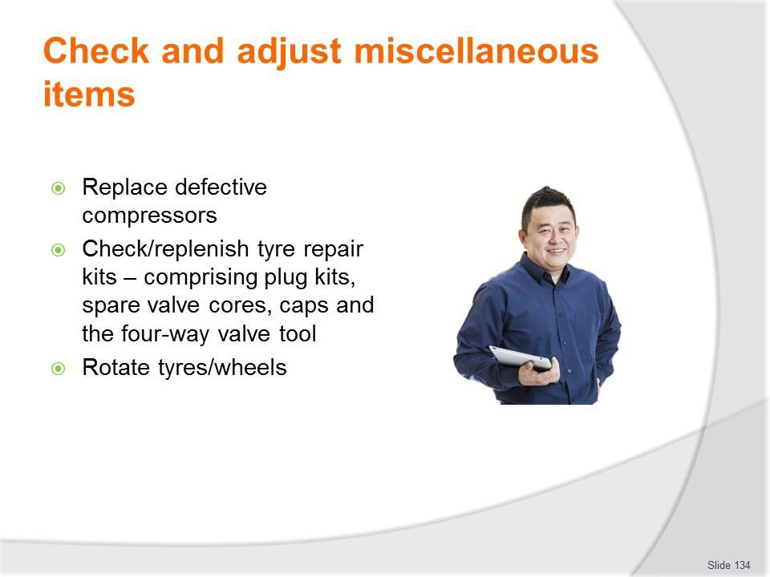
Slide No | Trainer Notes
134. | Trainer continues presenting tyre adjustments:  - Replace defective compressors  - Check/replenish tyre repair kits – comprising plug kits, spare valve cores, caps and the four-way valve tool  - Rotate tyres/wheels.  Classroom Activity – Demonstration and Practical  Trainer shows students how to undertake activities listed on the slide and provides an opportunity for them to do the same.

Slide
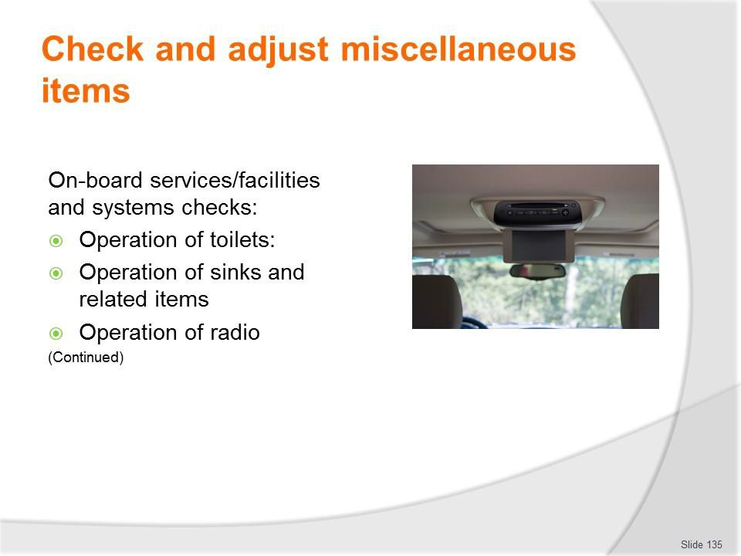
Slide No | Trainer Notes
135. | Trainer discusses on-board services/facilities and systems checks:  - Physically checking operation of toilets – Including:  - Operation of seat cover  - Operation of door and locking mechanism  - Physically checking operation of sinks – Including:  - Operation of hot water heater  - Operation of hot and cold water and taps  - Operation of plugs and drainage  - Operation of hand drying facilities  - Operation of soap dispenser  - Physically checking operation of the radio – including:  - Operation of station selection and AM/FM selector  - Operation of volume and other controls  - Visual displays  - Condition of speakers – with attention to physical damage and clarity of sound  - Condition of the aerial.

Classroom Activity – Demonstration and Practical
Trainer shows students how to undertake activities listed on the slide and provides an opportunity for them to do the same.

Slide
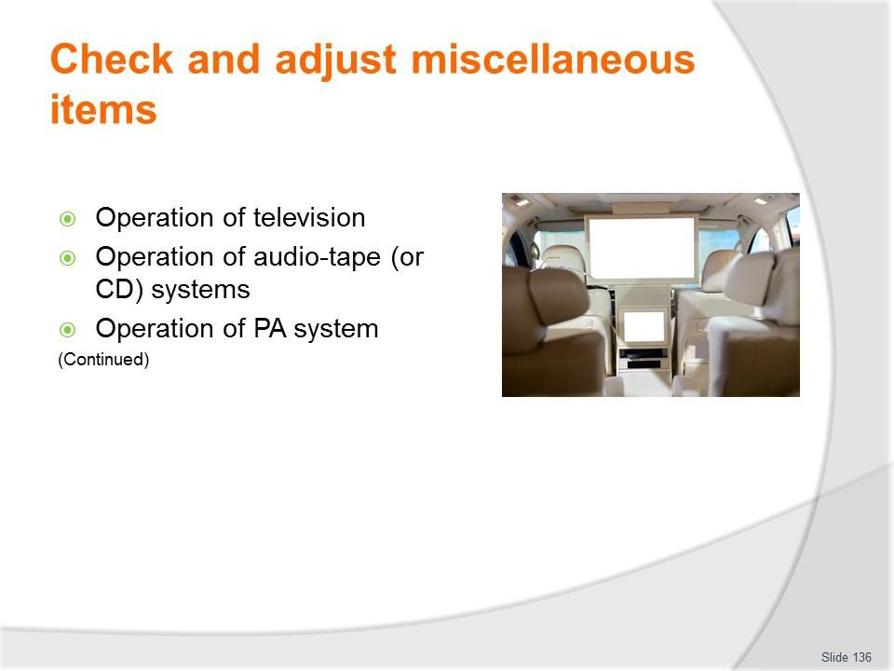
Slide No | Trainer Notes
136. | Trainer continues discussing on-board services/facilities and systems checks:  - Physically checking operation of television – including:  - Operation of channel selection  - Operation of volume controls  - Condition of speakers – with attention to physical damage and clarity of sound  - Clarity of picture  - Operation of DVD facility  - Operation of remote control unit  - Visual displays  - Condition of the antenna  - Physically checking operation of audio-tape systems – including:  - Operation of volume and other (fast forward, rewind) controls  - Condition of speakers – with attention to physical damage and clarity of sound  - Operation of remote control unit  - Visual displays  - Physically checking operation of public address systems – including:  - Operation of volume controls

- Condition of speakers – with attention to physical damage and clarity of sound
- Operation of microphone.
Classroom Activity – Demonstration and Practical
Trainer shows students how to undertake activities listed on the slide and provides an opportunity for them to do the same.

Slide
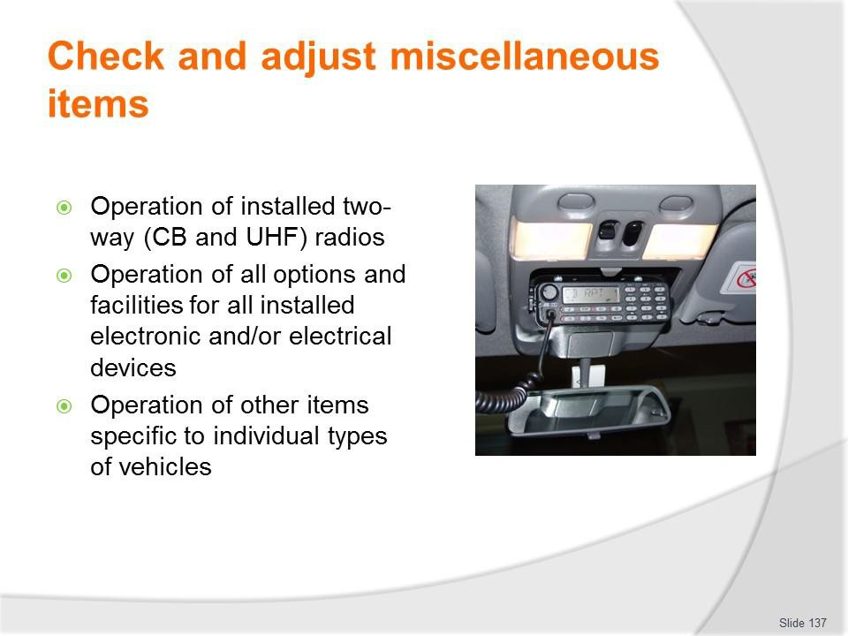
Slide No | Trainer Notes
137. | Trainer continues discussing on-board services/facilities and systems checks:  - Physically checking operation of installed two-way (CB and UHF) radios – including:  - Operation of volume controls  - Operation of channel selection  - Visual displays  - Condition of speakers – with attention to physical damage and clarity of sound  - Condition of the aerial/s  - The maintenance of hand-held communication devices is the responsibility of the persons who use the vehicle/use the units  - Physically checking operation of all options and facilities for all installed electronic and/or electrical devices – such as:  - Global positioning systems (navigation aids)  - On-board cameras and recording equipment  - Battery management  - ECUs  - Asset management (RFID/vehicle tracking)  - Physically checking operation of other items specific to individual types of vehicles.

Classroom Activity – Demonstration and Practical
Trainer shows students how to undertake activities listed on the slide and provides an opportunity for them to do the same.

Slide
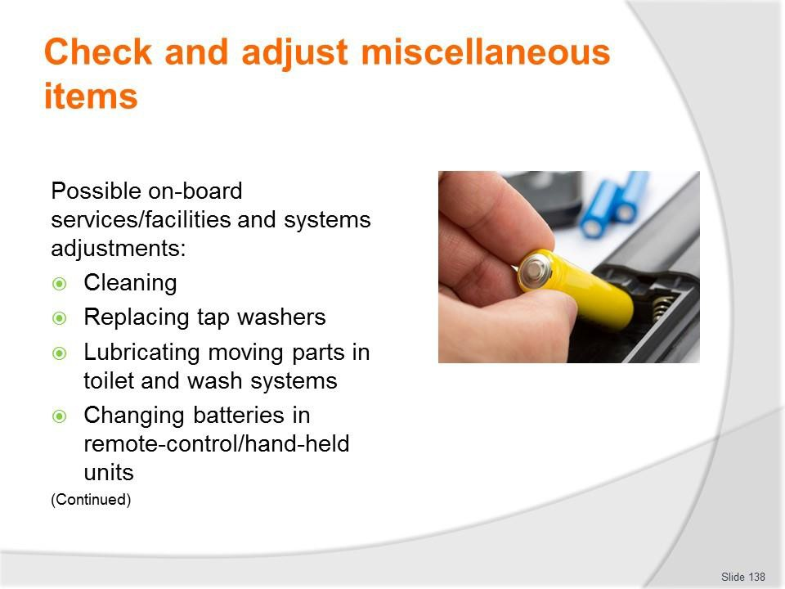
Slide No | Trainer Notes
138. | Trainer presents adjustments:  - Cleaning – especially dust and dirt  - Replacing tap washers  - Lubricating moving parts in toilet and wash systems  - Changing batteries in remote-control/hand-held units.  Classroom Activity – Demonstration and Practical  Trainer shows students how to undertake activities listed on the slide and provides an opportunity for them to do the same.

Slide
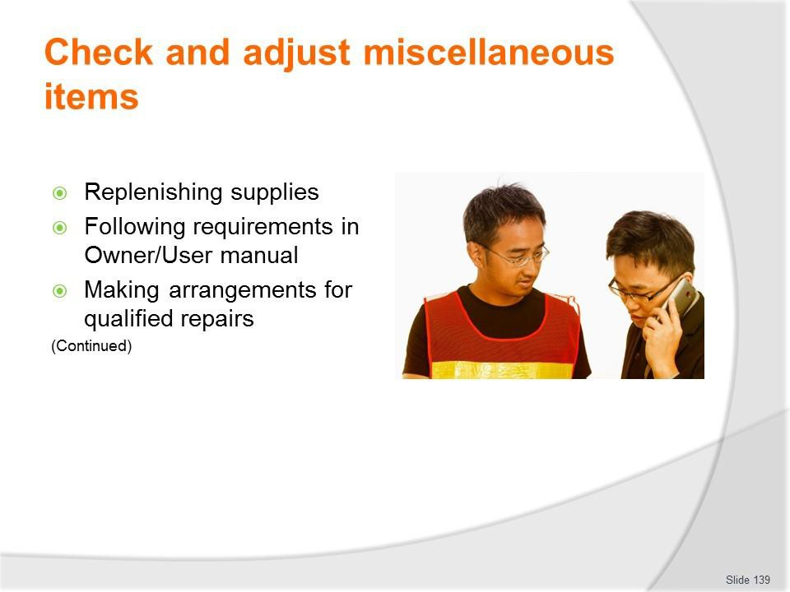
Slide No | Trainer Notes
139. | Trainer continues presenting adjustments:  - Replenishing bathroom/toilet supplies (or this may be done by cleaning staff)  - Reading the ‘User Manual’ for the vehicle or for the individual on-board system to:  - Identify required service/preventative maintenance requirements  - Diagnose the cause of faults/problems  - Effect necessary repairs  - Making arrangements for qualified service technicians to service/repair the items.  Classroom Activity – Demonstration and Practical  Trainer shows students how to undertake activities listed on the slide and provides an opportunity for them to do the same.

Slide
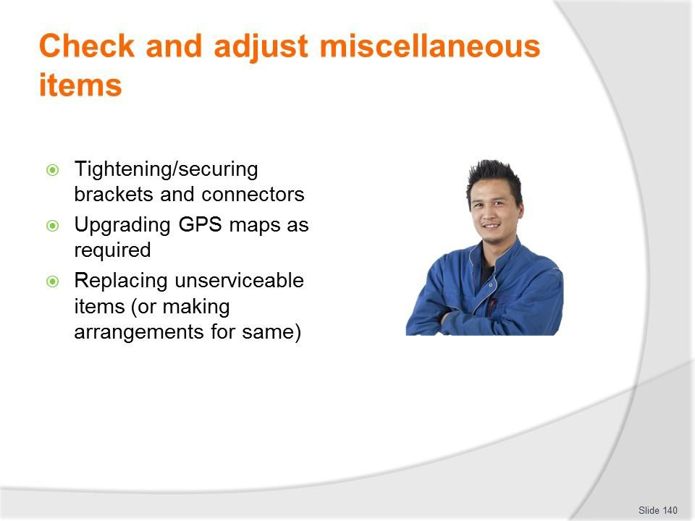
Slide No | Trainer Notes
140. | Trainer continues presenting adjustments:  - Tightening/securing brackets and connectors  - Upgrading GPS maps as required  - Replacing unserviceable items (or making arrangements for same).  Classroom Activity – Demonstration and Practical  Trainer shows students how to undertake activities listed on the slide and provides an opportunity for them to do the same.

Slide
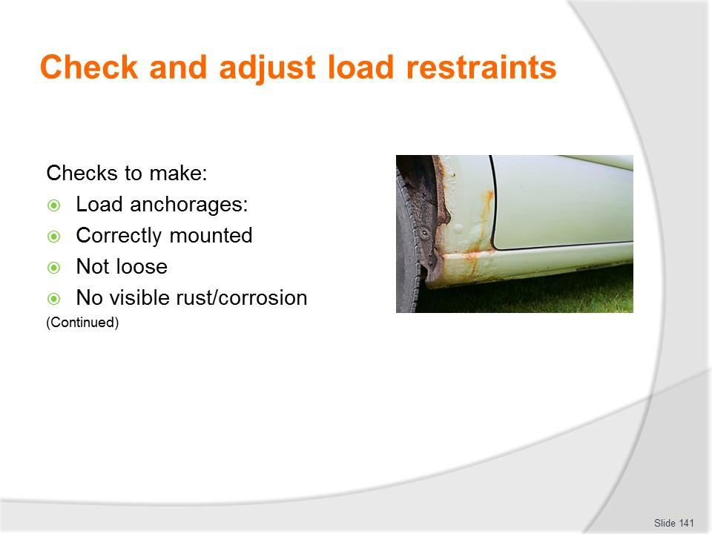
Slide No | Trainer Notes
141. | Trainer discusses checks:  - Load anchorages – inspecting and testing to:  - Ensure they are securely mounted and have not worked loose  - Make sure there is no visible rust/corrosion to the anchorages or surfaces to which they are attached.  Classroom Activity – Demonstration and Practical  Trainer shows students how to undertake activities listed on the slide and provides an opportunity for them to do the same.

Slide
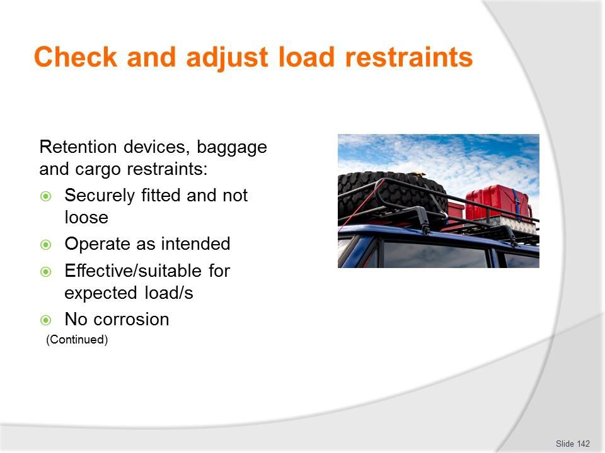
Slide No | Trainer Notes
142. | Trainer continues discussing checks:  - Retention devices, baggage and cargo restraints – inspecting and testing to:  - Ensure they remain securely fitted and have not worked loose  - Verify operation as intended  - Confirm effectiveness and suitability for loads/items to be secured/restrained  - Make sure there is no corrosion to steel components.  Classroom Activity – Demonstration and Practical  Trainer shows students how to undertake activities listed on the slide and provides an opportunity for them to do the same.

Slide
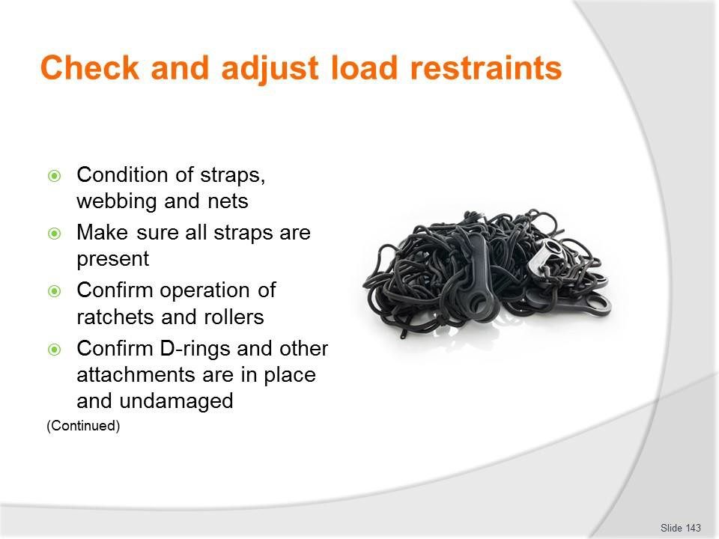
Slide No | Trainer Notes
143. | Trainer continues discussing checks:  - (Continued) Retention devices, baggage and cargo restraints – inspecting and testing to:  - Check condition of straps, webbing and nets – no rips, missing parts, damage, deterioration  - Count/examine number of cords/straps to ensure they are all present  - Confirm operation of ratchets and rollers  - Make sure D-rings and other attachments/connectors are in place, undamaged and fully-functional.  Classroom Activity – Demonstration and Practical  Trainer shows students how to undertake activities listed on the slide and provides an opportunity for them to do the same.

Slide
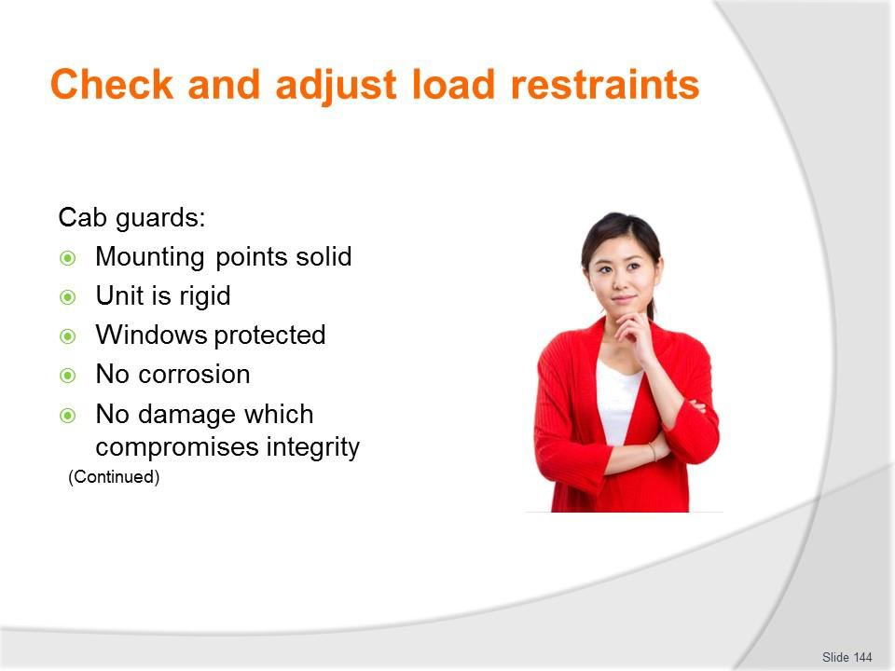
Slide No | Trainer Notes
144. | Trainer continues discussing checks:  - Cab guards – these are the devices designed to protect people in the cab of a vehicle from intrusion of items coming in through the rear window during an accident or a quick stop/hard braking:  - Mounting points are secure and solid  - Unit is rigid and fully covering the window being protected  - No corrosion/rust near mounting/anchor points  - No damage to the unit which compromises its integrity.  Classroom Activity – Demonstration and Practical  Trainer shows students how to undertake activities listed on the slide and provides an opportunity for them to do the same.

Slide
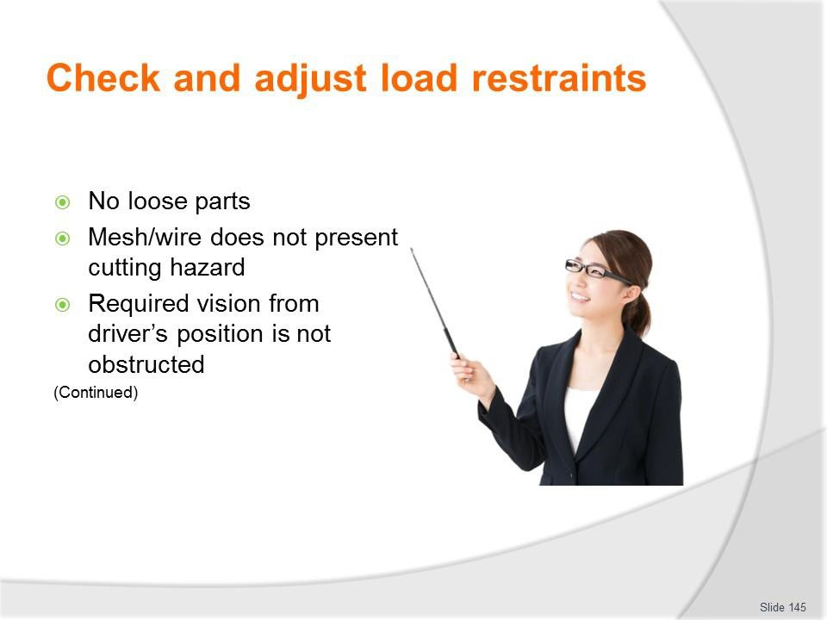
Slide No | Trainer Notes
145. | Trainer continues discussing checks:  - (Continued) Cab guards:  - No loose parts  - Mesh/wire has not broken/become unattached and become a hazard for people to cut themselves on  - Required vision from the cab is not obstructed.  Classroom Activity – Demonstration and Practical  Trainer shows students how to undertake activities listed on the slide and provides an opportunity for them to do the same.

Slide
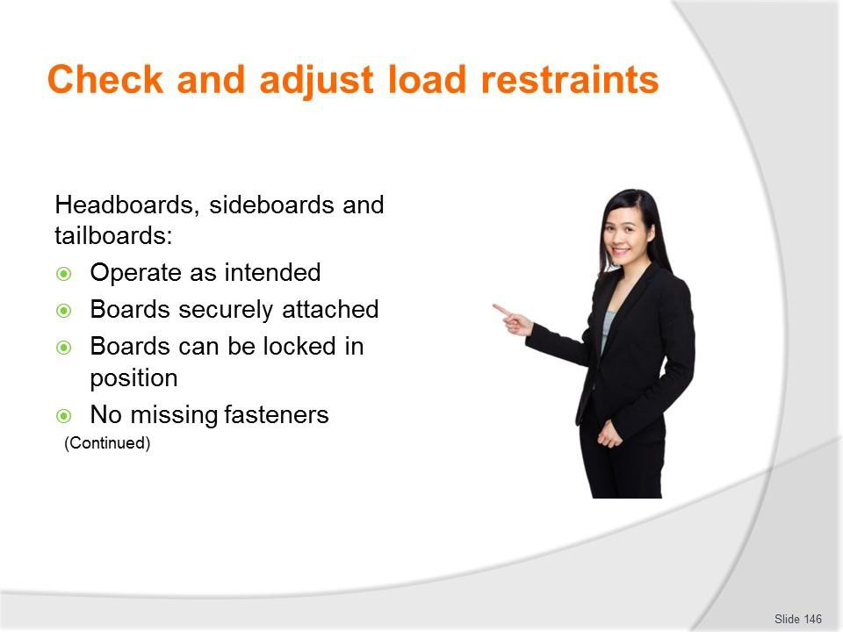
Slide No | Trainer Notes
146. | Trainer continues discussing checks:  - Headboards, sideboards and tailboards – inspecting and testing to ensure:  - Operation as intended – opening and closing/moving up and down  - Boards are securely attached to the vehicle itself  - Boards can be securely locked in position  - No fasteners are missing or loose.  Classroom Activity – Demonstration and Practical  Trainer shows students how to undertake activities listed on the slide and provides an opportunity for them to do the same.

Slide
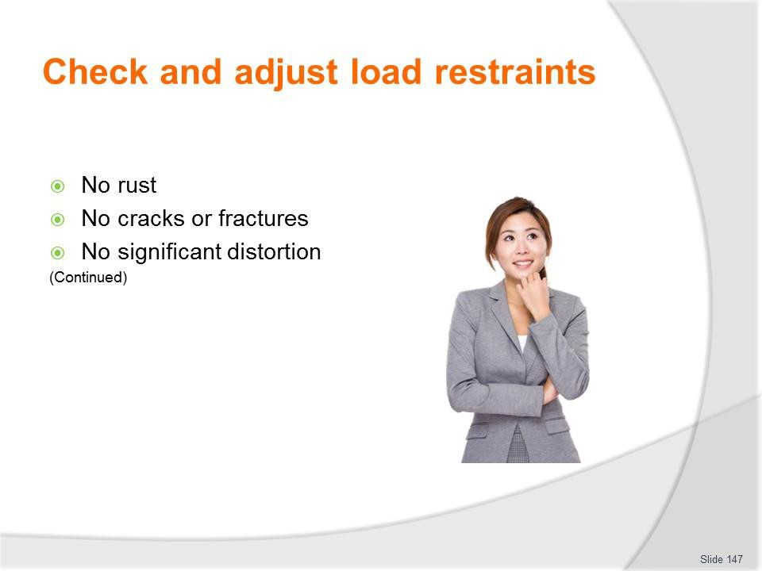
Slide No | Trainer Notes
147. | Trainer continues discussing checks:  - (Continued) Headboards, sideboards and tailboards – inspecting and testing to ensure:  - No evidence of rust or corrosion – at mounting points and on boards themselves  - No evidence of cracks or fractures  - No proof of significant damage or distortion – which impacts function and/or presents a hazard.  Classroom Activity – Demonstration and Practical  Trainer shows students how to undertake activities listed on the slide and provides an opportunity for them to do the same.

Slide
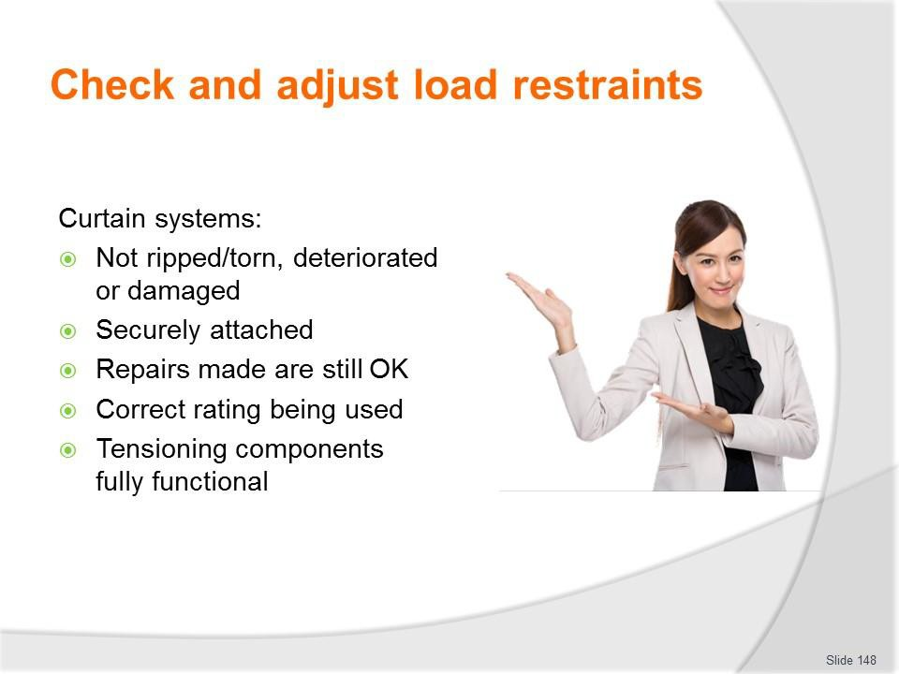
Slide No | Trainer Notes
148. | Trainer continues discussing checks:  - Curtain systems – these are the flexible curtains commonly used on the side of vehicles/trucks to contain loads  - They are not ripped/torn or have not otherwise deteriorated or been damaged  - They are securely attached to the frame which supports them – and the frame is securely attached to the vehicle  - Previous repairs made to the fabric/material remain satisfactory  - Correct rating system/curtain is being used (where applicable) – and relevant certificate is available  - Curtain tensioning components are fully functional, secure and in good condition.  Classroom Activity – Demonstration and Practical  Trainer shows students how to undertake activities listed on the slide and provides an opportunity for them to do the same.

Slide
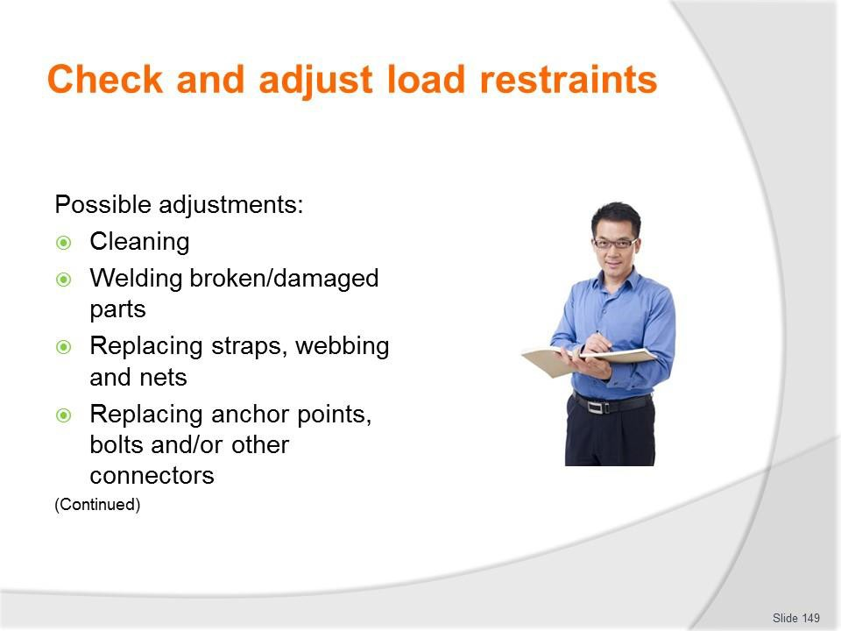
Slide No | Trainer Notes
149. | Trainer presents adjustments:  - Cleaning  - Welding broken/damaged parts  - Replacing straps, webbing and nets  - Replacing anchor points, bolts and/or other connectors.  Classroom Activity – Demonstration and Practical  Trainer shows students how to undertake activities listed on the slide and provides an opportunity for them to do the same.

Slide
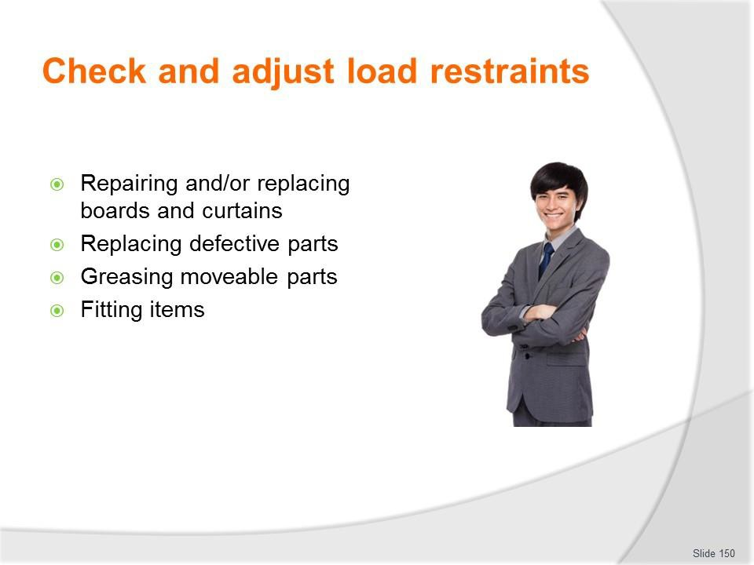
Slide No | Trainer Notes
150. | Trainer continues presenting adjustments:  - Repairing and/or replacing boards and curtains  - Replacing defective parts – where repairs cannot be successfully undertaken  - Greasing moveable parts  - Fitting items where revised use of vehicles indicates need to do so.  Classroom Activity – Demonstration and Practical  Trainer shows students how to undertake activities listed on the slide and provides an opportunity for them to do the same.

Slide
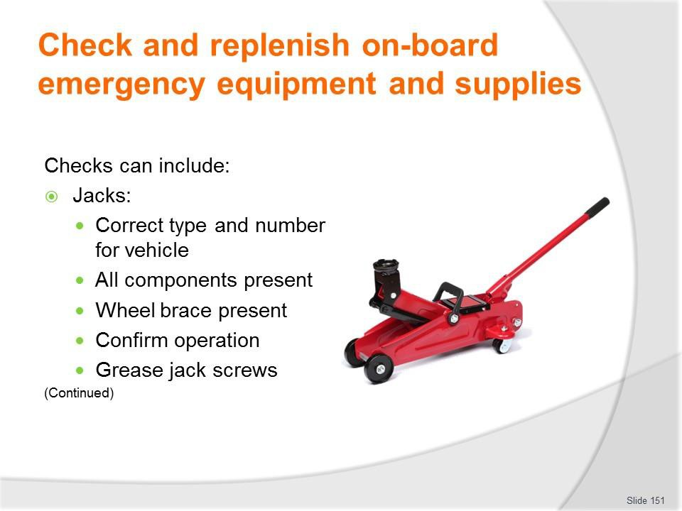
Slide No | Trainer Notes
151. | Trainer discusses checks:  - Jack/s for the vehicle – with attention to:  - Verifying designated vehicles have the correct type/s of jacks stowed on board  – for example, sedans for city/local use may have just one standard jack (as supplied by the car manufacturer) while 4WDs may also be required (under organisational SOPs) to also carry a high-lift jack or some other secondary lifting system  - Making sure all components of each jack are present and located in their designated position  - Checking a wheel brace is provided  - Confirming physical operation of the jacks  - Greasing jack screws as required.  Classroom Activity – Demonstration and Practical  Trainer shows students how to undertake activities listed on the slide and provides an opportunity for them to do the same.

Slide
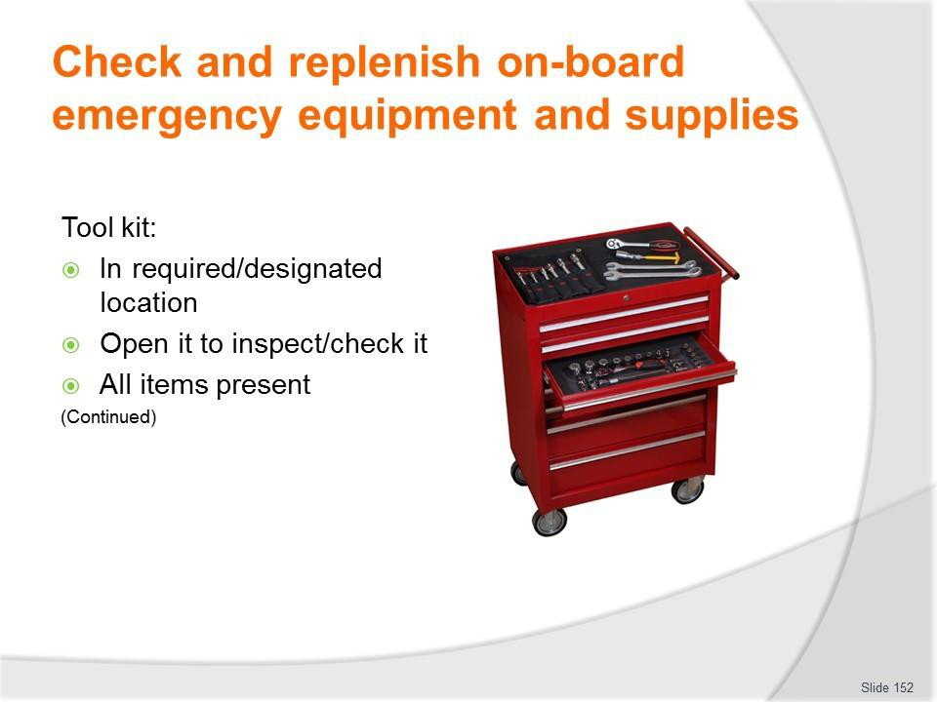
Slide No | Trainer Notes
152. | Trainer continues discussing checks:  - Tool kit – as provided for the vehicle, in terms of:  - Confirming presence of all items using a checklist to guide and record the inspection/check  - Replacing missing items.  Classroom Activity – Demonstration and Practical  Trainer shows students how to undertake activities listed on the slide and provides an opportunity for them to do the same.

Slide
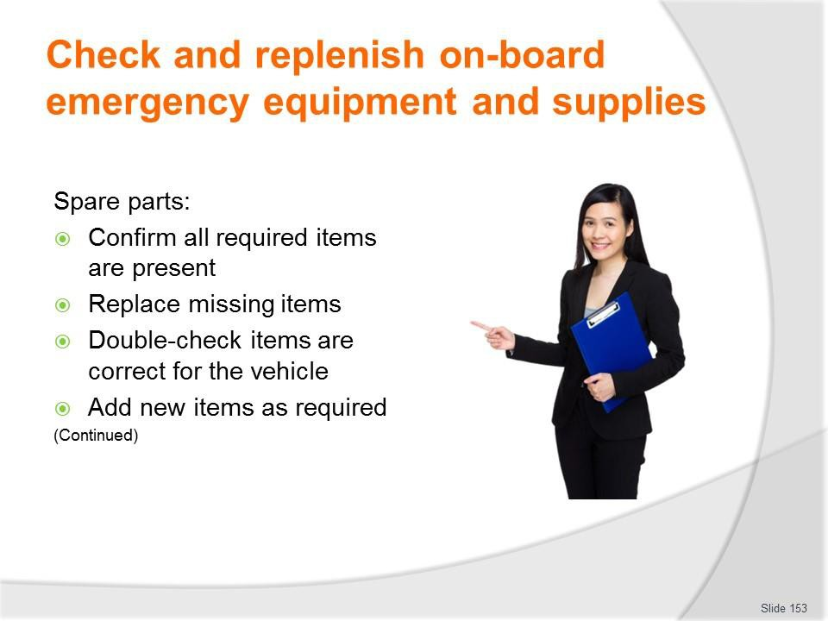
Slide No | Trainer Notes
153. | Trainer continues discussing checks:  - Spare parts – as required for the vehicle, in terms of:  - Confirming presence of all items using a checklist to guide and record the inspection/check  - Replacing missing items  - Adding new items – in accordance with expected/upcoming vehicle use.  Classroom Activity – Demonstration and Practical  Trainer shows students how to undertake activities listed on the slide and provides an opportunity for them to do the same.

Slide
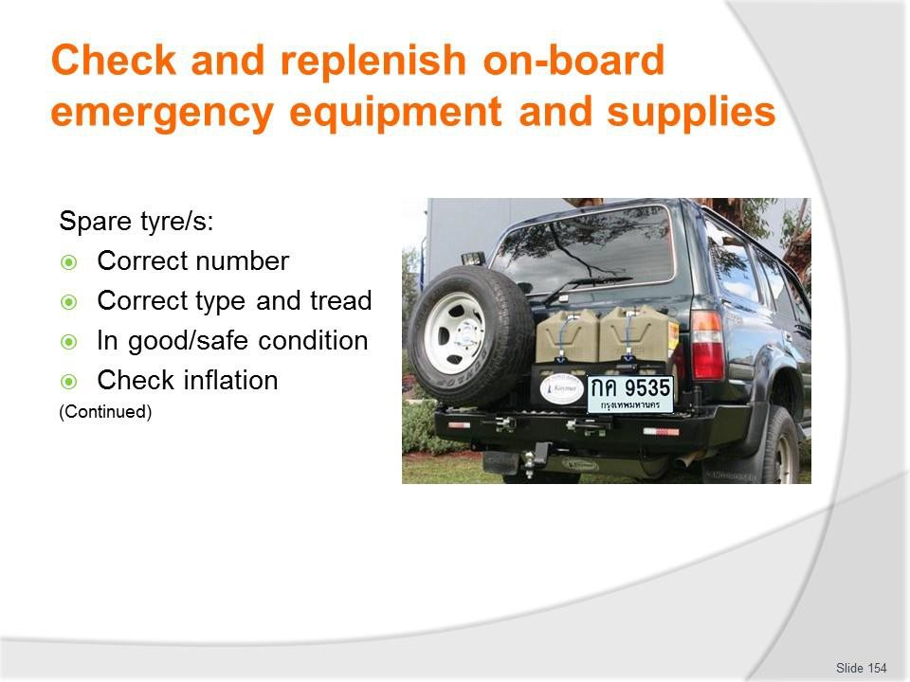
Slide No | Trainer Notes
154. | Trainer continues discussing checks:  - Spare tyre/s – to check:  - Inflation  - Load and speed rating  - Tread pattern and depth  - Condition of wheel, rims and sidewall of tyre/s.  Classroom Activity – Demonstration and Practical  Trainer shows students how to undertake activities listed on the slide and provides an opportunity for them to do the same.

Slide
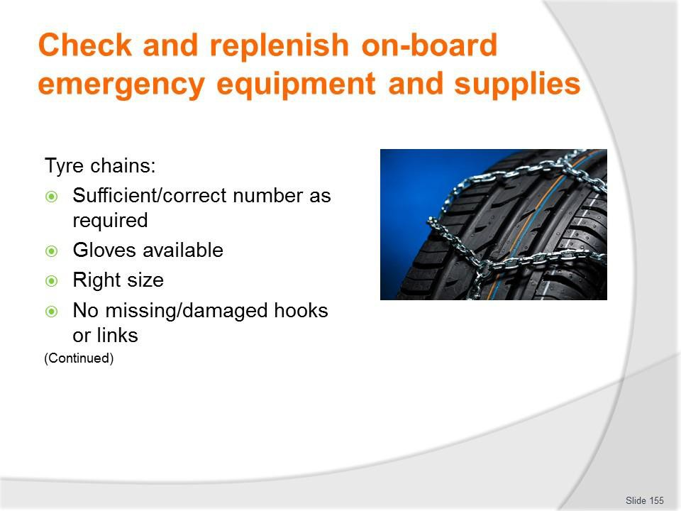
Slide No | Trainer Notes
155. | Trainer continues discussing checks:  - Tyre chains – checking:  - Sufficient wheel chains are present – there must be chains for all the drive wheels, at least  - Appropriate gloves are available for user to wear when fitting chains  - Chains are the right size for the tyres of the vehicle  - Hooks and links are sound – there should be no missing links or obvious damage.  Classroom Activity – Demonstration and Practical  Trainer shows students how to undertake activities listed on the slide and provides an opportunity for them to do the same.

Slide
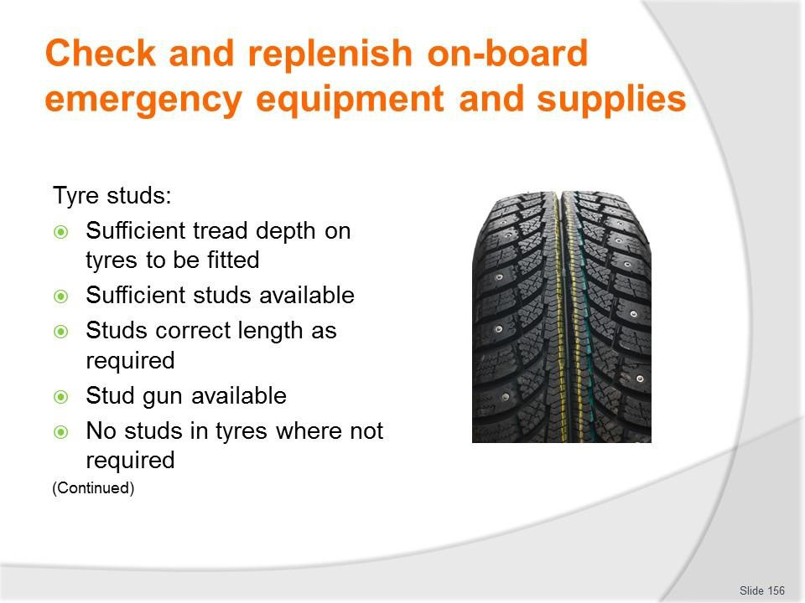
Slide No | Trainer Notes
156. | Trainer continues discussing checks:  - Tyre studs – checking:  - Tyres have sufficient tread depth – and holes are clean  - Sufficient studs are available for the type and number of tyres to be studded  - Available studs are correct length to match stud holes in the tyres to be fitted  - Stud gun is used to insert studs  - Studs are removed from tyres where they are not required – including spare tyre/s.  Classroom Activity (1) – Demonstration and Practical  Trainer shows students how to undertake activities listed on the slide and provides an opportunity for them to do the same.  Classroom Activity (2) – internet Research  Trainer facilitates research and discussion of:  http://www.tyrerack.com/winter/tech/techpage.jsp?techid=151 – Studded tyres for winter driving  http://www.tyrerack.com/winter/tech/techpage.jsp?techid=124 – Stud removal from tyres  https://www.youtube.com/watch?v=BC6Kp-1gtc0 – Studding tyres: GW stud gun.

Slide
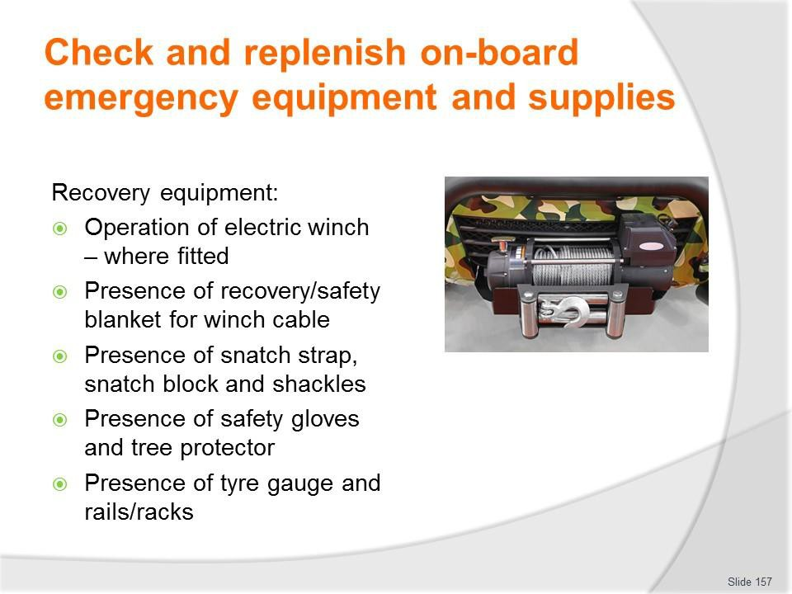
Slide No | Trainer Notes
157. | Trainer continues discussing checks:  - Recovery equipment – which may involve checking:  - Operation of electric winch and presence of recovery blanket – including hand- held operating unit for winch, all functions  - Presence of snatch strap and shackles  - Availability of safety/recovery gloves and tree trunk protector  - Availability of snatch blocks  - Availability of tyre gauge  - Availability of rails/tracks.  Classroom Activity (1) – Demonstration and Practical  Trainer shows students how to undertake activities listed on the slide and provides an opportunity for them to do the same.  Classroom Activity (2) – internet Research  Trainer facilitates research and discussion of:  http://www.tjm.com.au/en-oceania/recovery-equipment - Commercial site http://www.maxtrax.com.au/faq - Commercial site http://www.arb.com.au/products/recovery-equipment/ - Commercial site.

Slide
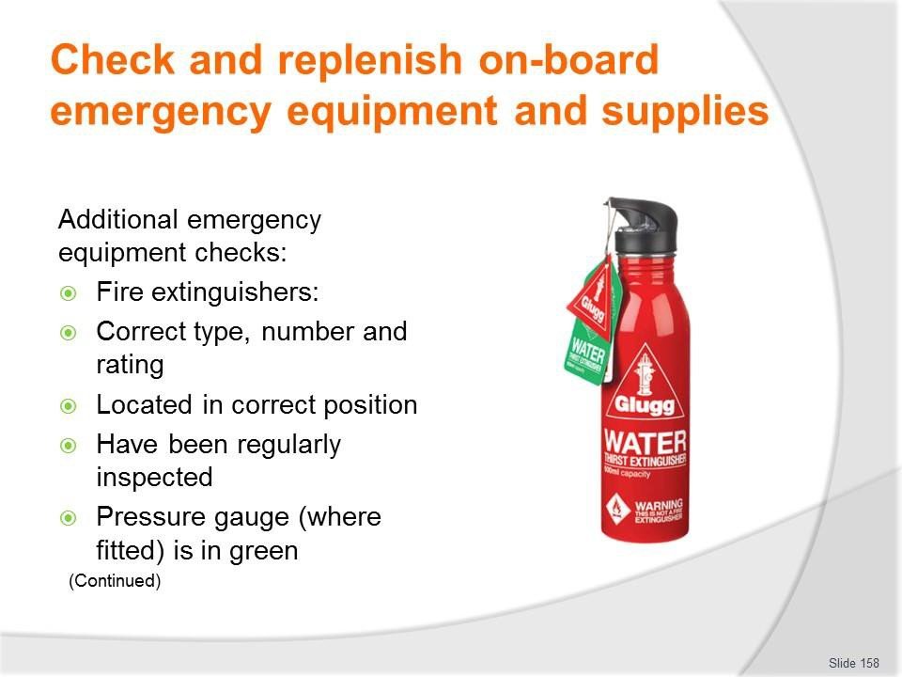
Slide No | Trainer Notes
158. | Trainer discusses additional emergency equipment and checks:  - Fire extinguishers:  - Vehicle is supplied with mandated type/rating and number/s of fire – where applicable, for example for passenger-carrying vehicles/tour vehicles  - Extinguisher is located in correct, suitable and accessible position  - Extinguishers have been regularly inspected – commonly, every six months by certified officer/nominated agency and these inspections have been logged  - Where extinguisher has a pressure gauge, the indicator is in the green section  – if not, the extinguisher must be re-charged.  Classroom Activity – Demonstration and Practical  Trainer shows students how to undertake activities listed on the slide and provides an opportunity for them to do the same.

Slide
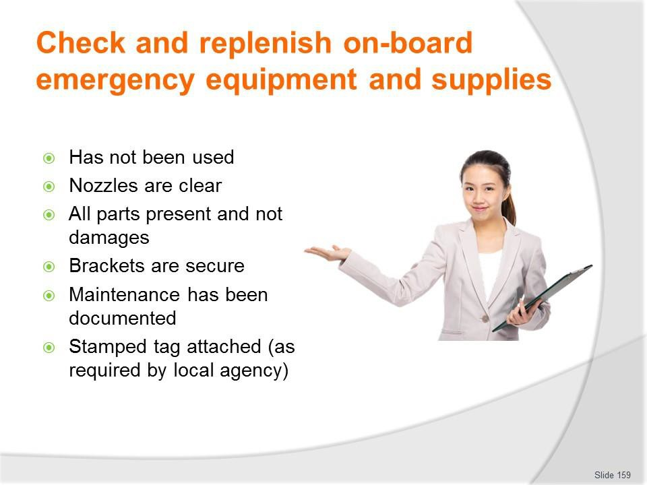
Slide No | Trainer Notes
159. | Trainer continues discussing additional emergency equipment and checks:  - (Continued) Fire extinguishers:  - Extinguisher has not been used – if it has been used it must be re-charged or replaced  - Nozzles are clear – and free of obstructions  - All parts of the extinguisher are present and are not damaged  - Holding brackets are tight/secure and the extinguisher is securely mounted  - All maintenance is documented/recorded  - Stamped tag is attached to the extinguisher – as required by local agencies.  Classroom Activity – Demonstration and Practical  Trainer shows students how to undertake activities listed on the slide and provides an opportunity for them to do the same.

Slide
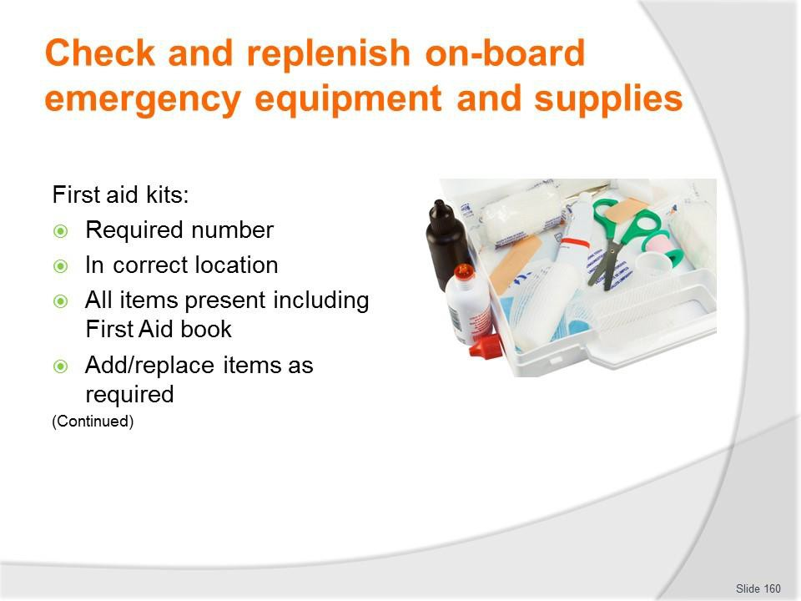
Slide No | Trainer Notes
160. | Trainer continues discussing additional emergency equipment and checks:  - First aid kits:  - Verifying the required number of kits are available – in the designated locations  - Confirming presence of all items using a checklist to guide and record the inspection/check  - Confirming presence of First Aid book  - Confirming presence of disposable gloves and mask  - Replacing missing items  - Adding new items – in accordance with expected/upcoming vehicle use/tour.  Classroom Activity – Demonstration and Practical  Trainer shows students how to undertake activities listed on the slide and provides an opportunity for them to do the same.

Slide
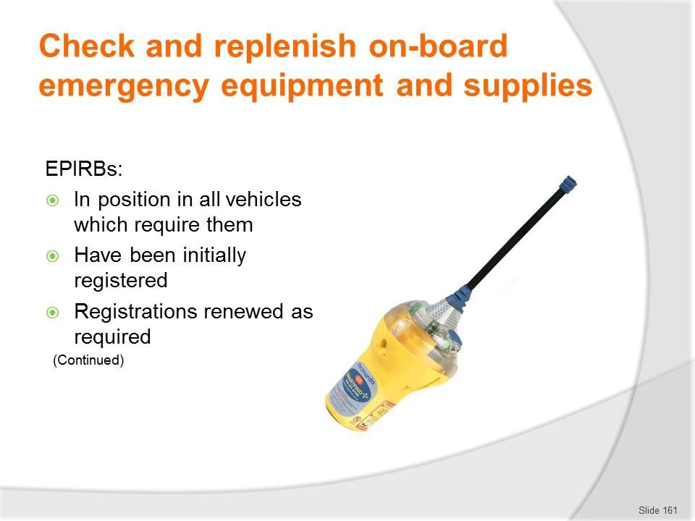
Slide No | Trainer Notes
161. | Trainer continues discussing additional emergency equipment and checks:  - EPIRBs:  - They are provided in/for all vehicles which are designated as needing to use them – such as tour vehicles and those to be used in remote locations  - They are registered initially – with the relevant authority/agency  - Registrations are renewed as required – such as every two years even where there is no change in the registered owner.  Classroom Activity – Demonstration and Practical  Trainer shows students how to undertake activities listed on the slide and provides an opportunity for them to do the same.

Slide
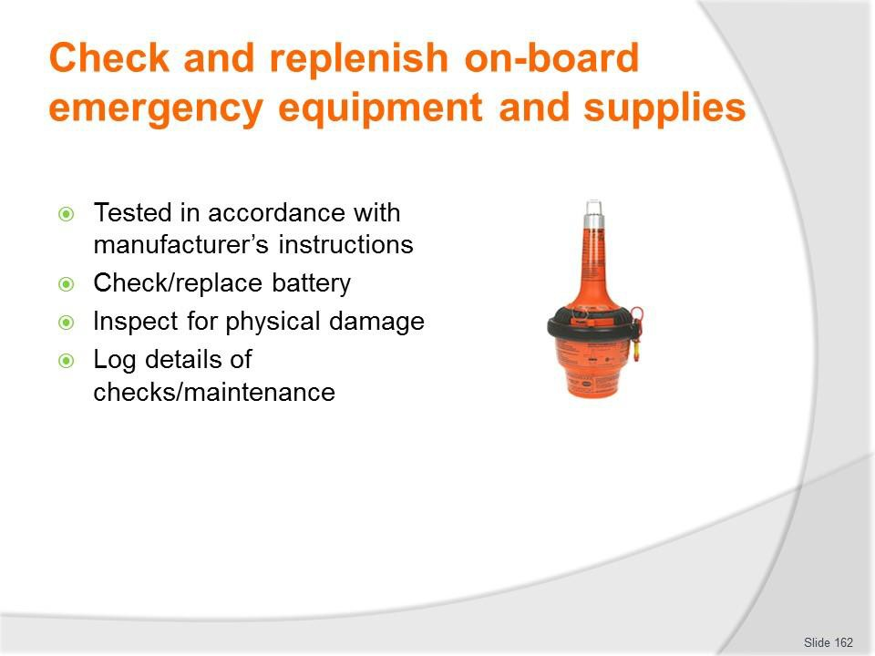
Slide No | Trainer Notes
162. | Trainer continues discussing additional emergency equipment and checks:  - (Continued) EPIRBs:  - Testing – in accordance with manufacturer’s instructions taking care not to accidentally initiate a false alarm  - Checking battery dates – and:  - Replacing before listed expiration date of the battery  - Replacing if the unit has been used  - Inspecting the unit for physical damage, cracks or other defects  - Logging details of the checks, tests and maintenance performed.  Classroom Activity – Demonstration and Practical  Trainer shows students how to undertake activities listed on the slide and provides an opportunity for them to do the same.

Slide
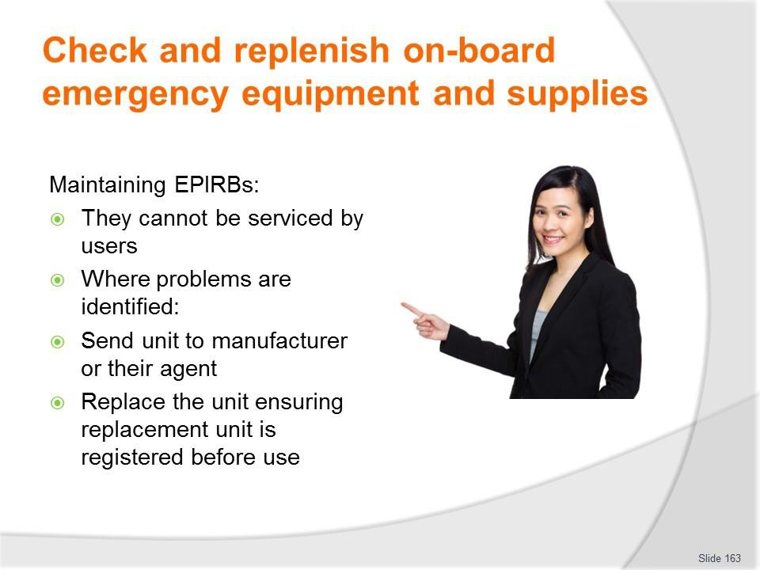
Slide No | Trainer Notes
163. | Trainer presents information on EPIRM maintenance noting:  - EPIRBs cannot be maintained by users  - Where problems are identified with EPIRBS the recommended course of action to:  - Forward to the manufacturer or their agent  - Replace the unit with a new one ensuring it is registered prior to being put into use.  Classroom Activity – Demonstration and Practical  Trainer shows students how to undertake activities listed on the slide and provides an opportunity for them to do the same.

Slide
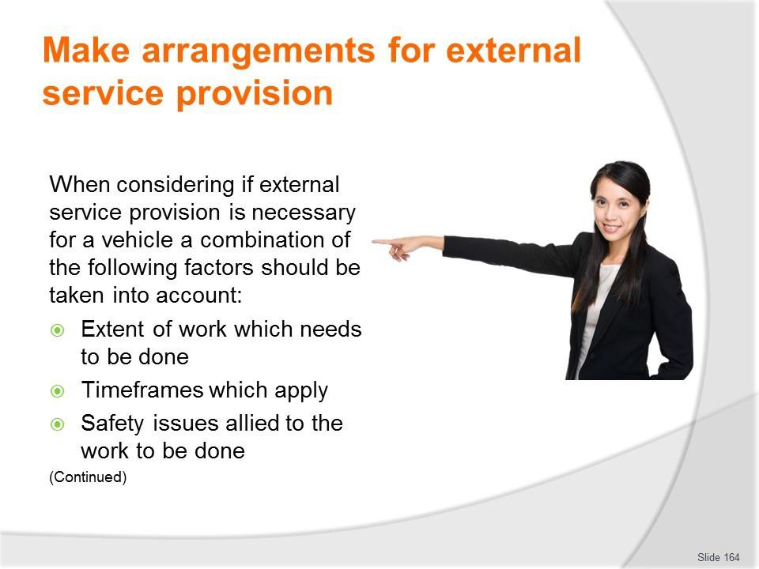
Slide No | Trainer Notes
164. | Trainer presents factors to consider in relation to making arrangements for external service provision:  - Extent of work which needs to be done – smaller jobs may be handled internally but larger jobs tend to be sent out  - Timeframes which apply – where there is a definite or tight timeline for the completion of work, it can be better to have the work done by a professional  - Safety issues – anything which relates to matters of safety tends to be undertaken by suitably qualified technicians and service people so as to discharge the common law Duty of Care imposed on businesses.

Slide

Slide No | Trainer Notes
165. | Trainer continues presenting relevant factors to consider:  - Complexity of the job – simple jobs may be done in-house but the more difficult work tends to be outsourced  - Tools and equipment available – where specialist tools and equipment are required for work it can be more economical to get outside businesses to do the job  - Expertise – there will just be some jobs where organisational personnel have no experience and no real idea of what to do so there is an obvious imperative for the work to be done by experienced professionals  - Terms of warranties and guarantees – in order to maintain the protection/coverage provided by some warranties and guarantees there can be a need for specified work to be done by ‘authorised dealers or agents’.

Slide
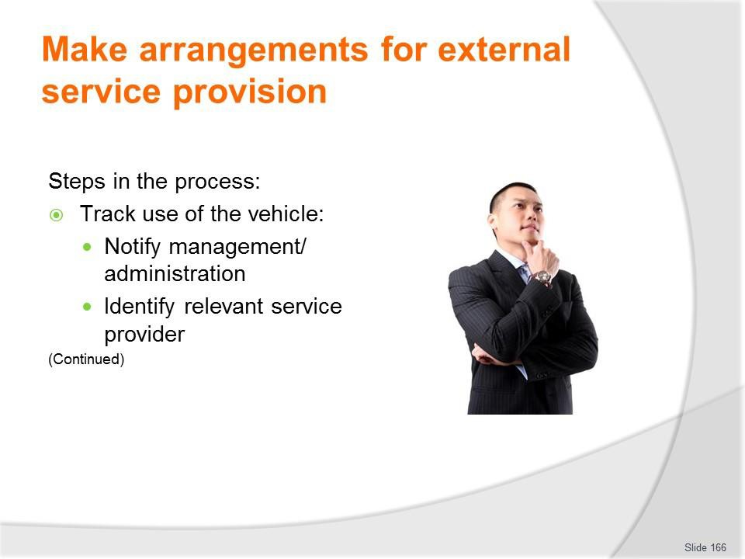
Slide No | Trainer Notes
166. | Trainer presents steps in the process:  - Track use of the vehicle – so:  - Odometer readings are monitored – as service times are usually related to distances travelled  - Projected date for service can be identified  - Advance bookings can be made – with service providers  - Notify management or administration – and:  - Advise them of the situation and the reason for external service provision  - Discuss known details of the work required  - Give an estimate of cost, if known  - Identify urgency of work that needs to be done  - Tell them of any bookings/identified up-coming use for the vehicle  - Determine if quotations are required – and if so, how many  - Seek and obtain formal approval to proceed  - Identify the relevant service provider – this may be:  - The organisation from which the vehicle was purchased  - The authorised dealer for the make  - The preferred service provider as determined by the business  - An approved repairer as designated by a recognised motoring body or insurer.

Classroom Activity – Guest Speaker
Trainer arranges for Service Manager from local agency to attend and:
- Identify work they can perform and services they can provide together with indicative costs
- Suggest protocols for deciding whether external service is required
- Describe their preferred actions when making a booking for service/repairs to a vehicle.

Slide

Slide No | Trainer Notes
167. | Trainer presents steps in the process:  - Speak to the selected business by phone or in person – and:  - Advise of the nature and extent of work required  - Explain urgency of work required and need for vehicle to be returned to service by given date, if applicable  - Take the vehicle in to the business – for them to see/inspect  - Request quotation for the work to be done – if necessary  - Schedule the work – to:  - Best integrate repairs with any other work to be done – so as to minimise down- time  - Maintain vehicle ‘in service’ for maximum time – providing it is safe to do so  - Make a booking for the work to be done – with the chosen provider which may be chosen based on:  - Quotation received  - Ability to perform the work by required date  - Previous experience with the business  - Direction from management, warranty/guarantee or insurer

- Take necessary other action – which may entail:
  - Ensuring vehicle is not used until the required repairs have been completed, where safety is a concern
  - Re-arranging vehicle usage sheets to accommodate absence of the vehicle
  - Hiring/renting another vehicle to replace the one being repaired
  - Advising known vehicle users of changes made.
Classroom Activity – Guest Speaker
Trainer arranges for representative from local venue/operator to attend and:
- Describe protocols regarding external service provision
- Identify factors determining when/if external service will be used
- Provide samples of relevant documentation involved
- Talk about issues related to having a vehicle taken out of service for maintenance and how that is handled.

Slide
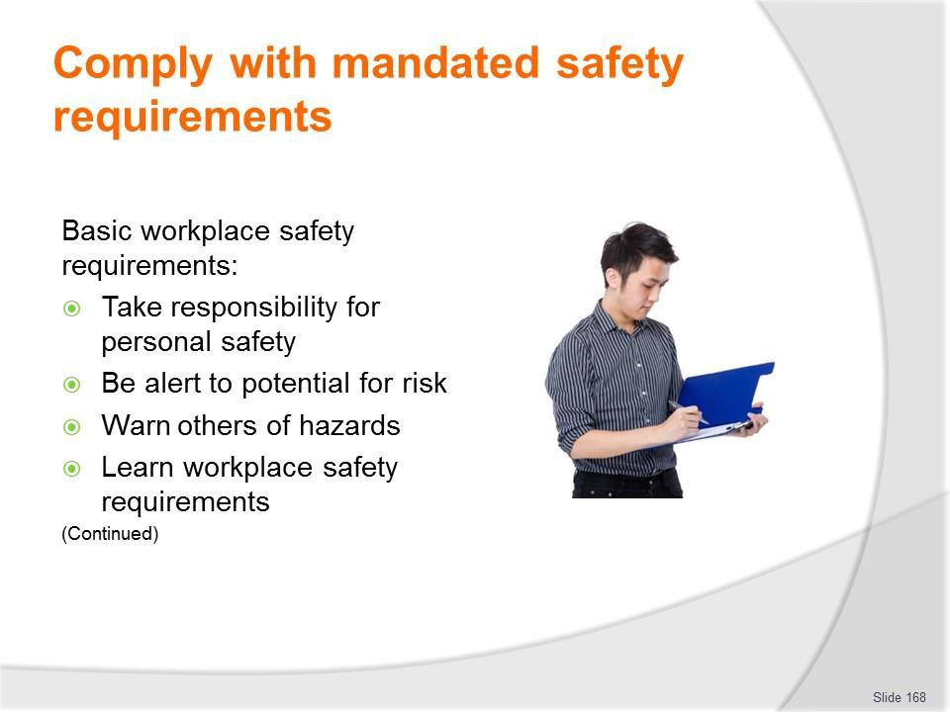
Slide No | Trainer Notes
168. | Trainer describes basic safety requirements:  - Taking responsibility for personal safety – people must take responsibility for their own safety regardless of all other protocols  - Being alert to the possibility of risk – due to faulty equipment, risky practice, introduction of a new product or procedure into the workplace: being aware the workplace is a dangerous environment and has the potential to cause injury is the biggest, single factor in taking the initiative for safety at work  - Warning others of hazards – so they avoid them  - Learning workplace safety policies and procedures – what applied at a previous workplace may not apply at the current workplace.  Classroom Activity – Guest Speaker  Trainer arranges for representative from local workplace safety authority to attend and:  - Provide advice on safety when servicing and repairing vehicles  - Distribute handouts on workplace safety  - Indicate obligations on employers to provide a safe workplace  - Emphasise responsibilities/onus on workers for their own safety.

Slide
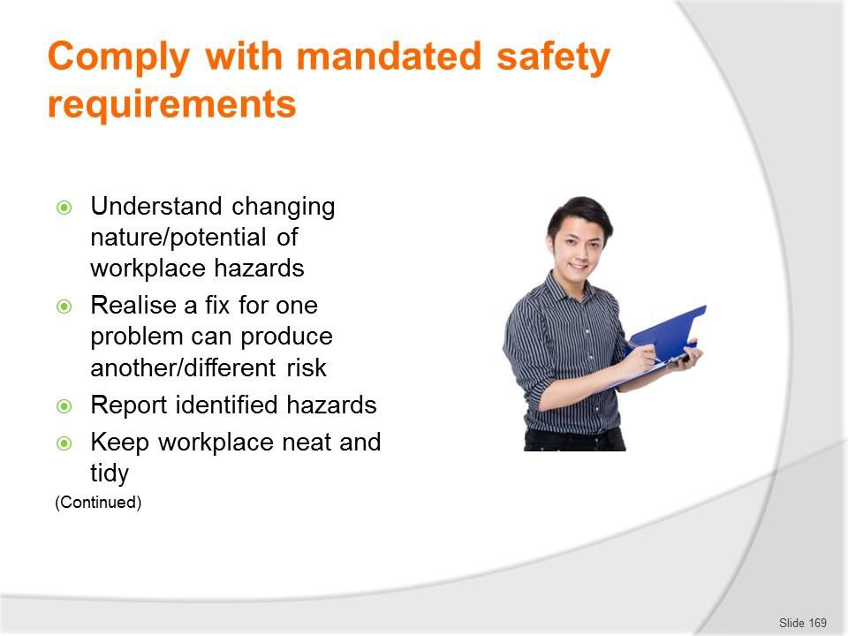
Slide No | Trainer Notes
169. | Trainer continues describing basic safety requirements:  - Understanding a hazard can exist today that did not exist yesterday – due to the dynamic nature of work  - Realising a remedy for one workplace risk can introduce a new/other workplace hazard  - Reporting any workplace risk/hazard – as soon as it is identified  - Keeping the work area neat and tidy – as this helps create a safety-oriented mind set: there seem to be fewer accidents and injuries in neat and clean workplaces.  Classroom Activity – Guest Speaker  Trainer arranges for person who services vehicles at local venue/operator to attend and:  - Stress need for workplace safety  - Advise of safety measures they take  - Give examples of workplace safety policies and procedures  - Describe accidents and near misses they have experienced.

Slide
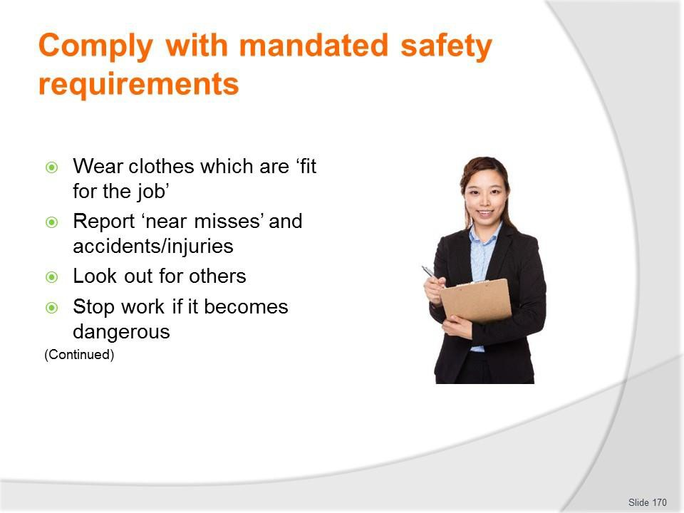
Slide No | Trainer Notes
170. | Trainer continues describing basic safety requirements:  - Wearing clothes that are fit for the job – no hanging threads, loose sleeves: wear/provide safe and comfortable clothes  - Reporting ‘near misses’ as well as actual accidents/injury – so investigation and preventative action can be taken  - Looking out for the safety of others – other staff and members of the public  - Immediately ceasing any work as soon as it becomes dangerous – rather than ‘pressing on’ in dangerous conditions.

Slide
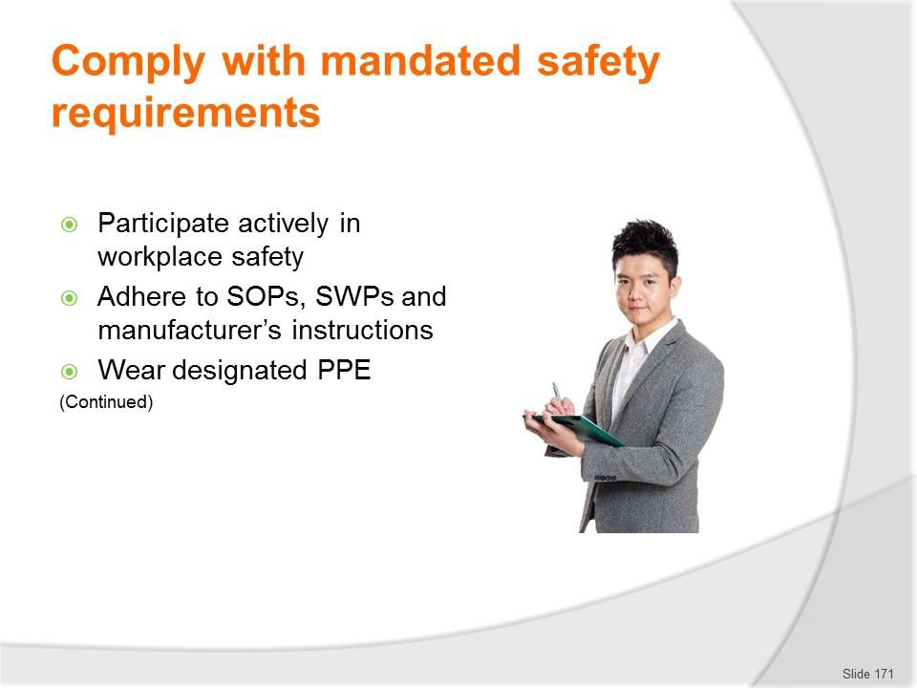
Slide No | Trainer Notes
171. | Trainer continues describing basic safety requirements:  - Participating in workplace safety discussions, inspections, feedback and management – so workplace safety is consultative  - Adhering to SOPs, SWPs and manufacturer’s instructions – as these have been developed with safety in mind  - Wearing/using designated PPE as directed – such as eye protection, gloves, steel- capped boots  - Using all appliances, equipment, tools as directed – making sure the right tool is used for the right job.  Classroom Activity – Samples  Trainer shows and demonstrates/explains the use of a range of relevant workplace PPE.

Slide
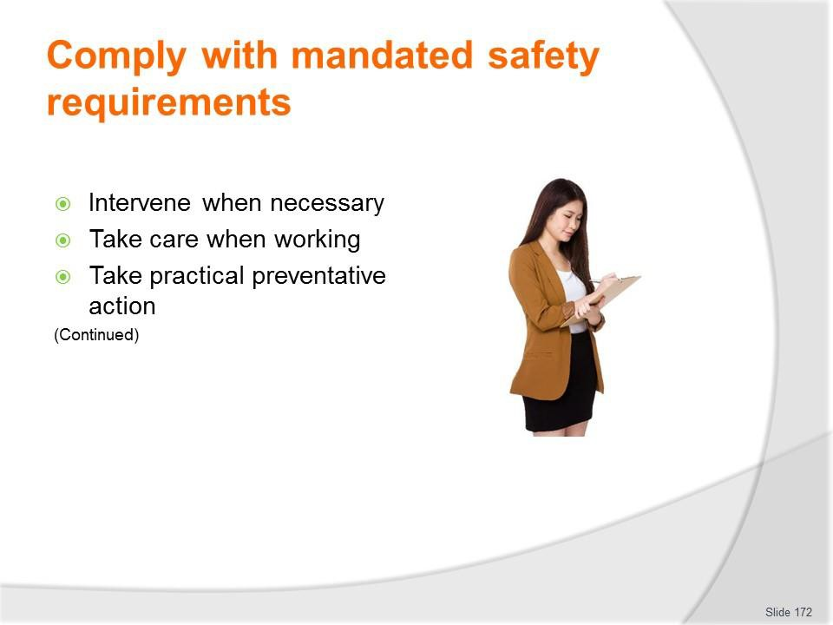
Slide No | Trainer Notes
172. | Trainer continues describing basic safety requirements:  - Intervening when a dangerous workplace situation is identified – to protect people/others against injury  - Taking care when working, which includes:  - Not rushing  - Thinking about what needs to be done  - Thinking about how to do what needs to be done  - Not doing anything believed to be unsafe  - Taking practical action when required, such as:  - Picking up items from the floor when they have been dropped  - Cleaning up spills immediately – instead of ignoring them or leaving them for someone else to do  - Disposing of glass (including broken glass) into designated containers.

Slide

Slide No | Trainer Notes
173. | Trainer continues describing basic safety requirements:  - Undertaking a first aid course – so help can be provided if necessary  - Being trained in workplace health and safety – as it applies to the workplace, and attending all workplace-based health, safety and welfare training  - Not working when unfit to do so – as a result of tiredness, injury, other causes  - Seeking to establish a safe place/working environment – rather than relying on employees working in a safe manner.

Slide
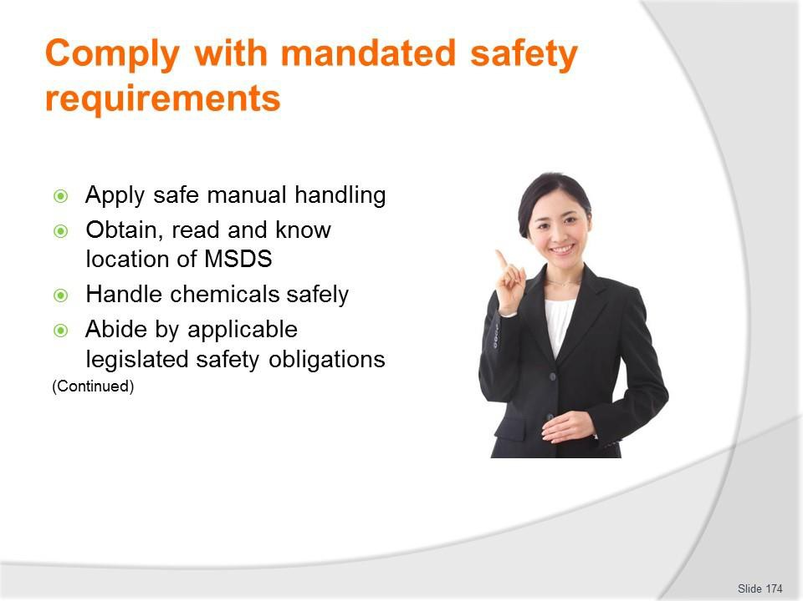
Slide No | Trainer Notes
174. | Trainer continues describing basic safety requirements:  - Applying safe manual handling protocols – in relation to moving and lifting objects in the workplace  - Ensuring there are MSDS for all chemicals used in the workplace – and they are readily available to workers  - Handling chemicals according to established safe chemical handling, storing and usage protocols – as developed by the organisation for the chemicals used within the business  - Abiding by the requirements of health, safety and welfare legislation – as it applies locally/nationally.  Classroom Activity (1) – Demonstration  Trainer demonstrates safe manual handling and chemical handling techniques.  Classroom Activity (2) – Handouts  Trainer distributes and discusses sample range of relevant MSDS.

Slide
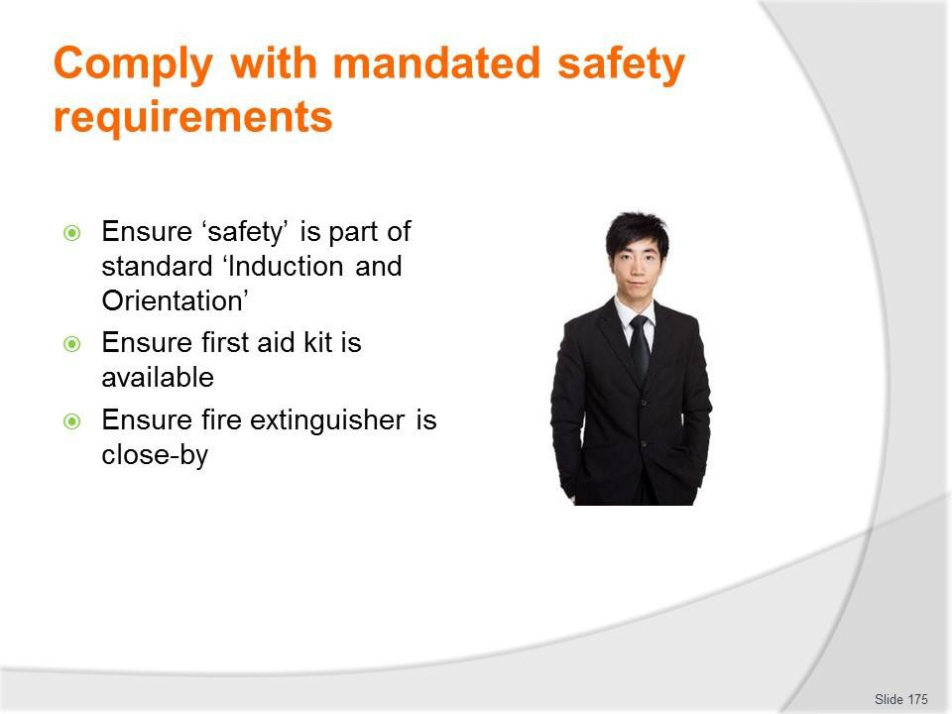
Slide No | Trainer Notes
175. | Trainer continues describing basic safety requirements:  - Including health and safety training as part of the Induction and Orientation – for all new employees  - Ensuring suitable first aid kit is present/available  - Ensuring a fire extinguisher is close-by – just in case it is needed.

Slide
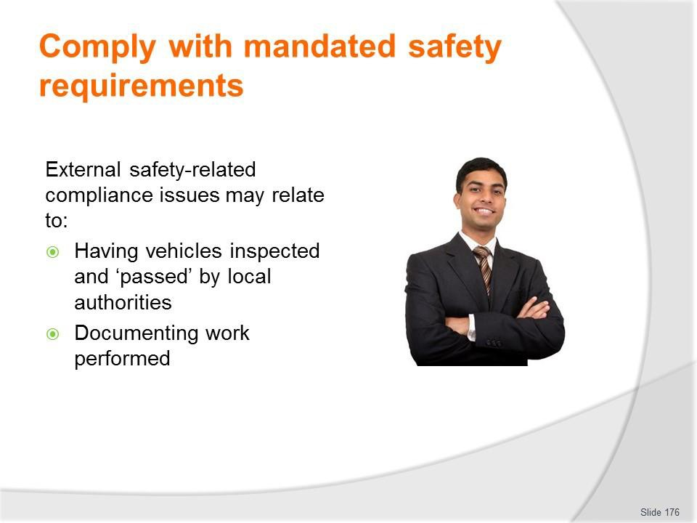
Slide No | Trainer Notes
176. | Trainer discusses possible need for external compliance with regard to safety:  - Where repairs are made to vehicles (and trailers) – and perhaps where nominated service has to be provided – there can be a need to have this work inspected and ‘passed’ by local transportation, vehicle or road authorities  - These requirements may apply to all vehicles, or just to those registered as commercial and/or passenger-carrying  - Where these obligations apply it is generally the case:  - The vehicle must be taken or driven to the inspection point  - It must be inspected, checked and approved by an authorised officer of inspector  - A certificate approving the repairs must be issued and obtained to sign-off on the repairs before the vehicle is legally allowed to be driven/used on the roads.

Slide

Slide No | Trainer Notes
177. | Trainer explains general safety obligations imposed on employers:  - Conduct risk assessments to remove or control risks to workers at the workplace  - Maintain safe work facilities and arrangements for the workers at work  - Ensure safety in machinery, equipment, plant, articles, substances and work processes at the workplace;  - Develop and implement control measures for dealing with emergencies;  - Provide workers with adequate instruction, information, training and supervision.

Slide
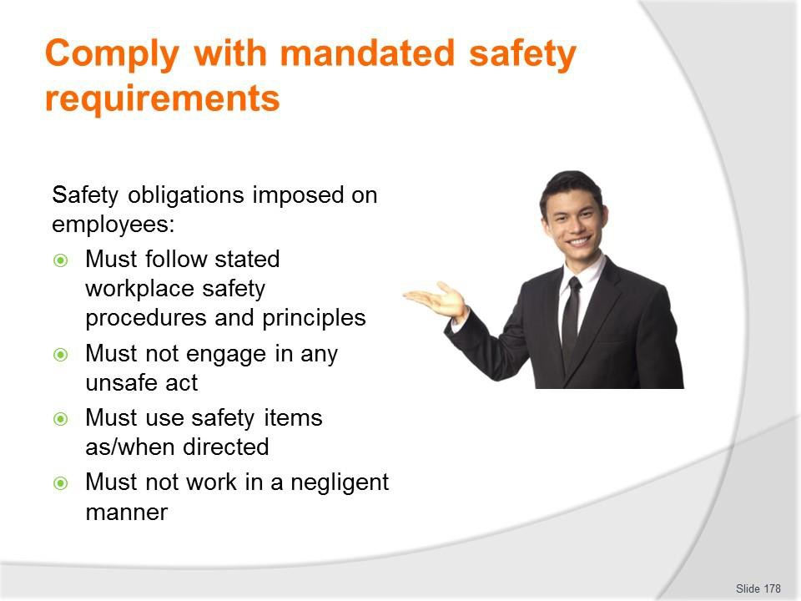
Slide No | Trainer Notes
178. | Trainer explains general safety obligations imposed on employees:  - Must follow the safe working procedures and principles introduced at the workplace  - Must not engage in any unsafe act that may endanger yourself or others working around you  - Must use, in proper manner, any personal protective equipment, devices, equipment or other means provided to secure your safety, health and welfare while working. You must not tamper or misuse such items provided  - Must not engage in any negligent act that may endanger yourself or others working around you.”

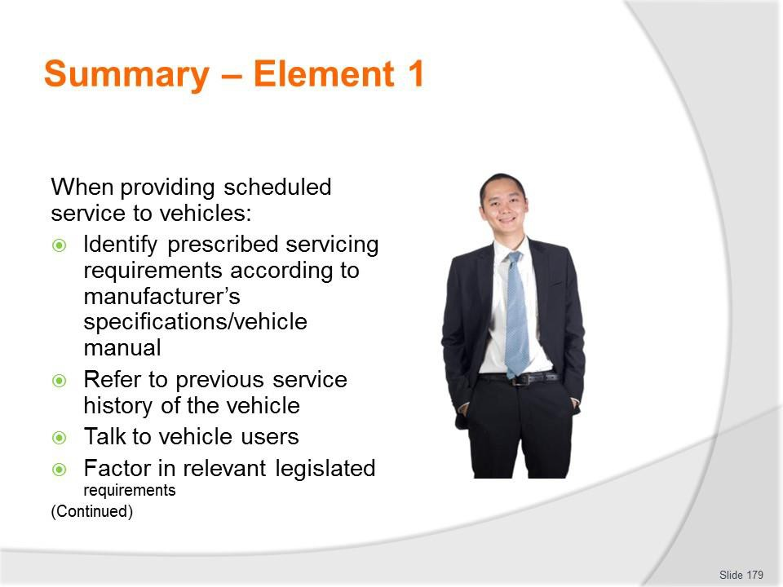
Slide
Slide No
Trainer Notes
179.
Trainer provides a recap of the Element asking questions to check trainee understanding and responding to questions from trainees, as required.

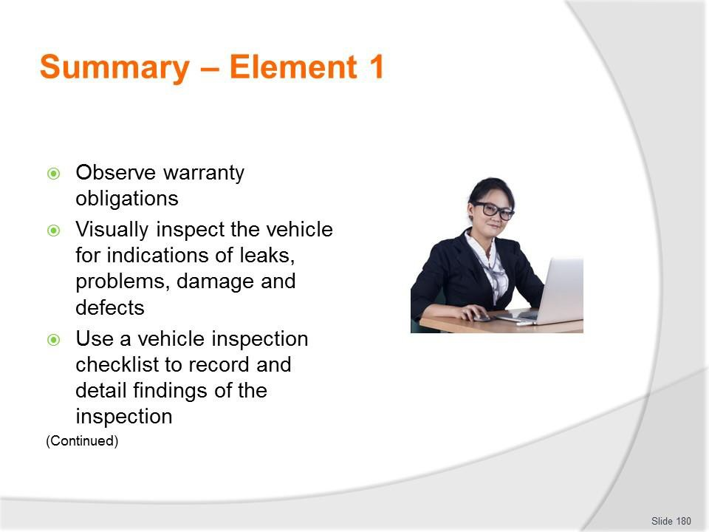
Slide
Slide No
Trainer Notes
180.
Trainer provides a recap of the Element asking questions to check trainee understanding and responding to questions from trainees, as required.

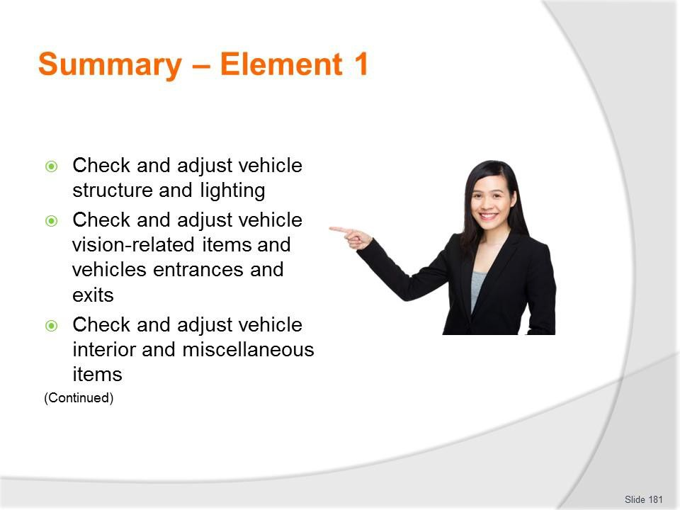
Slide
Slide No
Trainer Notes
181.
Trainer provides a recap of the Element asking questions to check trainee understanding and responding to questions from trainees, as required.

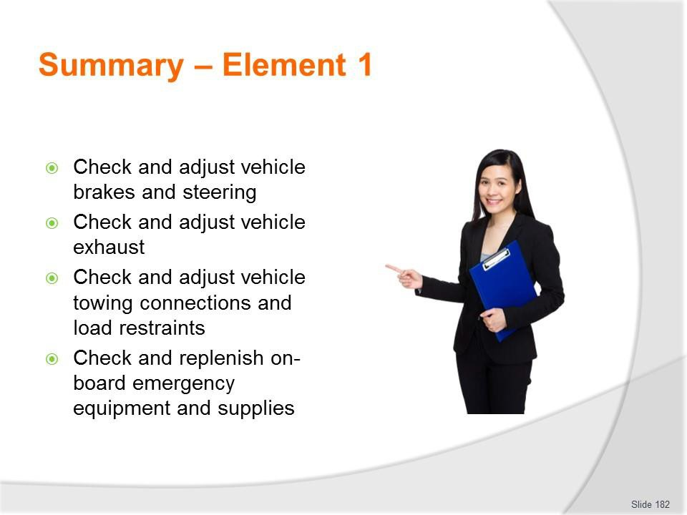
Slide
Slide No
Trainer Notes
182.
Trainer provides a recap of the Element asking questions to check trainee understanding and responding to questions from trainees, as required.

Slide
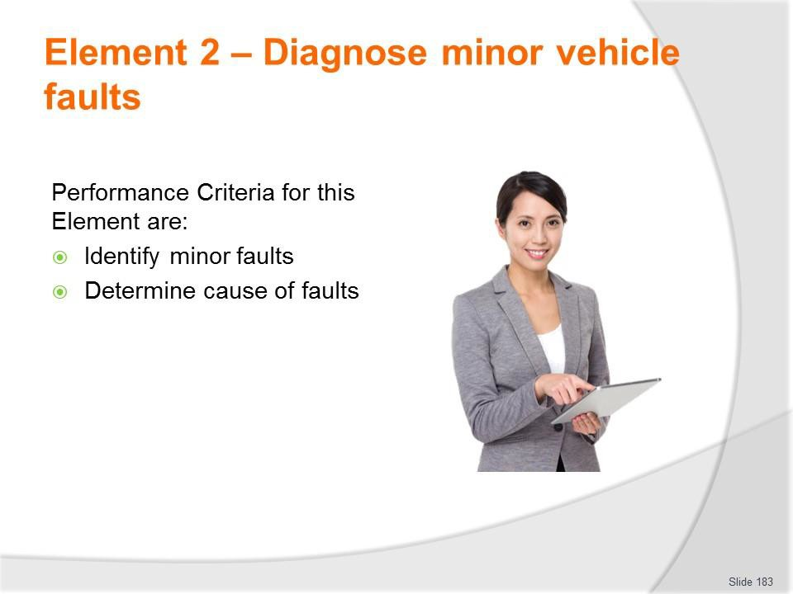
Slide No | Trainer Notes
183. | Trainer identifies for trainees the Performance Criteria for this Element, as listed on the slide.  Class Activity – General Discussion  Trainer leads a general class discussion by asking questions such as:  - What does ‘diagnose’ mean?  - How can you go about diagnosing faults/what do you do to diagnose them?  - What experience have you had in doing this?  - Give me some examples of vehicles you have diagnosed faults on and what those faults were.

Slide
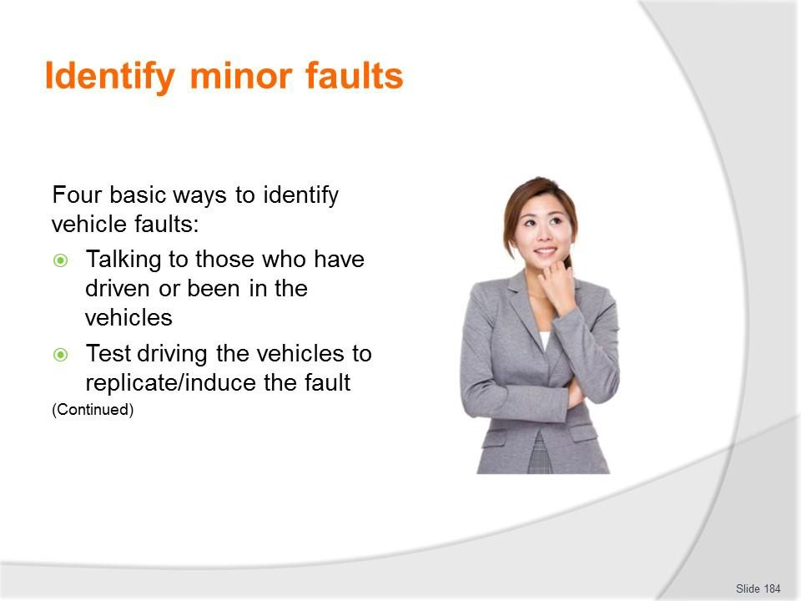
Slide No | Trainer Notes
184. | Trainer explains there are four basic ways to identify vehicle faults:  - Talking with those who have operated/driven or been in a vehicle  - These people may be drivers or passengers  - Actions required include:  - Asking open and closed questions  - Asking probing questions  - Using terminology appropriate to the individual – such as avoiding complex automotive terms if the person does not understand them  - Listening to what is said  - Getting them to point to locations  - The discussion should aim to:  - Identify type and nature of fault  - Describe the fault if it cannot be identified  - Explain whereabouts it is located (if appropriate)  - Describe symptoms and indicators  - Give an idea of frequency of the problem  - Identify conditions under which fault occurs/presents

- Test driving the vehicle – to:
  - Attempt to induce the fault – which can often be a frustrating experience as a problem ‘on tour’ often fails to manifest itself on return
  - Listen to sounds made by the vehicle
  - Get a feel for the vehicle – and how it handles and responds
  - Smell any odour which may be generated by the fault
  - Duplicate causal conditions which were known to trigger the problem
  - Compare the way it is ‘now’ to how it normally behaves – in some cases a ‘fault’ with a vehicle as identified by someone else can simply be a ‘lack of performance’ which is really not a fault but simply the standard operating parameters of the vehicle.

Slide
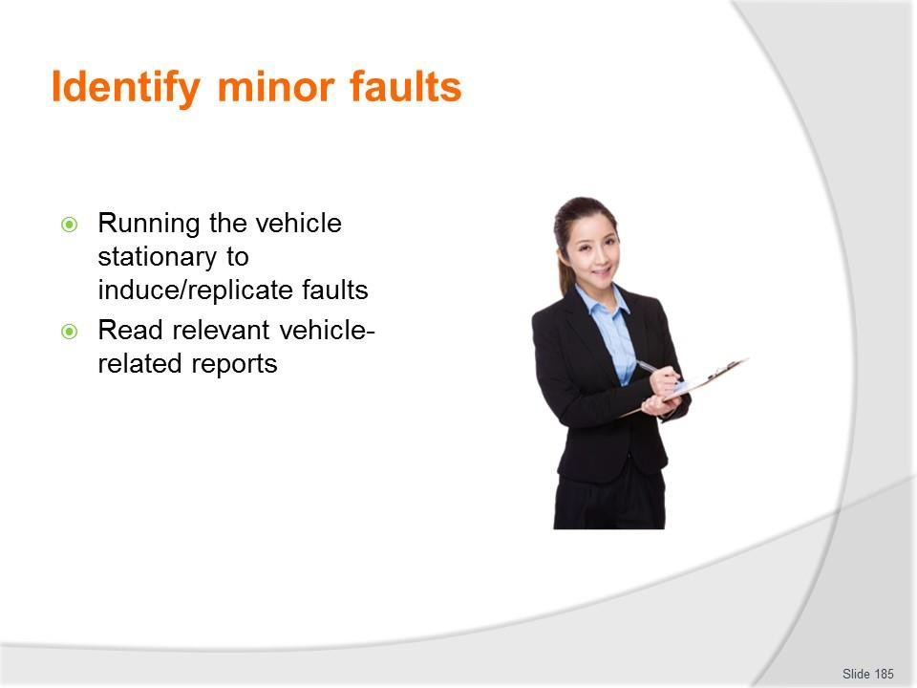
Slide No | Trainer Notes
185. | Trainer continues identifying ways to identify vehicle faults:  - Running stationary vehicle to induce fault – which may involve:  - Applying handbrake and/or chocking vehicle  - Running vehicle from a cold start  - Starting vehicle from a hot start  - Running vehicle with nominated accessories turned ’on’ (and/or ‘off’) as required  - Running vehicle for nominated period of time  - Monitoring/observing vehicle from inside and/or outside of the vehicle  - Reading reports which have been prepared on the vehicle – such as:  - Roadworthy/unroadworthy certificates  - Vehicle defect notices  - Service reports  - Daily vehicle inspection checklists  - End of Tour reports  - Damage reports  - Maintenance requests  - Usage log.

Classroom Activity – Handouts
Trainer distributes and discusses examples of reports/documents identified on the slide.

Slide
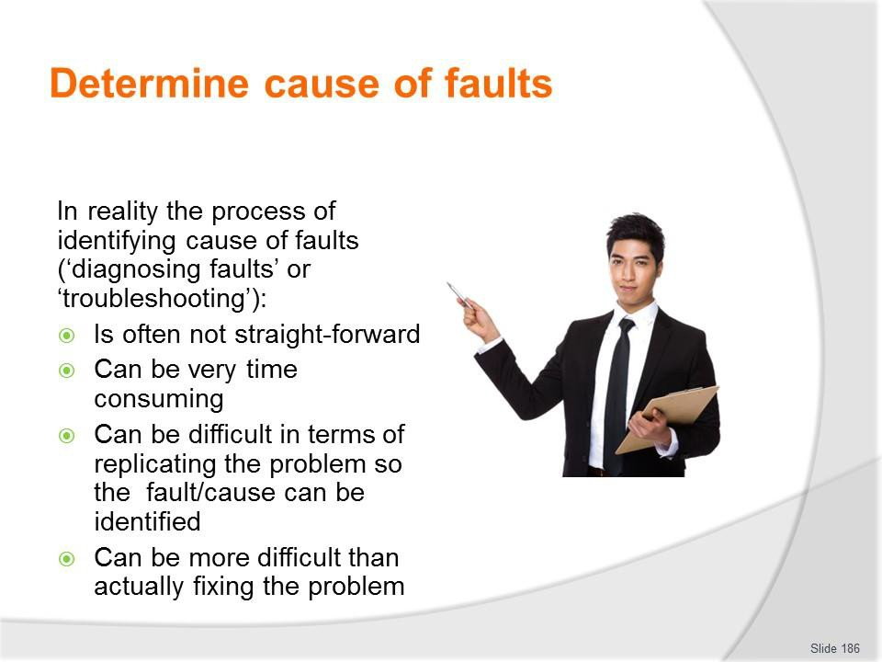
Slide No | Trainer Notes
186. | Trainer provides context stating:  - Identifying the cause of faults may also be known as:  - ‘Diagnosing’ faults  - ‘Troubleshooting’  - In many cases the reality of this stage is:  - It is not straight-forward  - The process can be very time consuming  - It is difficult to re-produce the fault so the cause can be found  - It can be harder to determine the cause than it is to fix the fault.

Slide
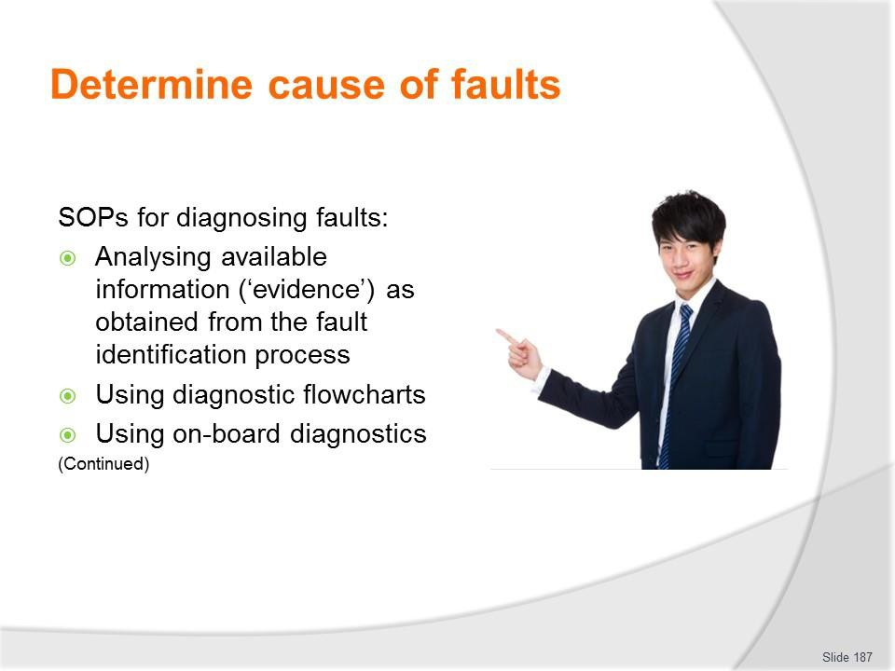
Slide No | Trainer Notes
187. | Trainer presents SOPs for diagnosing faults:  - Analysing available information (‘evidence’) as obtained from the fault identification process to provide a list of tests to perform in order to:  - Generate/cause the fault  - Test options  - Eliminate possible causes in a structured and sequential, one-at-a-time basis  - Identify causes  - Using diagnostic flowcharts – as provided by manufacturers for different parts/components of the vehicle  - Using on-board diagnostics (OBD) – which require a purpose-built scanning tool to (reader) be plugged into the on-board computer to display and interpret a Diagnostic Trouble Code which describes the fault.  Classroom Activity – Demonstration and Practical  Trainer shows students how to undertake activities listed on the slide and provides an opportunity for them to do the same.

Slide
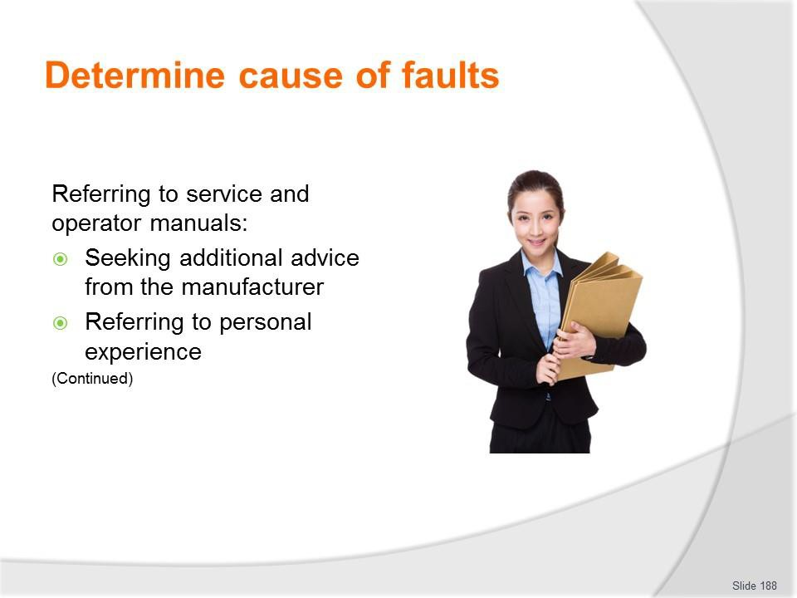
Slide No | Trainer Notes
188. | Trainer continues presenting SOPs for diagnosing faults:  - Referring to service and operator manuals – as most minor faults can be determined with reference to these books  - Seeking additional advice from the manufacturer – which may take the form of:  - On-line advice – using:  - Free, password protected access to contracted assistance provided as part of new vehicle purchase  - Fee-for-service specialist advice  - Over the phone assistance – from the manufacturer or the agent/business that sold the vehicle  - In-person help – which may include:  - Talking face-to-face with the Service Manager at the agency  - Taking the vehicle in to the business for one of the mechanics to look at and give free-of-charge advice on – this is a viable option where the organisation purchases significant vehicles from the one car dealership and/or where a ‘preferred supplier’ arrangement exists with the business  - Referring to personal experience – the more experience a person has in diagnosing faults, the greater their pool of experience becomes  - This personal experience generates a useful source of information as it is based on ‘legitimate’, first-hand practice.

Classroom Activity – Demonstration and Practical
Trainer shows students how to undertake activities listed on the slide and provides an opportunity for them to do the same.

Slide
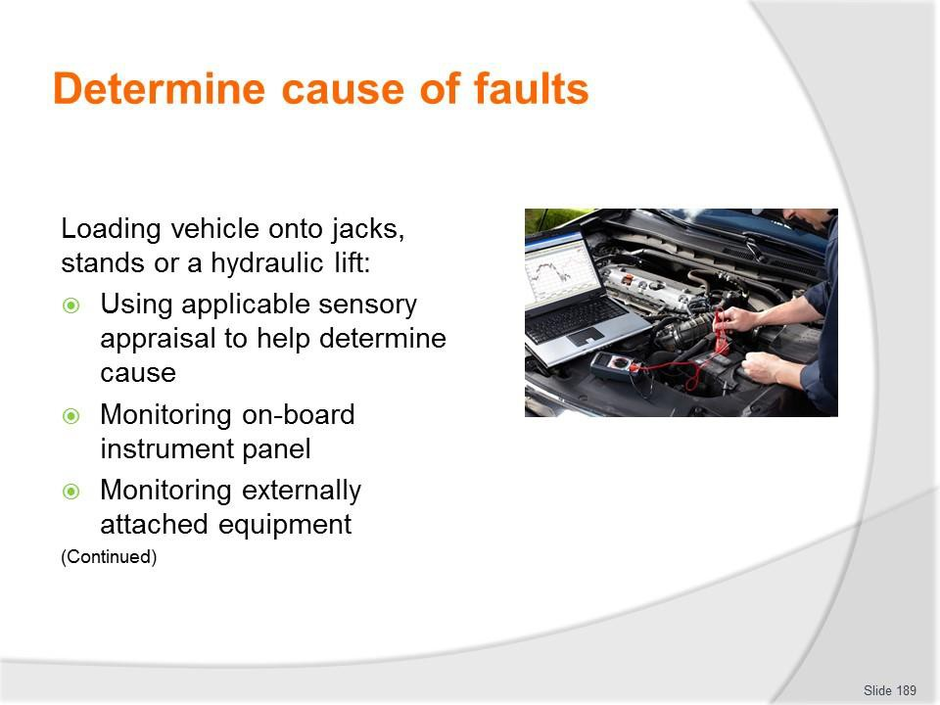
Slide No | Trainer Notes
189. | Trainer continues presenting SOPs for diagnosing faults:  - Loading vehicle onto jacks, stands or a hydraulic lift – in order to:  - Get a better look at the vehicle and be able to see ‘up and under’ it and the engine bay Certainly, raised vehicles always make it easier to identify the location of leaks and drips; Free up certain suspension components;  - Make it easier to manipulate other parts of the vehicle  - Using applicable sensory appraisal to help determine cause – this is similar to using the senses to help identify a fault in the first place, and can (depending on the issue) rely on:  - Sight; Feel; Smell; Hearing  - Monitoring on-board instrument panel – which can mean watching and interpreting the readings of:  - Temperature gauges; Tachometers; Oil pressure; Battery charge  - Monitoring externally attached equipment – such as:  - Various diagnostic tools; Battery/alternator testers; Vacuum and fuel pump testers; Electronic brake service tool; Compression test; Circuit testers and multi-meters.  Classroom Activity – Demonstration and Practical  Trainer shows students how to undertake activities listed on the slide and provides an opportunity for them to do the same.

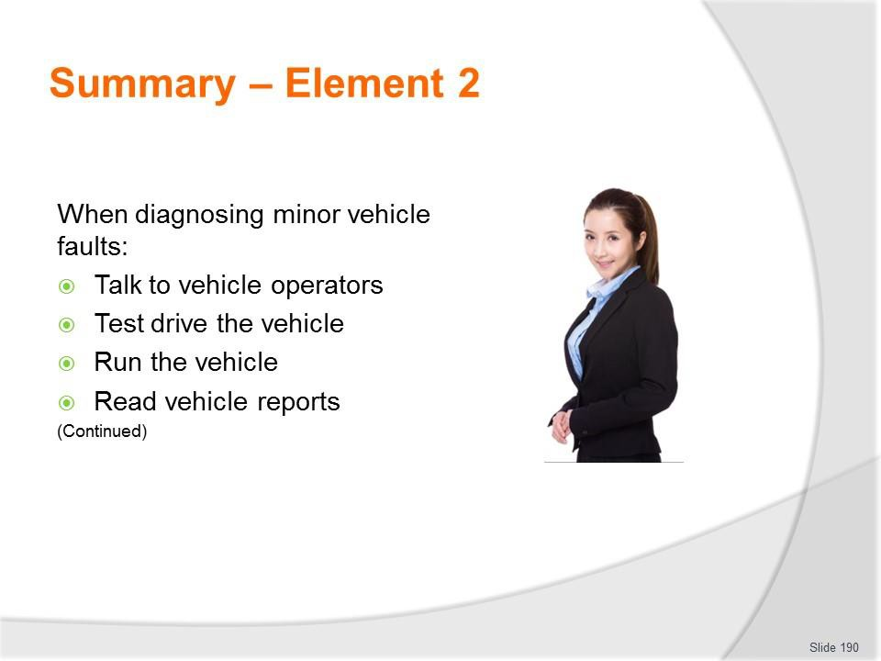
Slide
Slide No
Trainer Notes
190.
Trainer provides a recap of the Element asking questions to check trainee understanding and responding to questions from trainees, as required.

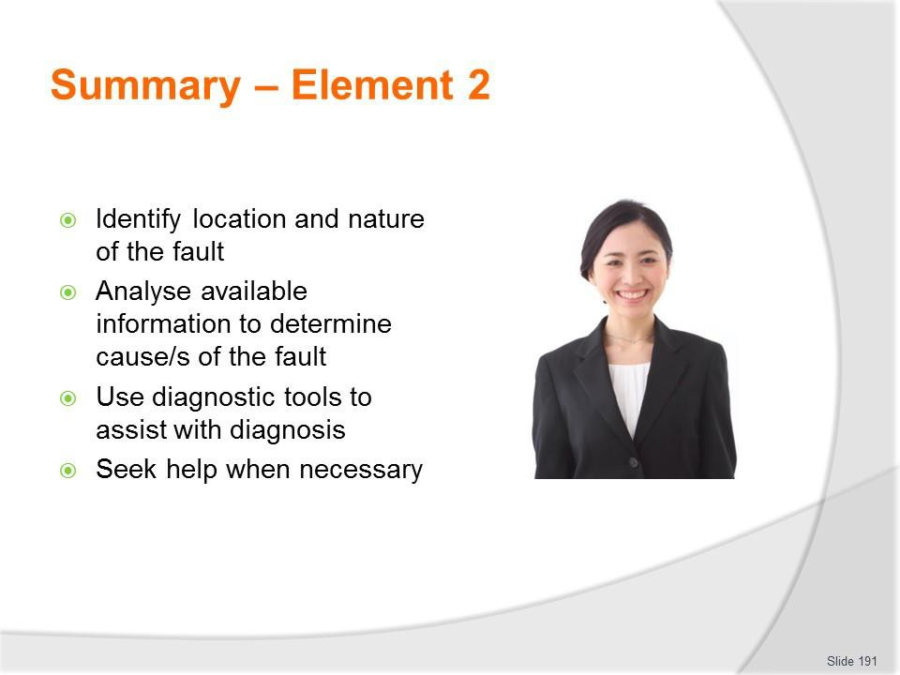
Slide
Slide No
Trainer Notes
191.
Trainer provides a recap of the Element asking questions to check trainee understanding and responding to questions from trainees, as required.

Slide
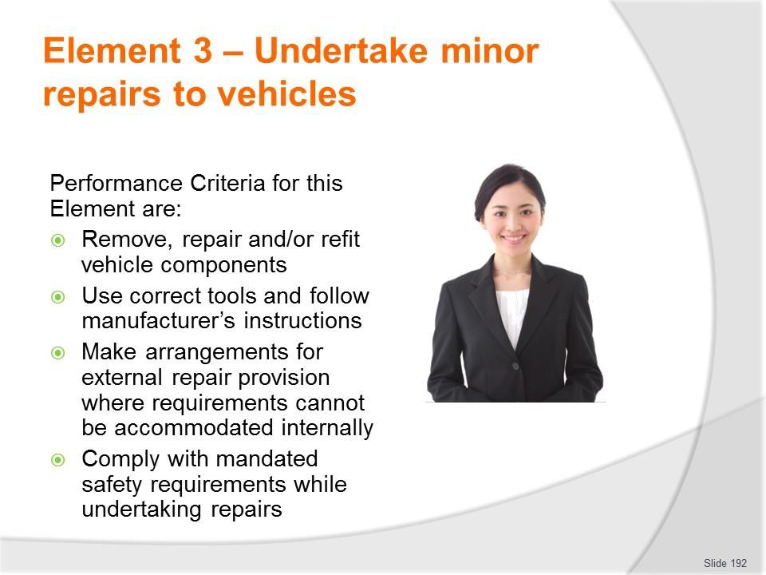
Slide No | Trainer Notes
192. | Trainer identifies for trainees the Performance Criteria for this Element, as listed on the slide.  Class Activity – General Discussion  Trainer leads a general class discussion by asking questions such as:  - What experience do you have in undertaking minor repairs?  - Where have you performed these repairs?  - What vehicles did you work on and what repairs did you complete?

Slide
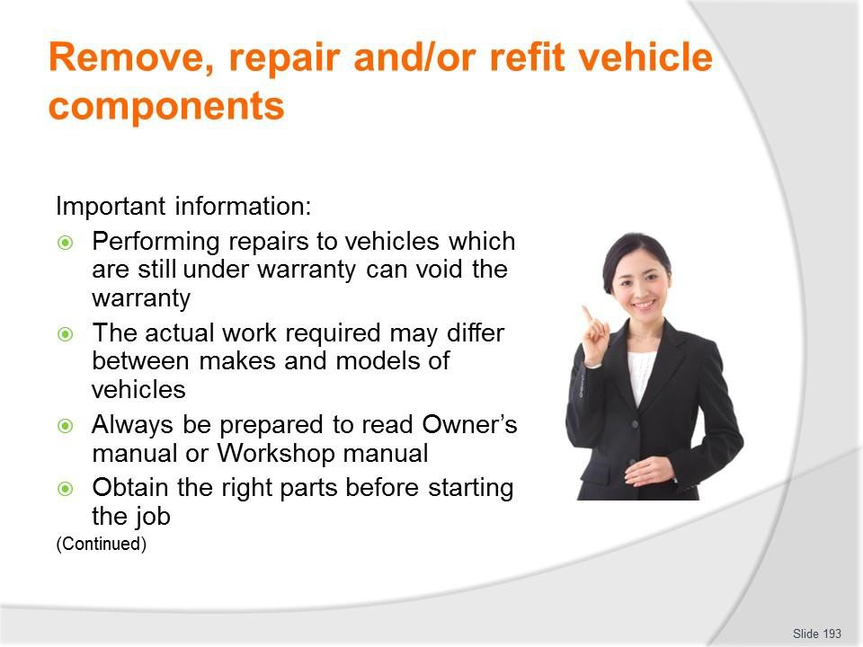
Slide No | Trainer Notes
193. | Trainer provides important background information to this Element:  - Performing repairs to vehicles which are still under warranty can void the warranty – so there is a need to check this before proceeding any further  - The actual work required may differ between makes and models of vehicles – the procedures listed in the notes are indicative only  - Always be prepared to read Owner’s manual or Workshop manual  - Obtain the right parts before starting the job.

Slide
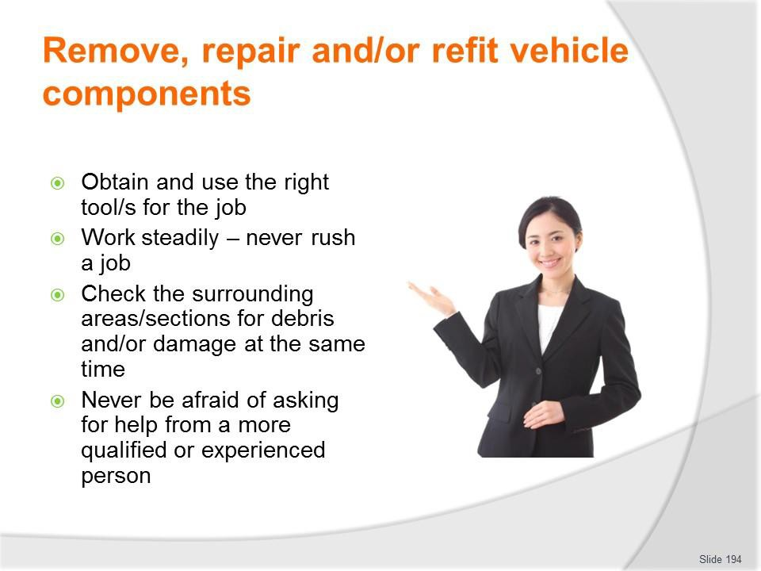
Slide No | Trainer Notes
194. | Trainer provides important background information to this Element:  - Obtain and use the right tool/s for the job  - Work steadily – never rush a job  - Check the surrounding areas/sections for debris and/or damage at the same time – and respond as indicated  - Never be afraid of asking for help, advice or direction from a more qualified or experienced person.

Slide
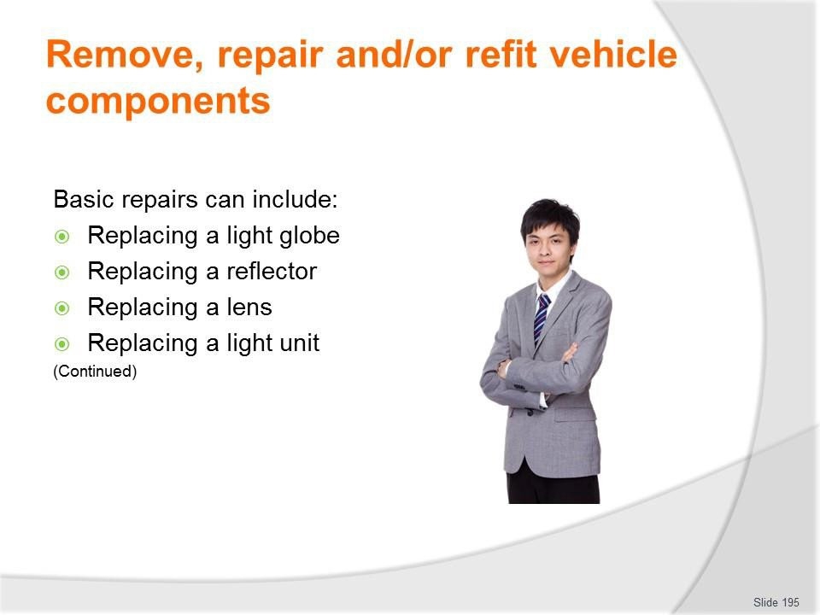
Slide No | Trainer Notes
195. | Trainer identifies range of basic repairs to be made:  - Replacing a light globe  - Replacing a reflector  - Replacing a lens  - Replacing a light unit.  Classroom Activity (1) – Demonstration and Practical  Trainer shows students how to undertake activities listed on the slide and provides an opportunity for them to do the same.  Classroom Activity (2) – internet Research  Trainer facilitates research and discussion of: http://www.supercheapauto.com.au/how-to/Outside-the-Car/Checking-and-Changing-  an-Automotive-Light-Globe.aspx?id=79 – Check and change an automotive light globe  https://www.youtube.com/watch?v=6hURsa46t4M – How to change a headlight bulb https://www.youtube.com/watch?v=jk1kFc56dwk – How to replace headlight bulbs https://www.youtube.com/watch?v=cB99QN1AYBU – Install/replace front reflector  https://www.youtube.com/watch?v=mgGWFqPe0Ms – Headlight bulb replacement service: 2005 Honda CRV

https://www.youtube.com/watch?v=5F31wzh60zo – How to replace taillight https://www.youtube.com/watch?v=9POigqpLxQc – How to replace fog light and bulb.

Slide
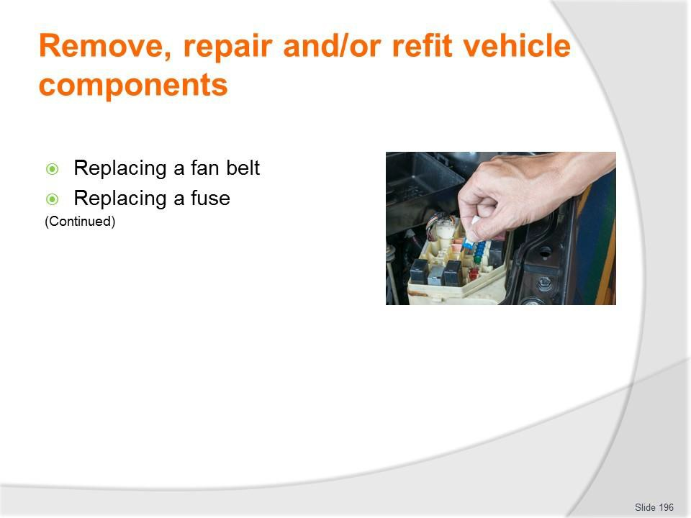
Slide No | Trainer Notes
196. | Trainer continues identifying range of basic repairs to be made:  - Replacing a fan belt  - Replacing a fuse.  Classroom Activity (1) – Demonstration and Practical  Trainer shows students how to undertake activities listed on the slide and provides an opportunity for them to do the same.  Classroom Activity (2) – internet Research  Trainer facilitates research and discussion of: https://www.youtube.com/watch?v=4hnOUs9eiN4 – Change a fan belt  http://www.supercheapauto.com.au/how-to/Servicing-Mechanical/Replacing-a-Drive- Belt.aspx?id=76 – Replacing a drive belt  https://www.youtube.com/watch?v=Wg1AX77xEBQ – How to replace a serpentine belt  https://www.youtube.com/watch?v=01J3Fp9_bMA – Replace serpentine belt- Toyota Corolla  https://www.youtube.com/watch?v=XD0LNkFYPGQ – Toyota timing belt http://www.wikihow.com/Change-an-Automotive-Belt. https://www.youtube.com/watch?v=kOXeo-kqg68 – Replace a blown fuse in a car  https://www.youtube.com/watch?v=faWZmG0fXy8 – Replace a blown fuse in a car or truck.

Slide
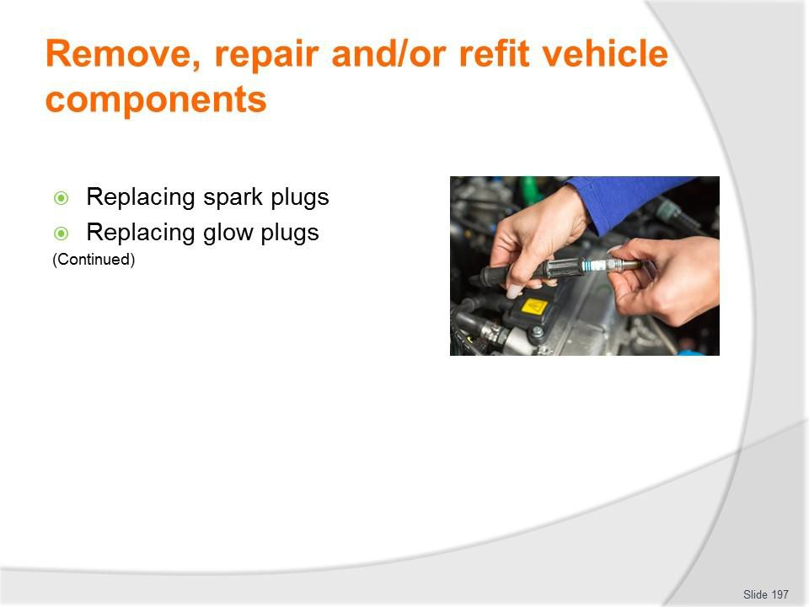
Slide No | Trainer Notes
197. | Trainer continues identifying range of basic repairs to be made:  - Replacing spark plugs  - Replacing glow plugs.  Classroom Activity (1) – Demonstration and Practical  Trainer shows students how to undertake activities listed on the slide and provides an opportunity for them to do the same.  Classroom Activity (2) – internet Research  Trainer facilitates research and discussion of:  http://www.supercheapauto.com.au/how-to/Servicing-Mechanical/Replacing-Spark- Plugs.aspx?id=68 – Replacing spark plugs  https://www.youtube.com/watch?v=jj06A6UdHvI – Changing spark plugs and replacing plug wires  https://www.youtube.com/watch?v=RCcmN-r5Z9M – Replacing glow plugs in a Mitsubishi Delica L400  https://www.youtube.com/watch?v=4Po_1pNHE1Y – Glow plug change https://www.youtube.com/watch?v=4Po_1pNHE1Y – Easy and complete glow plug test.  http://autorepair.about.com/od/enginerelateddiyjobs/l/aa081404a.htm - How to replace your diesel glow plugs

Slide
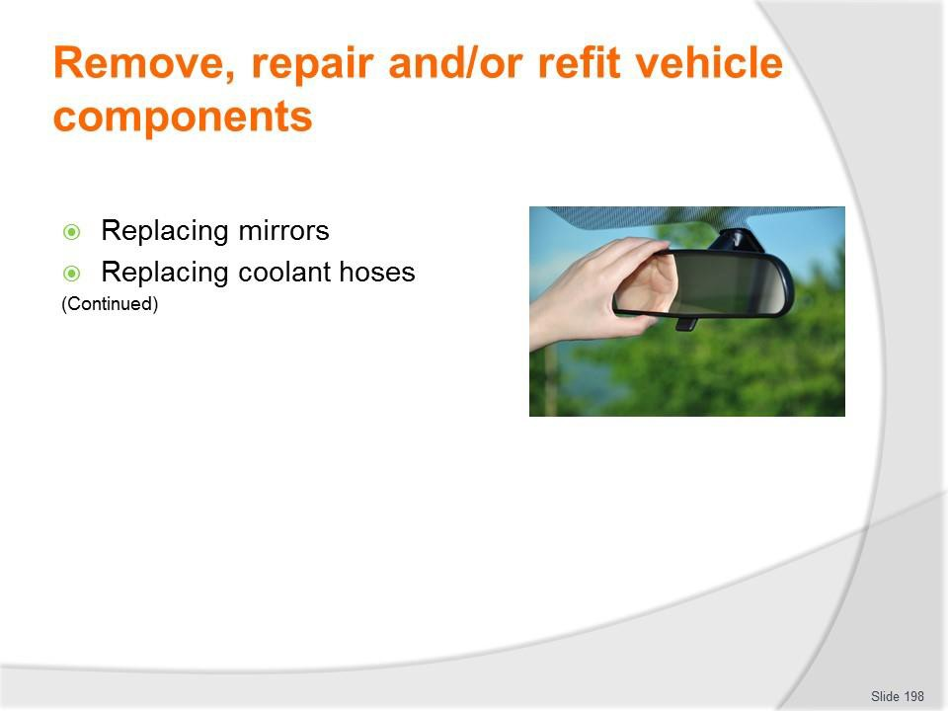
Slide No | Trainer Notes
198. | Trainer continues identifying range of basic repairs to be made:  - Replacing mirrors  - Replacing coolant hoses.  Classroom Activity (1) – Demonstration and Practical  Trainer shows students how to undertake activities listed on the slide and provides an opportunity for them to do the same.  Classroom Activity (2) – internet Research  Trainer facilitates research and discussion of: https://www.youtube.com/watch?v=U-1y8NIEhKM – Auto side mirror replacement  https://www.youtube.com/watch?v=77lBQ_CRqdo – Replace passenger side mirror  https://www.youtube.com/watch?v=d8ASeN4rgek – Plastic backed mirror glass installation  https://www.youtube.com/watch?v=D6j8fwGCrHs – Side mirror glass replacement  https://www.youtube.com/watch?v=AGmQ50naiGg – How to replace a radiator hose (upper and lower)  https://www.youtube.com/watch?v=C64z0L9816A – Replacing radiator hose  https://www.youtube.com/watch?v=xH0D22ITjQU – How to replace the upper radiator hose.

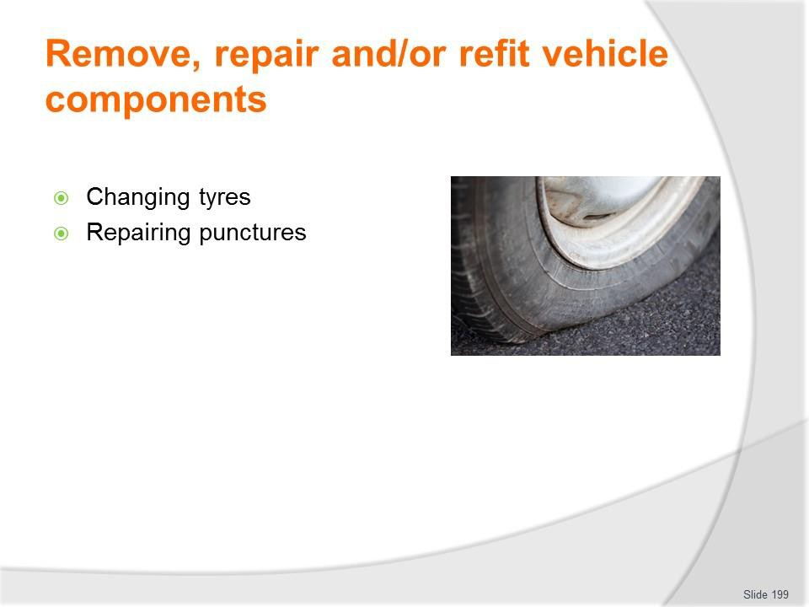
Slide
Slide No
Trainer Notes
199.
Trainer continues identifying range of basic repairs to be made:
- Changing tyres
- Repairing punctures.

Slide
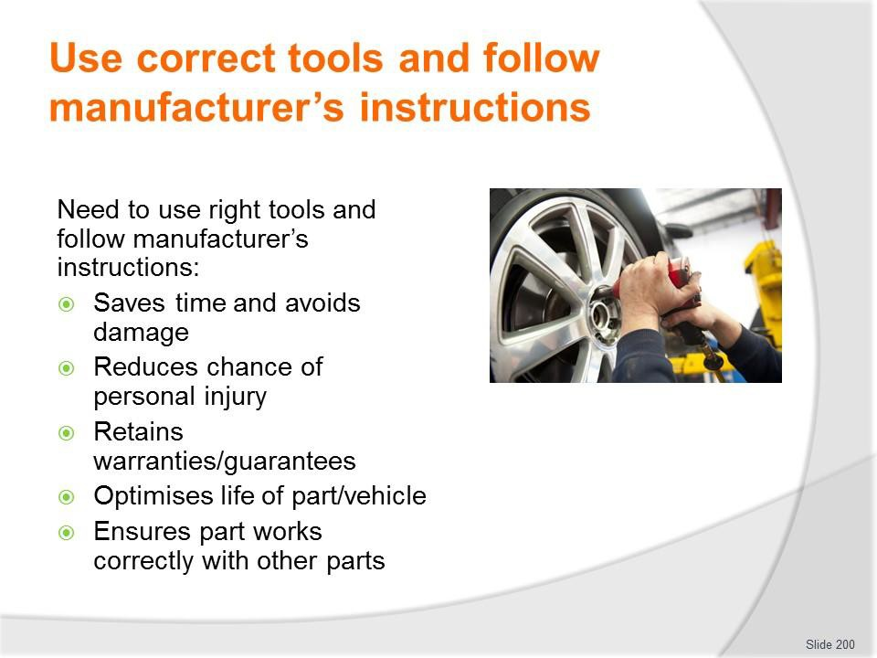
Slide No | Trainer Notes
200. | Trainer identifies reasons to use correct tools and follow manufacturer’s instructions:  - Save time  - Save damage to the item being fitted and/or vehicle  - Reduce potential for personal injury  - Retain parts warranties and guarantees  - Optimise service life of part being fitted  - Ensure part integrates fully/properly with other items.

Slide
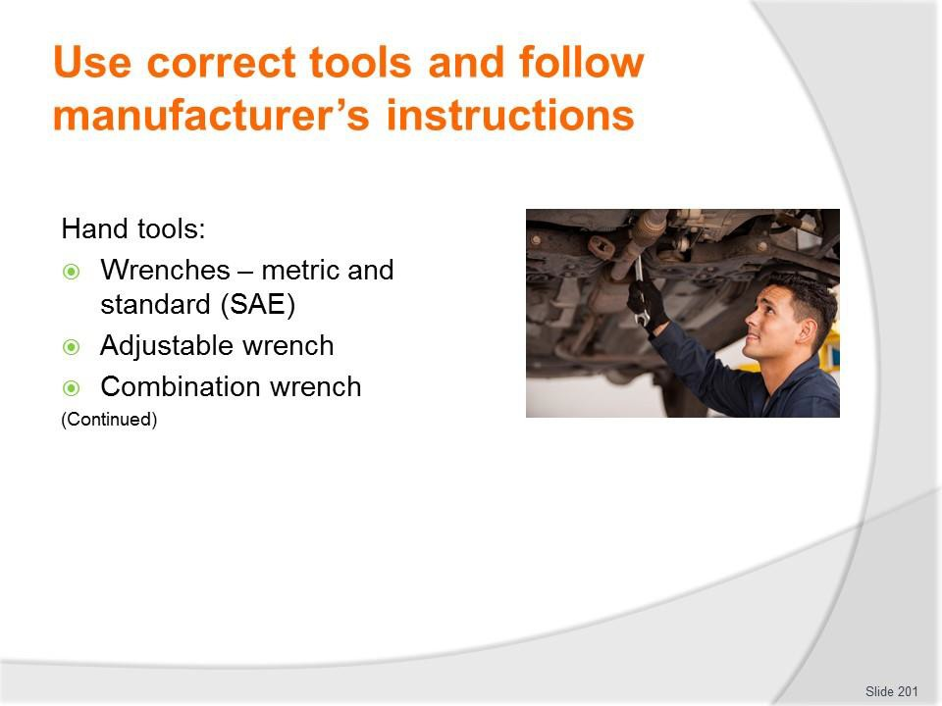
Slide No | Trainer Notes
201. | Trainer identifies range of tools which may be used:  Hand Tools Wrenches  Wrenches come in various sizes and designs. Adjustable, open-end, box-end, combination, and specialty wrenches are important tools to have when performing basic maintenance and repair. Both metric and standard (aka SAE) fixed jaw wrenches should be included in a basic tool kit.  Wrench Size  Metric sizes commonly increase by 1 millimeter (mm) for each wrench size increase. For example, a metric wrench set may have the following sizes: 7mm, 8mm, 9mm, 10mm, 11mm, 12mm, 13mm, 14mm, 15mm, etc. Standard wrenches commonly increase by 1/16” for each wrench size increase. Note: A quote mark ( ” ) is a symbol for inch units. For example, a standard wrench set may have these sizes: 1/4”, 5/16”, 3/8”, 7/16”, 1/2”, 9/16”, 5/8”, 11/16”, 3/4”, etc. The size corresponds to the distance between the two jaws in an open-end wrench.  Adjustable Wrench  An adjustable wrench is versatile. The jaw can be adjusted to fit metric or standard nuts and bolts. However, it does not fit as snugly on the fastener as a fixed sized jaw wrench. In addition, the head of an adjustable wrench may not fit in all locations and is not as strong. An adjustable wrench is sometime called a Crescent wrench (an industry brand name). If you are going to have only one wrench in your tool box, choose an adjustable wrench.

Combination Wrench
The two most common types of wrench ends are box and open. A combination wrench will have a box-end on one end and an open-end on the other. The box-end usually has 6-points or 12-points. Use the box-end 6-point when a great amount of torque is required to reduce the chance of stripping the fastener (i.e., a nut or bolt). An open-end is handy when the fastener position will not allow access with the box-end.
Classroom Activity – Example, Demonstration and Practical
Trainer presents example/s of items identified on the slide, demonstrates their use when repairing vehicles and gives students an opportunity to do the same.

Slide
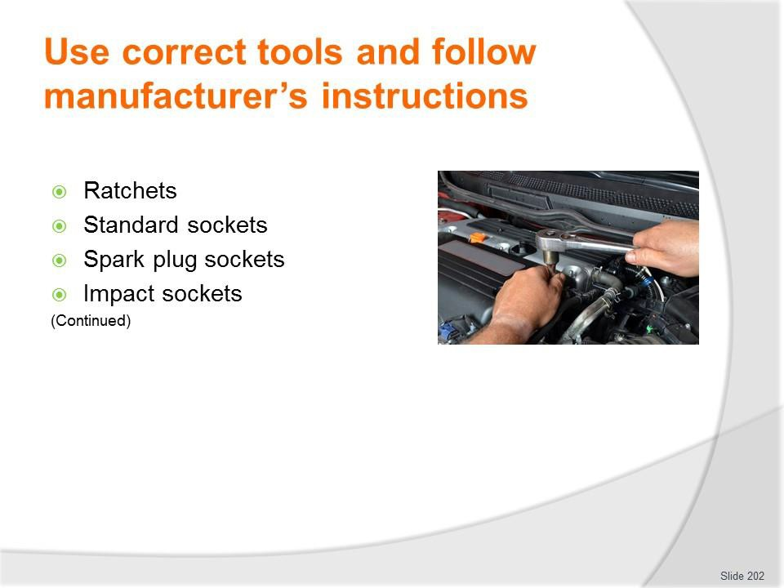
Slide No | Trainer Notes
202. | Trainer continues identifying range of tools which may be used:  Ratchets  Ratchets in combination with sockets are used to quickly turn nuts and bolts. A ratchet is basically a lever with a pivoting mechanism. The pivoting mechanism allows the user to tighten or loosen a fastener without removing the tool. Ratchets are sized according to the square driver head. For example, 1/4” drive ratchets have driver heads that are 1/4” x 1/4”. Common ratchet sizes are 1/4”, 3/8”, and 1/2”. A 3/8” ratchet is the most common size that many do-it-yourselfers include in their basic tool kit.  Standard Sockets  Sockets can be directly connected to the ratchet or first connected to a universal joint or driver extension. Sockets are classified as regular or deep well. Deep well sockets can fit over the threads of a long bolt. Sockets, like wrenches, have points inside that fit over the fastener and come in both metric and standard sizes. Common sockets will have either 6-points or 12-points.  Spark Plug Sockets  Some sockets are specially designed. For example, spark plug sockets have rubber boot inserts to protect the plug from cracking and to keep it centered.  Impact Sockets  Impact sockets should be used to avoid shattering standard sockets in situations where high torque and speed are needed, especially when using an electric or pneumatic (air powered) impact wrench. Impact sockets can be identified by their black color and thicker sides.

Classroom Activity – Example, Demonstration and Practical
Trainer presents example/s of items identified on the slide, demonstrates their use when repairing vehicles and gives students an opportunity to do the same.

Slide
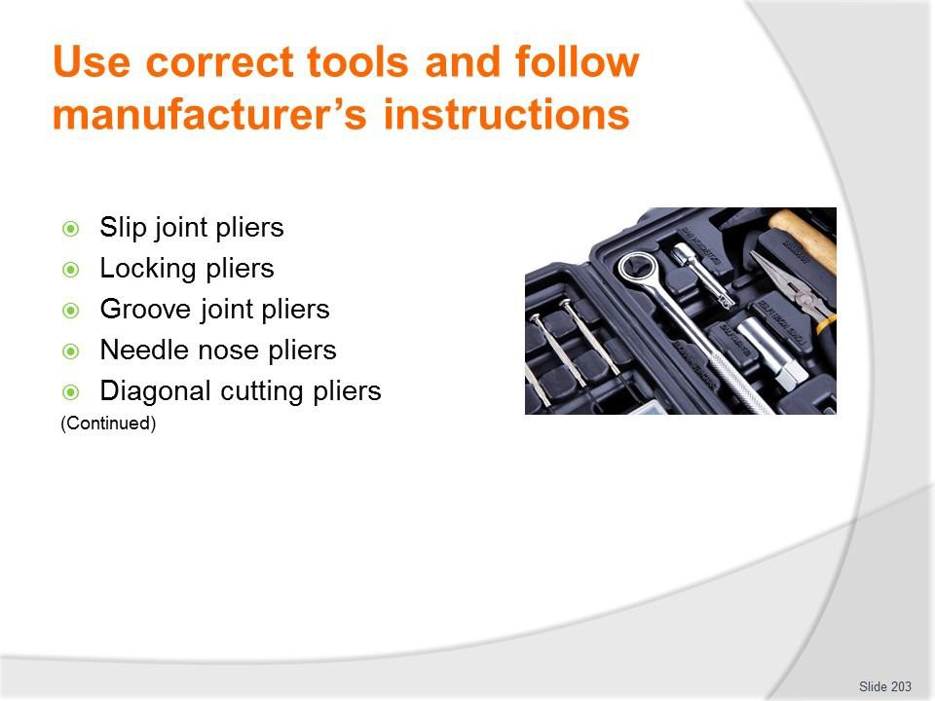
Slide No | Trainer Notes
203. | Trainer continues identifying range of tools which may be used:  Pliers  Pliers are handy adjustable tools that can be used in a variety of situations. Pliers are used to grab, turn, cut, or bend. Several types include: slip joint, locking, groove joint, needle nose, and diagonal cutters. Pliers consist of two levers that pivot at one point. This pivoting point is called a fulcrum.  Slip Joint Pliers  Slip joint pliers are one of the most basic and versatile hand tools. However, do not use slip joint pliers in situations where a wrench would be better (e.g., turning a nut or bolt). Trying to loosen a stubborn nut with slip joint pliers can strip the head or if the pliers slip, bruise your knuckles.  Locking Pliers  Locking pliers are sometimes called Vise-Grips, a brand name in the industry. Locking pliers are used to tightly grip and then lock on the fastener. These pliers come in handy when a bolt or nut is already stripped beyond the point where a wrench no longer works. Grabbing onto flat pieces of metal or oddly shaped items are additional functions of locking pliers.  Groove Joint Pliers  Also called adjustable pliers or Channellocks (an industry brand name), groove joint pliers adjust to a wide range of sizes. These are especially useful for gripping cylindrical objects, like pipes.

Needle Nose Pliers
Needle nose pliers have long pointed jaws. These can be used to grip or pull objects that are in hard-to-reach areas. Next to the fulcrum is also a cutting mechanism to cut wire or other objects.
Diagonal Cutting Pliers
Also called side cutters, diagonal cutters have sharp cutters instead of gripping jaws like most pliers. They are commonly used for cutting wires.
Classroom Activity – Example, Demonstration and Practical
Trainer presents example/s of items identified on the slide, demonstrates their use when repairing vehicles and gives students an opportunity to do the same.

Slide
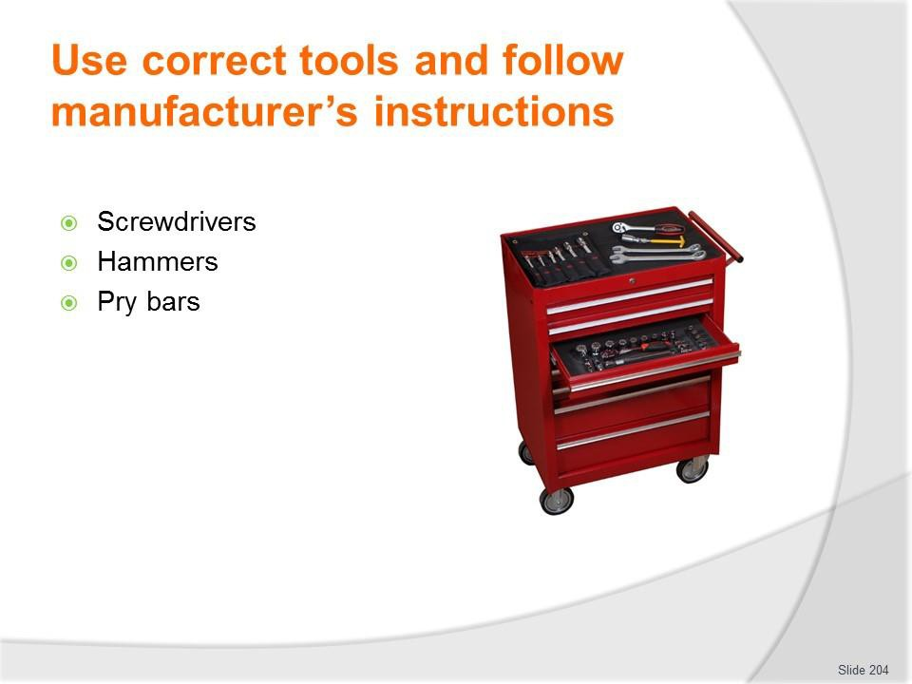
Slide No | Trainer Notes
204. | Trainer continues identifying range of tools which may be used:  Screwdrivers  Just about everyone is familiar with screwdrivers. They turn screws or other fasteners. Some screwdrivers have magnetic tips to help with positioning fasteners in tight spaces. The head of a fastener determines the type and size of screwdriver tip that is needed.  The proper tip will fit in a fastener head snugly. Damage or tool slippage may occur if an incorrect sized tip is used. Common types of screwdriver tips include Phillips, slotted, square, Allen, Torx, and hex. Various types of screwdriver tips are also made as bits that can be placed in a 1/4” socket for ratcheting in tight places.  Hammers  Sometimes what you are working on needs a little more persuasion. Using the correct hammer will ensure that you don’t damage components. A ball peen hammer, a favorite hammer by many technicians, is commonly used to drive a chisel or a punch. A rubber mallet, a hammer with a rubber head, comes in handy to drive on stubborn wheel covers and other parts without damaging them.  Pry Bars  Pry bars are long bars with handles that come in a variety of sizes and styles. They can be useful when trying to leverage a component that is heavy or stuck.  Classroom Activity – Example, Demonstration and Practical  Trainer presents example/s of items identified on the slide, demonstrates their use when repairing vehicles and gives students an opportunity to do the same.

Slide
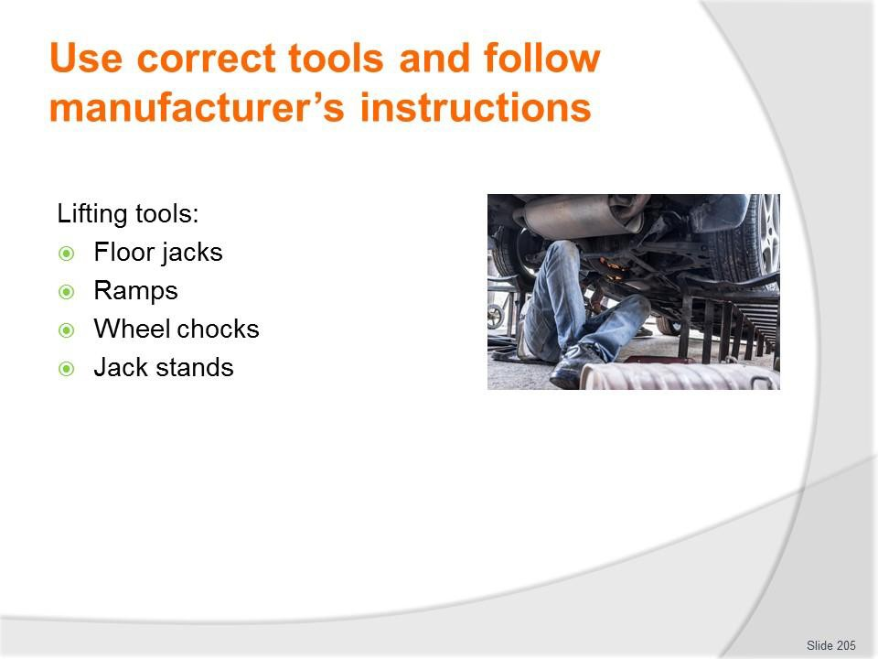
Slide No | Trainer Notes
205. | Trainer continues identifying range of tools which may be used:  Lifting Tools  When performing work under a vehicle it is often necessary and convenient to raise the vehicle off the ground with a floor jack and jack stands or drive-on ramps. Work safely by using lifting equipment on a surface that is solid and chock at least one wheel still on the ground. Warning: Lifting equipment ratings should exceed the weight of the vehicle being lifted.  Floor Jack  A floor jack is used to lift a vehicle. Be sure to place the jack’s lifting pad under the frame or other solid chassis component. Lifting the vehicle by the body’s sheet metal underbody will damage the vehicle and make it more likely to fall off the jack. Warning: To prevent serious injury or death jack stands should be used. Do not go under a vehicle that is only supported by a jack.  Ramps  Drive-on ramps can make raising one end of your vehicle very easy. All you need to do is line the ramps up in front of your tyres, drive onto them, set your emergency brake, and chock one wheel remaining on the ground. Since the vehicle is still resting on its tyres, don’t plan on doing any wheel work. Ramps are convenient for oil changes and undercarriage inspections.

Wheel Chocks
To prevent a vehicle from moving forward or backward, wheel chocks are used to block a wheel when jacking. Place the wheel chocks in front and in back of a wheel that is not being lifted.
Jack Stands
Jack stands are used to hold a vehicle up after a jack has raised it. Warning: Do not use concrete blocks or other non-approved stands to hold up a vehicle.
Classroom Activity – Example, Demonstration and Practical
Trainer presents example/s of items identified on the slide, demonstrates their use when repairing vehicles and gives students an opportunity to do the same.

Slide
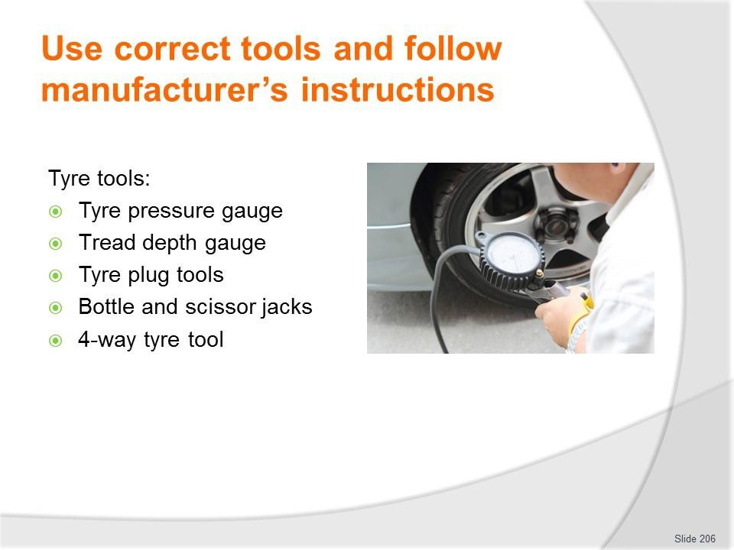
Slide No | Trainer Notes
206. | Trainer continues identifying range of tools which may be used:  Tyre Tools  Tyre Pressure Gauges  tyre pressure is measured with tyre pressure gauges and should be checked often. A dial gauge is more accurate than a stick gauge. A recommended tyre pressure is calculated according to the tyre type, vehicle weight, and the desired ride. Look in your driver’s side door for a tyre placard that lists the correct tyre pressure. Maintaining the recommended tyre pressure is critical to minimizing tyre wear and optimizing handling stability. For every 10 degrees temperature drop, tyre pressure drops by 1 psi. The inverse also occurs as temperature rises.  Tread Depth Gauge  A tread depth gauge is a simple measuring devise to help determine the actual amount of tread remaining on your tyres. It provides a depth reading within 1/32nd’s of an inch from the top of the tread surface to the bottom of the tread groove. When that reading is less than 1/16th of an inch, new tyres are needed.  Tyre Plug Tools  tyre plug tools make it possible to plug holes smaller than 1/4” in diameter in the tread of a tyre without taking the tyre off the rim. The plug rasp tool prepares the hole for the plug and the insert tool installs the plug.

Bottle and Scissor Jacks
Most newer vehicles have a scissor or bottle jack stored in the trunk for emergency tyre changes. These manufacturer supplied jacks are not as easy or as safe to use as a hydraulic floor jack. Save them for roadside emergencies and invest in a hydraulic jack for your garage.
4-Way Tyre Tool
A 4-way tyre tool is more versatile for removing lug nuts than the basic manufacturer lug wrench (aka tyre iron) supplied with your vehicle. A 4-way has a different sized wrench on each end. It is also easier to use because the design provides more leverage and you can spin the lug nuts off quicker.
Classroom Activity – Example, Demonstration and Practical
Trainer presents example/s of items identified on the slide, demonstrates their use when repairing vehicles and gives students an opportunity to do the same.

Slide
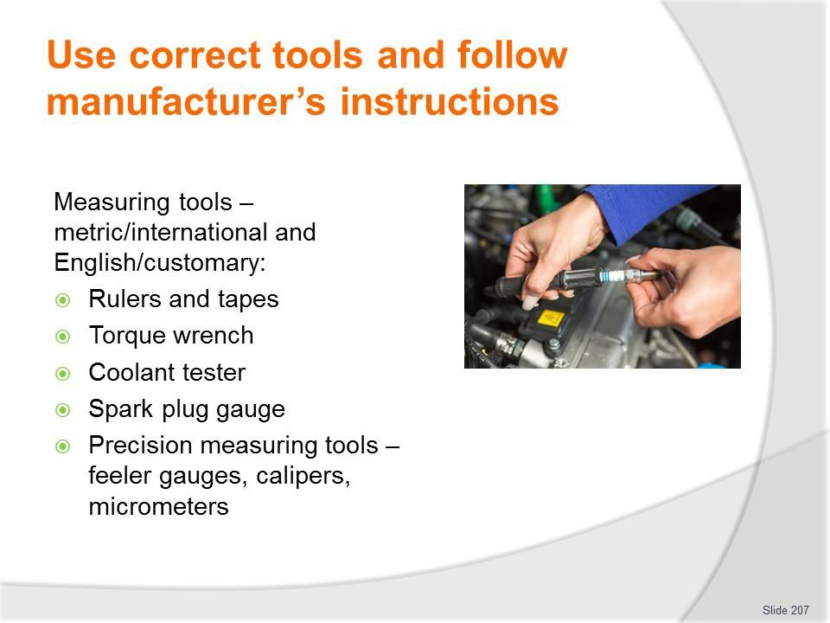
Slide No | Trainer Notes
207. | Trainer continues identifying range of tools which may be used:  Measuring Tools  Measuring accurately requires the use of measuring tools like rulers, gauges, and micrometers. In the United States two systems of measurement are often used: the metric (aka International) system and the English (aka Customary) system.  Rulers  Rulers are used to measure linear distances. Measuring tapes are used to measure large distances whereas small rigid rulers are used to measure short linear distances.  Torque Wrench  A torque wrench, either beam or clicker style, can be used to tighten a fastener to a specific amount of force. For example, wheel lug nuts should be tightened to the manufacturer’s specifications. Lug nuts that are not tight enough could loosen over time, while lug nuts that are too tight are hard to remove, can warp brake rotors, and can damage the stud’s threads. A torque wrench is critically important when completing internal engine repairs.  Coolant Tester  A coolant tester measures specific gravity to determine if the cooling system contains the correct mixture of antifreeze to water. To draw coolant up into the tester, squeeze the bulb while the tube end is inserted in the radiator. An indicator inside the tester floats to give a reading based on the percentage of antifreeze in the coolant.

Spark Plug Gauge
A spark plug gauge tool has various diameter wires for checking the electrode gap and benders to adjust the gap. The gap is the distance between the center and side electrodes on the spark plug. A spark must arc across the gap in order to ignite the air- fuel mixture in a cylinder. The correct gap is located on the EPA sticker in the engine compartment.
Precision Measuring Tools
Feeler gauges, calipers, micrometers, and dial indicators are used to obtain very precise measurements. These tools can provide measurements to the nearest thousandths (0.001) of an inch or to the nearest hundredths (0.01) of a millimeter. Feeler gauges consist of flat metal blades that are a specific thickness. You can put several feeler blades together to obtain a desired thickness. For example, if you needed to obtain a thickness of 0.045”, you could put the 0.025” and 0.020” together. A caliper is an especially versatile measuring tool able to measure inside, outside, and depth dimensions. However, when extremely precise measurements are required consider using a micrometer. Micrometers are particularly good for measuring the diameter of objects.
Classroom Activity – Example, Demonstration and Practical
Trainer presents example/s of items identified on the slide, demonstrates their use when repairing vehicles and gives students an opportunity to do the same.

Slide
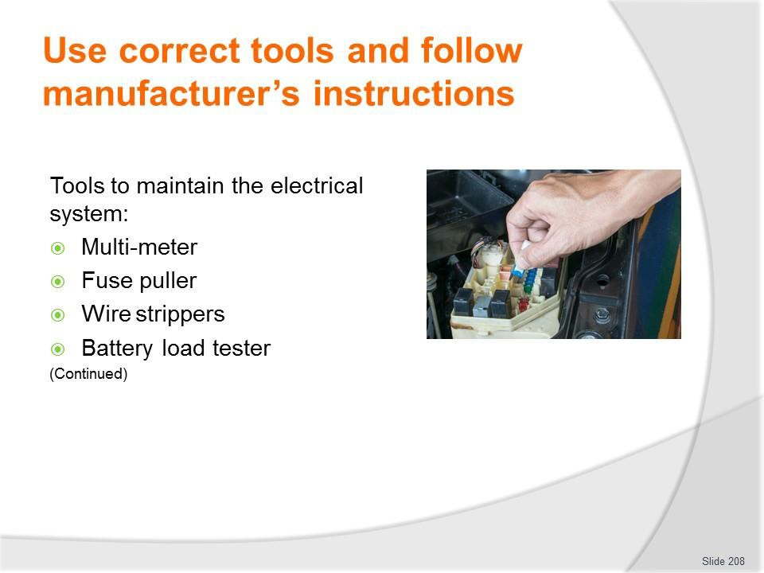
Slide No | Trainer Notes
208. | Trainer continues identifying range of tools which may be used:  Electric Tools  If you plan to maintain a vehicle’s electrical system some electrical tools will be necessary. At the very least every vehicle should carry a set of jumper cables.  Multimeters  Multimeters make a great addition to any toolbox. Multimeters can be used to measure voltage, resistance, and amperage.  Fuse Puller  Fuses are fairly small, very close to one another in a fuse junction block, and often tightly held making it difficult to pull them out. A fuse puller is a small plastic device designed to grasp a fuse so it can be pulled out easily.  Wire Strippers  Wire strippers can be used to remove wire insulation, cut wires, and to crimp solderless connectors and terminals.  Battery Load Tester  A battery load tester is a specialty tool used to evaluate a battery’s condition. The tester should be set to the battery’s temperature and cold-cranking amperage (CCA) rating to receive accurate results. Note: Some automotive part stores will test your battery for free.

Classroom Activity – Example, Demonstration and Practical
Trainer presents example/s of items identified on the slide, demonstrates their use when repairing vehicles and gives students an opportunity to do the same.

Slide
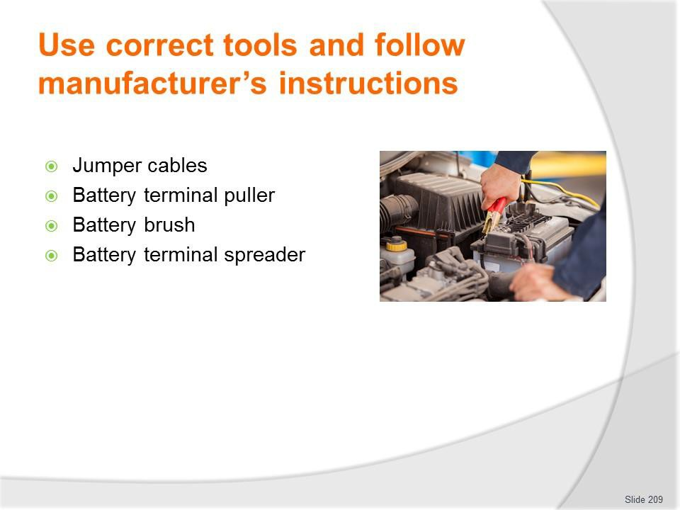
Slide No | Trainer Notes
209. | Trainer continues identifying range of tools which may be used:  Jumper Cables  A battery can discharge simply by leaving your lights on or a door ajar. You should know how to properly hook up jumper cables in case of an emergency. For step-by-step procedures on safely hooking up jumper cables see your owner’s manual and the  Jump-Starting Activity. Warning: Incorrectly jump-starting a battery can be dangerous. If cables are hooked up incorrectly the battery could explode or electrical components could fry.  Battery Terminal Puller  The battery terminal puller is designed to remove a stubborn or corroded battery terminal clamp, after the battery terminal nut has been loosened, without causing damage to the battery terminal post. The lower jaws of the puller are placed under the battery terminal clamp and then the top lever is turned to lower the center screw onto the terminal post until it forces the clamp free. This type of puller is only used on top post batteries.  Battery Brush  Once the battery terminal clamps have been disconnected from the battery posts, use battery brushes to scrape off any visible white or light colored corrosive powder. Rotate the external wire battery brush inside each clamp and the internal wire battery brush over each post.

Battery Terminal Spreader
The battery terminal spreader is specially designed to spread battery terminal post clamps. They can also be used to scrape corrosion from the inside of terminal clamps.
Classroom Activity – Example, Demonstration and Practical
Trainer presents example/s of items identified on the slide, demonstrates their use when repairing vehicles and gives students an opportunity to do the same.

Slide
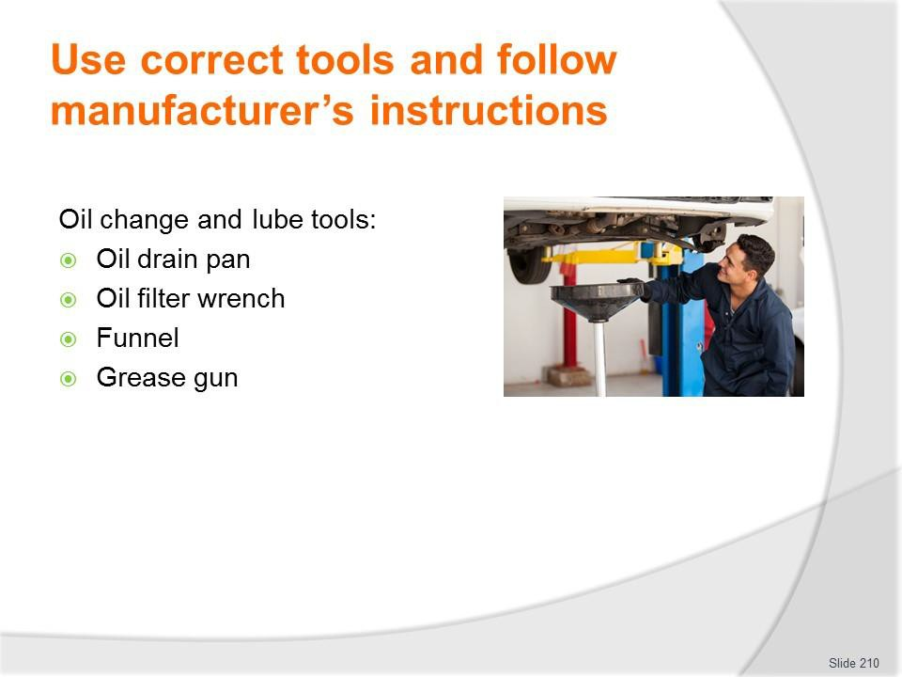
Slide No | Trainer Notes
210. | Trainer continues identifying range of tools which may be used:  Oil Change and Lube Tools  To perform an oil change and lubrication you will need a socket or wrench to remove the drain plug, lifting equipment, an oil drain pan, an oil filter wrench, a funnel, and a grease gun.  Oil Drain Pan  An oil drain pan helps to keep used oil from spilling on the floor. A good oil pan will have a wide collection area, a place for the oil filter to set while draining, enough capacity to hold at least one oil change, and a cap to prevent spilling during transportation to an oil recycling facility. Used oil is considered a hazardous waste.  Oil Filter Wrenches  There are mainly two styles of oil filter wrenches. The band filter wrench is made to adjust to several different sized filters within a range. For hard to reach filters get a filter wrench with a swivel handle. The cup oil filter wrench is used with a ratchet for leverage. Select the cup size that fits snugly on your filter.  Funnel  A funnel helps prevent spills when adding oil to the engine. Always make sure the funnel is clean so you don’t contaminate the engine with other fluids or dirt.  Grease Gun  A grease gun, containing a grease cartridge, is used to lubricate steering, suspension, and drivetrain components. A vehicle’s service manual should identify the location of lubrication fittings (if there are any) and the type of grease recommended.

Classroom Activity – Example, Demonstration and Practical
Trainer presents example/s of items identified on the slide, demonstrates their use when repairing vehicles and gives students an opportunity to do the same.

Slide
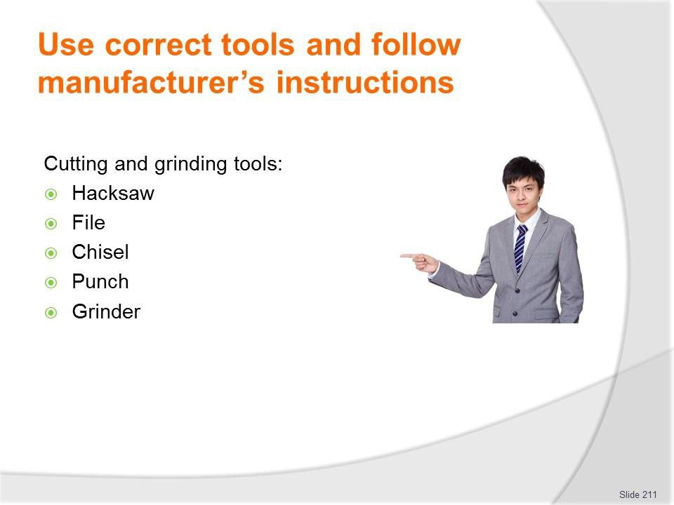
Slide No | Trainer Notes
211. | Trainer continues identifying range of tools which may be used:  Cutting and Grinding Tools  Sometimes it is necessary to remove a piece of metal such as an exhaust pipe or a rusted bolt. To do this, cutting and grinding tools come in handy.  Hacksaw  Hacksaws cut metal using thin blades. Blades commonly have 18, 24, or 32 teeth per inch. Blades with more teeth per inch cut cleaner and slower. Point the teeth away from the handle to cut mainly on the forward stroke.  File  A file can be used to smooth, shape, and de-burr surfaces by removing metal. Common machinist files come in square, flat, half-round, and round types.  Chisel  To use a cold chisel place the chiseled end on an object, such as a seized/rusted nut or rivet, and hit the blunt end with a hammer.  Punch  Punches can be used to drive parts during removal or installation, mark points, or align objects. To use a punch, place the pointed end on the object you want to drive and hit the blunt end with a hammer.

Grinder
An electric grinder can be used to remove metal much faster than a file. Warning: Grinding metal can create sparks. Be sure that all flammable materials are away from the grinding area and do not grind so that sparks go near the vehicle’s fuel tank. It is also important to wear the appropriate safety gear, including a full face shield.
Classroom Activity – Example, Demonstration and Practical
Trainer presents example/s of items identified on the slide, demonstrates their use when repairing vehicles and gives students an opportunity to do the same.

Slide
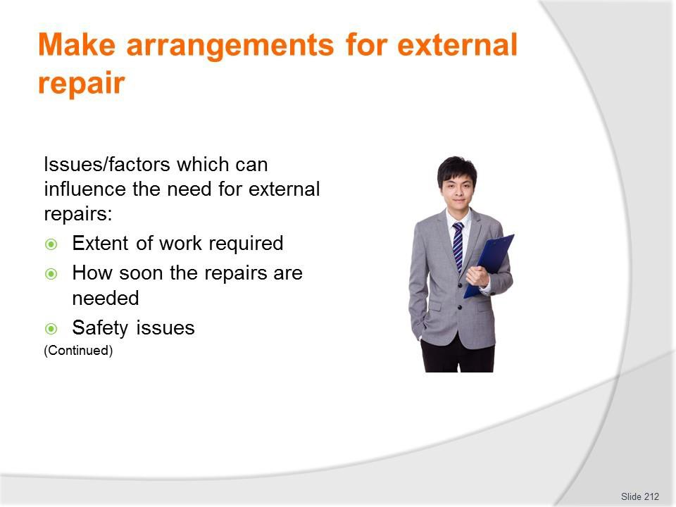
Slide No | Trainer Notes
212. | Trainer presents issues which can influence the need to take a vehicle to an external repairer for work may include:  - Extent of work which needs to be done – smaller jobs may be handled internally but larger jobs tend to be sent out  - Timeframes which apply – where there is a definite or tight timeline for the completion of work, it can be better to have the work done by a professional  - Safety issues – anything which relates to matters of safety tends to be undertaken by suitably qualified technicians and service people so as to discharge the common law Duty of Care imposed on businesses.

Slide
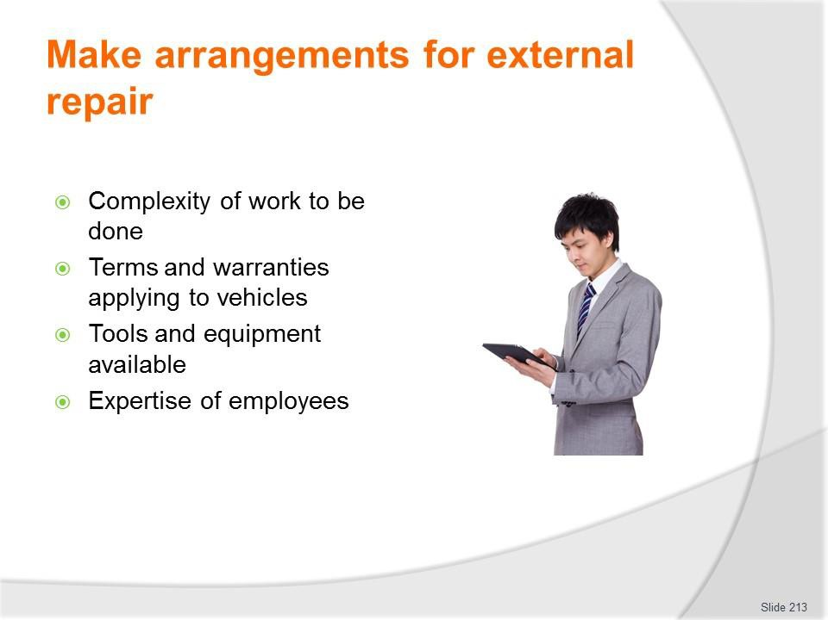
Slide No | Trainer Notes
213. | Trainer continues presenting issues which can influence the need to take a vehicle to an external repairer for work:  - Complexity of the job – simple jobs may be done in-house but the more difficult work tends to be outsourced  - Terms of warranties and guarantees – in order to maintain the protection/coverage provided by some warranties and guarantees there can be a need for specified work to be done by ‘authorised dealers or agents’  - Tools and equipment available – where specialist tools and equipment are required for work it can be more economical to get outside businesses to do the job  - Expertise – there will just be some jobs where organisational personnel have no experience and no real idea of what to do so there is an obvious imperative for the work to be done by experienced professionals.

Slide
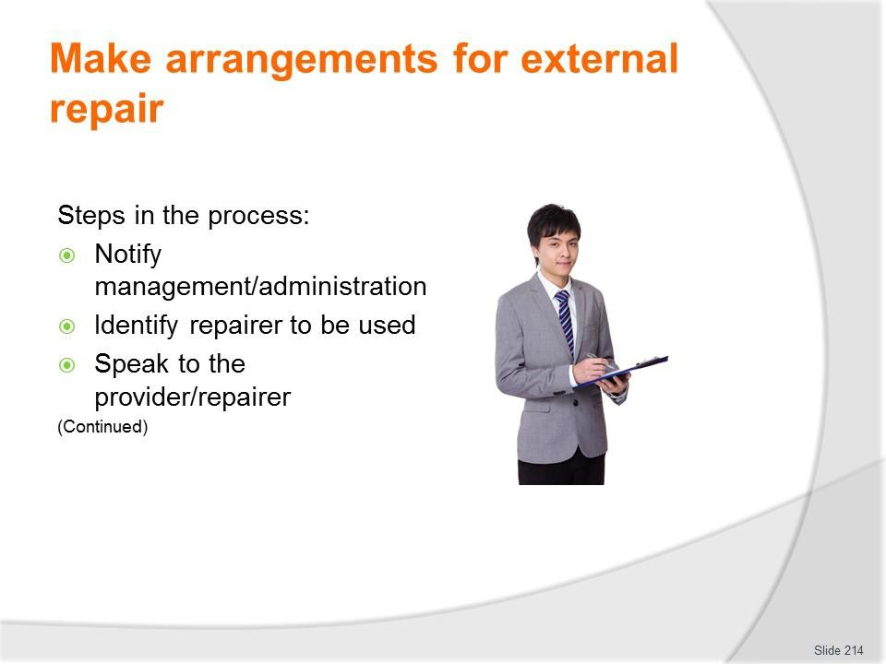
Slide No | Trainer Notes
214. | Trainer identifies steps in the process:  - Notify management or administration – and:  - Advise them of the situation and the reason for external service provision  - Discuss known details of the work required  - Give an estimate of cost, if known  - Identify urgency of work that needs to be done  - Tell them of any bookings/identified up-coming use for the vehicle  - Determine if quotations are required – and if so, how many  - Seek and obtain formal approval to proceed  - Identify the relevant repairer/s – this may be:  - The organisation from which the vehicle was purchased  - The authorised dealer for the make  - The preferred service provider as determined by the business  - An approved repairer as designated by a recognised motoring body or insurer

- Speak to the selected provider/s by phone or in person – and:
  - Advise of the nature and extent of work required
  - Explain urgency of work required and need for vehicle to be returned to service by given date, if applicable
  - Take the vehicle in to the business, if possible or required – for them to see/inspect
  - Request quotation for the work to be done – if necessary.

Slide
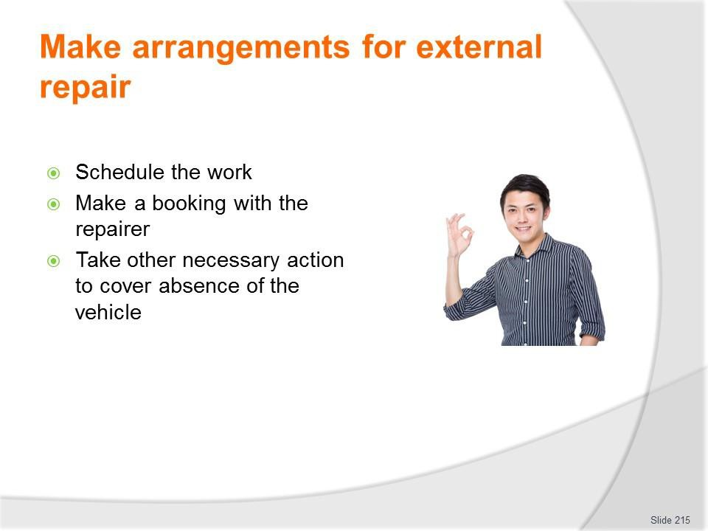
Slide No | Trainer Notes
215. | Trainer continues identifying steps in the process:  - Schedule the work – to:  - Best integrate repairs with any other work to be done – so as to minimise down- time  - Maintain vehicle ‘in service’ for maximum time – providing it is safe to do so  - Make a booking for the work to be done – with the chosen provider which may be chosen based on:  - Quotation received  - Ability to perform the work by required date  - Previous experience with the business  - Direction from management, warranty/guarantee or insurer  - Take necessary other action – which may entail:  - Ensuring vehicle is not used until the required repairs have been completed, where safety is a concern  - Re-arranging vehicle usage sheets to accommodate absence of the vehicle  - Hiring/renting another vehicle to replace the one being repaired  - Advising known vehicle users of changes made.

Slide
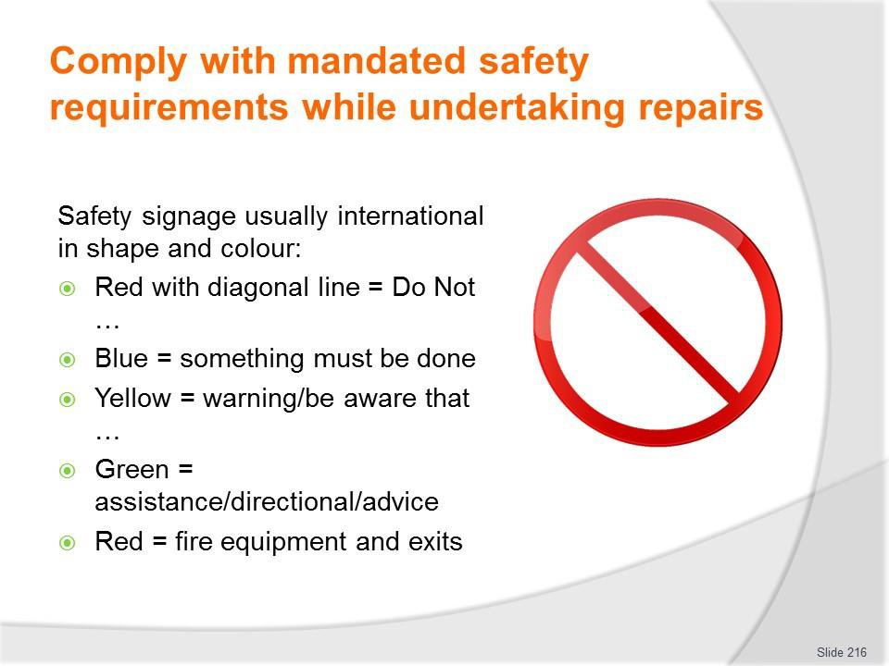
Slide No | Trainer Notes
216. | Trainer refreshes previous safety information provided on earlier slides and then adds new information regarding:  Safety signage observing safety signs are usually international in shape and colour:  - A red circle with a diagonal line indicates ’No’/’Do Not ... Smoke/Enter’  - Blue indicates something must be done – such as wear hearing protection, boots, safety glasses  - Yellow/orange is used for warning signs – be aware that …  - Green is used for assistance and directional signage – showing the location of First Aid, Emergency exits  - All red signs indicate fire equipment/exits.

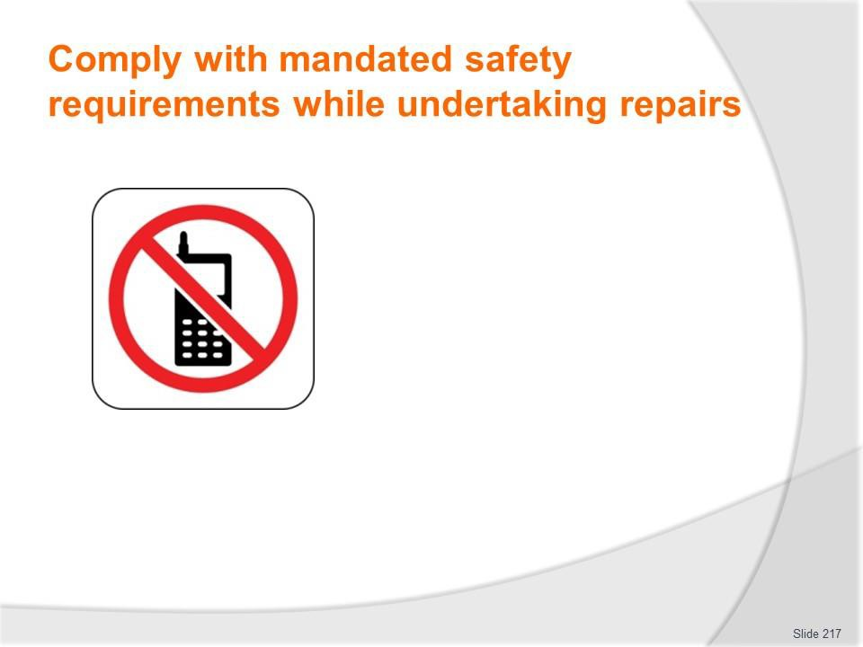
Slide
Slide No
Trainer Notes
217.
Trainer asks class to interpret signs:
- Do not use cell phones in this area.

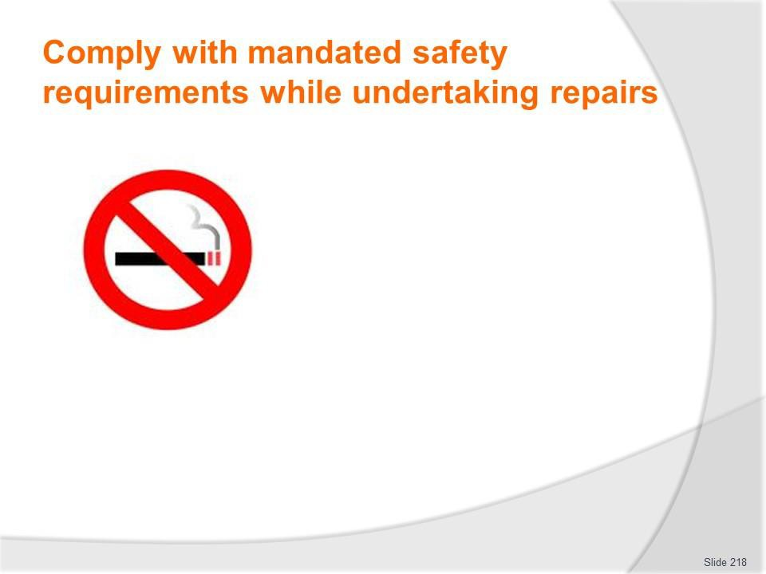
Slide
Slide No
Trainer Notes
218.
Trainer asks class to interpret signs:
- No smoking

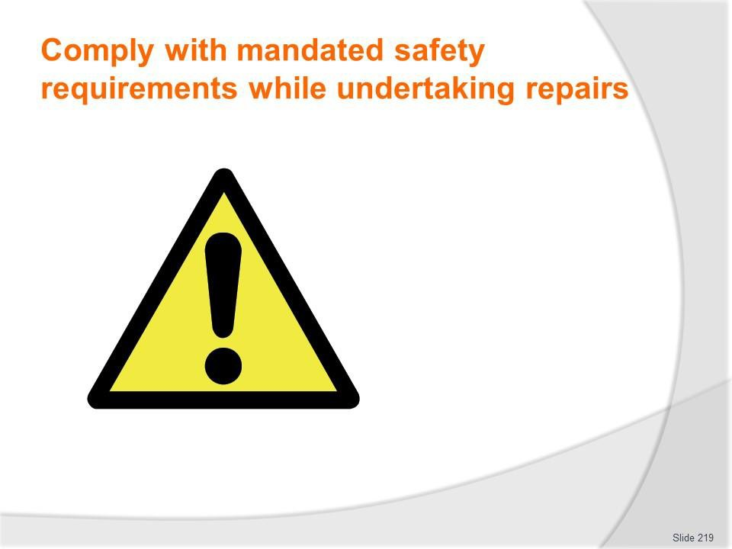
Slide
Slide No
Trainer Notes
219.
Trainer asks class to interpret signs:
- Be aware/Danger

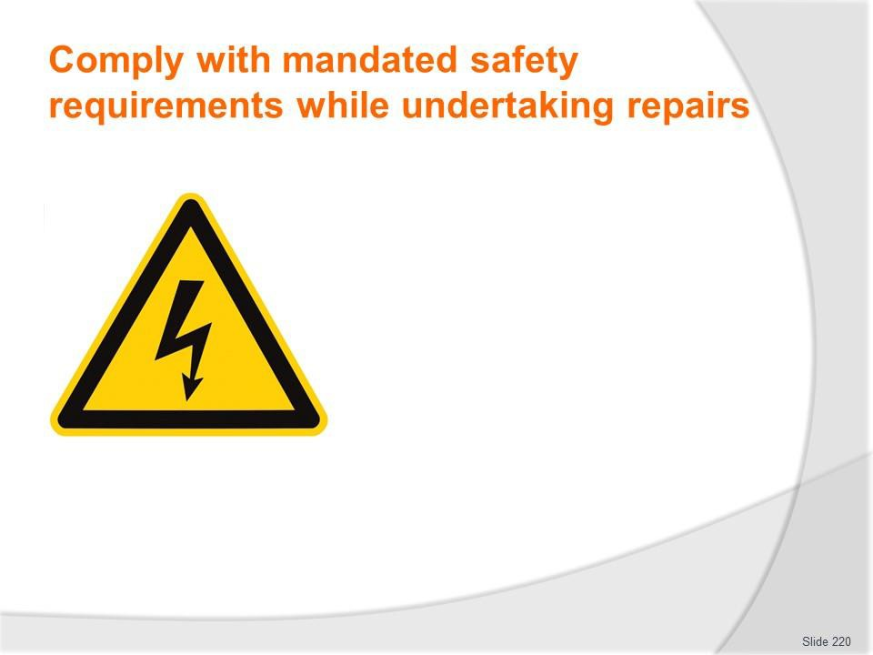
Slide
Slide No
Trainer Notes
220.
Trainer asks class to interpret signs:
- Electrical risk

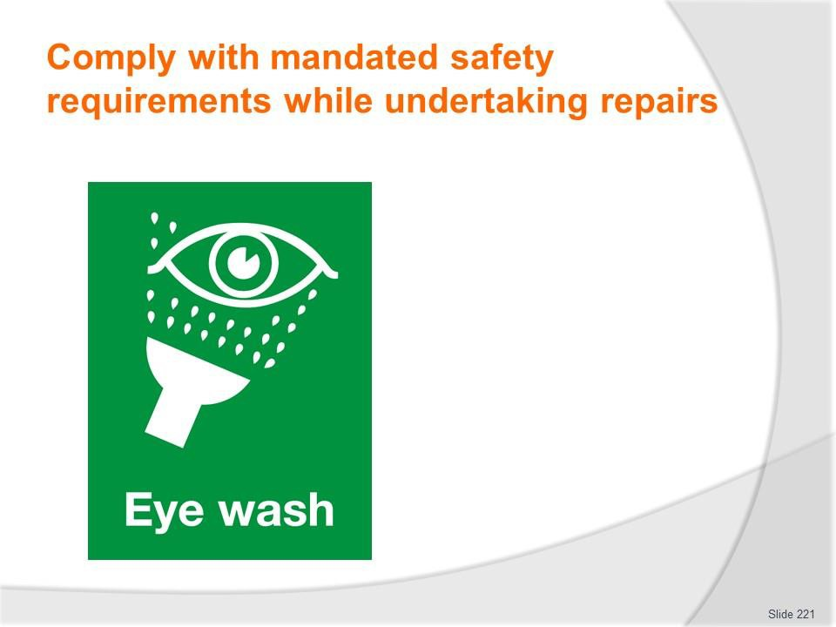
Slide
Slide No
Trainer Notes
221.
Trainer asks class to interpret signs:
- Location of eye wash station

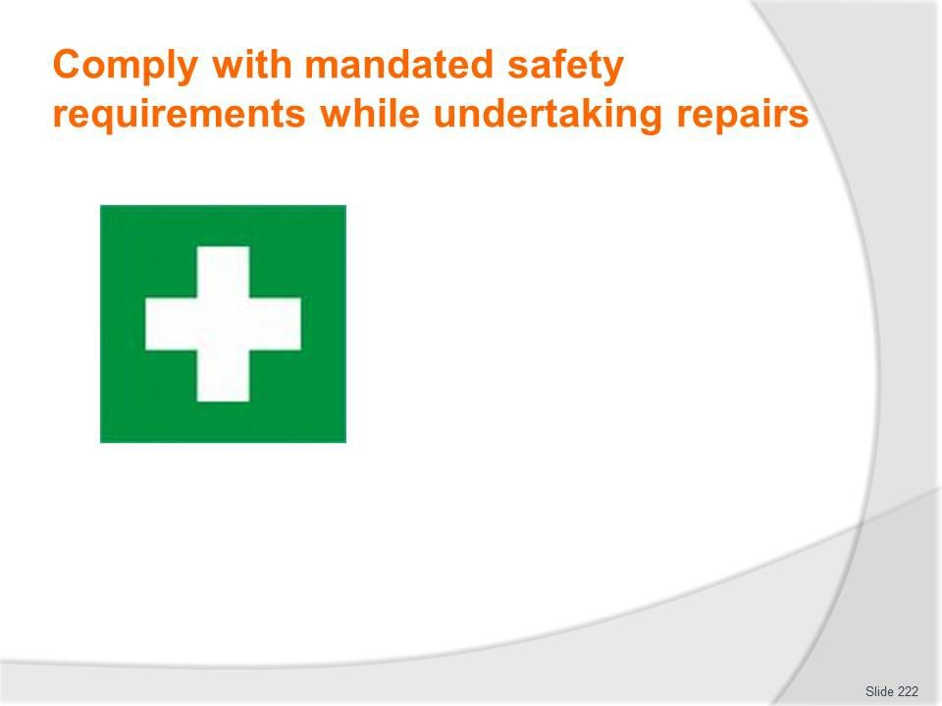
Slide
Slide No
Trainer Notes
222.
Trainer asks class to interpret signs:
- Location of first aid kit

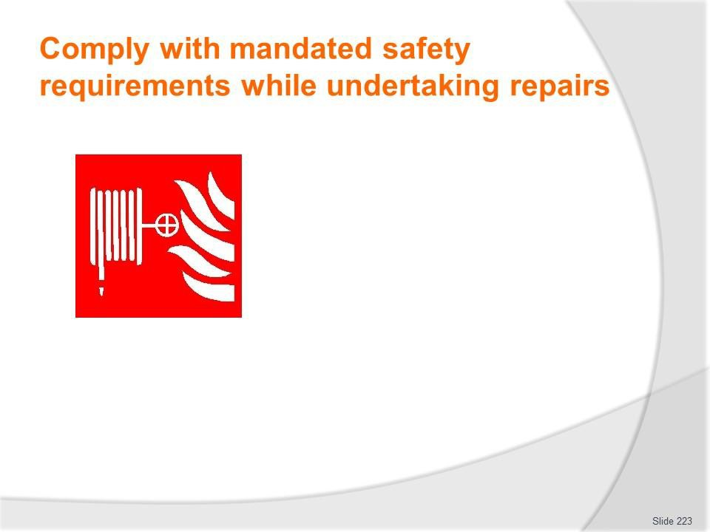
Slide
Slide No
Trainer Notes
223.
Trainer asks class to interpret signs:
- Location of fire hose

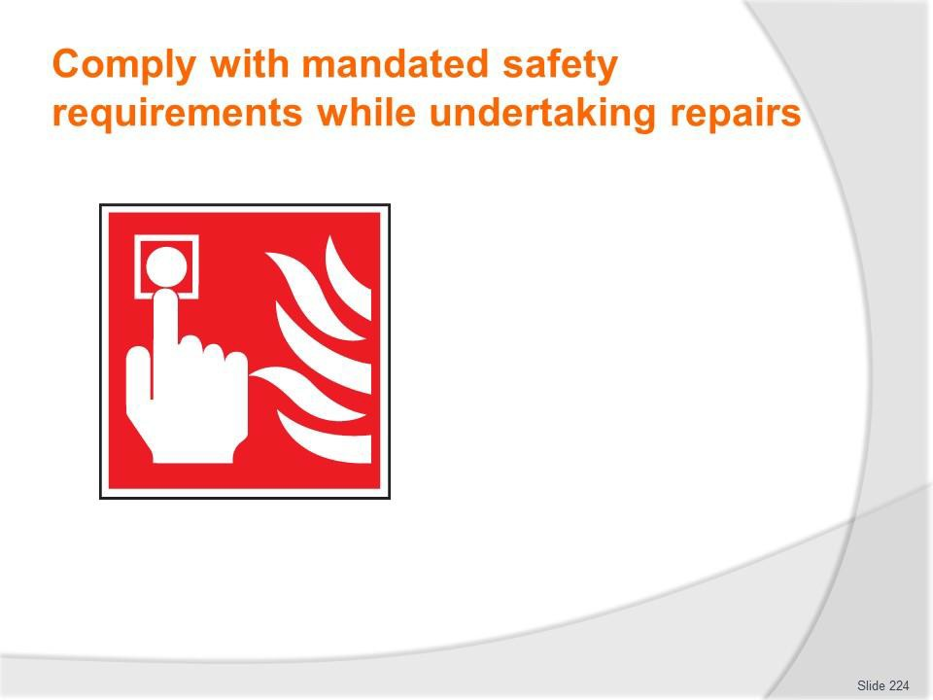
Slide
Slide No
Trainer Notes
224.
Trainer asks class to interpret signs:
- Location of fire alarm

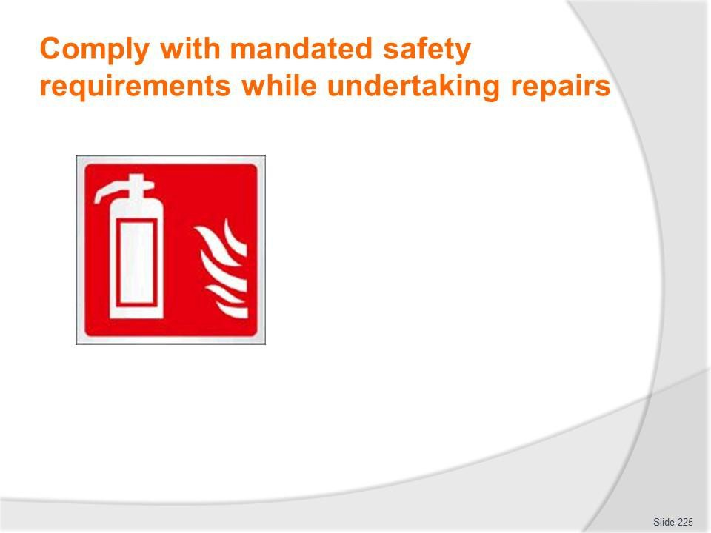
Slide
Slide No
Trainer Notes
225.
Trainer asks class to interpret signs:
- Location of fire extinguisher

Slide
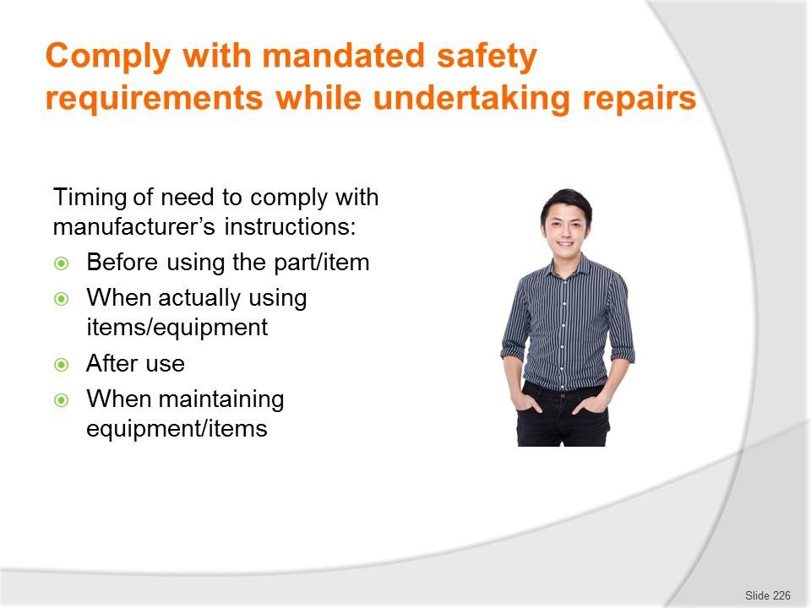
Slide No | Trainer Notes
226. | Trainer identifies times when there is a need to comply with manufacturer’s instructions:  - Prior to using the item – to:  - Check it is safe to use  - Verify all parts of the item are present  - When actually using the equipment for its intended purposes – by ensuring workers:  - Do not exceed load levels, pressures, speed, temperature, run times etc  - Never use the item for a task it was not intended/designed for  - Use/wear the necessary PPE – where/if applicable  - Use the correct attachments/tools for the different actions the equipment is being asked to perform  - After using the equipment – by:  - Cleaning the item as required  - Storing/stowing the equipment

- Maintaining the equipment – by:
  - Providing service as set out in the instructions
  - Changing/replacing parts (filters, O-rings, springs, spacers and other components as identified) at designated times
  - Only having repairs to nominated tools and equipment undertaken by qualified and authorised service technicians
  - Using only genuine parts for service.

Slide
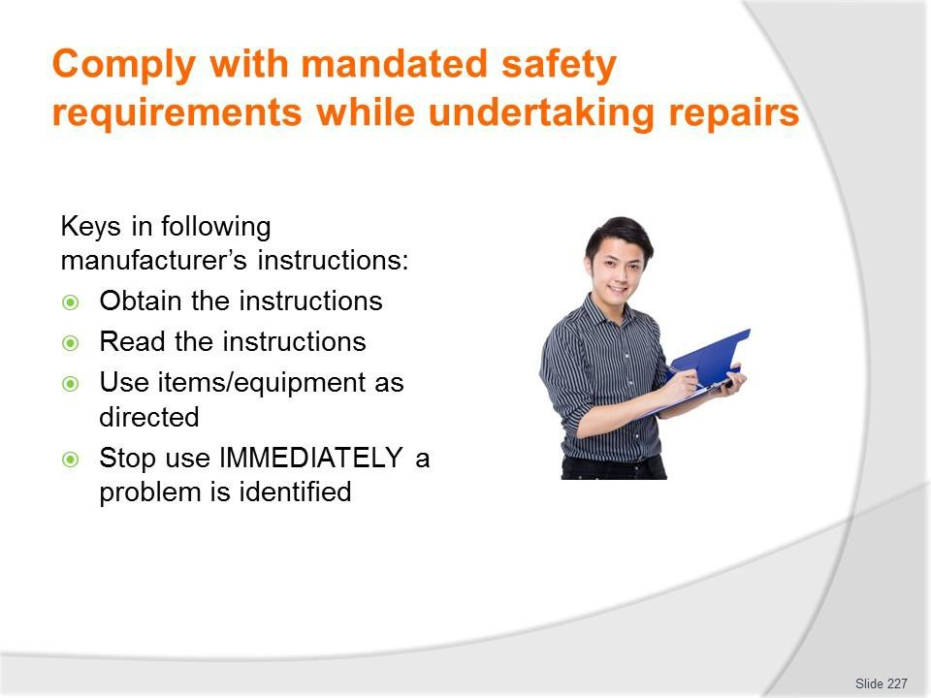
Slide No | Trainer Notes
227. | Trainer presents keys in following manufacturer’s instructions:  - Obtain a copy of the manufacturer’s instructions – by:  - Contacting supervisor and requesting a copy  - Talking to the Purchasing Officer at the workplace – they often remove instructions from the item when it is delivered and keep them on file for future reference  - Speaking to the training department – as they often have these instructions for training purposes  - Contacting the manufacturer and asking for a copy – ring the supplier, or speak to the representative and ask them to forward a copy  - Going on the internet and visiting the website of the manufacturer – many businesses provide operating instructions for free download  - Looking on the intranet – the employer may have loaded the instructions onto a section called ‘Manufacturer’s instructions’  - Photocopy the instructions so there is a spare copy  - Read the instructions – and ensure understanding of them: ask questions where necessary to clarify ambiguities  - Use equipment as instructed – which means avoiding taking short-cuts and/or avoiding the belief a better way of doing things has been found  - Stop using the item immediately a problem has been detected – unusual vibration,

 | strange smell, different noise.
Slide

Slide No | Trainer Notes
228. | Trainer introduces safety signage regarding chemicals asking students to identify signs on slide  Globally Harmonised System of Classification and Labelling of Chemicals (GHS)  Background  The Globally Harmonised System of Classification and Labelling of Chemicals (GHS) is a United Nations (UN)-developed system for chemical classification and hazard communication through harmonized provisions for standardized labels and safety data sheets (SDS). It is developed from various existing systems in the US, EU, Canada, and from the UN’s own research and study of universal standards.  The GHS was endorsed by the UN World Summit for Sustainable Development in 2002. At the 14th APEC Ministerial Meeting in Oct 2002, APEC Trade Ministers also set its stamp of approval on the GHS for APEC-wide implementation by 2006. This target date was rescheduled to 2008 at the APEC Chemical Dialogue meeting in 2006.  GHS in a Nut Shell  The GHS is documented in the UN publication - GHS Document (commonly known as the “Purple Book”).  The GHS is essentially a hazard communication system for identifying and conveying chemical hazards, and for providing information related to chemical hazards and their control and prevention.

The GHS requires chemicals to be classified based on their inherent properties or hazards and in accordance with certain classification criteria. The classified chemicals are assigned to a fixed set of GHS pictogram(s), signal word, hazard and precautionary statements.
Classroom Activity (1) – internet Research
Trainer facilitates research and discussion of: http://www.unece.org/trans/danger/publi/ghs/implementation_e.html. http://www.unece.org/trans/danger/publi/ghs/ghs_rev03/03files_e.html Classroom Activity (2) – Handout
Trainer distributes and discusses examples of GHS Pictograms as presented in the Trainee Manual.

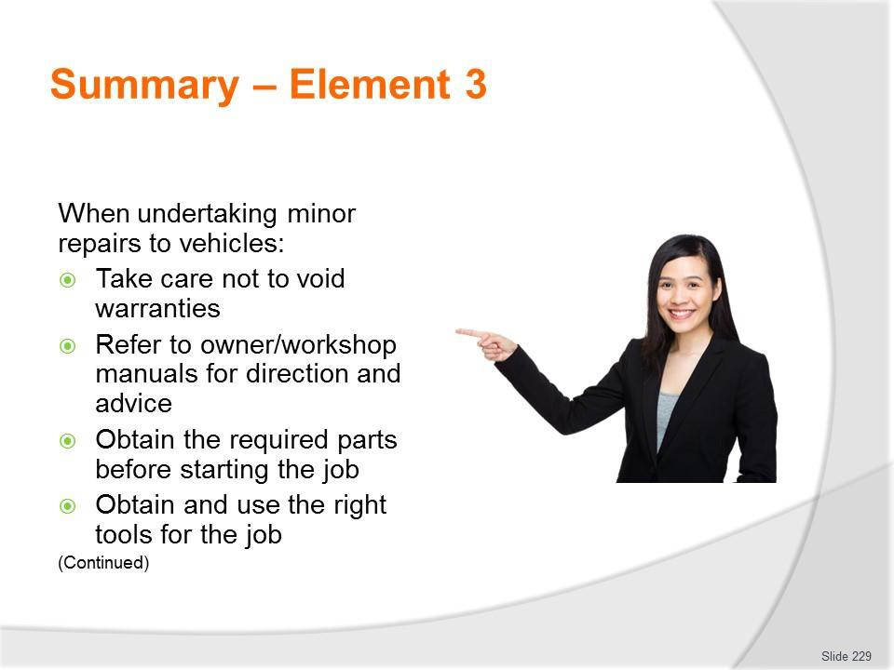
Slide
Slide No
Trainer Notes
229.
Trainer provides a recap of the Element asking questions to check trainee understanding and responding to questions from trainees, as required.

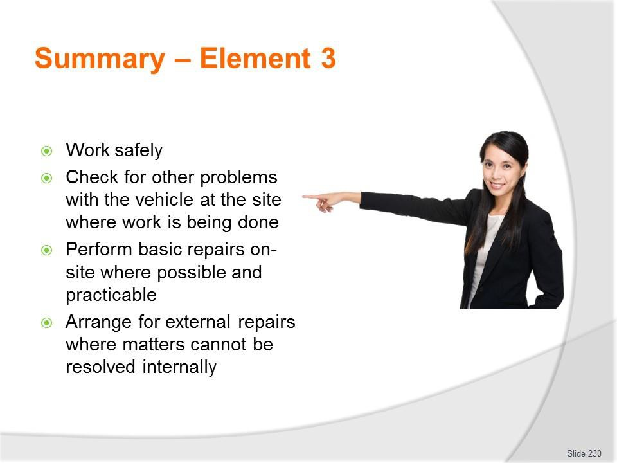
Slide
Slide No
Trainer Notes
230.
Trainer provides a recap of the Element asking questions to check trainee understanding and responding to questions from trainees, as required.

Slide
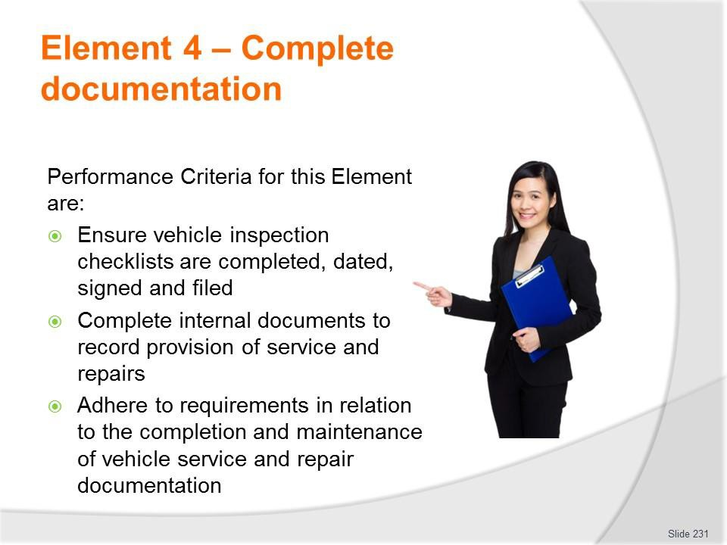
Slide No | Trainer Notes
231. | Trainer identifies for trainees the Performance Criteria for this Element, as listed on the slide.  Class Activity – General Discussion  Trainer leads a general class discussion by asking questions such as:  - What records might need to be completed?  - Why are these records needed/kept?  - Who completes them?  - What happens to them after they have been completed?

Slide
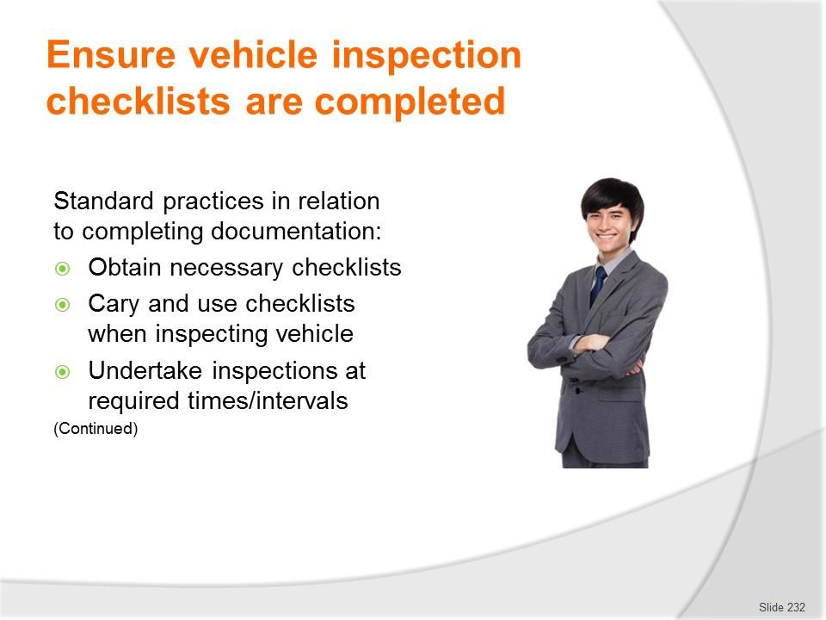
Slide No | Trainer Notes
232. | Trainer presents standard practice for completing vehicle inspection checklists:  - Obtain the necessary checklist – there may be different checklists for different types of vehicles, based on factors such as makes, models, carrying capacity, vehicle configuration or registration number  - Other operators may use a generic inspection checklist where users are required to enter relevant details (registration number, make and model) to identify the vehicle being inspected  - Checklists also exist for trailers  - Carry and use the checklist while inspecting the vehicle – do not inspect the vehicle and rely on memory to fill in the form  - Undertake the inspection at the required times – which may be:  - Before a vehicle departs for a tour  - Every morning before a vehicle is used while on tour  - Weekly for office vehicles.  Classroom Activity – Handout  Trainer distributes and discusses sample vehicle inspection checklist.

Slide
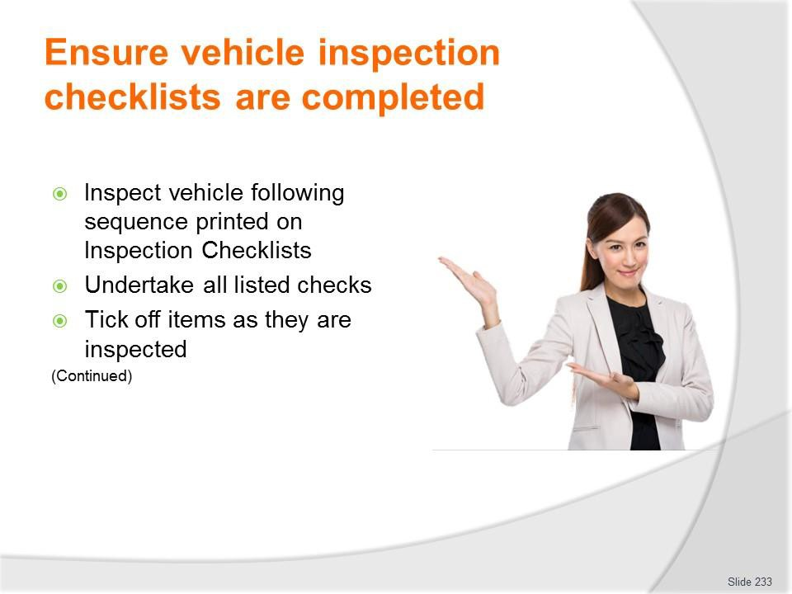
Slide No | Trainer Notes
233. | Trainer continues presenting standard practice for completing vehicle inspection checklists:  - Inspect the vehicle in the sequence of the checks listed on the checklist – the items to be checked should be listed in a logical and sequential manner that:  - Facilitates an ordered/structured inspection  - Minimises the amount of time needed to do the inspection  - Undertake all the listed inspections – never skip any of them  - Inspect the vehicle in the ways required by the checklist – which may be:  - Stationary and not running  - Stationary and running  - Operating/moving  - Tick off the items (✓) as they are inspected – to show they have been checked and are acceptable/OK.

Slide
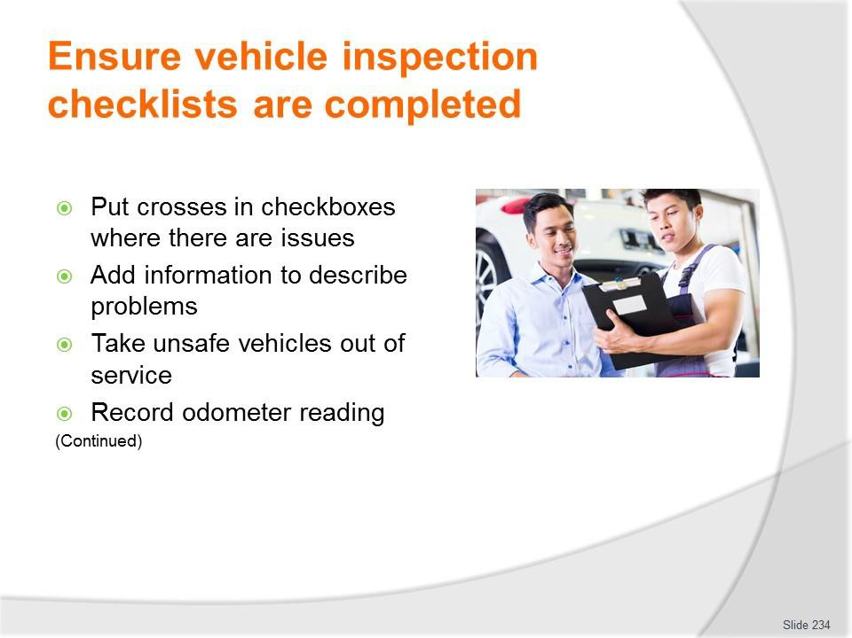
Slide No | Trainer Notes
234. | Trainer continues presenting standard practice for completing vehicle inspection checklists:  - Place a cross (X) in the tick boxes where a problem is identified – and add some written comment:  - Explaining/describing the problem  - Identifying the urgency of the need for maintenance or repairs  - Being honest and accurate in the responses and information provided/written down  - Place unsafe/un-roadworthy vehicles out-of-service – so they cannot be used  - Write down the odometer reading – this is a standard requirement for most vehicle checklists.  Classroom Activity – internet Research  Trainer facilitates research and discussion of:  http://www.atyourbusiness.com/vehicleinspection.php - Sample vehicle inspection report forms  www.adtasa.com.au/forms/Vehicle_checklist_2011.doc - Vehicle inspection checklist  http://www.ehs.gatech.edu/general/weekly_vehicle_inspection_checklist.pdf - Weekly motor vehicle inspection checklist.

Slide
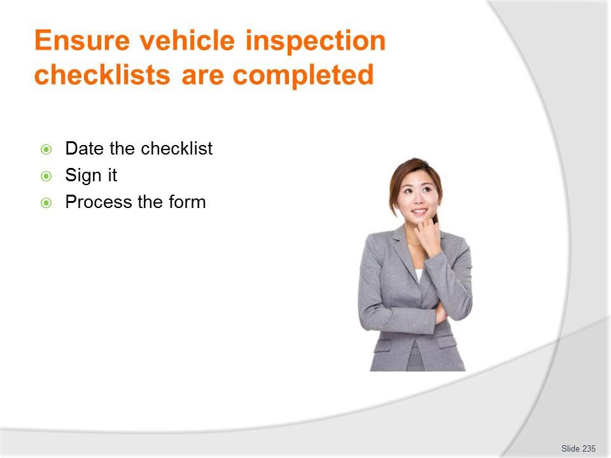
Slide No | Trainer Notes
235. | Trainer continues presenting standard practice for completing vehicle inspection checklists:  - Date the completed checklist – to give a point of reference  - Sign the form (there may also be a need to print name) – so others know who did the inspection  - Process the completed form – which may involve:  - Forwarding the form to the nominated person or department so it can be auctioned as needed according to internal protocols 9where maintenance or repairs are necessary)  - Arranging repairs and service by external businesses – where the problems cannot be fixed internally  - Filing the form for future reference  - Using/providing/accessing the form when work needs to be performed on the vehicle.  Classroom Activity – Demonstration and Practical  Trainer demonstrates how to use vehicle inspection checklist and provides opportunity for students to do the same.

Slide

Slide No | Trainer Notes
236. | Trainer explains standard practice as part of the process for providing service and repairs to organisational vehicles is to complete a ‘Service Report’ form/log or similar and completing this documentation includes:  - Using the approved template/form – where businesses require this information to be recorded they will provide a document especially for the purpose  - The document is commonly hard copy but may be electronic  - Identifying the vehicle which has been serviced/repaired – as required by the business, which require:  - Registration number  - Make and model  - Odometer reading  - Completing the form immediately after the work has been completed – or as the work progresses, rather than the next day or at the end of the week.  Classroom Activity – Handout  Trainer distributes and discusses sample record document.

Slide
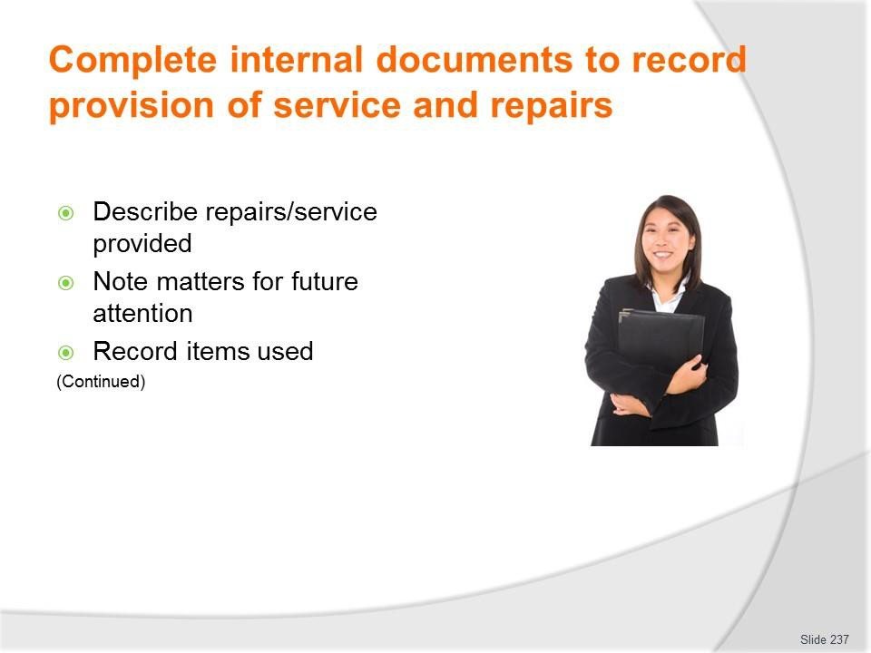
Slide No | Trainer Notes
237. | Trainer continues to present requirements when recording service/repairs:  - Describing service and repairs provided – in sufficient detail to allow others to interpret and understand the work that was undertaken. Keys are:  - Write clearly  - Be honest  - Cover all work done  - Use recognised abbreviations and acronyms  - Cross-reference to parts used  - Noting matters that will/may require attention at the next service – so that:  - Vehicle users/operators are aware of this – and can factor it into their use of the vehicle  - Management/administration are made aware of significant/costly issues which are imminent  - Necessary resources, parts and other requirements are purchased/obtained in advance of the next scheduled service session  - Recording the action taken for cost and stock control purposes – which may require:  - Listing items used – parts and fluids  - Costing each unit/item

- Including hours spent on the job
- Calculating totals – for parts and labour involved in service and/or repair.
Classroom Activity – internet Research
Trainer facilitates research and discussion of:
download.microsoft.com/download/9/d/c/.../Vehicle_Repair_Log.xlt – Vehicle repair log
http://www.vertex42.com/ExcelTemplates/vehicle-maintenance-log.html - Vehicle maintenance log.

Slide
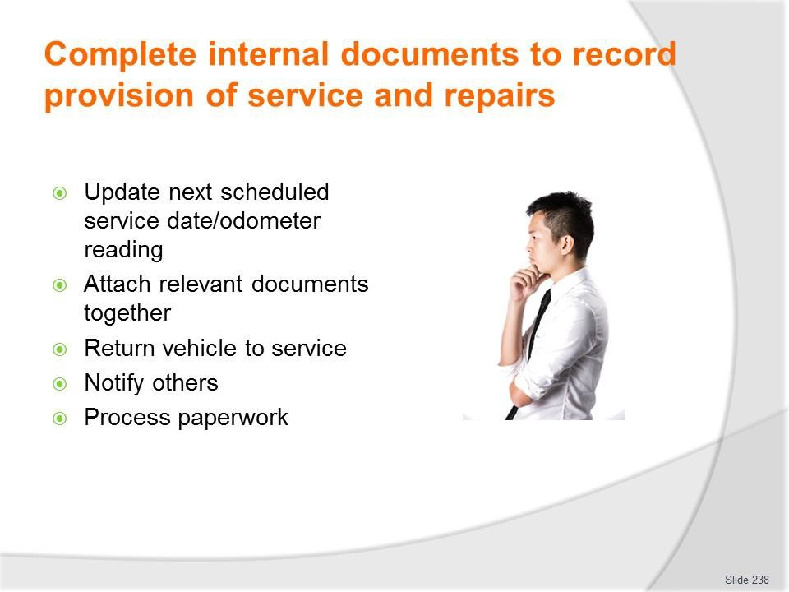
Slide No | Trainer Notes
238. | Trainer continues to present requirements when recording service/repairs:  - Updating next scheduled service for the vehicle – in terms of (as appropriate):  - Date when service is required  - Odometer reading when service is required  - This update might be required:  - in a central Service Index – kept to monitor service dates for all vehicles  - In the manual for the vehicle – kept in the glove box/similar in the vehicle  - On a sticker placed on the windscreen of the vehicle  - Attaching the inspection checklist (or copy) which initiated/triggered the work to the completed ‘Service Report’ – if required  - Returning the vehicle to its normal location – to return it to service  - Notifying personnel who may be waiting on the vehicle – that it is now ready  - Processing paperwork – forwarding it as required to administration/management.  Classroom Activity – Demonstration and Practical  Trainer demonstrates how complete service/repair record and provides opportunity for students to do the same.

Slide
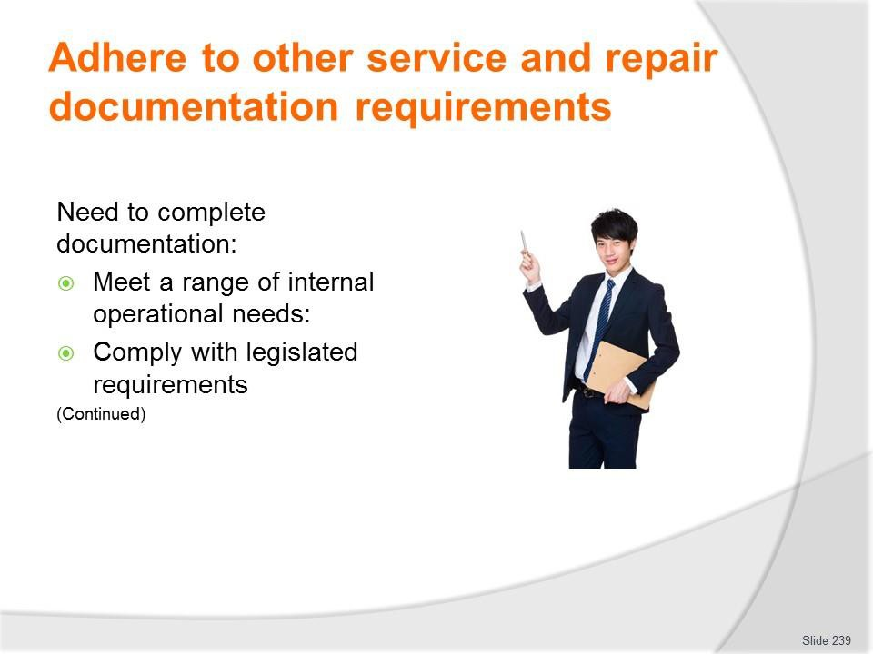
Slide No | Trainer Notes
239. | Trainer explains the need to record the completion and maintenance of vehicle service and repairs may include:  - A range of host enterprise requirements - which can relate to:  - Monitoring costs  - Tracking vehicle use  - Identifying vehicle service dates  - Identifying vehicle dates  - Calculating economy  - Need to comply with legislated requirements – especially:  - Vehicle registration in the correct (‘commercial’) category  - Mandatory insurance  - Roadworthiness.  Classroom Activity – Guest Speaker  Trainer arranges for relevant Service Manager or Business owner/manager to attend and:  - Identify records needing to be kept  - Provide examples of same  - Explain completion of same.

Slide

Slide No | Trainer Notes
240. | Trainer continues identifying need to complete these records:  - Requirements imposed on the business by clients such as tour operators, venues and site operators who contract the use of vehicles – as these apply to:  - Cleaning of vehicles ready for use  - Maintaining service of vehicles for operational reliability and safety  - Ensuring availability of vehicle at times they are required/booked/contracted  - Recording use by external parties  - Capturing usage facts for administration and charging purposes  - Requirements imposed on the business by third parties such as insurers and auditors – such as:  - Advising of incidents and accidents, as/if necessary  - Notifying of repairs and/or modifications  - Maintaining insurance coverage  - Ensuring vehicles are maintained in a condition (operational, appearance, comfort, safety, facilities) that complies with the standard demanded by the code/system being audited

- Requirements imposed by Taxation agency for the country – in terms of:
  - Maintaining records to show usage information of the vehicle/distance travelled and other data as may be required to demonstrate legitimate business-related use – for example:
    - Times and dates
    - Destinations
    - Purpose/reason for travel
  - Retaining evidence/receipts of work performed on vehicle and fuel for it.

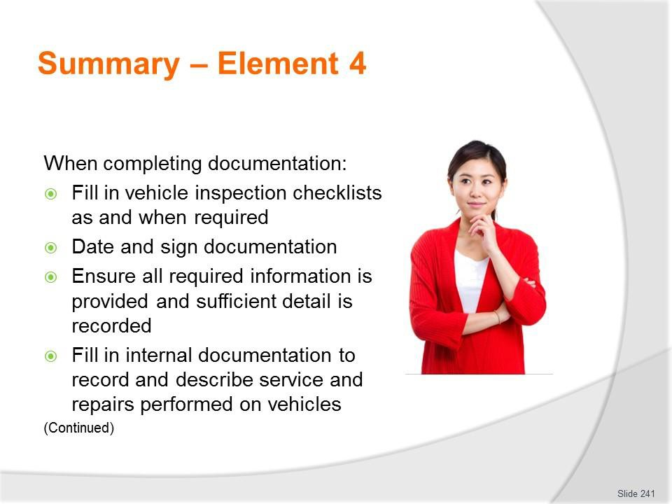
Slide
Slide No
Trainer Notes
241.
Trainer provides a recap of the Element asking questions to check trainee understanding and responding to questions from trainees, as required.

Slide
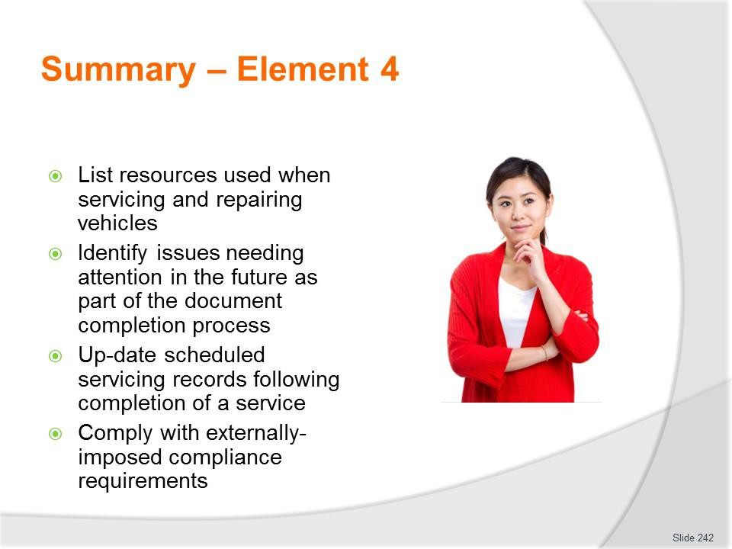
Slide No | Trainer Notes
242. | Trainer provides a recap of the Element asking questions to check trainee understanding and responding to questions from trainees, as required.  Trainer thanks trainees for their attention and encourages them to apply course content as required in their workplace activities.

Recommended training equipment
- Vehicles on which to practice/demonstrate maintenance and minor repairs – selection should embrace:
  - Two-wheel drives
  - Four-wheel drives
  - Coaches
  - Trailers – complete with draw bar, lights, electrical fittings, jockey wheel, chains
  - Petrol engines
  - Diesel motors
- Range of large and small hand and electrical tools and specialist equipment/tools required to perform maintenance and undertake repairs:
  - Wrenches – various sizes, imperial and metric
  - Torque wrench
  - Adjustable, open end, box end (6 and 12 sided) wrenches
  - Combination wrenches
  - Ratchets – various sizes, imperial and metric
  - Standard sockets – various sizes, imperial and metric
  - Spark plug sockets
  - Impact sockets
  - Pliers
  - Slip joint pliers
  - Locking pliers
  - Groove joint pliers
  - Needle nose pliers
  - Diagonal cutting pliers
  - Screwdrivers – range of sizes and lengths, flat-head and Phillips head
  - Hammers – ball peen, rubber
  - Pry bars – different sizes/lengths
  - Slide hammer bars
  - Vehicle hoist
  - Wheel jacks – different types: scissor, bottle, pneumatic; trolley
  - Vehicle ramps
  - Wheel chocks
  - Jack stands
  - Tyre pressure gauge

  - Tread depth gauge
  - Four-way tyre tool
  - Measuring rulers and tapes – metric and imperial
  - Coolant tester
  - Sparkplug gauge
  - Feeler gauge
  - Calipers
  - Micrometers
  - Dial indicators
  - Multi-meters
  - Fuse pullers
  - Wire strippers
  - Battery load tester
  - Jumper cables
  - Battery terminal puller
  - Battery brush
  - Battery terminal spreader
  - Oil drain pan
  - Oil filter wrench
  - Funnel – different sizes/shapes
  - Grease guns
  - Hacksaw
  - Grinder
  - Chisels
  - Punches
  - Files
  - Hex keys/Allen keys
  - Compressors – for driving pneumatic equipment and for tyre inflation
  - Vice
- Range of replacement parts/spare parts:
  - Spark plugs
  - Glow plugs
  - Range of nuts, bolts, screws, connectors, electrical wire, fuses
  - HT leads
  - Fan belts and other engine drive belts
  - Radiator hoses – top and bottom

  - Oil filters
  - Fuel filters
  - Tyres and tubes
  - Tyre cores and caps
  - Tyre repair kits
  - Range of globes
  - Mirrors
  - Reflectors
  - Windscreen wiper blades
  - Fuel – petrol, diesel, LPG
- Range of grease, engine oils, brake fluids, transmission fluids, power steering fluid, coolant, anti-freeze
- EPIRB (Emergency Position Indicating Radio Beacon)
- GPS (Global Positioning System)
- Two-way radios
- Public address systems
- Vehicle fire extinguishers
- Baggage and cargo restraints – different types and sizes for a range of vehicles
- Samples/examples of:
  - Warranties and guarantees
  - Service manuals
  - Owner manuals
  - Workshop manuals
  - Repair manuals
  - Documentation completed when a vehicle has been services, repaired and/or maintained
  - Inspection checklists
  - Service reports/logs/forms
  - Material Safety Data Sheets
  - Workplace safety signs and GHS pictograms
  - SOPs and SWPs
- Safety clothing and equipment (PPE) required for undertaking vehicle repairs/service
- Copies of host country legislation that applies to the maintenance of commercial vehicles used for passenger transport.
- It can be useful to watch https://www.youtube.com/watch?v=0b7XfJJ6KcI – Tools of the small engine mechanic.

Instructions for Trainers for using PowerPoint – Presenter View
Connect your laptop or computer to your projector equipment as per manufacturers’ instructions.
In PowerPoint, on the Slide Show menu, click Setup Show.
Under Multiple monitors, select the Show Presenter View check box.
In the Display slide show on list, click the monitor you want the slide show presentation to appear on.
Source: http://office.microsoft.com

Note:

In Presenter View:
You see your notes and have full control of the presentation Your trainees only see the slide projected on to the screen

More Information

You can obtain more information on how to use PowerPoint from the Microsoft Online Help Centre, available at: http://office.microsoft.com/training/training.aspx?AssetID=RC011298761033

Note Regarding Currency of URLs

Please note that where references have been made to URLs in these training resources trainers will need to verify that the resource or document referred to is still current on the internet. Trainers should endeavour, where possible, to source similar alternative examples of material where it is found that either the website or the document in question is no longer available online.

Appendix – ASEAN acronyms

AADCP | ASEAN – Australia Development Cooperation Program
ACCSTP | ASEAN Common Competency Standards for Tourism Professionals
AEC | ASEAN Economic Community
AMS | ASEAN Member States
ASEAN | Association of Southeast Asian Nations
ASEC | ASEAN Secretariat
ATM | ASEAN Tourism Ministers
ATPMC | ASEAN Tourism Professionals Monitoring Committee
ATPRS | ASEAN Tourism Professional Registration System
ATFTMD | ASEAN Task Force on Tourism Manpower Development
CATC | Common ASEAN Tourism Curriculum
MRA | Mutual Recognition Arrangement
MTCO | Mekong Tourism Coordinating office
NTO | National Tourism Organisation
NTPB | National Tourism Professional Board
RQFSRS | Regional Qualifications Framework and Skills Recognition System
TPCB | Tourism Professional Certification Board



